STATISTICAL ANALYSIS OF
E-GOVERNANCE PERFORMANCE METRICS
A Statistical Study of CPGRAMS Public Grievance Performance

Submitted by
Kalyan Dutta
Yuva Intern

1. Introduction
E-governance refers to the use of digital technologies by government organizations to improve public service delivery, administrative efficiency, transparency, and responsiveness. Public grievance redressal is an important e-governance function because it provides citizens with a digital mechanism to register complaints and seek administrative action.
This report analyzes department-wise public grievance performance using data from the Centralised Public Grievance Redress and Monitoring System (CPGRAMS). Statistical techniques are used to examine grievance workload, disposal performance, and the relationship between these indicators.

2. Objectives
- To analyze CPGRAMS public grievance performance using official government data.
- To study the relationship between Total Receipts and Total Disposal.
- To calculate and interpret Disposal Rate (%).
- To apply correlation and regression analysis to e-governance performance metrics.
- To connect the statistical findings with digital public-service performance.

3. Dataset and Data Source
The dataset used for this analysis is the official Government of India Open Government Data (OGD) dataset “Department-wise receipts, disposal and pendency of Public Grievance detailed statistics,” provided by the Department of Administrative Reforms and Public Grievances (DARPG), Ministry of Personnel, Public Grievances and Pensions.
Dataset period: 01.01.2016 to 01.11.2019
Number of observations: 124
Original variables: 8
Main indicators used: Total Receipts, Total Disposal, Disposal Rate (%)
The original dataset contains the following fields:
- Ministry/Department/State
- Total Receipts
- Total Disposal
- Total Pending
- Pending More Than 1 Year
- Pending Between 6 To 12 Months
- Pending Between 2 To 6 Months
- Pending Less Than 2 Months

4. Performance Indicators
Three main performance indicators were selected for the analysis. Total Receipts represents the grievance workload, Total Disposal represents the number of grievances disposed, and Disposal Rate represents the proportion of received grievances that were disposed.
Disposal Rate (%) = (Total Disposal / Total Receipts) × 100

5. Statistical Analysis

5.1 Correlation Analysis
Pearson correlation was used to measure the direction and strength of linear relationships between the selected variables.
Variable 1 | Variable 2 | Correlation (r)
Total Receipts | Total Disposal | 0.95917
Total Receipts | Disposal Rate (%) | -0.042
Total Disposal | Disposal Rate (%) | 0.139
The correlation of 0.95917 between Total Receipts and Total Disposal indicates a very strong positive relationship. Departments with larger grievance workloads generally also record larger numbers of disposals. In contrast, the correlation of -0.042 between Total Receipts and Disposal Rate is very close to zero, indicating almost no linear relationship between grievance volume and disposal percentage.

5.2 Regression Analysis
Simple linear regression was performed with Total Receipts as the independent variable (X) and Total Disposal as the dependent variable (Y). The Excel trendline gives the following equation:
Total Disposal = -1854.83 + 0.8429 × Total Receipts
The regression has R² = 0.92. Therefore, approximately 92% of the variation in Total Disposal is associated with variation in Total Receipts within this dataset.

6. Graphical Analysis
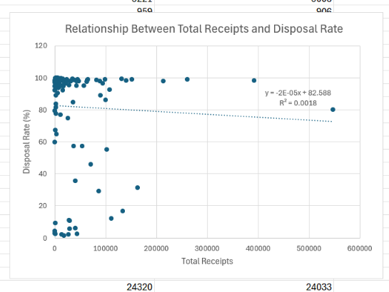
Figure 1. Relationship Between Total Receipts and Total Disposal
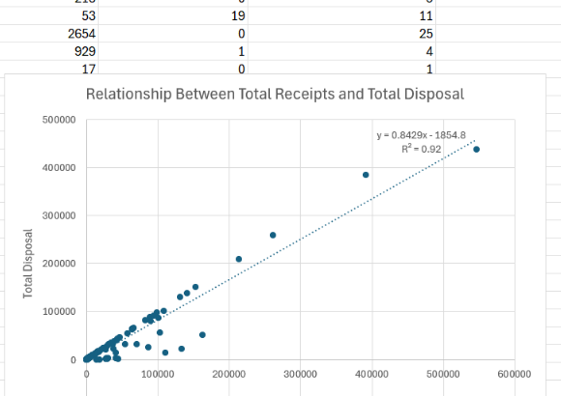
Figure 2. Relationship Between Total Receipts and Disposal Rate (%)
Figure 1 shows a strong upward trend, consistent with the high correlation and R² value. Figure 2 shows an almost flat trendline, consistent with the very small R² value of 0.0018.

7. Interpretation in the Context of E-Governance
- Workload and capacity: A high number of receipts naturally creates a larger disposal workload. The strong receipts-disposal relationship reflects this operational connection.
- Efficiency measurement: Raw disposal counts should not be used alone to judge performance. Disposal Rate provides a more normalized measure of performance.
- Backlog management: Total Pending and pending-age categories can help identify whether unresolved grievances are accumulating and how long they remain pending.
- Data-driven governance: Correlation and regression can help administrators identify patterns in digital grievance-management performance and support evidence-based decisions.
- Citizen responsiveness: Faster and more consistent grievance disposal can improve the effectiveness and credibility of digital public-service systems.

8. Excel Methodology and Reproducibility
The original government data was preserved in the original worksheet. A separate Statistical_Analysis worksheet was used for calculated indicators, while Statistical_Tests was used for correlation and regression calculations.
- Disposal Rate (%) = (Total Disposal / Total Receipts) × 100
- Pending Rate (%) = (Total Pending / Total Receipts) × 100
- Correlation was calculated using Excel CORREL.
- Regression R² was calculated using Excel RSQ.
- Regression slope was calculated using Excel SLOPE.
- Regression intercept was calculated using Excel INTERCEPT.
The accompanying Excel workbook contains the original data, calculated indicators, statistical tests, and the two scatter plots, making the analysis reproducible.

9. Limitations
- The dataset ends in 2019 and therefore does not represent current CPGRAMS performance.
- Correlation and regression show association and do not establish causation.
- Disposal Rate measures quantity-based disposal performance and does not directly measure grievance quality, resolution quality, or citizen satisfaction.
- Departments differ in size, workload, functions, staffing, and grievance complexity, which may affect the indicators.

10. Conclusion
The analysis demonstrates how statistical techniques can be applied to evaluate e-governance performance using official public-sector data. Total Receipts and Total Disposal have a very strong positive relationship (r = 0.95917), while the regression model gives R² = 0.92. This shows that grievance workload is strongly associated with the number of grievances disposed.
However, Total Receipts and Disposal Rate have an almost negligible relationship (r = -0.042; R² = 0.0018). This indicates that receiving more grievances does not automatically result in a higher disposal percentage. Therefore, a balanced e-governance performance assessment should consider both workload measures and efficiency measures such as disposal rate and pendency.

11. References
Department of Administrative Reforms and Public Grievances (DARPG), Ministry of Personnel, Public Grievances and Pensions. Department-wise receipts, disposal and pendency of Public Grievance detailed statistics. Open Government Data (OGD) Platform India.
Official source: https://www.data.gov.in/catalog/department-wise-receipts-disposal-and-pendency-public-grievance-detailed-statistics

