GEYSER

**BLOCK DIAGRAM:** 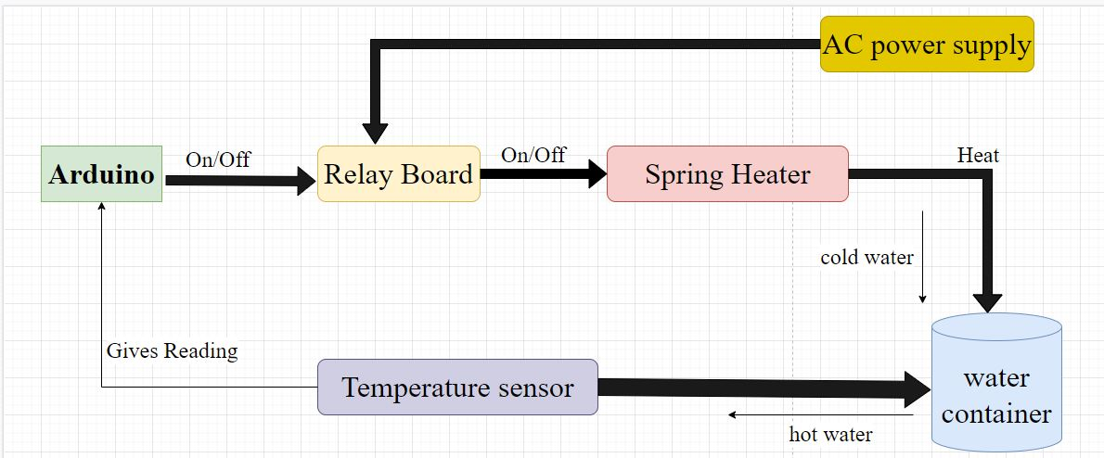

**Requirements:**

1. You can install electric geyser nearly everyplace.
2. Electric geyser is easy to handle.
3. It is portable.
4. No release of carbon monoxide because there is no burning of fuel.
5. Longer Life spam.

**Components:**

**1.Arduino:**

* Arduino is an open-source electronics platform based on easy-to-use hardware and software. Arduino boards are able to read inputs - light on a sensor, a finger on a button, or a Twitter message - and turn it into an output - activating a motor, turning on an LED, publishing something online.

**2.Relay Board:**

* Relays are switches that open and close circuits electromechanically or electronically. Relays **control one electrical circuit by opening and closing contacts in another circuit**.
* As relay diagrams show, when a relay contact is normally open (NO), there is an open contact when the relay is not energized.

**3.Spring Heater:**

* A heater is a device for supplying heat, for example a radiator or a convector. These water heaters heat water only when it is needed.
* Turn on the heater and the interior of the car will soon warm up. A heater is a device for supplying heat, for example a radiator or a convector.

**4.Temparature sensor:**

* A temperature sensor is a device used to measure temperature. This can be air temperature, liquid temperature or the temperature of solid matter.
* There are different types of temperature sensors available and they each use different technologies and principles to take the temperature measurement.