SQL
- Employee Table
Query:-
CREATE TABLE Employees(
EmpID INT PRIMARY KEY,
Name VARCHAR(50),
Department VARCHAR(30),
Salary DECIMAL(10,2),
);

INSERT INTO Employees(EmpID, Name, Department, Salary) VALUES
(1, 'John Doe', 'HR', 50000),
(2, 'Jane Smith', 'IT', 60000),
(3, 'Alice Johnson', 'Finance', 55000),
(4, 'Bob Brown', 'HR', 45000),
(5, 'Charlie White', 'IT', 65000);

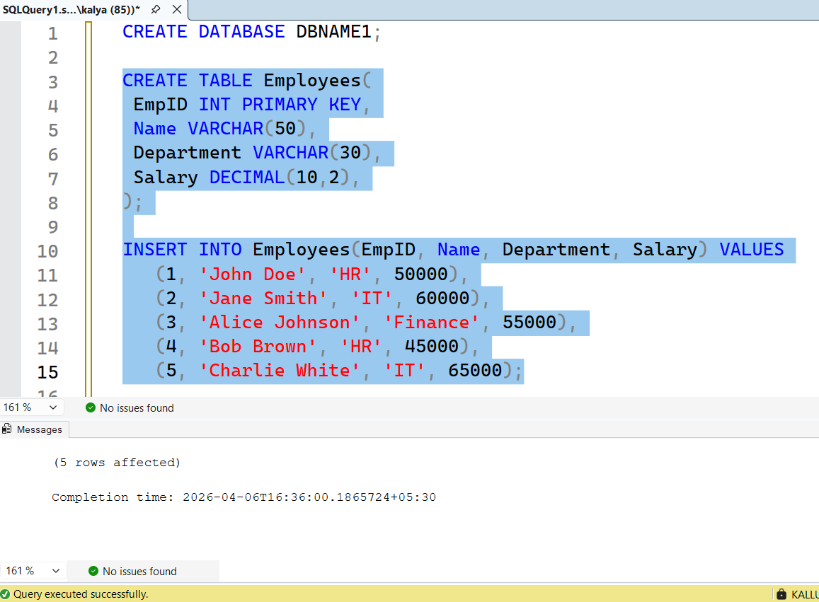

2. Departments Table
Query:-
CREATE TABLE Departments(
DeptID INT PRIMARY KEY,
DeptName VARCHAR(50),
Location VARCHAR(50),
);

INSERT INTO Departments (DeptID, DeptName, Location)
VALUES (101, 'Sales', 'New York');

SELECT * FROM Departments;
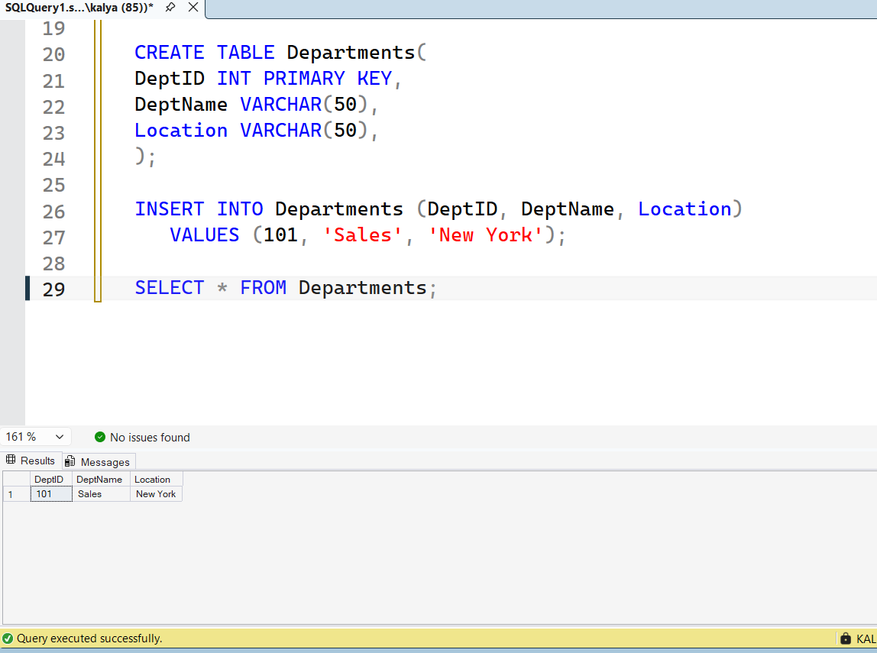

3. SQL Queries:
Query:- 3a
SELECT * FROM EMPLOYEES;
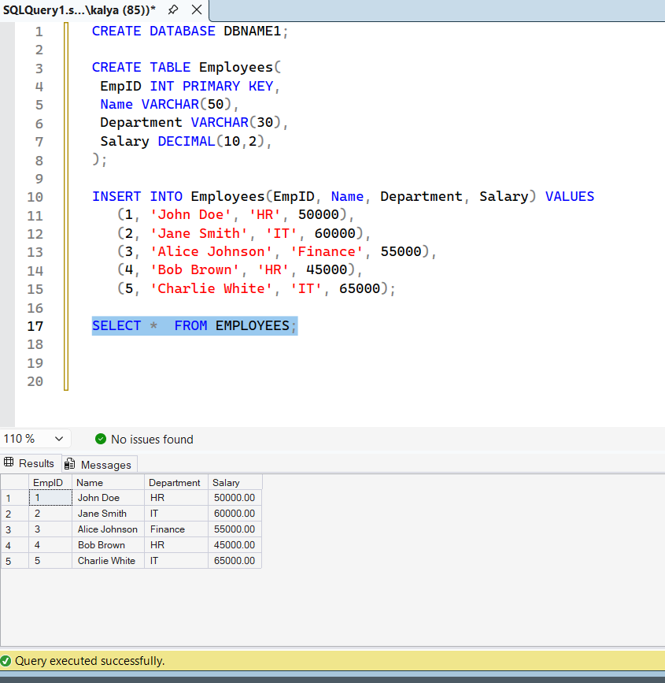
Query:- 3b
SELECT DISTINCT Department FROM Employees;
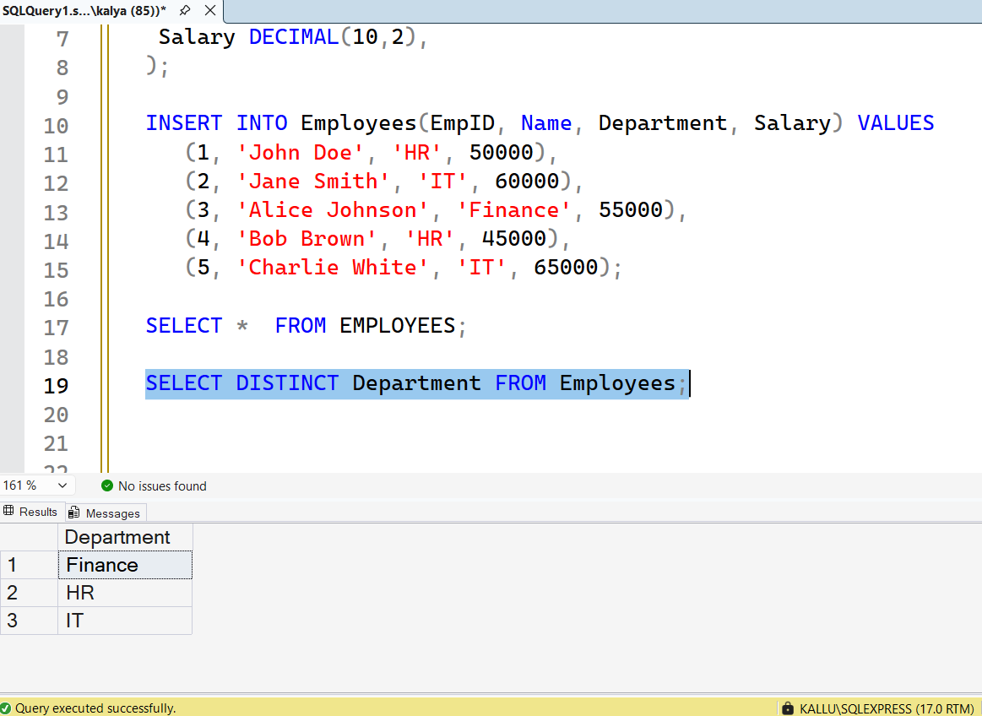
Query:- 3c
SELECT * FROM Employees WHERE Salary > 55000;
