SQL Aggregation, Filtering & Conditional Classification
1. Create and Populate Table
Query:-
CREATE TABLE Orders (
OrderID INT PRIMARY KEY,
CustomerName VARCHAR(50),
ProductCategory VARCHAR(50),
Quantity INT,
TotalPrice DECIMAL(10,2),
OrderDate DATE
);
INSERT INTO Orders (OrderID, CustomerName, ProductCategory, Quantity, TotalPrice, OrderDate) VALUES
(1, 'Alice', 'Electronics', 2, 1600.00, '2024-11-01'),
(2, 'Bob', 'Furniture', 1, 300.00, '2024-11-02'),
(3, 'Charlie', 'Electronics', 1, 800.00, '2024-11-03'),
(4, 'Diana', 'Stationery', 10, 50.00, '2024-11-04'),
(5, 'Eve', 'Electronics', 3, 2400.00, '2024-11-05'),
(6, 'Frank', 'Stationery', 20, 100.00, '2024-11-06');
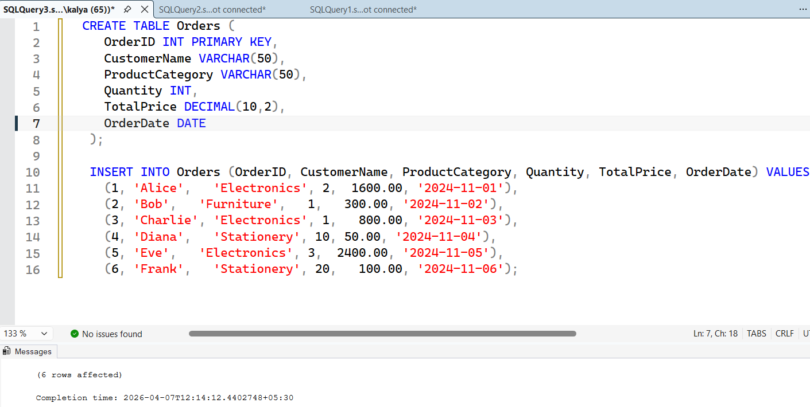

2. SQL Query Tasks
a) Total Quantity by Category: Compute total Quantity sold for each ProductCategory.
Query:-
SELECT ProductCategory, SUM(Quantity) AS TotalQuantity FROM Orders
GROUP BY ProductCategory;
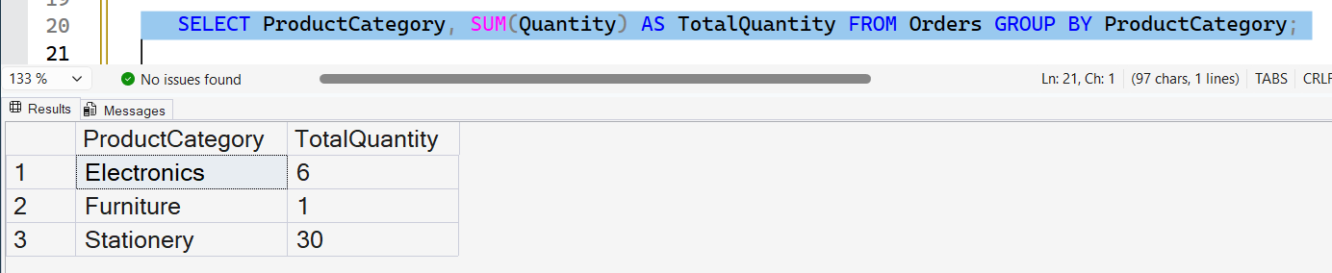

b) Categories with High Sales Volume: Find categories where total Quantity > 10.
SQL:
SELECT ProductCategory
FROM (SELECT ProductCategory, SUM(Quantity) AS TotalQuantity FROM Orders GROUP BY ProductCategory) AS T WHERE TotalQuantity > 10;
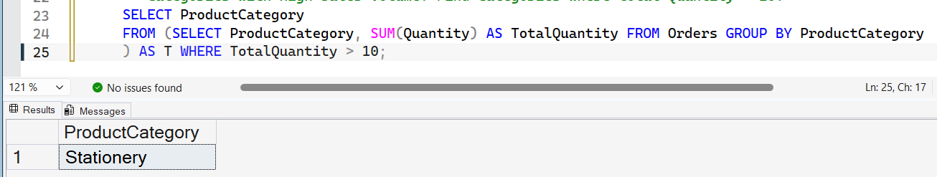

c) Average Order Value by Category: Calculate average TotalPrice per ProductCategory.
SQL:
SELECT ProductCategory, AVG(TotalPrice) AS AvgPrice FROM Orders
GROUP BY ProductCategory;
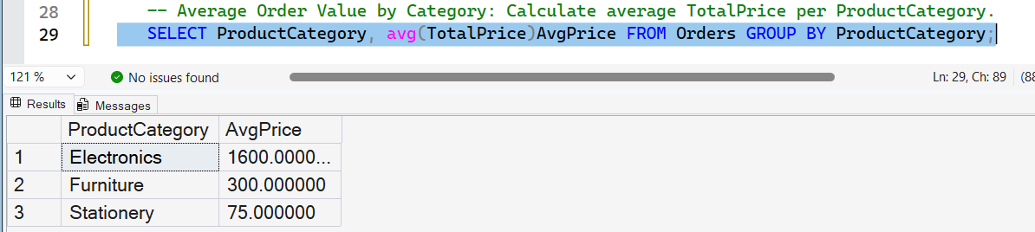

d) Categories with Low Average Price: Identify categories where average TotalPrice < 1000.
SQL:
SELECT ProductCategory
FROM (SELECT ProductCategory, AVG(TotalPrice) AS AvgPrice FROM Orders
GROUP BY ProductCategory) AS T WHERE AvgPrice < 1000;
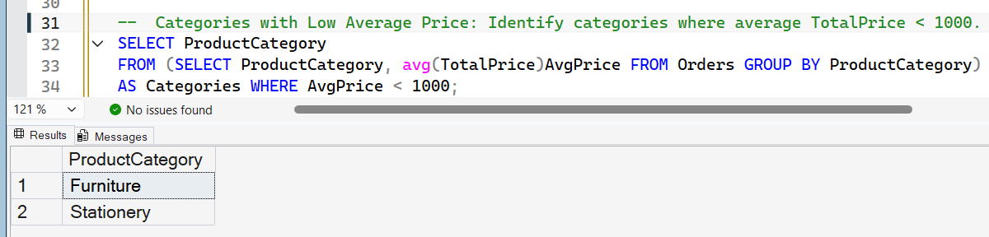

e) Classify Orders by Value: Add a column marking each order as 'High Value' if TotalPrice > 1000, else 'Low Value'.
SQL:
SELECT *,
CASE WHEN TotalPrice > 1000 THEN 'High Value' ELSE 'Low Value'
END AS ValueCategory FROM Orders;
