SQL Joins & Set Operations
1. Table Creation & Data Population
Query1:-
Employees table
CREATE TABLE Employees (
EmpID INT PRIMARY KEY,
EmpName VARCHAR(50),
DepartmentID INT
);
INSERT INTO Employees (EmpID, EmpName, DepartmentID) VALUES
(1, 'Alice', 101),
(2, 'Bob', 102),
(3, 'Charlie', 103),
(4, 'Diana', NULL),
(5, 'Eve', 101);
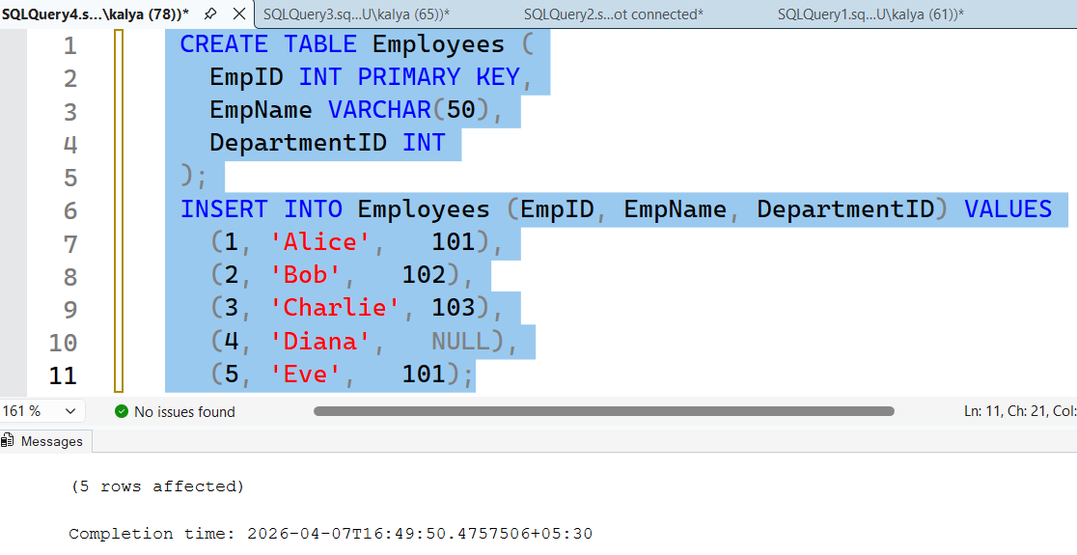
Query2:-
CREATE TABLE Departments (
DepartmentID INT PRIMARY KEY,
DeptName VARCHAR(50),
Location VARCHAR(50)
);
INSERT INTO Departments (DepartmentID, DeptName, Location) VALUES
(101, 'HR', 'New York'),
(102, 'IT', 'San Francisco'),
(103, 'Finance', 'Chicago'),
(104, 'Sales', 'Boston');
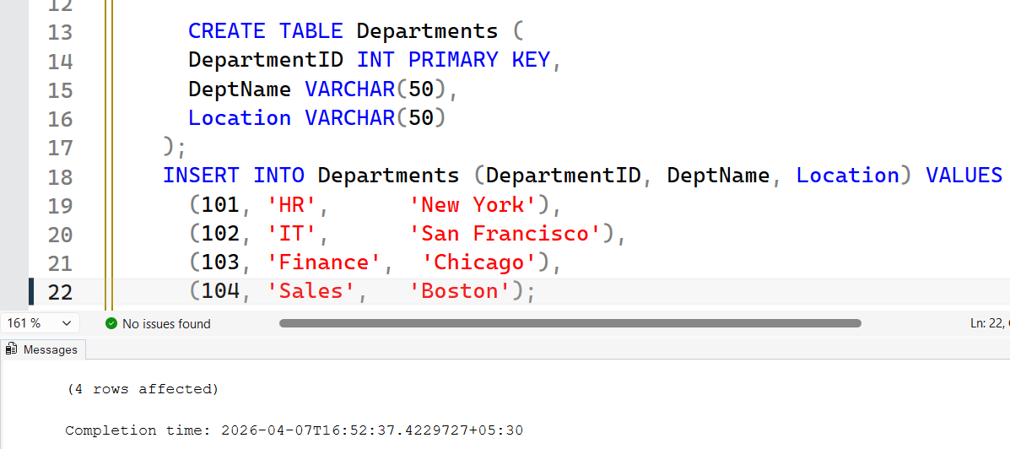

2. SQL Tasks
1. a) Inner Join: List all employees with assigned department names.
SQL:
SELECT E.EmpID, E.EmpName, D.DeptName
FROM Employees E
INNER JOIN Departments D
ON E.DepartmentID = D.DepartmentID;
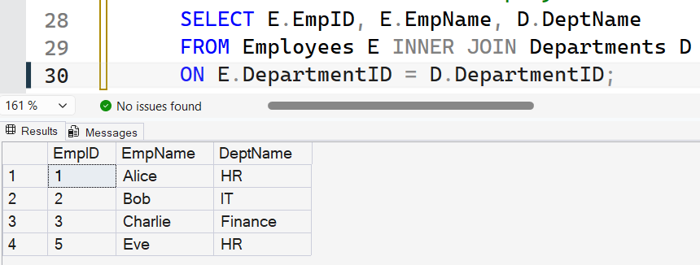

2. b) Left Join: Show all employees, with department name if assigned (NULL if not).
SQL:
SELECT E.EmpID, E.EmpName, D.DeptName
FROM Employees E
LEFT JOIN Departments D
ON E.DepartmentID = D.DepartmentID;
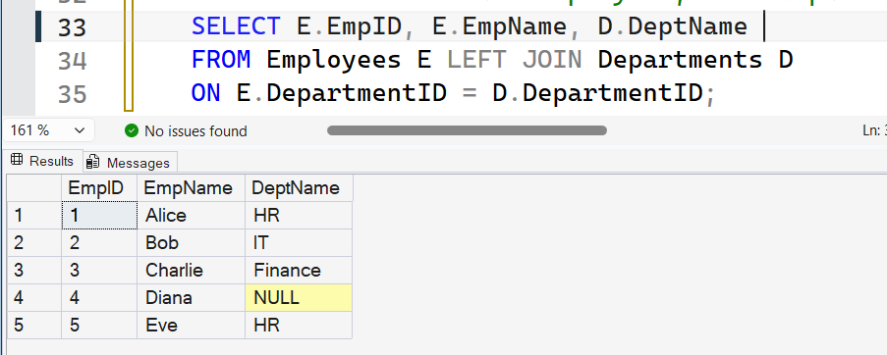

3. c) Right Join: Show all departments, with employee name if exists (NULL if none).
SQL:
SELECT D.DepartmentID, D.DeptName, E.EmpName
FROM Employees E
RIGHT JOIN Departments D
ON E.DepartmentID = D.DepartmentID;
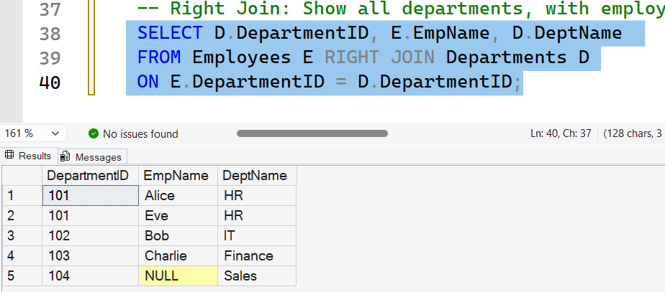

4. d) Full Outer Join: Include all employees and departments, matching where possible.
SQL:
SELECT E.EmpID, E.EmpName, D.DeptName
FROM Employees E
FULL OUTER JOIN Departments D
ON E.DepartmentID = D.DepartmentID;
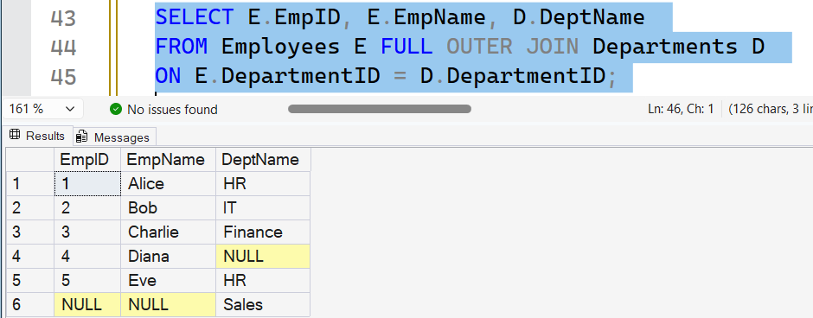

5. e) Cross Join: Generate every combination of employee names and department names.
SQL:
SELECT E.EmpName, D.DeptName
FROM Employees E
CROSS JOIN Departments D;
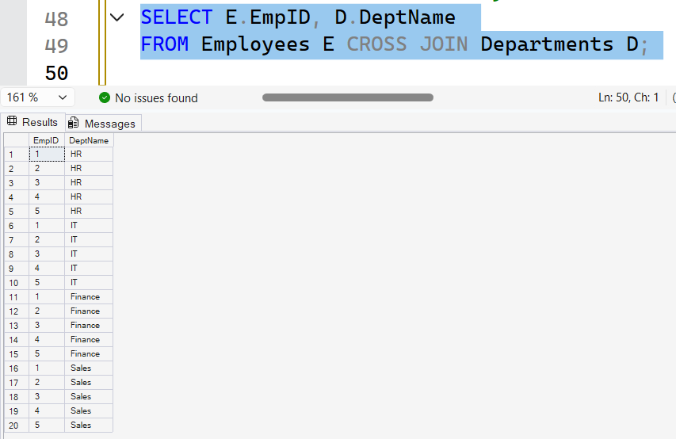

6. f) Union All: Create a list combining all employee names and department names in one column.
SQL:
SELECT EmpName AS Name FROM Employees
UNION ALL
SELECT DeptName FROM Departments;
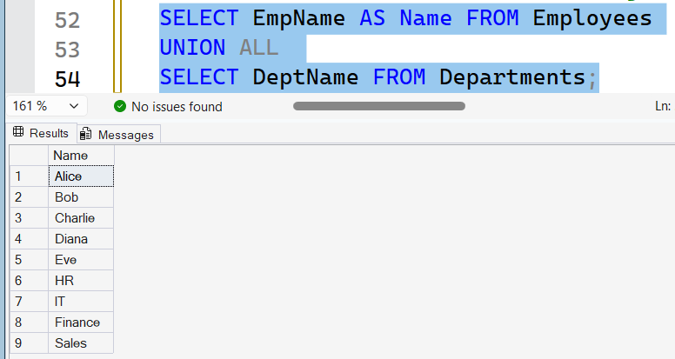

7. g) Intersect: Find department IDs present in both tables.
SQL:
SELECT DepartmentID FROM Employees
INTERSECT
SELECT DepartmentID FROM Departments;
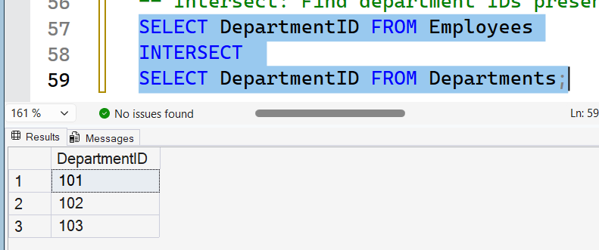

8. h) Except: List department IDs in Departments but not in Employees.
SQL:
SELECT DepartmentID FROM Departments
EXCEPT
SELECT DepartmentID FROM Employees;
