**Powerschool Assignment:**

Name: Kalyani Anjankar

Reg No.: 19MCB0011

**Backend:**

I used python language for constructing the backend.

For web development I used Flask.

**Flask** is a web framework. This means **flask** provides you with tools, libraries and technologies that allow you to build a web application. This web application can be some web pages, a blog, a wiki or go as big as a web-based calendar application or a commercial website

For using flask install python then set up virtual environment then install flask.

**For frontend :**

I used HTML ie hypertext mark-up language

For styling the webpage CSS ie Cascading Style Sheet is used.

Ajax is a set of web development techniques using many web technologies on the client side to create asynchronous web applications.

Description of code:

For text autocomplete I used a dataset of cities.

cities=["Spain","Aachen","Germany","Aalborg","Denmark","Abbotabad","Calangute", "Calicut", "Campirganj", "Canacona", "Chaba", "Chabbewal",

"Dabani"," Dabhadi", "Dabhoi","Jabal", "Jabalpur","K.Paramathi", "Kaas Plateau","Zadkala", "Zaheerabad"]

Now,

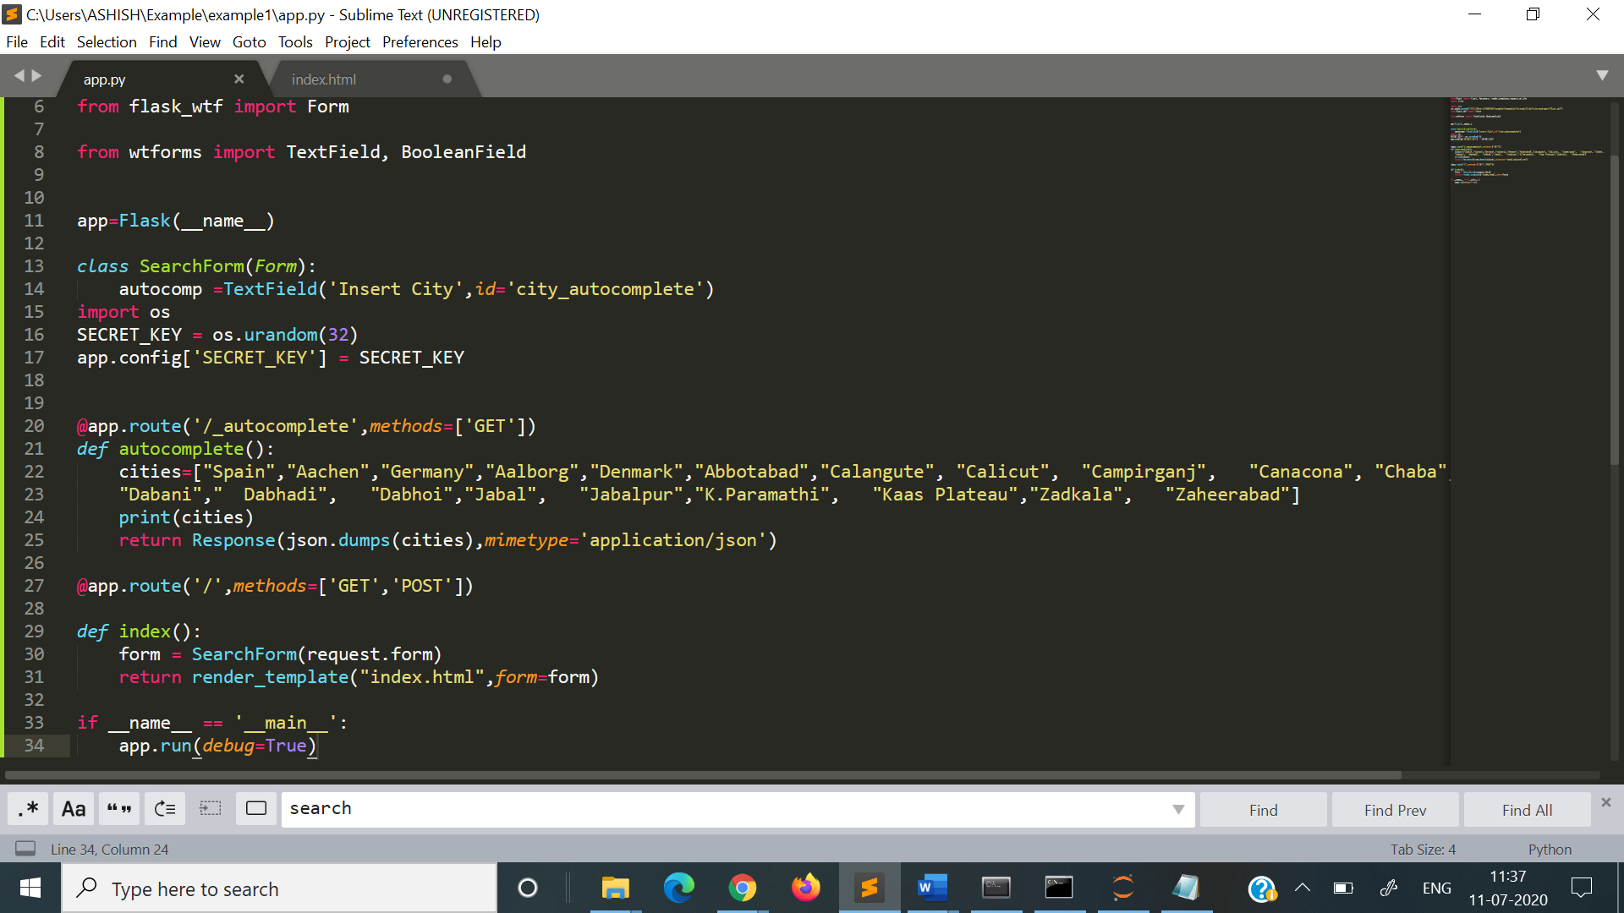

Autocomplete api will give data to the function and will dump the cities .

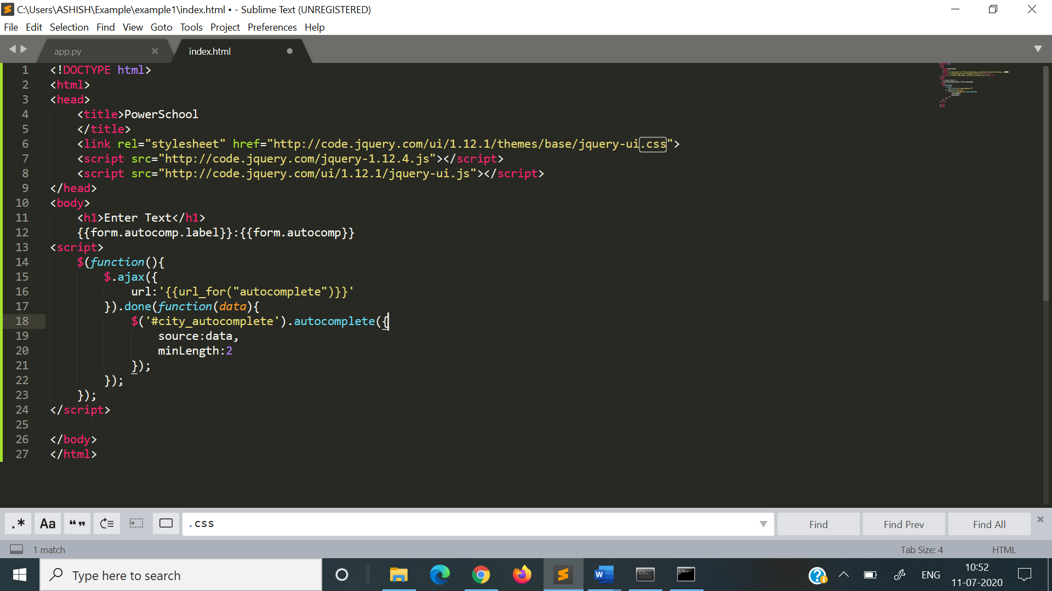

Index.html

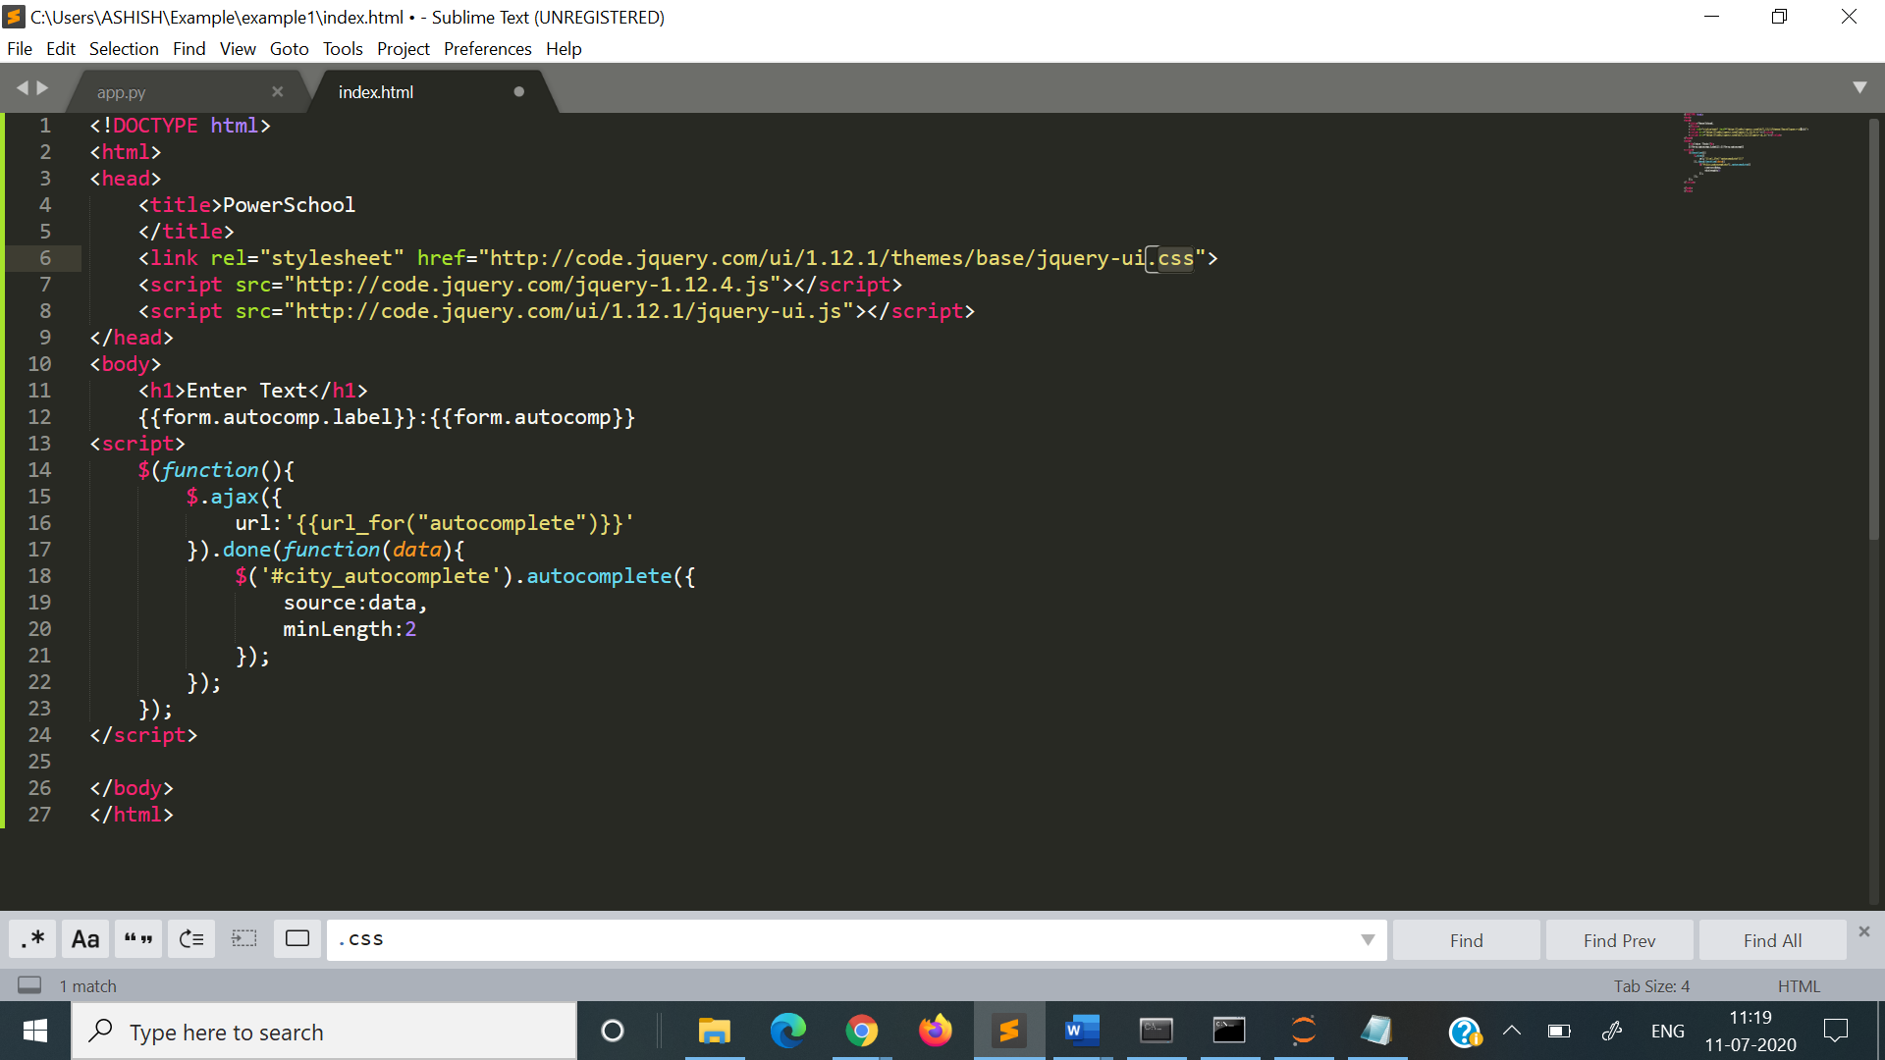

So this will show the textbox with insert cities and give dropdown list of cities.

To run use command prompt

Python app.py

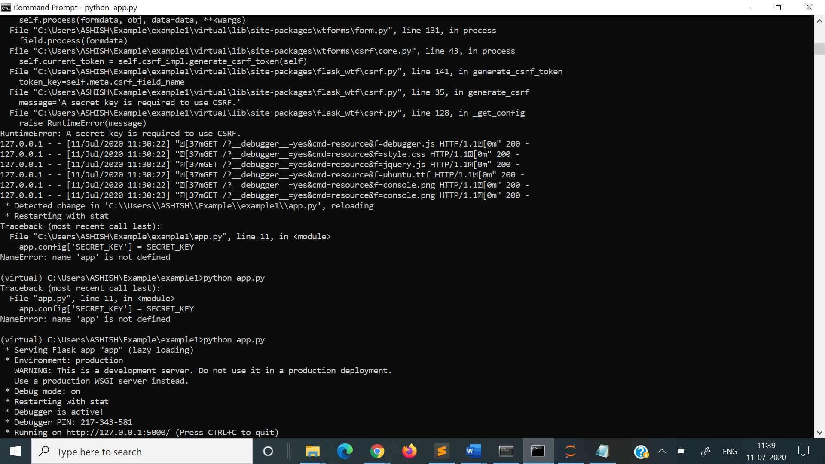

Use specified http for getting results.

Github profile: kalyanianjankar01@gmail.com