**CRAWLEE:** A python script for collecting user’s profile information from Twitter given the user’s Twitter ID  
  
Link to the repository: <https://github.com/kalyaniasthana/CRAWLEE>

Steps I followed to complete the assignment:

1. I had used Twython(similar to Tweepy) before so first I read the documentation for Tweepy here: <http://tweepy.readthedocs.io/en/v3.1.0/getting_started.html>
2. I watched a few videos on Coursera to recap what API’s really are and how are they different from SDK’s.
3. I already had a registered Twitter account and app with the necessary keys.
4. First, I tried out the example code under the Hello Tweepy heading of the documentation.
5. Then I clicked on the User Methods in the documentation and found a function called get_user() under the API class.
6. I used the function with my own user name and printed the object it returned

This is the object:  
  
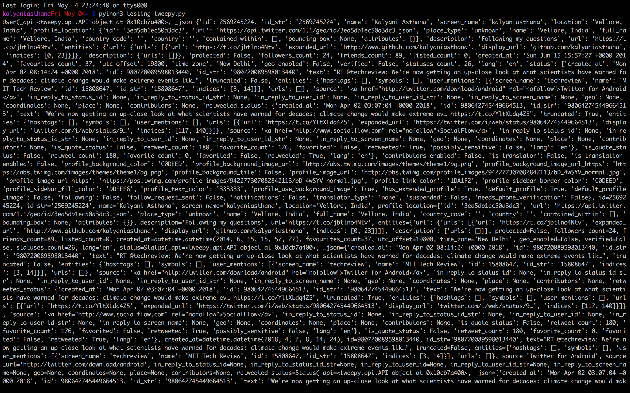

1. This looked similar to what I wanted as an end output
2. After this I tried printing different attributes of the object such as name, screen_name, followers etc. The final part was printing all the attributes separately.
3. The only problem left was the error the script was throwing when I entered an invalid user ID. So, I added try and except statements. The script will also show an error(under the except statement) if the computer is not connect to the internet.

Output:

