VS Code Setup Guide for Running main.py
Google Street View image download script - local Windows setup
Prepared for sharing in Microsoft Teams
Use this guide to set up Python, create a virtual environment, install required packages, set the Google API key, and run main.py in VS Code on Windows. It also includes screenshots for the two most common setup issues encountered during team onboarding.

1. Prerequisites
- Windows machine with VS Code installed.
- Python available from the py launcher. Test with: py --version
- Internet access to install packages.
- A Google Cloud API key with Street View Static API and Directions API enabled, plus billing enabled.

2. Step-by-step setup in VS Code
- Open the project folder: Open VS Code and open the folder that contains main.py (for example, D:\Code&Co). Then open a new terminal inside VS Code.
- Verify Python is installed: Run py --version. If a Python version is shown, continue. If not, install Python first and check the box to add the Python launcher.
- Create the virtual environment: Run: py -m venv .venv
- Activate the virtual environment: In PowerShell, first run: Set-ExecutionPolicy -Scope Process -ExecutionPolicy Bypass, then run: .\.venv\Scripts\Activate.ps1. Your prompt should start with (.venv).
- Install required packages: Run: python -m pip install --upgrade pip --no-cache-dir
Then run: python -m pip install --no-cache-dir googlemaps polyline geopy requests python-dotenv
- Set the Google API key for the current terminal: PowerShell: $env:GOOGLE_API_KEY="YOUR_KEY_HERE"
This is required because the script reads the key with os.getenv("GOOGLE_API_KEY").
- Create the output folder: Create the folder used by the script before running it: D:\Code&Co\streetview_images
- Run the script: Run: python .\main.py
If setup is correct, JPG files should start appearing in the output folder.

3. Common setup issues and fixes

Issue A: Wrong command used for activation
Symptom: A teammate runs py -m venv .\.venv\Scripts\activate and gets an error saying it cannot create the activate directory.
Cause: That command tries to create a new virtual environment inside the activate path. Activation is a separate command, not another venv creation step.
Fix:
- Create the venv only once with: py -m venv .venv
- Activate it with: .\.venv\Scripts\Activate.ps1
- If PowerShell blocks scripts, run: Set-ExecutionPolicy -Scope Process -ExecutionPolicy Bypass and then activate again.
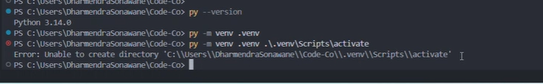
Screenshot 1. Example of the incorrect activation command entered in VS Code PowerShell.

Issue B: pip cache permission denied during package install
Symptom: Package install fails with a permission denied error under AppData\Local\pip\cache.
Cause: Windows is blocking access to the pip cache. This is not a code issue.
Fix:
- Use no-cache install: python -m pip install --no-cache-dir googlemaps polyline geopy requests python-dotenv
- If needed, upgrade pip first with: python -m pip install --upgrade pip --no-cache-dir
- If it still fails, close VS Code and reopen it as Administrator, then retry the same command.
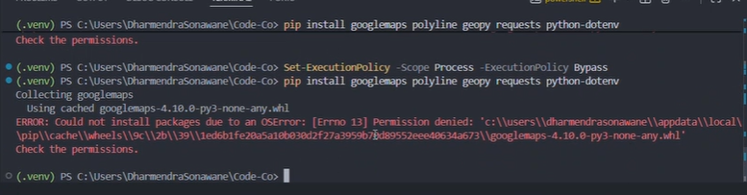
Screenshot 2. Example of the pip cache permissions error and the command that triggered it.

4. Quick troubleshooting checklist
Problem | What to check
403 Forbidden from Street View | Make sure GOOGLE_API_KEY is set in the same terminal, billing is enabled, Street View Static API is enabled, and key restrictions are not blocking local script usage.
FileNotFoundError while saving JPG | Create the output folder exactly as used in the save path: D:\Code&Co\streetview_images
PowerShell script disabled | Run Set-ExecutionPolicy -Scope Process -ExecutionPolicy Bypass in the current terminal only, then activate the venv again.
Packages not found | Confirm the terminal prompt starts with (.venv), then reinstall packages using python -m pip install --no-cache-dir ...

5. Recommended Teams message to share with the team
Please follow the attached setup guide to run main.py locally in VS Code. The guide covers Python setup, virtual environment creation, package installation, setting the Google API key, output folder creation, and the most common setup issues with screenshots. If you still see an error, send the exact terminal message or a screenshot so it can be diagnosed quickly.

6. Notes
This guide documents the setup and fixes without changing the existing script logic. It is intended only to standardize local setup across the team.

