Product Line Profitability & Margin Performance Analysis
A Data-Driven Profitability Study for Nassau Candy Distributor
Prepared for: Unified Mentor Pvt. Ltd.
Prepared by: Kalyani
Dataset: Nassau Candy Distributor Order Data (10,194 order records, 18 fields)

Abstract
Sales volume alone does not indicate financial health. This study analyzes 10,194 order-level records from Nassau Candy Distributor to determine which products and divisions genuinely drive profitability, as distinct from those that merely drive revenue. Using gross margin, profit-per-unit, revenue/profit contribution, and Pareto concentration analysis, the study finds that a small subset of Chocolate-division products generates the overwhelming majority of company profit, while several products and one entire division show revenue that is disproportionate to the profit they return. The findings are operationalized in an interactive Streamlit dashboard and translated into concrete pricing, sourcing, and portfolio recommendations.

1. Introduction & Background
Nassau Candy Distributor sells confectionery products across three divisions — Chocolate, Sugar, and Other — through a national distribution network. As with most distributors, some products sell in high volume yet consume disproportionate manufacturing or operational cost, while others sell modestly but return strong margins. Without visibility into product- and division-level profitability, pricing, promotion, and portfolio decisions remain reactive and intuition-driven rather than data-driven.
This report addresses that gap by answering four questions: (1) which product lines deliver the highest gross margin; (2) whether high-sales products are actually profitable; (3) how profitability varies across product divisions; and (4) which products represent margin risk requiring pricing or sourcing intervention.

2. Dataset Description
The analysis uses order-level transaction data with 10,194 rows and 18 fields, covering order and shipment details, customer geography, product and division identifiers, and the core financial fields: Sales, Units, Cost, and Gross Profit (Sales − Cost). A supplementary reference table maps each product to its manufacturing factory (used in Section 7).
Field | Description
Order ID / Row ID | Unique order and row identifiers
Order Date / Ship Date | Order and shipment dates
Division | Product division — Chocolate, Sugar, or Other
Product ID / Product Name | Product identifiers and names (15 distinct products)
Sales / Units / Cost | Order-level sales value, quantity, and manufacturing cost
Gross Profit | Sales − Cost
City / State / Region | Customer geography

3. Methodology

3.1 Data Cleaning & Validation
The dataset was validated before analysis. No missing values, duplicate rows, or negative Sales/Units/Cost/Gross Profit values were found across any of the 18 fields. The Gross Profit formula (Sales − Cost) was independently recomputed and matched the provided values to within floating-point precision (max deviation ≈ 7 × 10⁻¹⁵), confirming data integrity. One inconsistency was identified and corrected: the product name "Wonka Bar -Scrumdiddlyumptious" was missing a space before the hyphen relative to the naming convention used by all other products, which would otherwise have caused it to be treated as a distinct product during aggregation. Order Date and Ship Date fields, originally stored as text, were converted to proper datetime format to support date-range filtering.

3.2 KPI Calculation
Two order-level KPIs were derived to normalize for scale before aggregation:
- Gross Margin % = Gross Profit ÷ Sales × 100 — the share of each sale retained as profit.
- Profit per Unit = Gross Profit ÷ Units — the profit earned per item sold.
These were then aggregated by Product Name and by Division to compute Total Sales, Total Profit, Average Margin %, Revenue Contribution %, and Profit Contribution % at each level.

4. Product-Level Profitability Analysis
Products were ranked by total profit and classified into four categories using the dataset-wide average Sales (≈ $9,452) and average Margin (≈ 57.4%) as thresholds: Star (high-sales, high-margin), Niche (low-sales, high-margin), Weak (low-sales, low-margin), and Risk (high-sales, low-margin).
Product | Total Sales ($) | Total Profit ($) | Avg Margin (%) | Category
Wonka Bar - Scrumdiddlyumptious | 27,874.80 | 19,357.50 | 69.4 | Star
Wonka Bar - Triple Dazzle Caramel | 28,485.00 | 18,610.20 | 65.3 | Star
Wonka Bar - Milk Chocolate | 26,867.75 | 17,443.37 | 64.9 | Star
Wonka Bar - Nutty Crunch Surprise | 23,574.95 | 16,819.95 | 71.3 | Star
Wonka Bar - Fudge Mallows | 24,890.40 | 16,593.60 | 66.7 | Star
Lickable Wallpaper | 7,860.00 | 3,930.00 | 50.0 | Weak
Wonka Gum | 597.50 | 310.70 | 52.0 | Weak
Everlasting Gobstopper | 130.00 | 104.00 | 80.0 | Niche
Kazookles | 1,205.75 | 92.75 | 7.7 | Weak
Hair Toffee | 76.50 | 59.50 | 77.8 | Niche
Fizzy Lifting Drinks | 78.75 | 47.25 | 60.0 | Niche
Laffy Taffy | 53.73 | 33.48 | 62.3 | Niche
SweeTARTS | 61.50 | 28.70 | 46.7 | Weak
Nerds | 15.00 | 7.00 | 46.7 | Weak
Fun Dip | 12.00 | 4.80 | 40.0 | Weak

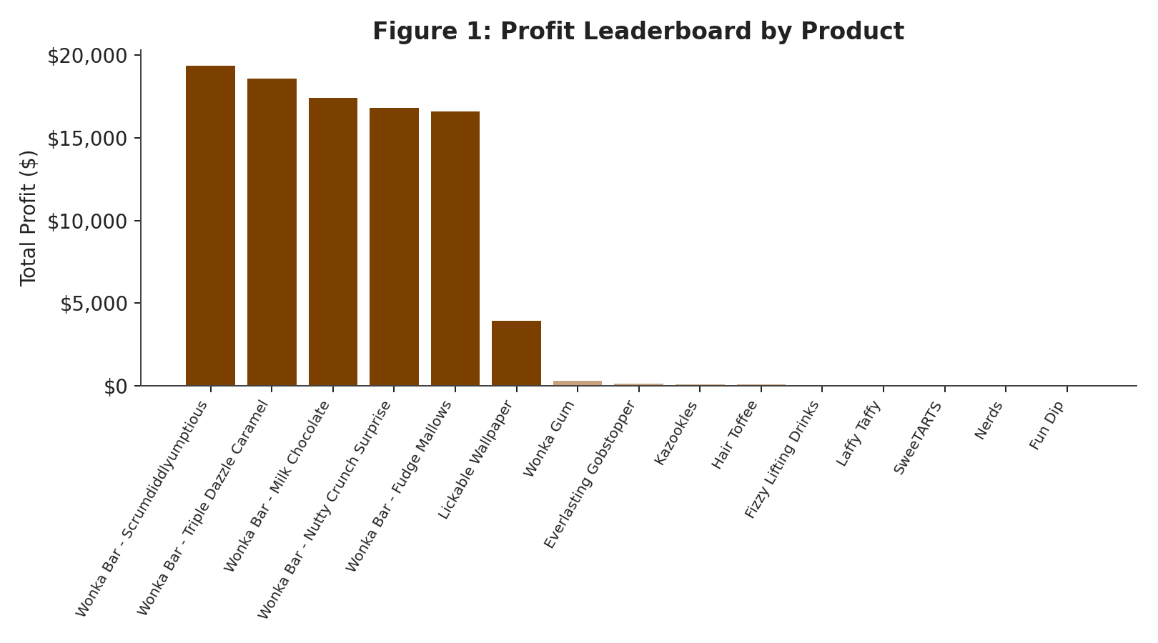
Figure 1: Total profit by product, ranked descending. The five Chocolate products form a distinct high-profit cluster.
The five Chocolate-division products dominate every ranking, together generating the large majority of company revenue and profit at healthy margins of 65–71%. The most significant risk finding is Kazookles: despite mid-tier sales of $1,205.75 (higher than most Sugar/Other products), its average margin is just 7.7% — far below the 57.4% dataset average — meaning almost the entire sale value is consumed by cost. This is the clearest case in the dataset of a product that appears active in the market while contributing almost nothing to profit. Everlasting Gobstopper and Hair Toffee, by contrast, show very high margins (78–80%) on minimal sales volume, representing under-promoted, high-margin "niche" opportunities.

5. Division-Level Performance Analysis
Division | Total Sales ($) | Total Profit ($) | Avg Margin (%) | Revenue Share (%) | Profit Share (%)
Chocolate | 131,692.90 | 88,824.62 | 67.5 | 92.9 | 95.1
Other | 9,663.25 | 4,333.45 | 37.7 | 6.8 | 4.6
Sugar | 427.48 | 284.73 | 57.7 | 0.3 | 0.3

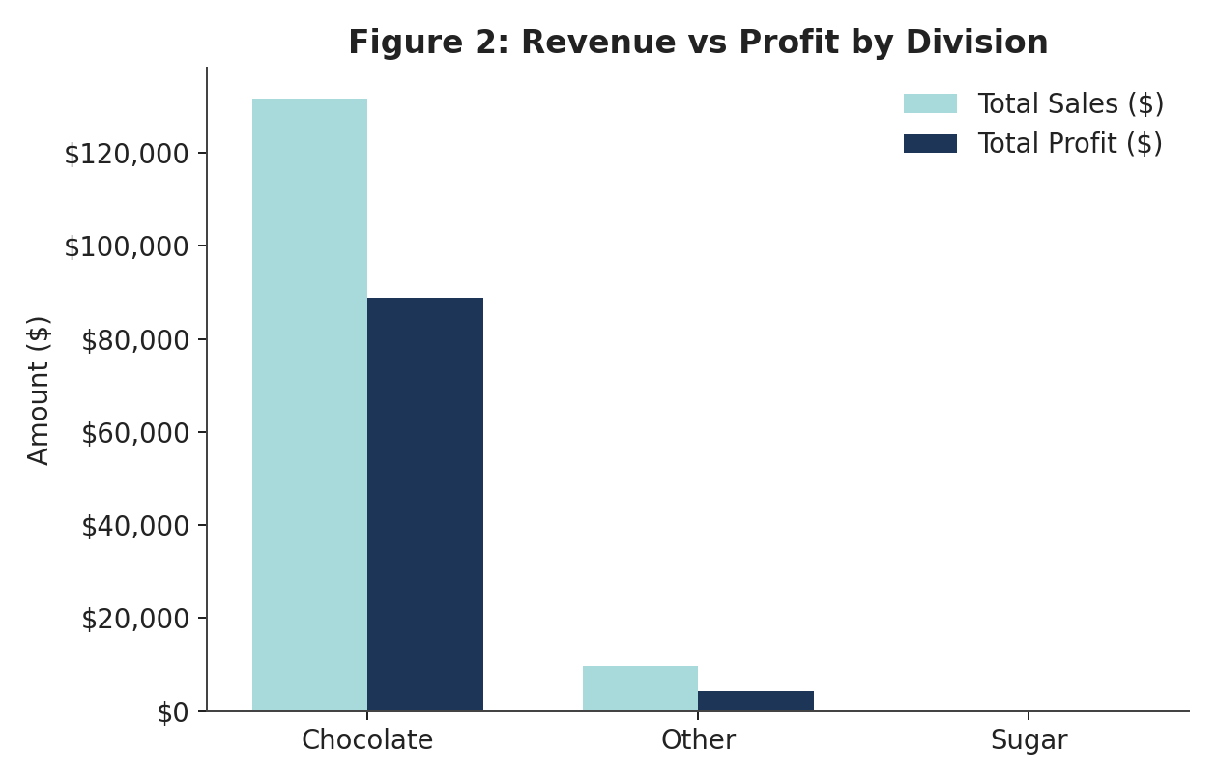
Figure 2: Revenue vs profit by division. Chocolate's profit bar proportionally exceeds its sales bar; Other shows the reverse pattern.
Chocolate is not only the largest division by revenue (92.9% of sales) but is proportionally even stronger in profit (95.1% of profit) — its Profit Share exceeds its Revenue Share, indicating an efficient, high-margin division. The Other division shows the inverse and more concerning pattern: it accounts for 6.8% of revenue but only 4.6% of profit, and its average margin (37.7%) is the lowest of the three divisions — a structural margin inefficiency rather than a one-product problem. Sugar's contribution to overall results is negligible (0.3% of both revenue and profit) and does not materially affect company performance in either direction.

6. Profit Concentration (Pareto) Analysis
Cumulative profit contribution was calculated after ranking all 15 products by profit in descending order, to test for over-dependency on a small number of products.
Rank | Product | Cumulative Profit (%)
1 | Wonka Bar - Scrumdiddlyumptious | 20.7
2 | Wonka Bar - Triple Dazzle Caramel | 40.6
3 | Wonka Bar - Milk Chocolate | 59.3
4 | Wonka Bar - Nutty Crunch Surprise | 77.3
5 | Wonka Bar - Fudge Mallows | 95.1

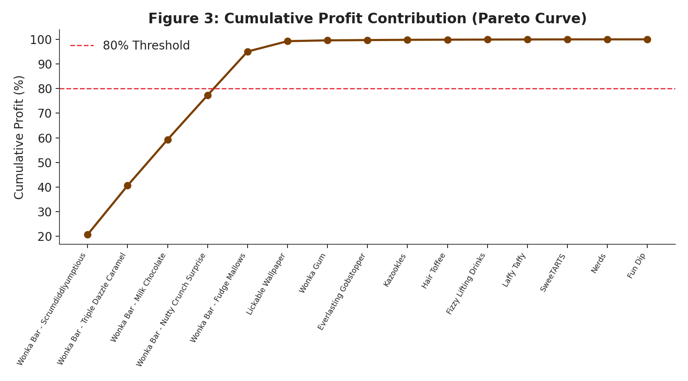
Figure 3: Cumulative profit contribution by product. The curve crosses the 80% threshold at just the 4th product.
The result is a sharper concentration than the conventional 80/20 Pareto pattern: just 5 of 15 products (33% of the product line) generate 95.1% of total profit, and the top 4 products alone already cross the 80% threshold. The remaining 10 products (67% of the catalog) collectively contribute under 5% of profit. This represents a significant business concentration risk — a supply disruption, cost increase, or demand shift affecting any one of these five Chocolate products would have an outsized impact on total company profitability, far greater than its single-product weight would suggest.

6.1 Revenue vs Profit Concentration
The same top 5 products account for 92.9% of total revenue, slightly below their 95.1% share of profit. This small gap (92.9% vs 95.1%) confirms these products are not just the biggest sellers but also the most efficient — they convert revenue into profit at a better-than-average rate, reinforcing the Division-level finding in Section 5 that Chocolate's profit share exceeds its revenue share.

6.2 Margin Volatility
Month-over-month margin volatility was calculated for every product (standard deviation of monthly Gross Margin % across its active months). The result was effectively zero for all 15 products (on the order of 10⁻¹⁴–10⁻¹⁵, i.e. floating-point noise rather than real variation). This indicates each product's margin is fixed and consistent every month it was sold, with no seasonal or month-to-month erosion. Practically, this means the margin risks identified in this report (Kazookles, the Other division, The Other Factory) are structural and pricing-based rather than caused by cost fluctuation over time — a one-time pricing or sourcing correction, rather than ongoing monitoring for drift, is the appropriate response.

7. Factory-Level Profitability Analysis
Using the product-to-factory reference table supplied with the dataset, product results were aggregated by manufacturing factory to test whether cost or margin problems trace back to a specific production site rather than to individual products.
Factory | Products Made | Sales ($) | Profit ($) | Margin (%)
Lot's O' Nuts | Nutty Crunch, Fudge Mallows, Scrumdiddlyumptious | 76,340 | 52,771 | 69.1
Wicked Choccy's | Milk Chocolate, Triple Dazzle Caramel | 55,353 | 36,054 | 65.1
Sugar Shack | Laffy Taffy, SweeTARTS, Nerds, Fun Dip, Fizzy Lifting Drinks | 221 | 121 | 54.9
Secret Factory | Everlasting Gobstopper, Lickable Wallpaper, Wonka Gum | 8,588 | 4,345 | 50.6
The Other Factory | Hair Toffee, Kazookles | 1,282 | 152 | 11.9

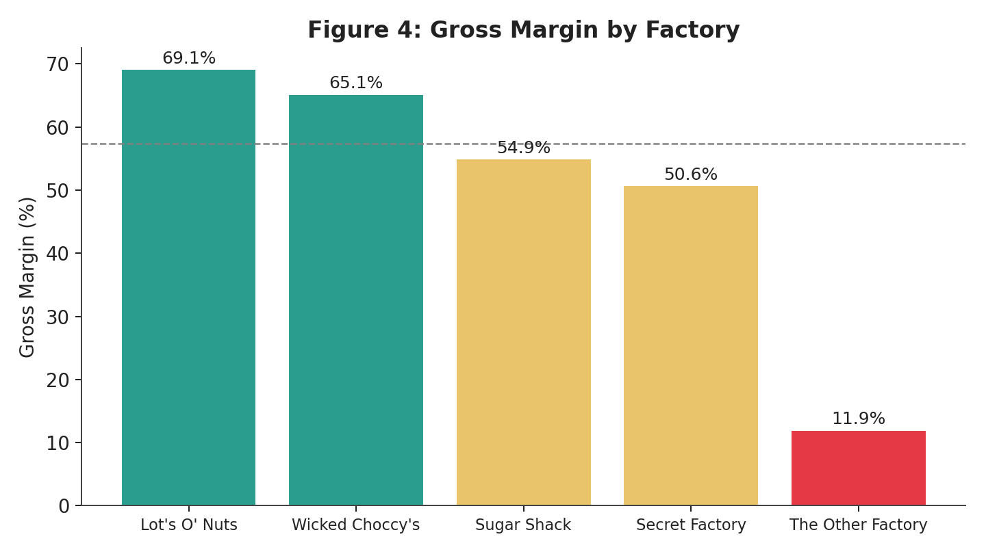
Figure 4: Gross margin by factory. The dashed line marks the dataset average margin (57.4%).
The two Chocolate factories (Lot's O' Nuts and Wicked Choccy's) are the strongest, at 69.1% and 65.1% margin, and together produce all five top-profit products. The Other Factory is the clear weak point at 11.9%, and the cause is Kazookles: with a 7.7% product margin and far more sales than its sister product Hair Toffee, it pulls the whole factory down. This links the product-level Kazookles finding to a specific production site, which strengthens the case for a cost renegotiation conversation with that factory rather than only a price change. The factory coordinates supplied with the dataset relate to shipping-route analysis and were not needed for this profitability study.

8. Cost Structure Diagnostics
A cost-vs-margin scatter analysis (by division) was used to visually separate cost-heavy, margin-poor products from the rest of the catalog. The five Chocolate products cluster tightly in a high-cost, high-margin band (65–71% margin), confirming that their cost structure is well matched to pricing. Sugar-division products split into two distinct clusters: a high-margin group (78–80%, minimal cost) and a lower-margin group (40–47%). Kazookles is a clear outlier within the Other division, sitting far below the average-margin line despite a mid-range cost base — the strongest visual and statistical case in the dataset for repricing or cost renegotiation.
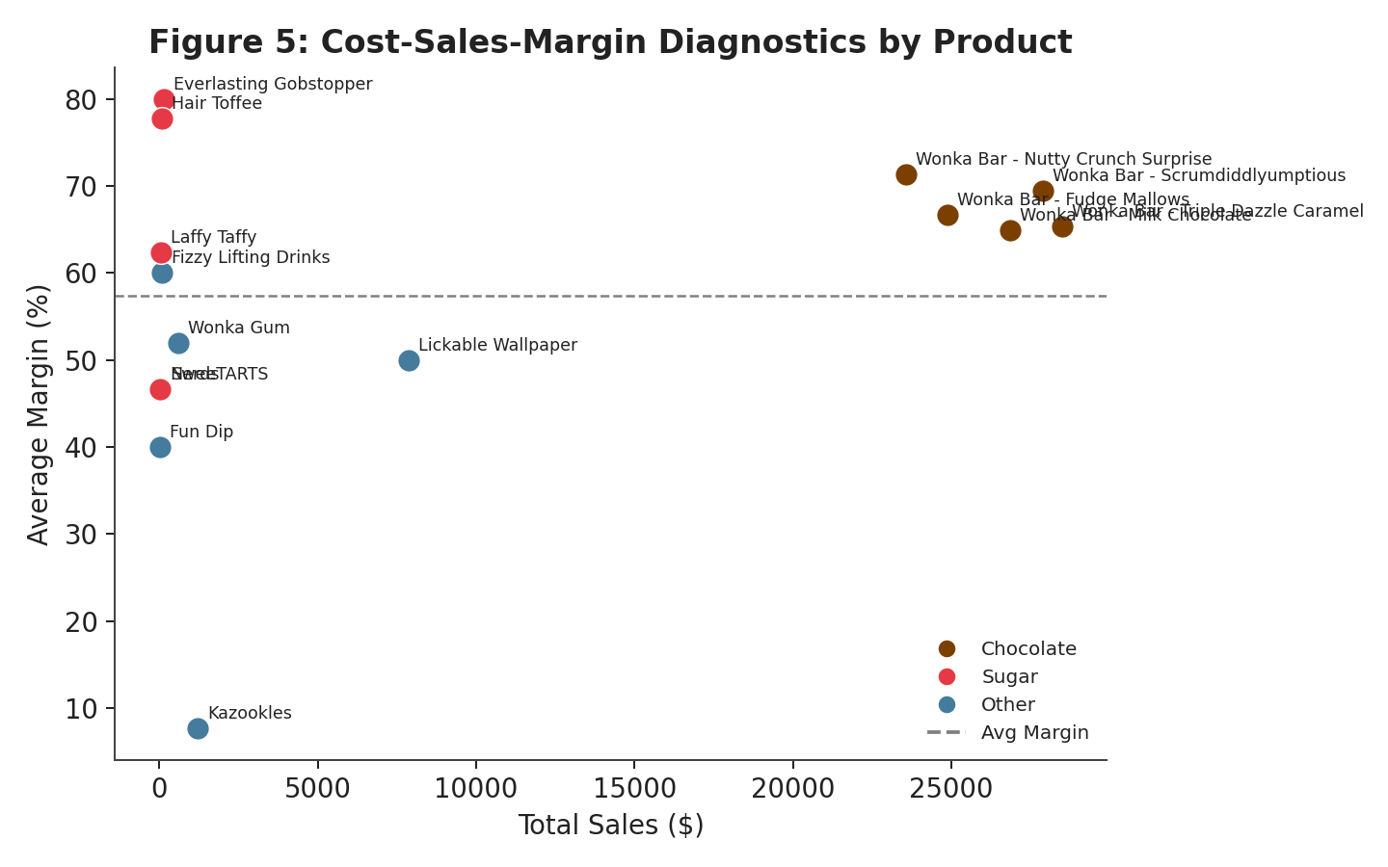
Figure 5: Sales vs average margin by product, colored by division. Kazookles sits well below the average-margin line despite mid-tier sales.

9. Key Findings Summary
- The Chocolate division drives the business: 92.9% of revenue and 95.1% of profit, at a healthy 67.5% average margin.
- Profit is highly concentrated: 5 of 15 products (33%) generate 95.1% of total profit — a significant single-category dependency risk.
- The Other division shows a structural margin problem: its revenue share (6.8%) exceeds its profit share (4.6%), and its average margin (37.7%) is the lowest of the three divisions.
- Kazookles is the clearest individual risk product: mid-tier sales ($1,205.75) but only 7.7% margin — sales volume without corresponding profitability.
- Everlasting Gobstopper and Hair Toffee are high-margin (78–80%) but low-volume — under-leveraged growth opportunities rather than risks.
- Factory-level results locate the problem: The Other Factory earns only an 11.9% margin versus 65–69% at the two Chocolate factories, driven by Kazookles.
- The Sugar division is financially negligible (0.3% of revenue and profit) and does not meaningfully affect overall results.

10. Recommendations
- Protect and reinforce the five top Chocolate products through supply-chain prioritization, given their disproportionate share of total profit.
- Initiate a cost or pricing review specifically for Kazookles — its margin is an outlier low even within its own division, and a modest price or cost correction would materially improve its contribution.
- Open a cost renegotiation discussion with The Other Factory, since its 11.9% margin is driven by Kazookles and points to a sourcing issue rather than a demand issue.
- Investigate the Other division's cost structure as a whole, rather than product-by-product, since its margin gap is structural rather than isolated to a single item.
- Trial increased marketing or distribution investment in Everlasting Gobstopper and Hair Toffee, where margin already supports profitable growth if volume increases.
- Re-evaluate the Sugar division's continued strategic priority given its negligible scale, unless it serves a non-financial purpose (e.g. shelf-space or customer-acquisition role) not captured in this dataset.
- Monitor product-level concentration on an ongoing basis using the accompanying dashboard, since a 33%-of-catalog / 95%-of-profit ratio warrants continuous tracking rather than a one-time assessment.

11. Conclusion
This analysis confirms that sales volume is not a reliable proxy for profitability at Nassau Candy Distributor. A small set of Chocolate products carries the business, one division (Other) shows a structural margin problem independent of any single product, and one product (Kazookles) stands out as a clear repricing candidate. Transforming raw order data into these product- and division-level metrics — and operationalizing them in the accompanying interactive dashboard — gives the organization a repeatable, data-driven basis for pricing, sourcing, and product-portfolio decisions, replacing the previously reactive, intuition-based approach.

