PROJECT DOCUMENTATION
ON
EDUGENIE
AI-BASED EDUCATIONAL ASSISTANT FOR STUDENTS

A Web-Based Learning Support Application

Technologies Used: HTML, CSS, JavaScript
Development Environment: Visual Studio Code

Project Documentation

ABSTRACT
EduGenie is an AI-based educational assistant designed to support students in their learning activities. The application provides a simple web interface through which students can ask academic questions, obtain explanations, summarize long study content, generate quizzes, and receive learning support. The main purpose of the project is to make learning more interactive, accessible, and easier to understand.
The application is developed as a web-based project using HTML for page structure, CSS for presentation and responsive interface design, and JavaScript for user interaction and functional behaviour. The project is developed and tested using Visual Studio Code. EduGenie provides a single interface where different learning-support activities can be accessed without requiring separate applications.
The project focuses on a student-friendly interface and demonstrates how an educational assistant can combine common study activities into one platform. The documentation describes the objectives, system requirements, major features, implementation, functional testing, results, advantages, limitations, and future enhancements of EduGenie.

1. INTRODUCTION
Students often spend time searching for explanations, preparing revision questions, and reducing lengthy study materials into short notes. EduGenie is proposed as a centralized educational assistant that brings these activities together in a simple web interface. Instead of using separate tools for every learning task, students can use the available EduGenie features from one application.
The system is designed with simplicity in mind. A student can enter a question and request an answer, enter a topic to receive an explanation, provide a paragraph for summarization, or use the quiz function for revision. These features are intended to support self-learning and exam preparation.

2. PROBLEM STATEMENT
Students may find it difficult to quickly obtain simple explanations for unfamiliar topics and may also spend considerable time preparing revision material manually. Long paragraphs can be difficult to revise, while creating practice questions requires additional effort. EduGenie addresses these learning-support needs through a unified educational assistant interface.

3. OBJECTIVES
- To develop a simple AI-based educational assistant for students.
- To provide a convenient interface for asking academic questions.
- To provide topic explanations in a student-friendly format.
- To summarize long educational content for quick revision.
- To generate quiz questions for practice and self-assessment.
- To provide learning support through a single web application.
- To develop the project using basic web technologies and a simple user interface.

4. SYSTEM REQUIREMENTS

4.1 Hardware Requirements
- Computer or laptop
- Minimum 4 GB RAM recommended
- Keyboard and mouse/touchpad
- Internet connection when online AI services are used

4.2 Software Requirements
- Operating System: Windows/Linux/macOS
- Visual Studio Code
- Modern web browser such as Chrome, Edge, or Firefox
- HTML, CSS and JavaScript environment

5. TECHNOLOGIES USED
Technology | Purpose
HTML | Creates the structure and content of the EduGenie web page.
CSS | Provides layout, styling, spacing, typography and visual appearance.
JavaScript | Handles user interaction, button actions and dynamic behaviour.
Visual Studio Code | Used as the development and code-editing environment.
Web Browser | Used to run and test the application.

6. SYSTEM FEATURES
The major functional features demonstrated in EduGenie are described below.

a. Asking a Question
Students can enter an academic question in the question field and request an answer from the educational assistant.

b. Getting an Explanation
Students can enter a topic and request a simple explanation to support understanding of the concept.

c. Summarising Long Paragraphs
Students can enter longer educational content and use the summary function to obtain a shorter version for revision.

d. Generating Quizzes
The quiz function generates practice questions with multiple options and provides feedback on the selected answer.

e. Personalized Learning Support
The interface can be extended to provide learning plans or study guidance according to a student's topic or learning requirement.

7. APPLICATION INTERFACE
The EduGenie interface is designed as a single learning-support screen. The main page presents the EduGenie title and separate input areas for the major learning functions. Each function contains an input field and an action button, making the application easy for students to understand and use.
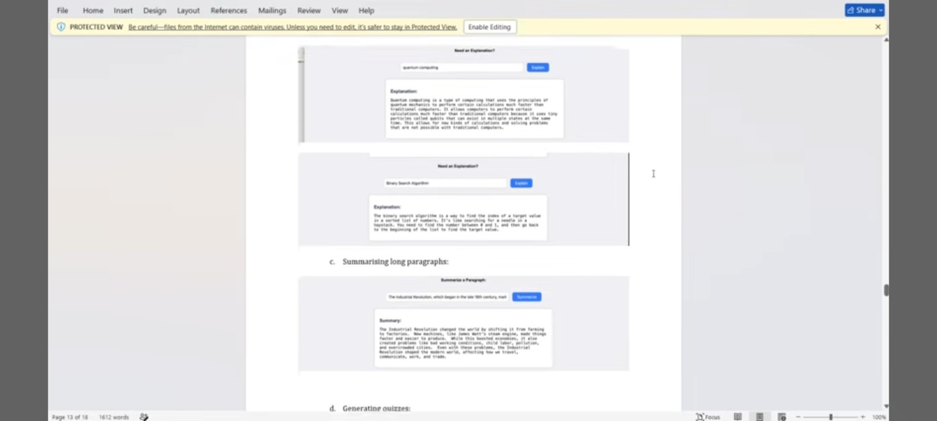
Fig. 7.1 EDUGENIE – Application Interface

8. FUNCTIONAL MODULES

8.1 Ask a Question
This module allows a student to enter a question in the input field and request an educational response. It is intended for quick doubt clarification. The student enters the question and selects the corresponding action button. The response is then displayed in the answer area.

8.2 Get an Explanation
This module is useful when a student knows the name of a topic but needs a clear explanation. The student enters a topic such as a computer science concept and selects the Explain option. The application displays the generated explanation in the output area.

8.3 Summarising Long Paragraphs
The summarization module is designed for revision. A student can enter a long paragraph or study material and select the Summarize option. The application presents a shorter summary containing the important information.
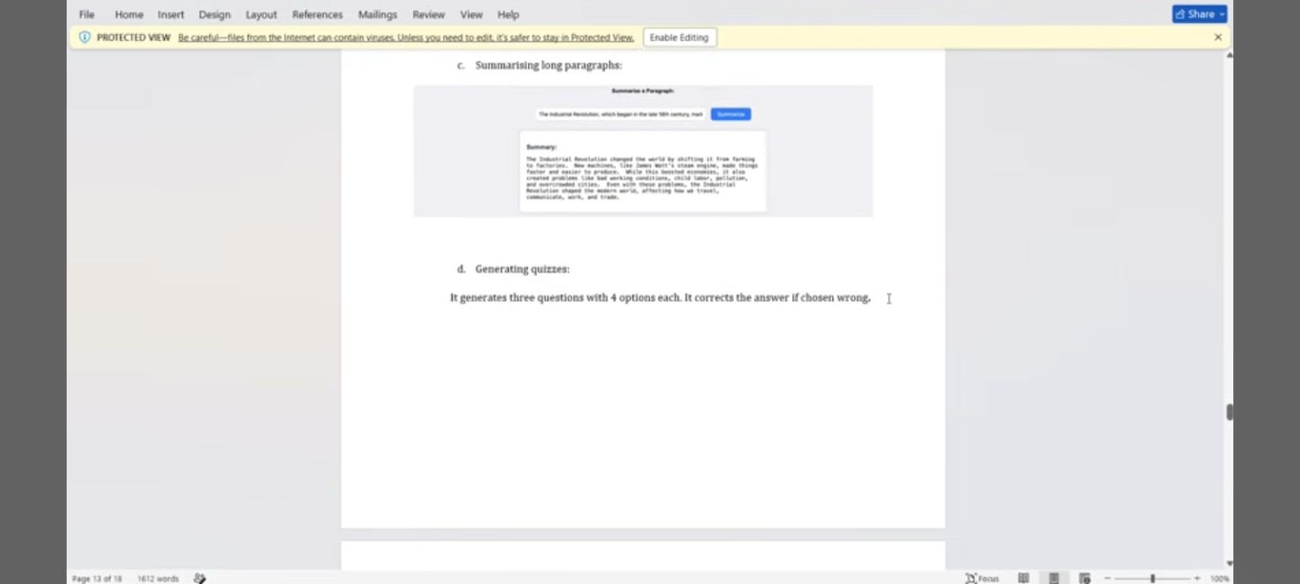
Fig. 8.1 Summarising Long Paragraphs in EduGenie

8.4 Generating Quizzes
The quiz module is used for practice and self-assessment. EduGenie can present multiple-choice questions based on a learning topic. The student selects an option and the system can provide feedback for the selected answer. This feature can be useful during exam preparation.

8.5 Personalized Learning Support
The learning-support section can be used to guide students towards a structured study approach. Based on the selected topic or learning requirement, the system can be extended to suggest topics, revision activities, or a simple study plan.

9. IMPLEMENTATION

9.1 HTML Implementation
HTML is used to create the basic structure of the EduGenie page. The page contains headings, input fields, buttons, response areas, and containers for the different educational functions. Semantic sections help organize the interface into understandable modules.

9.2 CSS Implementation
CSS is used to improve the visual appearance of the application. It controls page alignment, spacing, fonts, cards, buttons, input fields, response boxes, and responsive layout. The objective is to provide a clean interface that students can use without confusion.

9.3 JavaScript Implementation
JavaScript controls the interaction between the user and the interface. Button click events are used to read input values and display corresponding results. The same structure can be connected to an AI API or backend service to provide live AI-generated responses.

9.4 Development Environment
The project is developed in Visual Studio Code. The HTML, CSS, and JavaScript files are maintained as separate files so that the project remains organized and easy to modify.

10. FUNCTIONAL TESTING
The following functional tests are used to verify the main EduGenie features.
Test Case | Input | Expected Result | Status
Ask a Question | Academic question | Answer is displayed | Pass
Get an Explanation | Topic name | Explanation is displayed | Pass
Summarize Content | Long paragraph | Short summary is displayed | Pass
Generate Quiz | Learning topic | Quiz questions/options are displayed | Pass
Learning Support | Topic/learning requirement | Study guidance is displayed | Pass
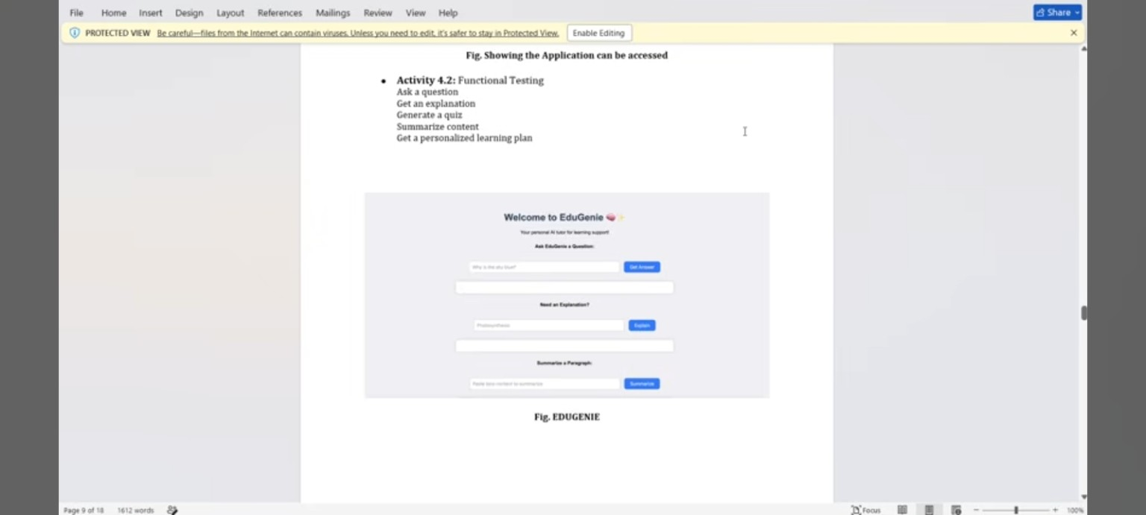
Fig. 10.1 EduGenie Functional Testing – Main Features

11. RESULTS AND DISCUSSION
The EduGenie prototype provides a single interface for common student learning activities. The main functions—question answering, topic explanation, summarization, and quiz generation—are organized so that users can identify and access each feature easily. The interface demonstrates how an educational assistant can support different stages of learning, including understanding, revision, and self-assessment.
Functional testing is performed by entering representative inputs into the available fields and checking whether the expected response area is populated. The modular design also makes it possible to improve individual functions without redesigning the entire interface.

12. ADVANTAGES
- Simple and student-friendly interface.
- Combines multiple learning-support activities in one application.
- Supports quick doubt clarification and topic understanding.
- Useful for revision through summaries and quizzes.
- Developed using widely used web technologies.
- Easy to modify and extend with additional AI features.

13. LIMITATIONS
- The quality of AI-generated responses depends on the AI service and input provided.
- An online AI service may require internet connectivity.
- The prototype may require backend/API integration for full real-time AI functionality.
- AI-generated educational content should be checked against reliable study materials when accuracy is important.

14. FUTURE ENHANCEMENTS
- Integrate a secure AI API for real-time answers.
- Add user login and individual student profiles.
- Add PDF or document upload for study material analysis.
- Add subject-wise quiz generation and score tracking.
- Add personalized study schedules and progress tracking.
- Add voice-based question input and text-to-speech support.
- Add multilingual support for students.

15. CONCLUSION
EduGenie demonstrates the concept of an AI-based educational assistant designed to support students in their learning process. The project brings question answering, explanations, summarization, quiz generation, and learning support into a single web interface. Using HTML, CSS, and JavaScript in Visual Studio Code, the application can be developed as a simple and accessible learning-support tool.
The project also provides a foundation for future development. By connecting the interface to a suitable backend and AI service, EduGenie can be extended into a more complete educational assistant with personalized learning, document analysis, progress tracking, and additional student-focused features.

16. REFERENCES
- HTML, CSS and JavaScript documentation and learning resources.
- Visual Studio Code documentation.
- Educational AI and web application development resources.

