PIZZA SALES ANALYSIS
KPI-
KPI gives us overall idea of business.

Charts - when we want to get some deep information from which category gives us profit and business performaning we used charts.
We have to make pizza dashboard in that appro. 48k records.

PROBLEM STATEMENT

KPI'S REQUIREMENT

We need to analyze key indicators for our pizza sales data to gain insights into our business performance. Specifically, we want to calculate the following metrics:

1. Total Revenue: The sum of the total price of all pizza orders.

2. Average Order Value: The average amount spent per order, calculated by dividing the total revenue by the total number of orders.

3. Total Pizzas Sold: The sum of the quantities of all pizzas sold.

4. Total Orders: The total number of orders placed.

5. Average Pizzas Per Order: The average number of pizzas sold per order, calculated by dividing the total number of pizzas sold by the total number of orders.

CHARTS REQUIREMENT

We would like to visualize various aspects of our pizza sales data to gain insights and understand key trends. We have identified the following requirements for creating charts:

1.Daily Trend for Total Orders:

Create a bar chart that displays the daily trend of total orders over a specific time period. This chart will help us identify any patterns or fluctuations in order volumes on a daily basis.

2.Monthly Trend for Total Orders:

Create a line chart that illustrates the hourly trend of total orders throughout the day. This chart will allow us to identify peak hours or periods of high order activity.

3.Percentage of Sales by Pizza Category:

Create a pie chart that shows the distribution of sales across different pizza categories. This chart will provide insights into the popularity of various pizza categories and their contribution to overall sales.

4.Percentage of Sales by Pizza Size:

Generate a pie chart that represents the percentage of sales attributed to different pizza sizes. This chart will help us understand customer preferences for pizza sizes and their impact on sales.

5.Total Pizzas Sold by Pizza Category:

Create a funnel chart that presents the total number of pizzas sold for each pizza category. This chart will allow us to compare the sales performance of different pizza categories.

6.Top 5 Best Sellers by Revenue, Total Quantity and Total Orders

Create a bar chart highlighting the top 5 best-selling pizzas based on the Revenue, Total Quantity, Total Orders. This chart will help us identify the most popular pizza options.

7. Bottom 5 Best Sellers by Revenue, Total Quantity and Total Orders

Create a bar chart showcasing the bottom 5 worst-selling pizzas based on the Revenue, Total Quantity, Total Orders. This chart will enable us to identify underperforming or less popular pizza options.

PIZZA SALES SQL QUERIES

A.KPI'S
1.Total Revenue:
select sum(total_price) as Total_Revenue from Pizza_Data;
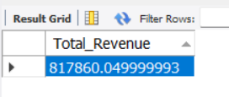
2. Average Order Value
SELECT SUM(TOTAL_PRICE) / COUNT(DISTINCT ORDER_ID) AS AVG_ORDER_VALUE FROM pizza_data;
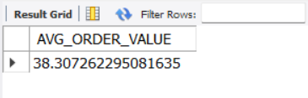

4. Total Orders:
SELECT count(distinct ORDER_ID) AS TOTAL_ORDERS FROM pizza_data;
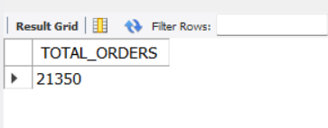
5. Average Pizzas Per Order:
. SELECT cast(SUM(QUANTITY) / COUNT(distinct ORDER_ID) AS DECIMAL(10,2)) AS AVG_PIZZAS_PER_ORDER FROM pizza_data;
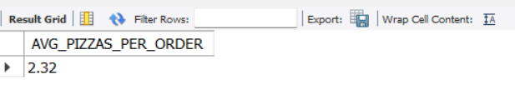
Charts
1. Daily Trend for Total Orders:
SELECT
DAYNAME(ORDER_DATE) AS ORDER_DAY,
COUNT(DISTINCT ORDER_ID) AS TOTAL_ORDERS
FROM pizza_data
GROUP BY DAYNAME(ORDER_DATE), DAYOFWEEK(ORDER_DATE)
ORDER BY DAYOFWEEK(ORDER_DATE);

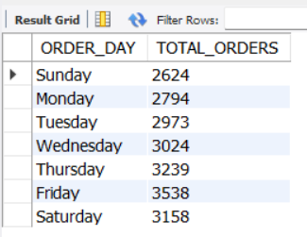
2.Monthly Trend for Total Orders:
SELECT MONTHNAME(ORDER_DATE) AS MONTH_NAME , COUNT(DISTINCT ORDER_ID) AS TOTAL_ORDER FROM PIZZA_DATA
GROUP BY MONTH(ORDER_DATE),MONTHNAME(ORDER_DATE)
ORDER BY TOTAL_ORDER DESC;
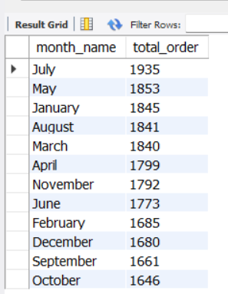
3.Percentage of Sales by Pizza Category:
SELECT PIZZA_CATEGORY ,SUM(TOTAL_SALES) AS TOTAL_SALES,ROUND(SUM(TOTAL_PRICE) * 100 /
(SELECT SUM(TOTAL_PRICE) FROM PIZZA_DATA)) AS SALES_PERCENTAGE
FROM PIZZA_DATA
GROUP BY PIZZA_CATEGORY;
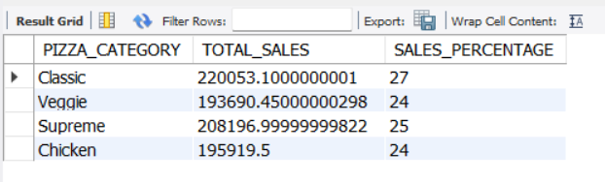
4.Percentage of Sales by Pizza Size:
SELECT PIZZA_SIZE,ROUND(SUM(TOTAL_PRICE),2) AS TOTAL_SALES,ROUND(SUM(TOTAL_PRICE) * 100 /
(SELECT SUM(TOTAL_PRICE) FROM PIZZA_DATA)) AS SALES_PERCENTAGE
FROM PIZZA_DATA
WHERE month(ORDER_DATE)= 1
GROUP BY PIZZA_SIZE
ORDER BY SALES_PERCENTAGE DESC;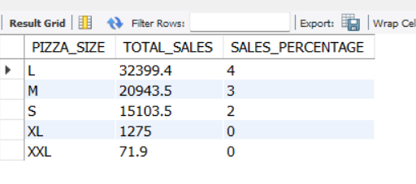
6.Top 5 Best Sellers by Revenue, Total Quantity and Total Orders
SELECT PIZZA_NAME,SUM(TOTAL_PRICE) AS TOTAL_REVENUE,SUM(QUANTITY) AS TOTAL_QUANTITY,
SUM(DISTINCT ORDER_ID) AS TOTAL_ORDERS
FROM PIZZA_DATA
GROUP BY PIZZA_NAME
ORDER BY TOTAL_REVENUE DESC LIMIT 5;
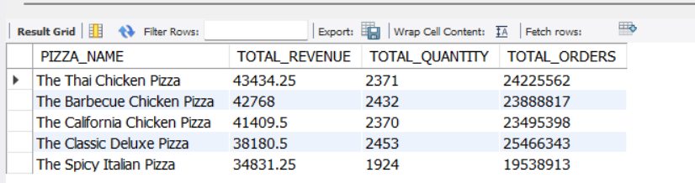
7. Bottom 5 Best Sellers by Revenue, Total Quantity and Total Orders
SELECT PIZZA_NAME,SUM(TOTAL_PRICE) AS TOTAL_REVENUE,SUM(QUANTITY) AS TOTAL_QUANTITY,
SUM(DISTINCT ORDER_ID) AS TOTAL_ORDERS
FROM PIZZA_DATA
GROUP BY PIZZA_NAME
ORDER BY TOTAL_REVENUE LIMIT 5;
