AZURE CLOUD DEPLOYMENT PROJECT
React Portfolio Deployment on Azure Static Web Apps
Using GitHub + GitHub Actions + Vite Production Build

Prepared by: Maruveni Kalyani
Platform: Microsoft Azure
Deployment model: Azure Static Web Apps

TABLE OF CONTENTS
1. Introduction
2. Project Objectives
3. Technologies and Tools Used
4. Azure Static Web App Creation
5. GitHub Repository Configuration
6. GitHub Actions CI/CD Workflow
7. React/Vite Production Build
8. Static Web App Deployment
9. Deployment Verification
10. Troubleshooting During Deployment
11. Live-Link and DNS Status
12. Final Architecture
13. Security and Cost-Control Practices
14. How to Deploy Updates Again
15. Lessons Learned
16. Conclusion
17. References

1. Introduction
This report documents the deployment of a React.js portfolio application on Microsoft Azure using Azure Static Web Apps. The application source code is maintained in the GitHub repository kalyanimaruveni7/kalyani_portfolio. The project uses React and Vite, and Azure Static Web Apps is connected to the GitHub repository so that GitHub Actions can build and deploy the application.
The final Static Web App deployment is accessed through an Azure-provided HTTPS URL. Unlike the earlier Virtual Machine deployment, this hosting model does not require managing an Ubuntu VM or Nginx server. Azure Static Web Apps provides the hosting layer and HTTPS endpoint while GitHub Actions handles automated deployment.

2. Project Objectives
- Deploy the React portfolio application to Microsoft Azure using Azure Static Web Apps.
- Connect the Azure Static Web App to the GitHub repository containing the React/Vite project.
- Configure GitHub Actions for automatic build and deployment from the main branch.
- Generate a Vite production build in the dist/ directory.
- Serve the portfolio over an Azure-provided HTTPS URL.
- Avoid unnecessary VM, operating-system, and Nginx administration for a static frontend.
- Use the Azure Static Web Apps Free plan where appropriate to minimize hosting cost.
- Document deployment, verification, troubleshooting, security, and cost-control practices.

3. Technologies and Tools Used
Technology / Tool | Purpose
Microsoft Azure | Cloud platform used to host the portfolio through Azure Static Web Apps.
Azure Static Web Apps | Managed hosting service used to publish the React/Vite static frontend.
React.js | Frontend framework/library used to build the portfolio.
Vite | Build tool used to generate the production dist/ output.
Node.js + npm | Runtime and package manager used by the build process.
GitHub | Source-code repository containing the frontend project.
GitHub Actions | CI/CD automation used to build and deploy the application.
HTTPS | Secure protocol used by the Azure Static Web App endpoint.

4. Azure Static Web App Creation
A Static Web App resource was created in the Microsoft Azure Portal. The deployment source was configured as GitHub and connected to the portfolio repository.

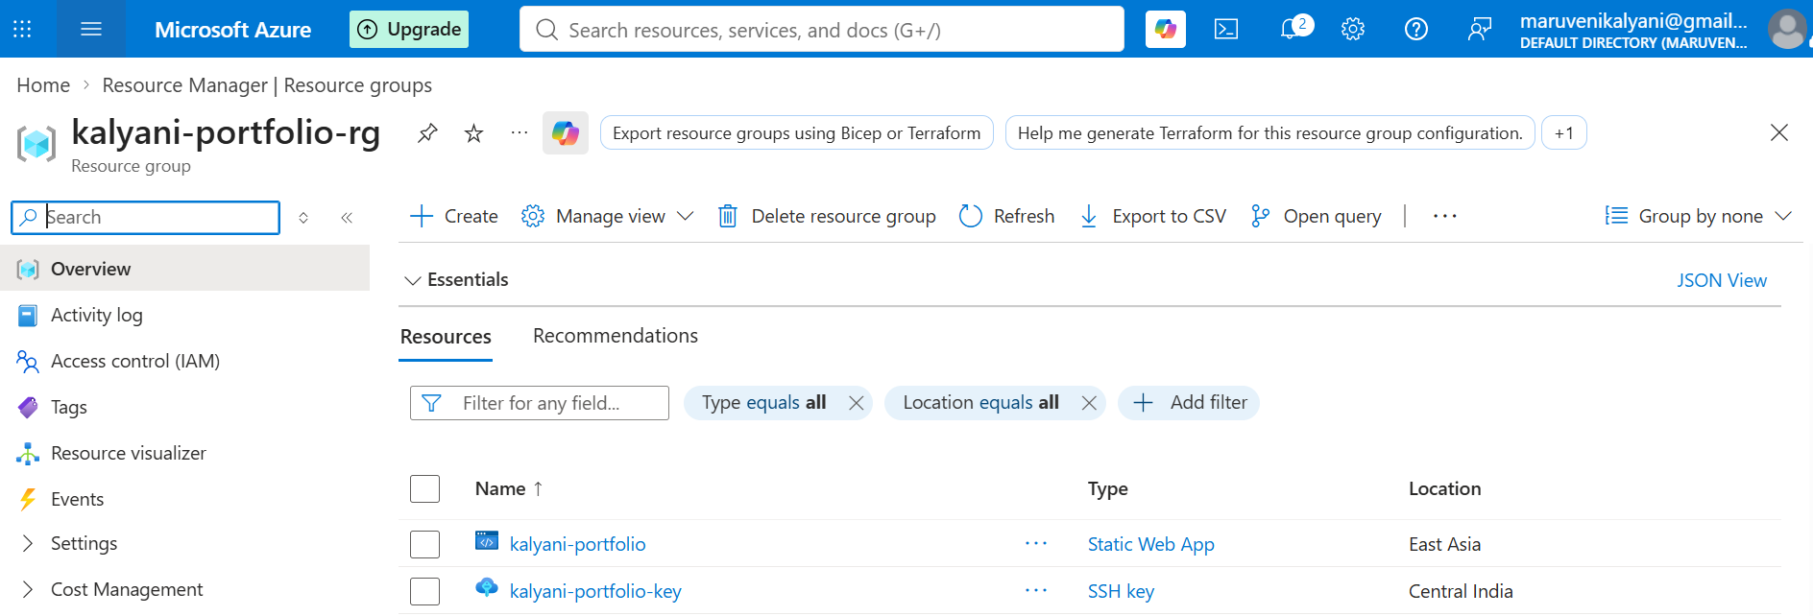
Setting | Project value
Service | Azure Static Web Apps
Plan | Free
Repository | kalyanimaruveni7/kalyani_portfolio
Branch | main
Framework | React / Vite
App location | /
API location | Empty / not used
Output location | dist
Deployment URL | https://jolly-cliff-0361dc600.3.azurestaticapps.net/
The portfolio is a frontend/static application and does not require a separate backend API for this deployment.

5. GitHub Repository Configuration
The GitHub repository contains the React/Vite application source. The repository structure observed for the project includes the source directory, public assets, package files, Vite configuration, and the Azure Static Web Apps workflow directory.
kalyani_portfolio/
├── .github/
│ └── workflows/
├── public/
├── src/
├── index.html
├── package.json
├── package-lock.json
├── vite.config.js
└── README.md
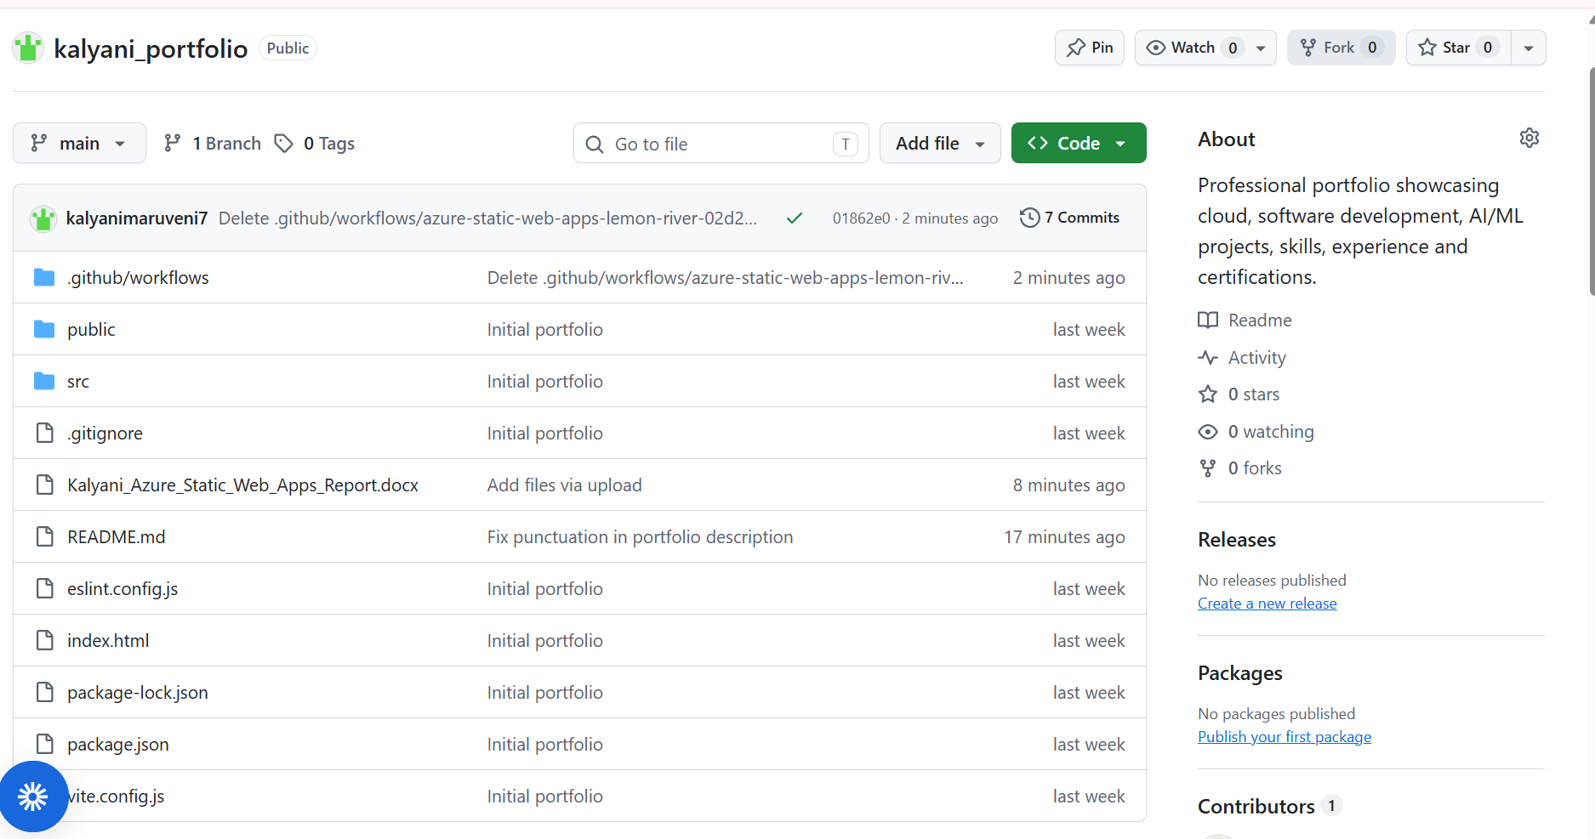
The src directory contains the React application files, including App.jsx, App.css, index.css and main.jsx. The package.json and package-lock.json files provide the dependencies and build scripts required for the Vite application.

6. GitHub Actions CI/CD Workflow
Azure Static Web Apps uses a GitHub Actions workflow to automatically build and deploy the application. The workflow runs when code is pushed to the main branch. It checks out the repository and uses the Azure/static-web-apps-deploy action to publish the application.
name: Azure Static Web Apps CI/CD
on:
push:
branches:
- main
jobs:
build_and_deploy_job:
runs-on: ubuntu-latest
steps:
- uses: actions/checkout@v3
- name: Build And Deploy
uses: Azure/static-web-apps-deploy@v1
with:
azure_static_web_apps_api_token: ${{ secrets.AZURE_STATIC_WEB_APPS_API_TOKEN }}
repo_token: ${{ secrets.GITHUB_TOKEN }}
action: "upload"
app_location: "/"
api_location: ""
output_location: "dist"
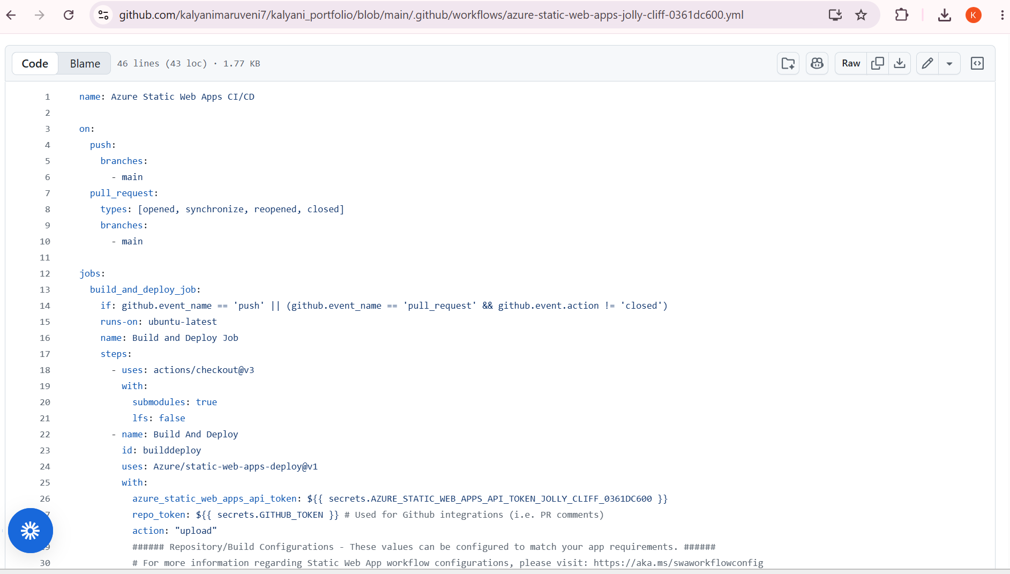

The actual project workflow contains an Azure Static Web Apps deployment token stored as a GitHub Actions secret. The secret is intentionally not reproduced in this report because deployment credentials must remain private.

7. React/Vite Production Build
The application is a React/Vite project. During deployment, the project is built into production-ready static files.
npm run build
Vite generates the production output in the dist directory. Azure Static Web Apps then publishes the contents of this output directory as the website.
dist/
├── index.html
└── assets/
├── index-*.css
└── index-*.js

8. Static Web App Deployment
- Open the Azure Portal and create an Azure Static Web App.
- Select the GitHub deployment source.
- Connect the GitHub account and select kalyanimaruveni7/kalyani_portfolio.
- Select the main branch.
- Choose React as the build preset.
- Set App location to /.
- Leave API location empty because the project does not use a backend API.
- Set Output location to dist.
- Choose the Free hosting plan.
- Create the Static Web App and allow Azure/GitHub Actions to perform the deployment.
After the resource is created, GitHub Actions performs the build and deployment. The workflow can be monitored from the repository's Actions tab.

9. Deployment Verification
The deployed portfolio uses the Azure Static Web Apps HTTPS endpoint:
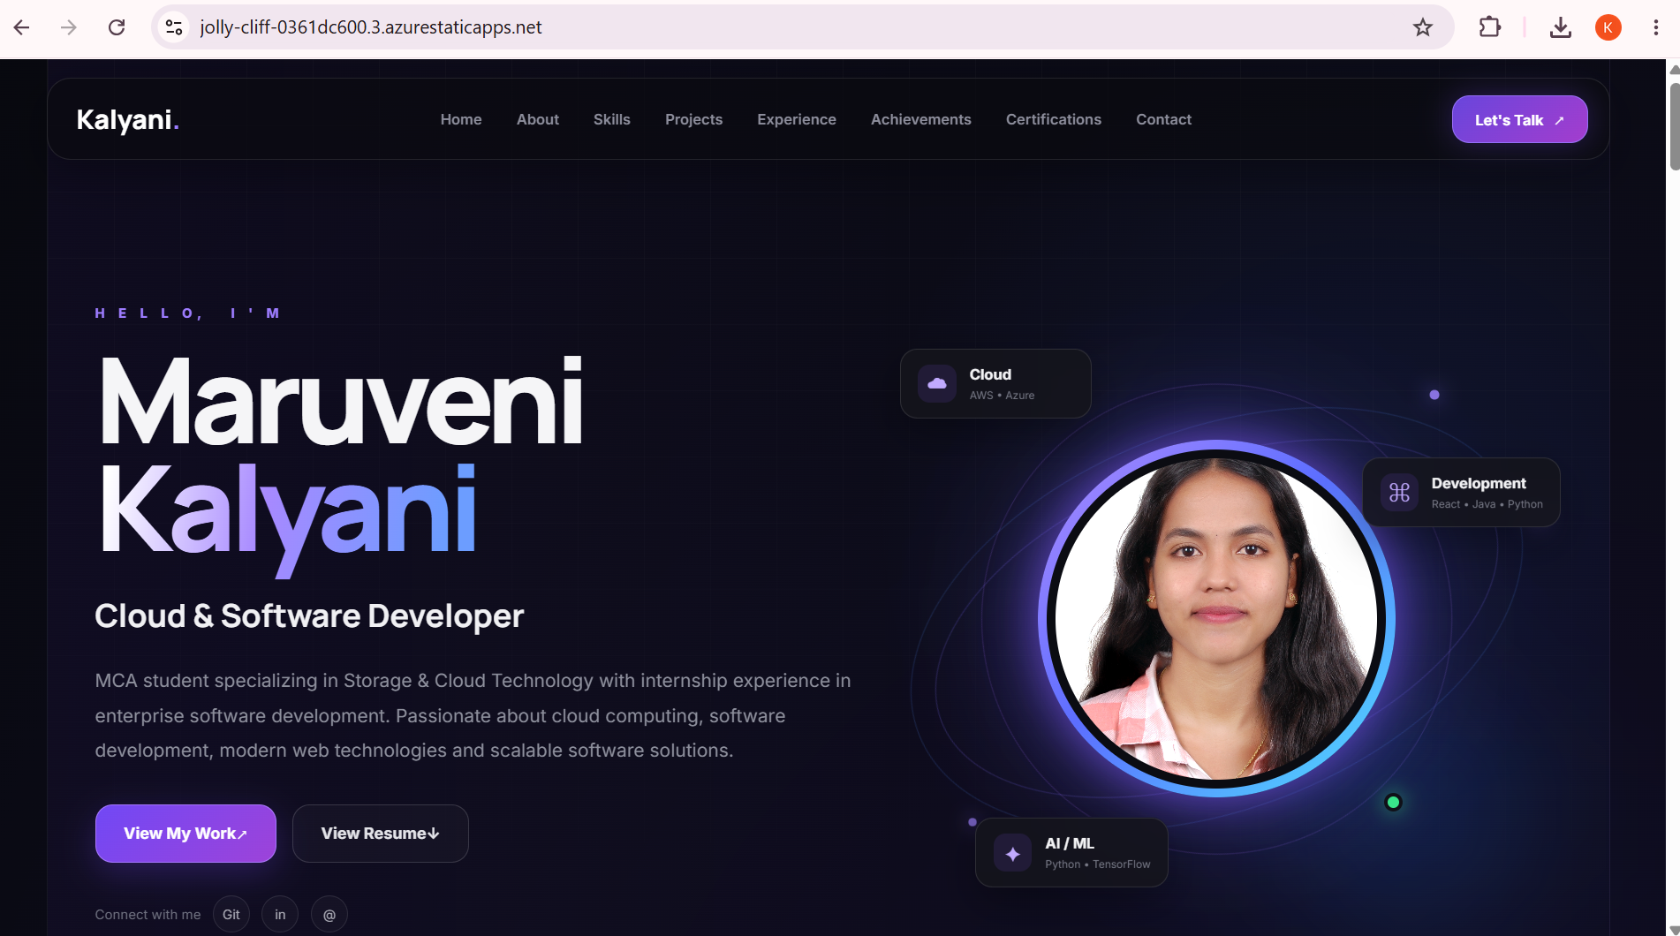https://jolly-cliff-0361dc600.3.azurestaticapps.net/
The endpoint initially displayed Azure's default 'Congratulations on your new site' page while the deployment was being prepared. After the GitHub Actions deployment completes successfully, the endpoint should display the React portfolio rather than the default page.
- Open the Azure Static Web Apps URL in a browser.
- Confirm that the portfolio home page loads.
- Check that CSS and JavaScript assets load correctly.
- Check portfolio images and public assets.
- Test navigation and React client-side routes if present.
- Verify GitHub/project links shown on the portfolio.
- Confirm that the browser uses HTTPS.

10. Troubleshooting During Deployment
- If the default Azure welcome page appears, check the latest GitHub Actions workflow run and wait for the deployment to complete.
- 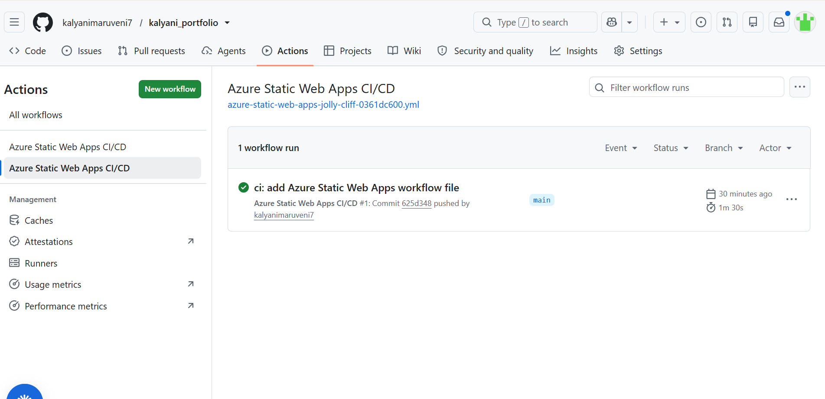If the workflow fails, open GitHub → Actions → Azure Static Web Apps CI/CD and inspect the failed Build and Deploy Job.
- If the build fails, verify package.json, Node/Vite compatibility, and the npm build command.
- If the site builds but shows a blank page, check that the Vite output is generated in dist/ and that the application assets use correct paths.
- Do not expose or paste the Azure Static Web Apps deployment token into public files, screenshots, or source code.
- Changes pushed to the main branch trigger a new deployment through GitHub Actions.

11. Live-Link and DNS Status
Item | Status
Azure Static Web App | Created
GitHub repository connection | Configured
GitHub Actions workflow | Configured
HTTPS Azure endpoint | Available
Live-link | https://jolly-cliff-0361dc600.3.azurestaticapps.net/
Custom domain purchase | Not required for this submission
Custom DNS A/CNAME configuration | Not completed
Azure-provided HTTPS certificate | Provided by the Static Web Apps service
A custom domain was not required for the project submission. The Azure-provided staticapps.net hostname is therefore used as the final live link.

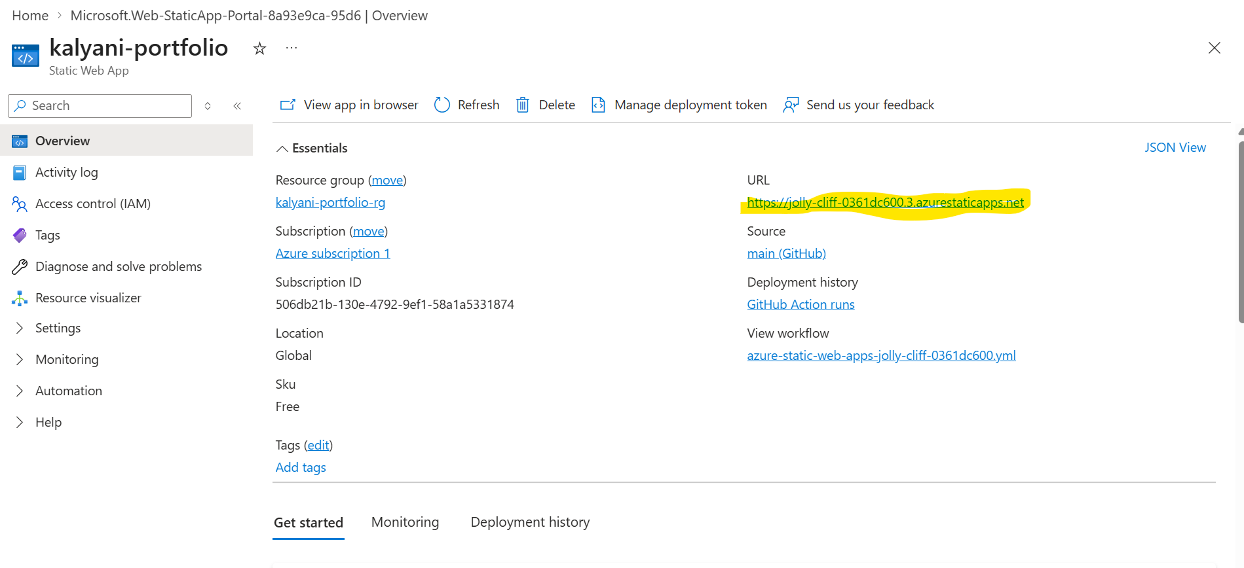12. Final Architecture
Layer | Component | Function
Source | GitHub | Stores the React/Vite frontend source code.
CI/CD | GitHub Actions | Checks out, builds and deploys the application.
Cloud hosting | Azure Static Web Apps | Hosts and publishes the production static frontend.
Build | Vite | Generates optimized files in dist/.
Application | React/Vite | Provides the portfolio user interface.
Delivery | HTTPS Azure endpoint | Provides secure browser access to the portfolio.
User | Web browser | Requests and displays the portfolio.
Request/deployment flow:

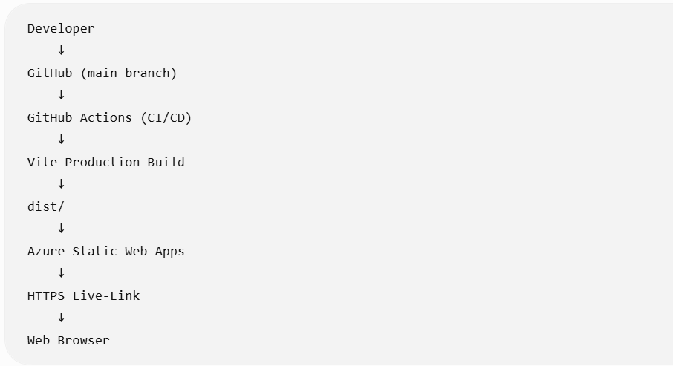

13. Security and Cost-Control Practices
- GitHub repository authentication and Azure deployment credentials are handled through GitHub/Azure mechanisms rather than hard-coded into the application.
- The Azure Static Web Apps deployment token is stored as a GitHub Actions secret and is not included in the source code.
- HTTPS is used for the public website endpoint.
- The Vite development server port 5173 is not required for public hosting.
- No SSH access, Linux VM administration, or Nginx configuration is required for this hosting model.
- The Free Static Web Apps plan is used for this portfolio deployment to minimize hosting cost, subject to Azure's applicable free-tier limits.
- The earlier VM can be stopped/deallocated or removed after the Static Web App deployment has been verified and the VM is no longer required.

14. How to Deploy Updates Again
- Make changes to the React portfolio in the GitHub repository.
- Commit the changes to the main branch.
- Push the changes to GitHub.
- Open GitHub → Actions and verify the Azure Static Web Apps CI/CD workflow.
- Wait for the Build and Deploy Job to complete successfully.
- Refresh the Azure Static Web Apps live URL and verify the updated portfolio.
The deployment is repeatable without manually connecting to a server, copying files, or restarting Nginx.

15. Lessons Learned
- Learned how Azure Static Web Apps can host a React/Vite frontend without managing a virtual machine.
- Learned how GitHub can act as the source repository for an Azure deployment.
- Learned how GitHub Actions provides automated CI/CD for cloud deployment.
- Learned the difference between a Vite development environment and a production dist/ build.
- Learned how app_location, api_location and output_location control the Static Web Apps deployment.
- Learned how deployment secrets should be protected using GitHub Actions secrets.
- Learned practical cloud cost control by selecting an appropriate managed hosting plan and avoiding unnecessary VM runtime.

16. Conclusion
The React portfolio was successfully prepared for deployment on Microsoft Azure using Azure Static Web Apps. The project source is maintained in GitHub, the React/Vite application is built into the dist directory, and GitHub Actions provides automated deployment to Azure.
The Static Web Apps approach removes the need to manage the Ubuntu operating system, SSH access, Nginx configuration, public VM networking, and server maintenance required by the earlier VM-based deployment. The final project uses an Azure-provided HTTPS live link and the Free plan to provide a simple, professional and cost-conscious hosting solution for a static portfolio.

17. References
- Microsoft Azure Documentation — Azure Static Web Apps
- Microsoft Azure Documentation — Azure Static Web Apps pricing
- Microsoft Azure Documentation — Deploying React applications to Azure Static Web Apps
- React Documentation
- Vite Documentation
- GitHub Documentation
- GitHub Actions Documentation

