Insertion sort:

Initially array of 1 element is considered as sorted array then the size is incremented in each stage by adding one element. When an element is added it is compared with all elements in sorted array and is inserted accordingly.

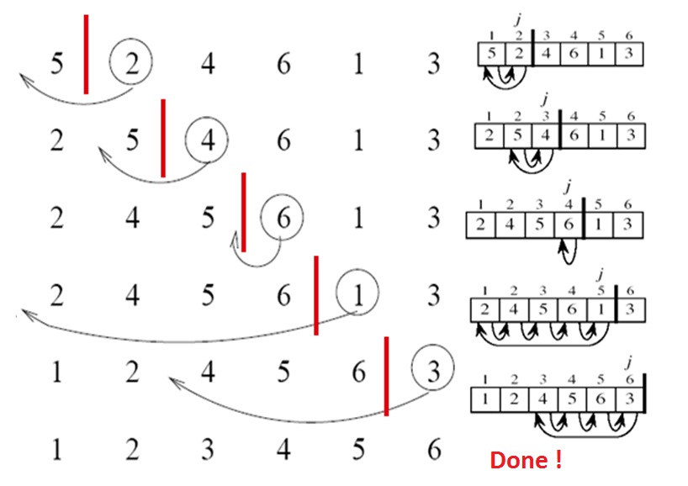

Bubble sort:

Bubble implies lighter element comes to the start on an array. First element becomes minimum element and it is compared with all elements. When an element lesser than minimum is present minimum value changes to lesser number.

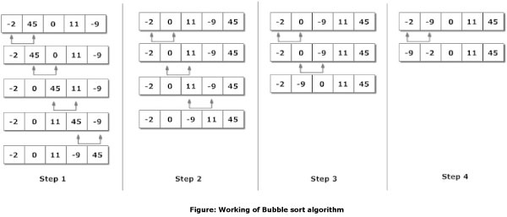

Selection sort:

Every two elements are compared and minimum of the two numbers is placed first as the steps goes by every pair is compared thus sorting is done.

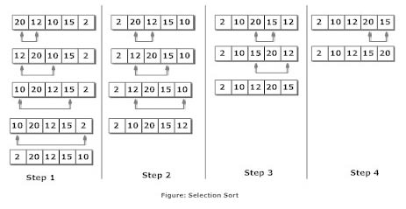

Merge sort:

Unsorted array is divided into single elements in phase1.In phase 2 elements are paired to sort the elements.

