**12. Demonstrate Infrastructure as a Service (IaaS) by creating a resources group using a Public Cloud Service Provider (Azure), configure with minimum CPU, RAM, and Storage.**

Step1:create resource groups

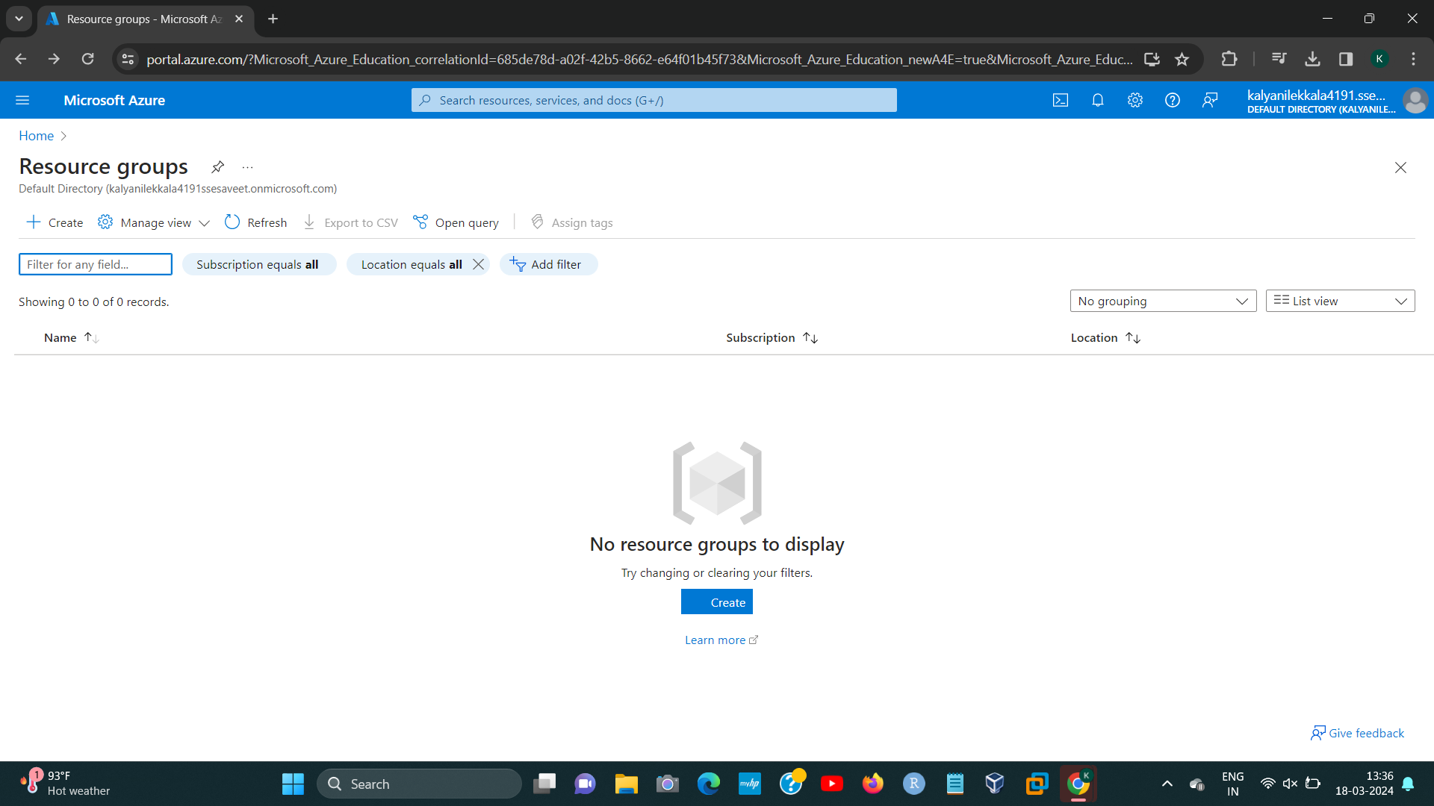

Step2:

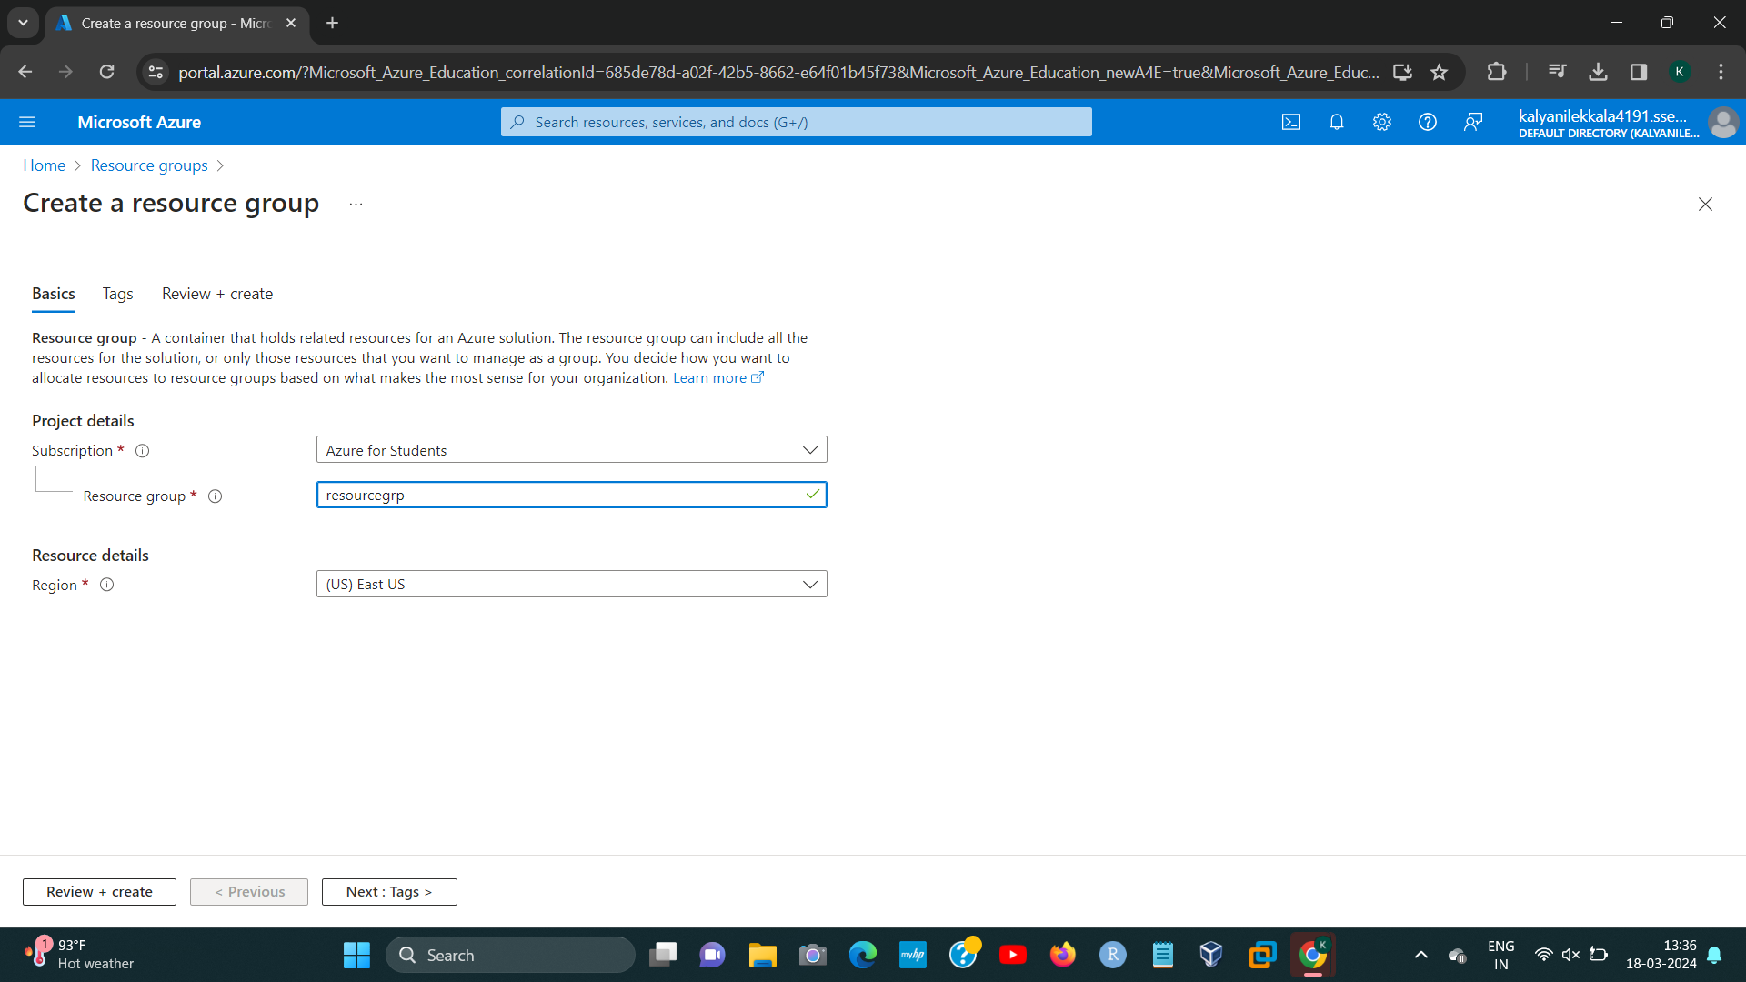

192224191 L.KALYANI

[1]

STEP3:

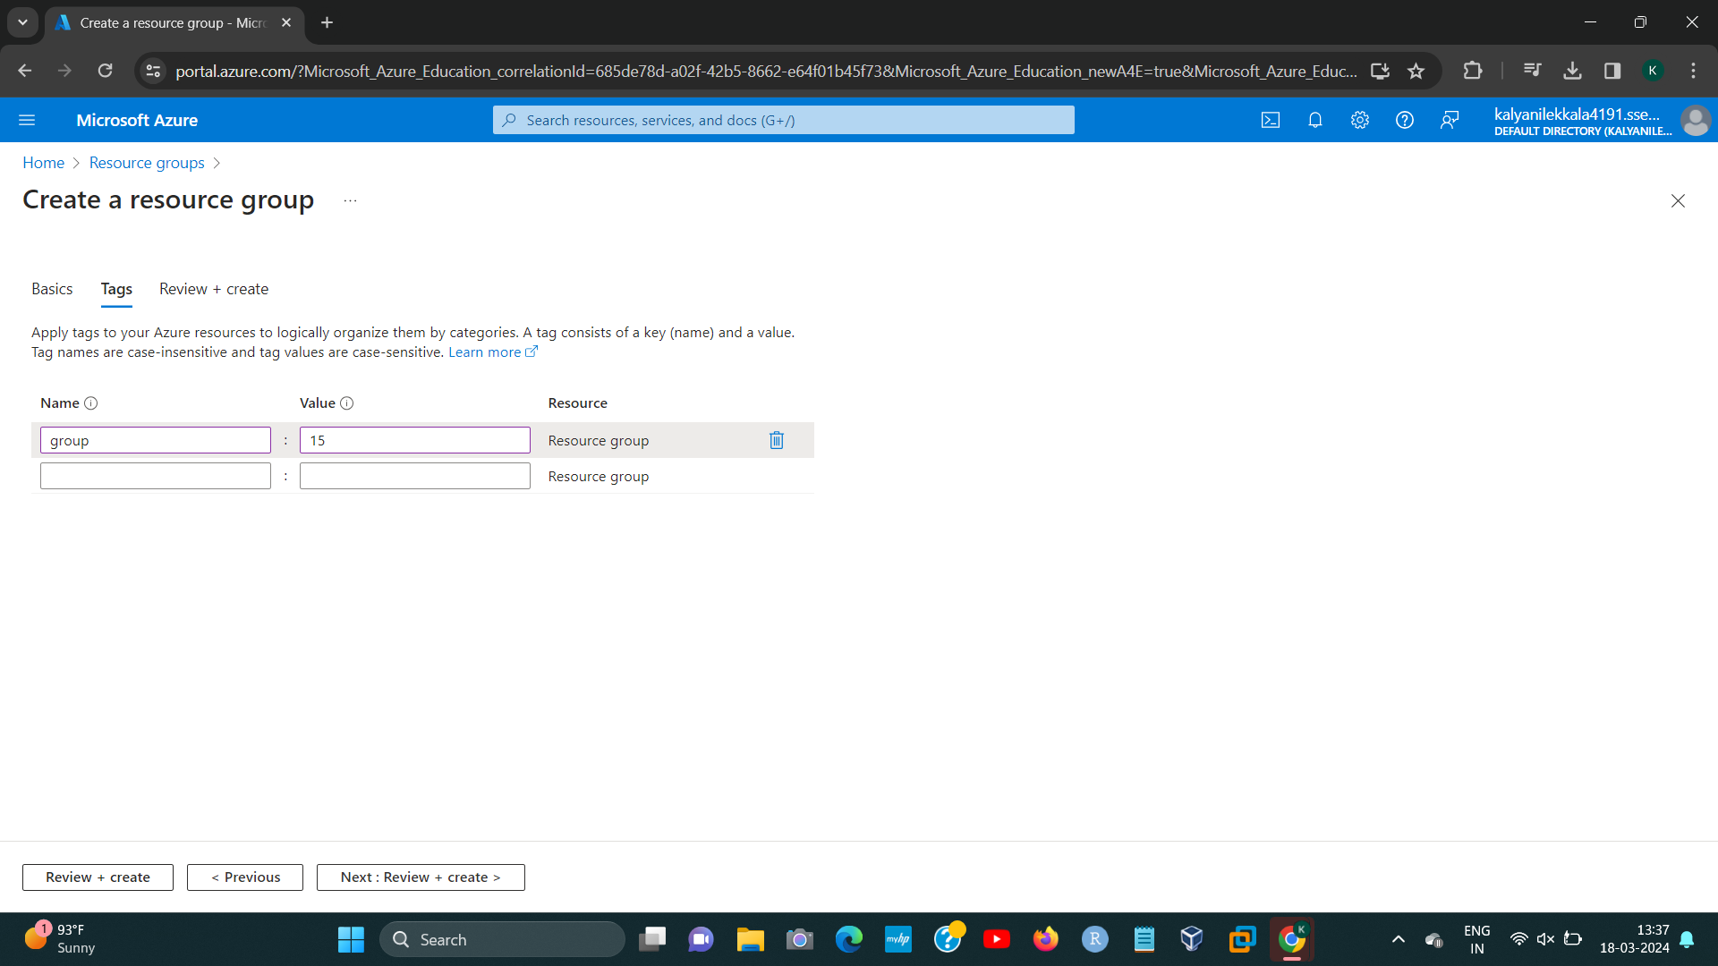

STEP4:

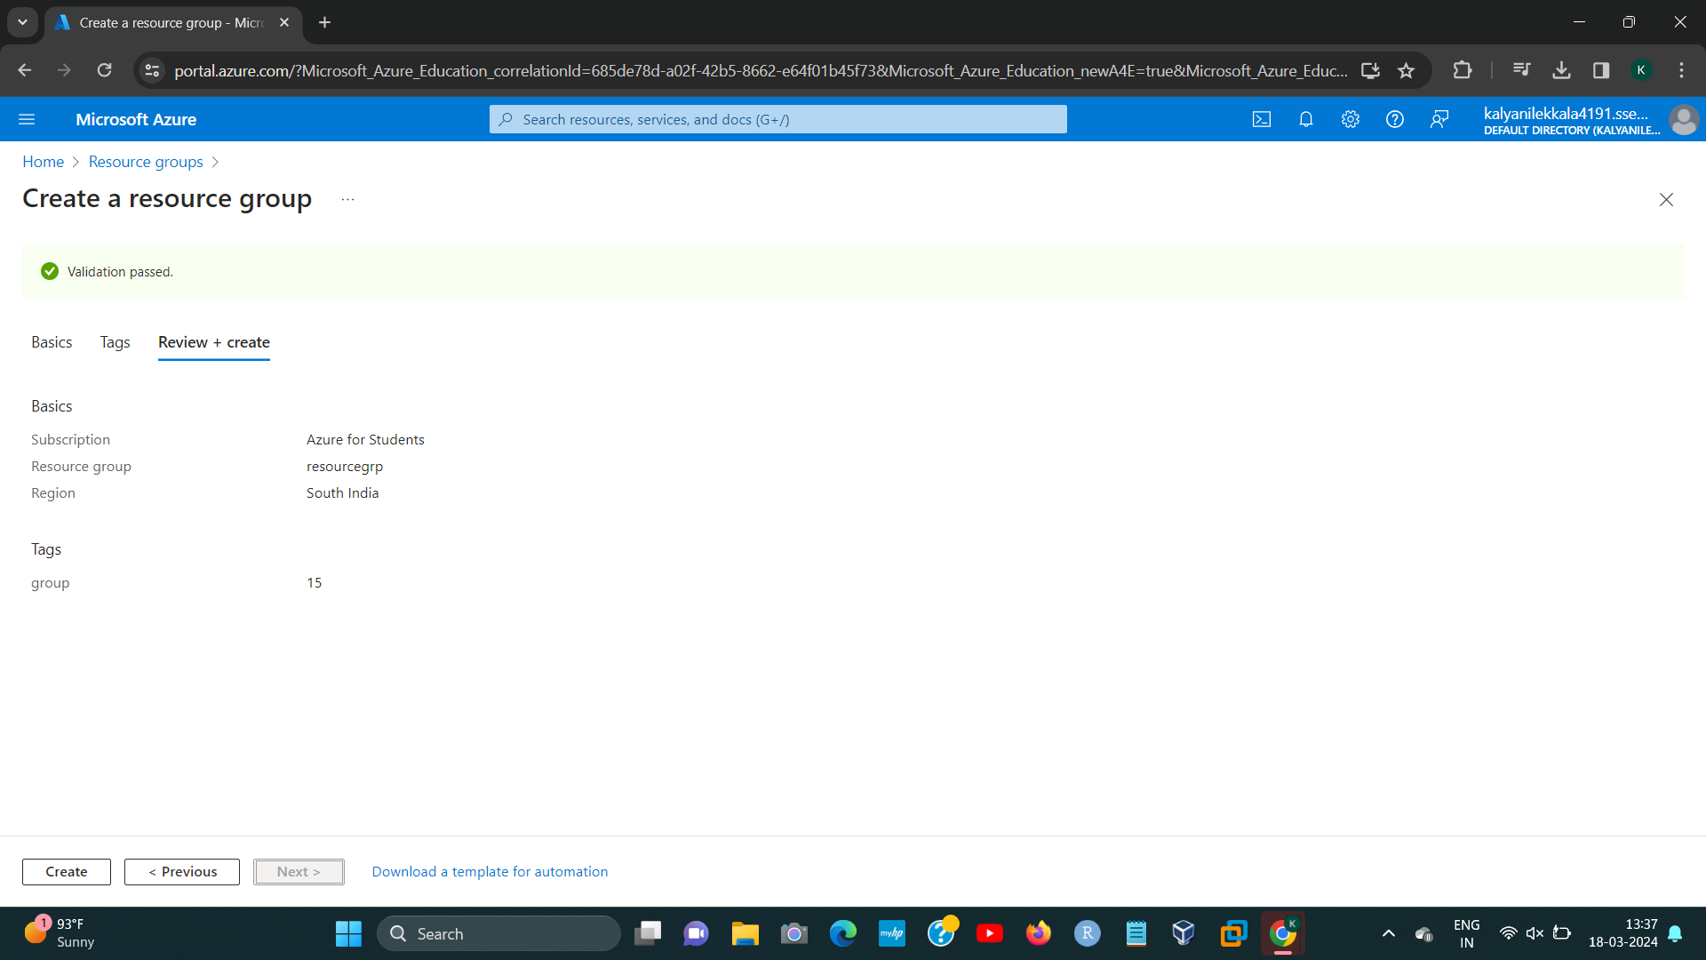

[2]STEP5:

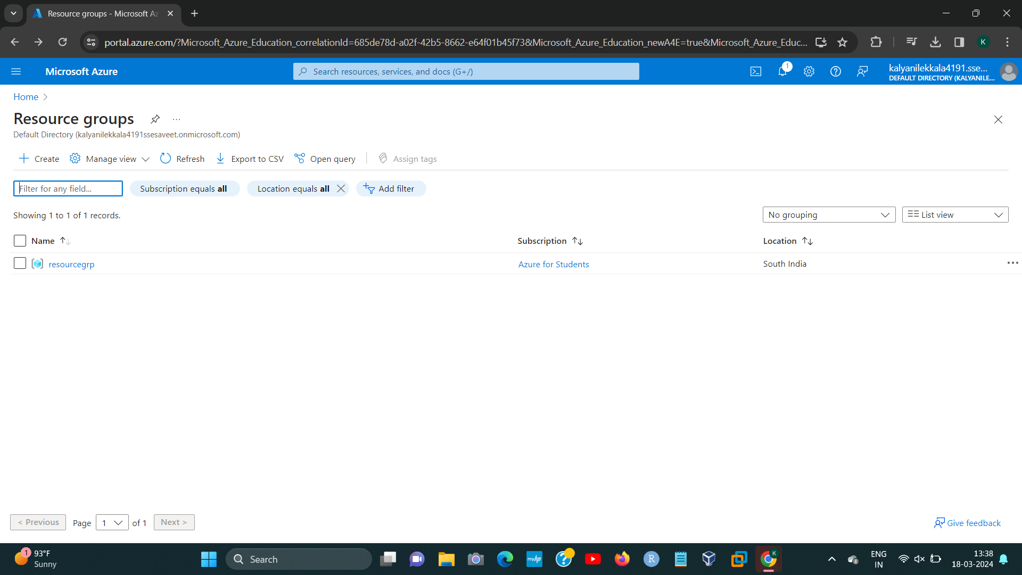

1. 192224191 L.KALYANI
2. 192224191 L.KALYANI