**13. Demonstrate Infrastructure as a Service (IaaS) by creating a Virtual Machine using a Public Cloud Service Provider (Azure), configure with required memory and CPU.**

STEP1:

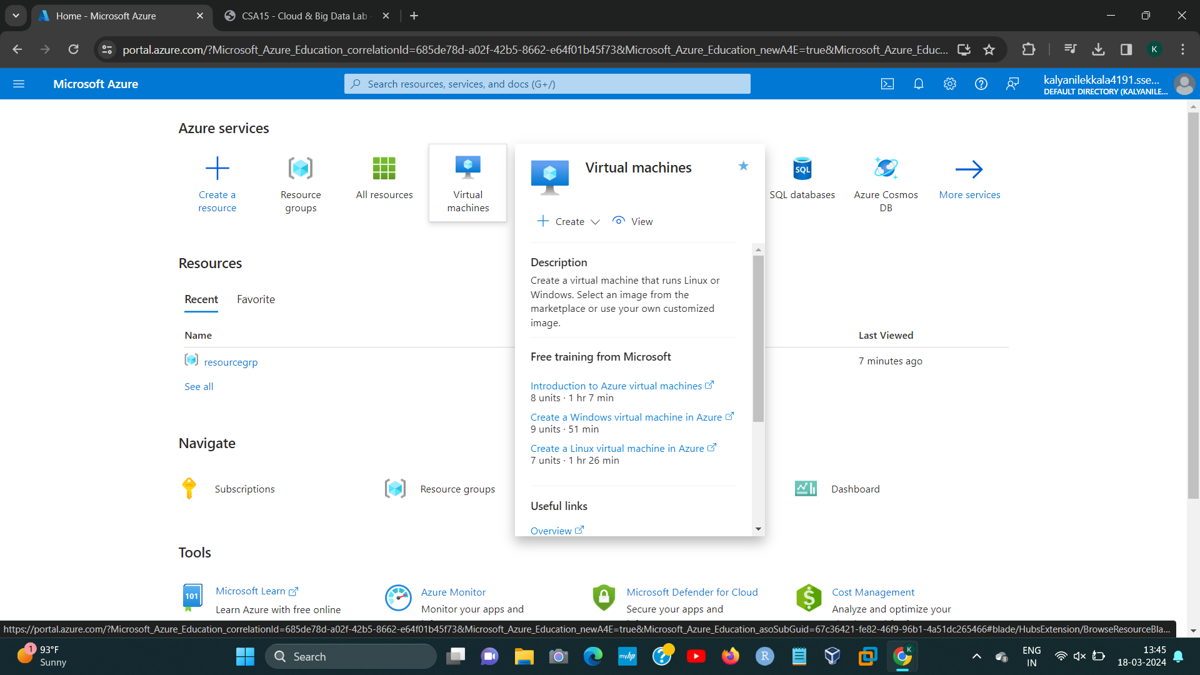

STEP2:

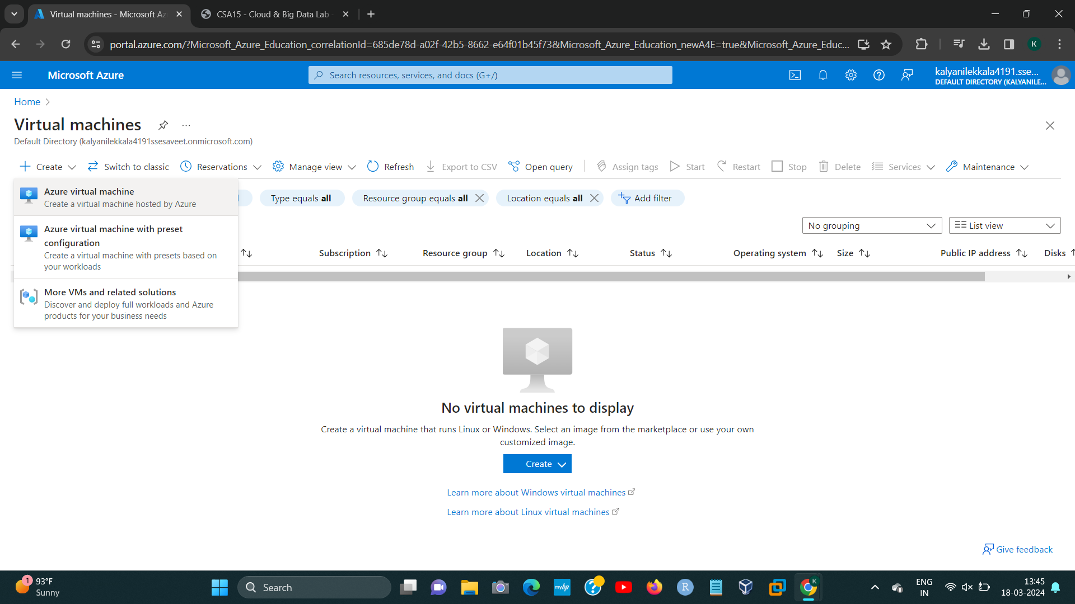

192224191 L.KALYANI

STEP3:

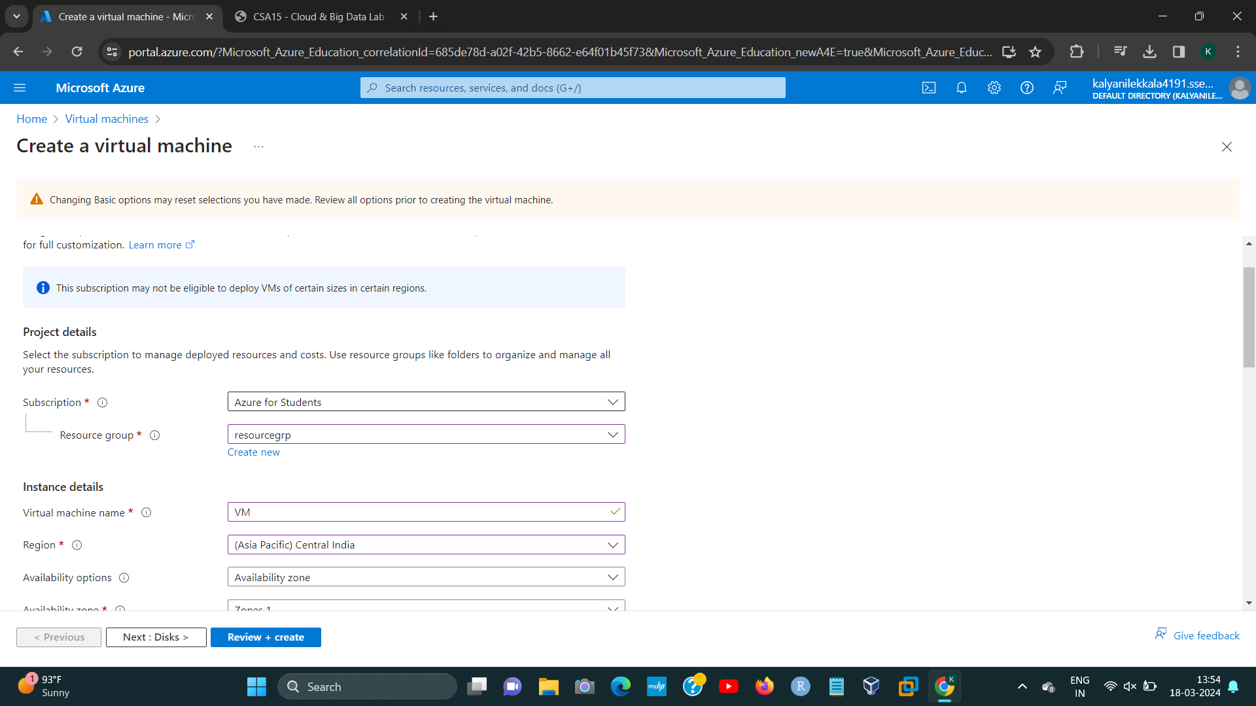

STEP4:

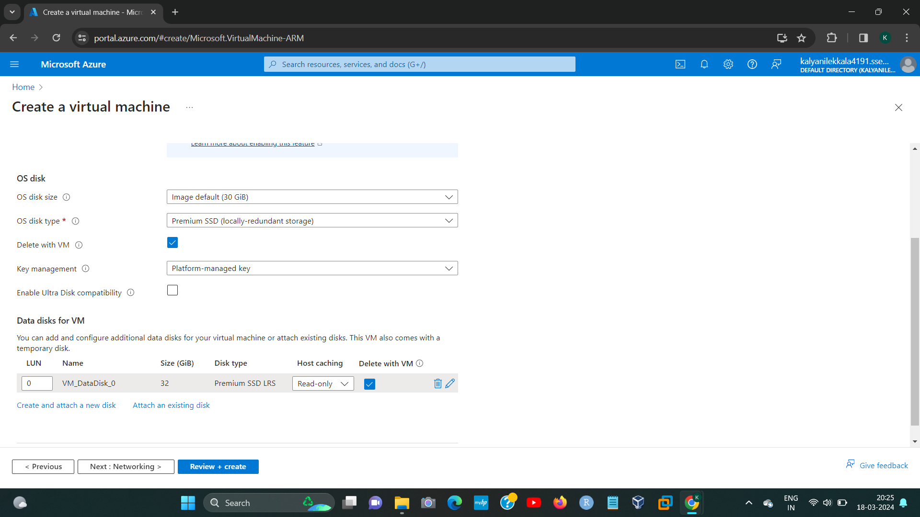

192224191 L.KALYANI

STEP5:

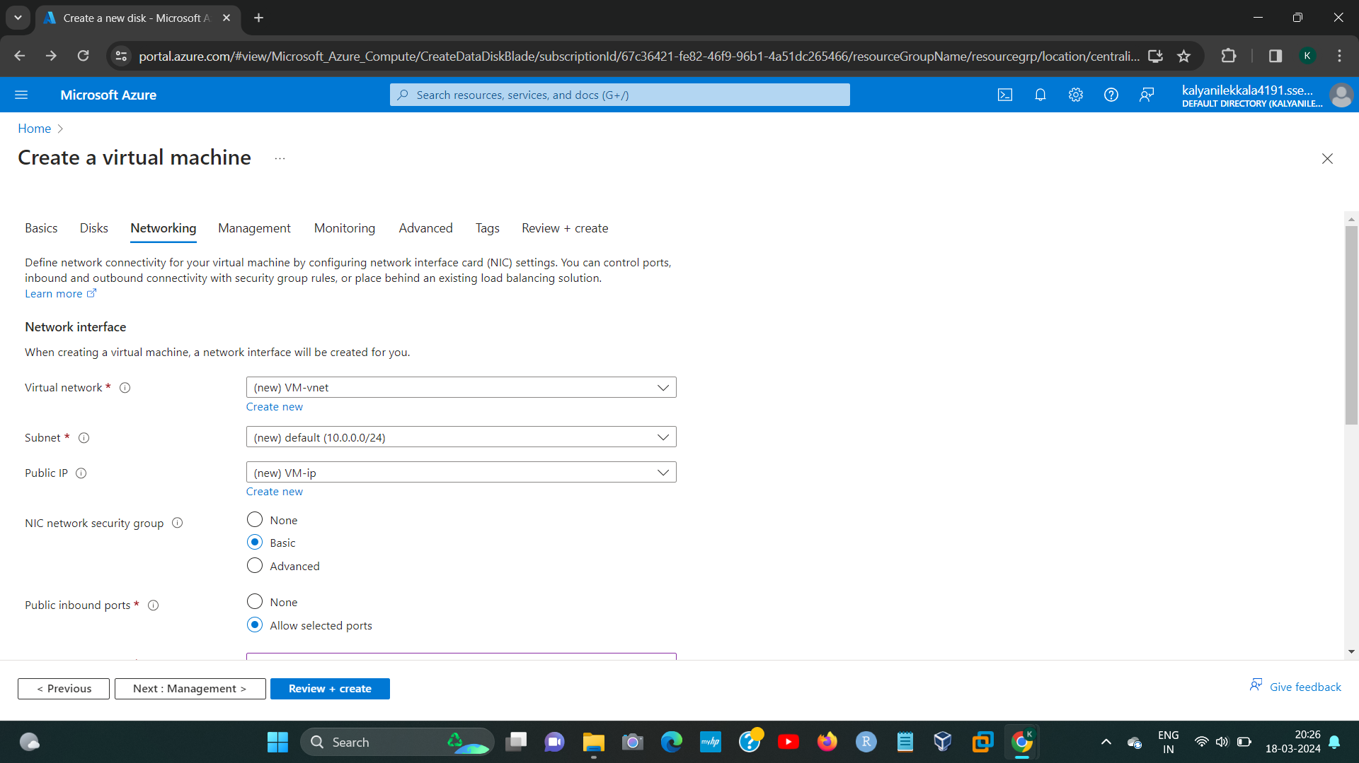

STEP6:

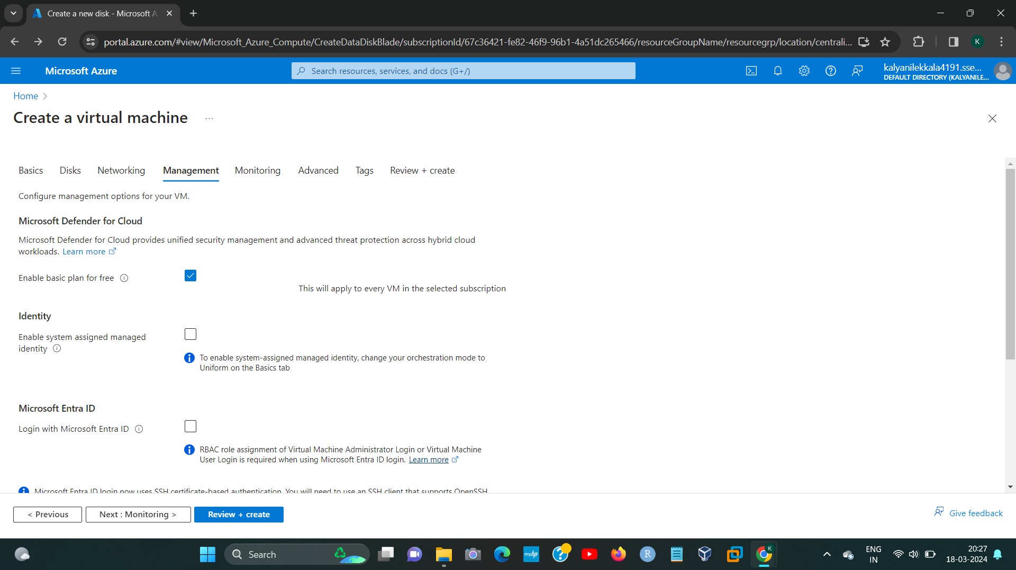

192224191 L.KALYANI

STEP7:

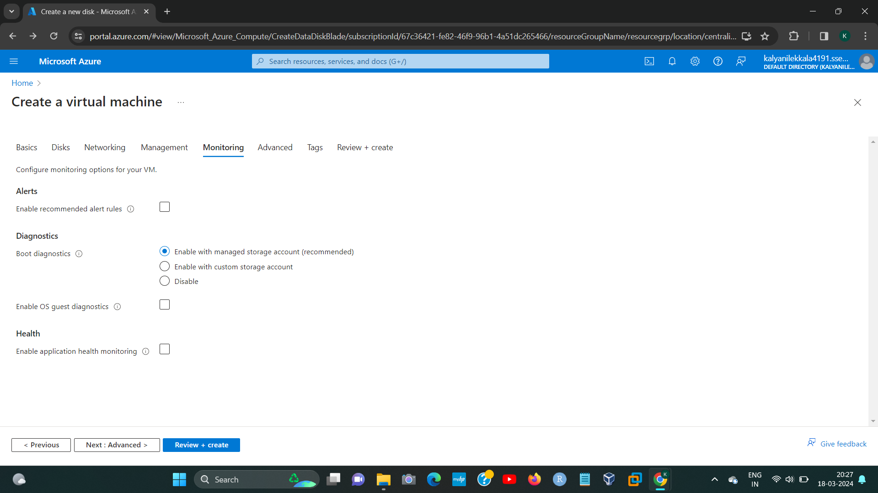

STEP8:

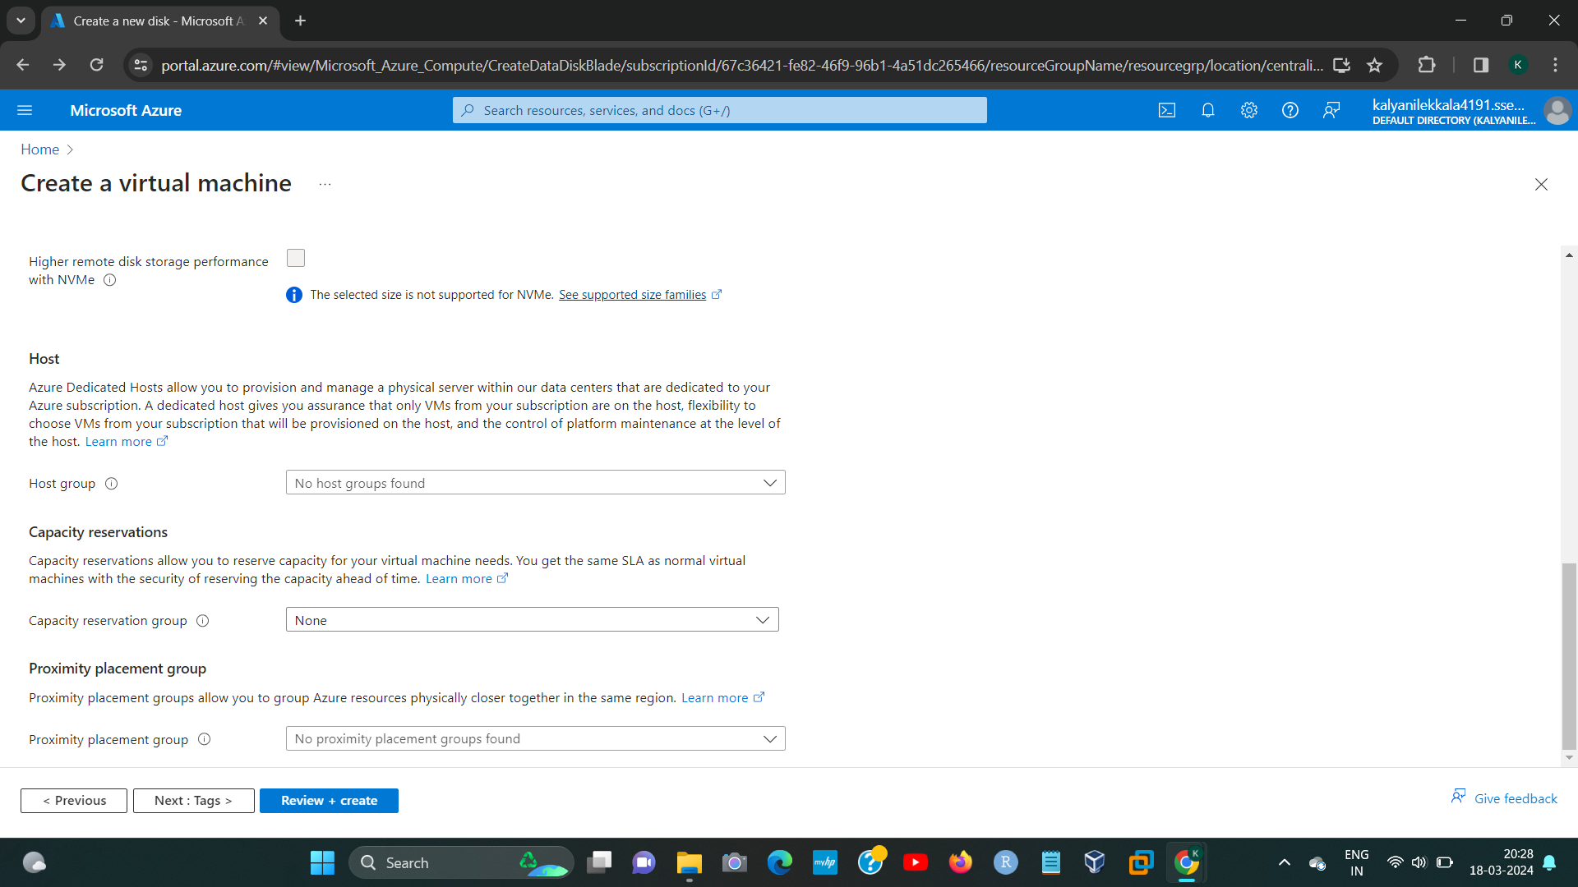

192224191 L.KALYANI

STEP9:

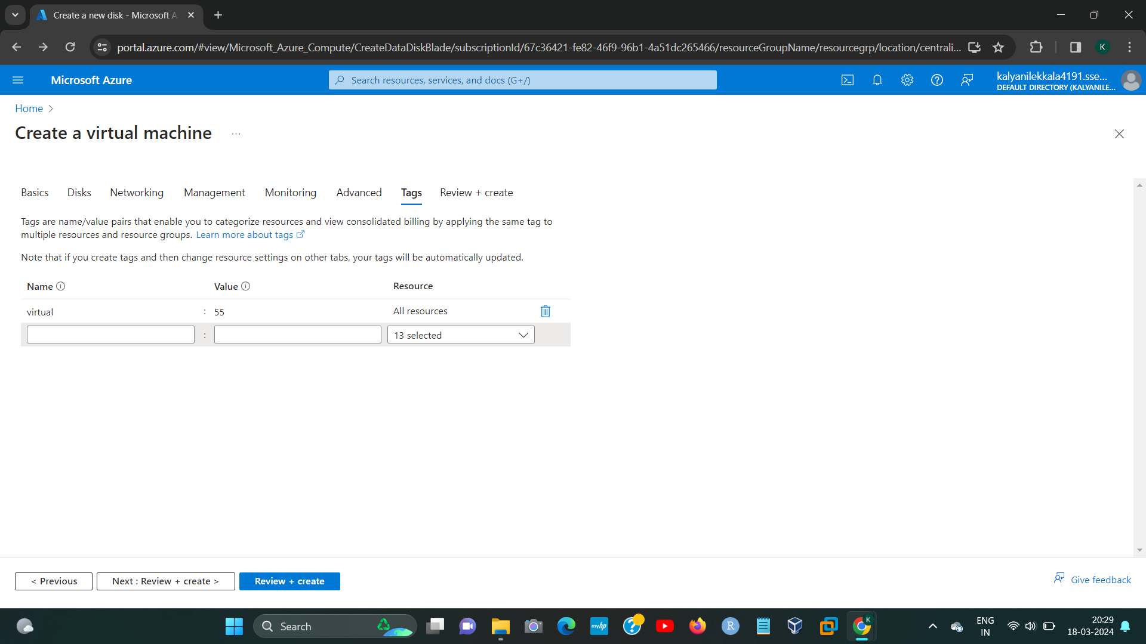

STEP10:

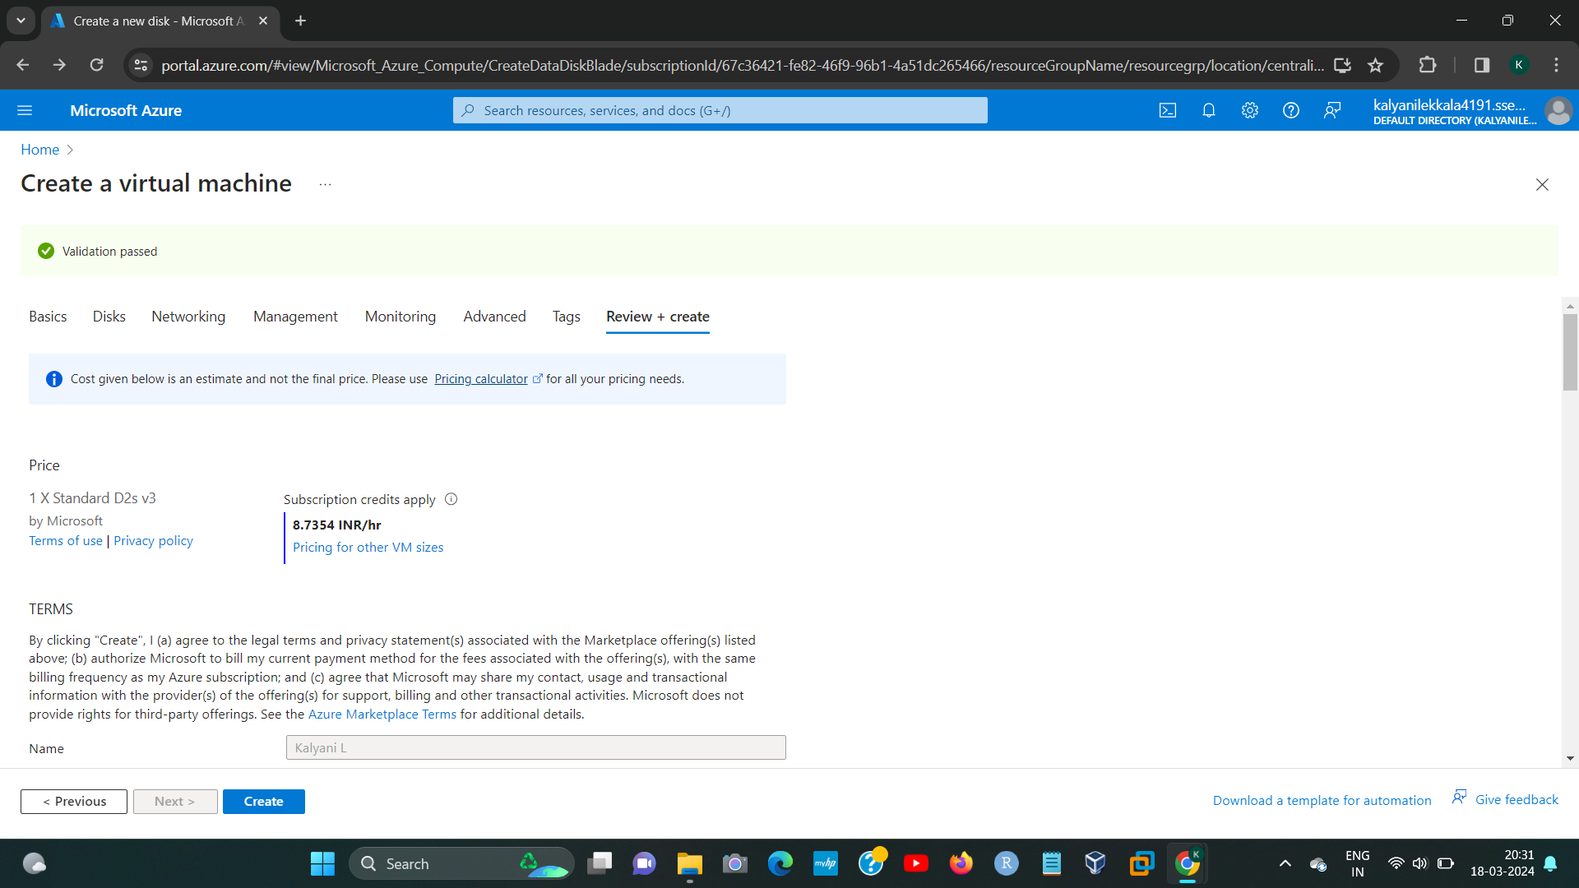

192224191 L.KALYANI

STEP11:

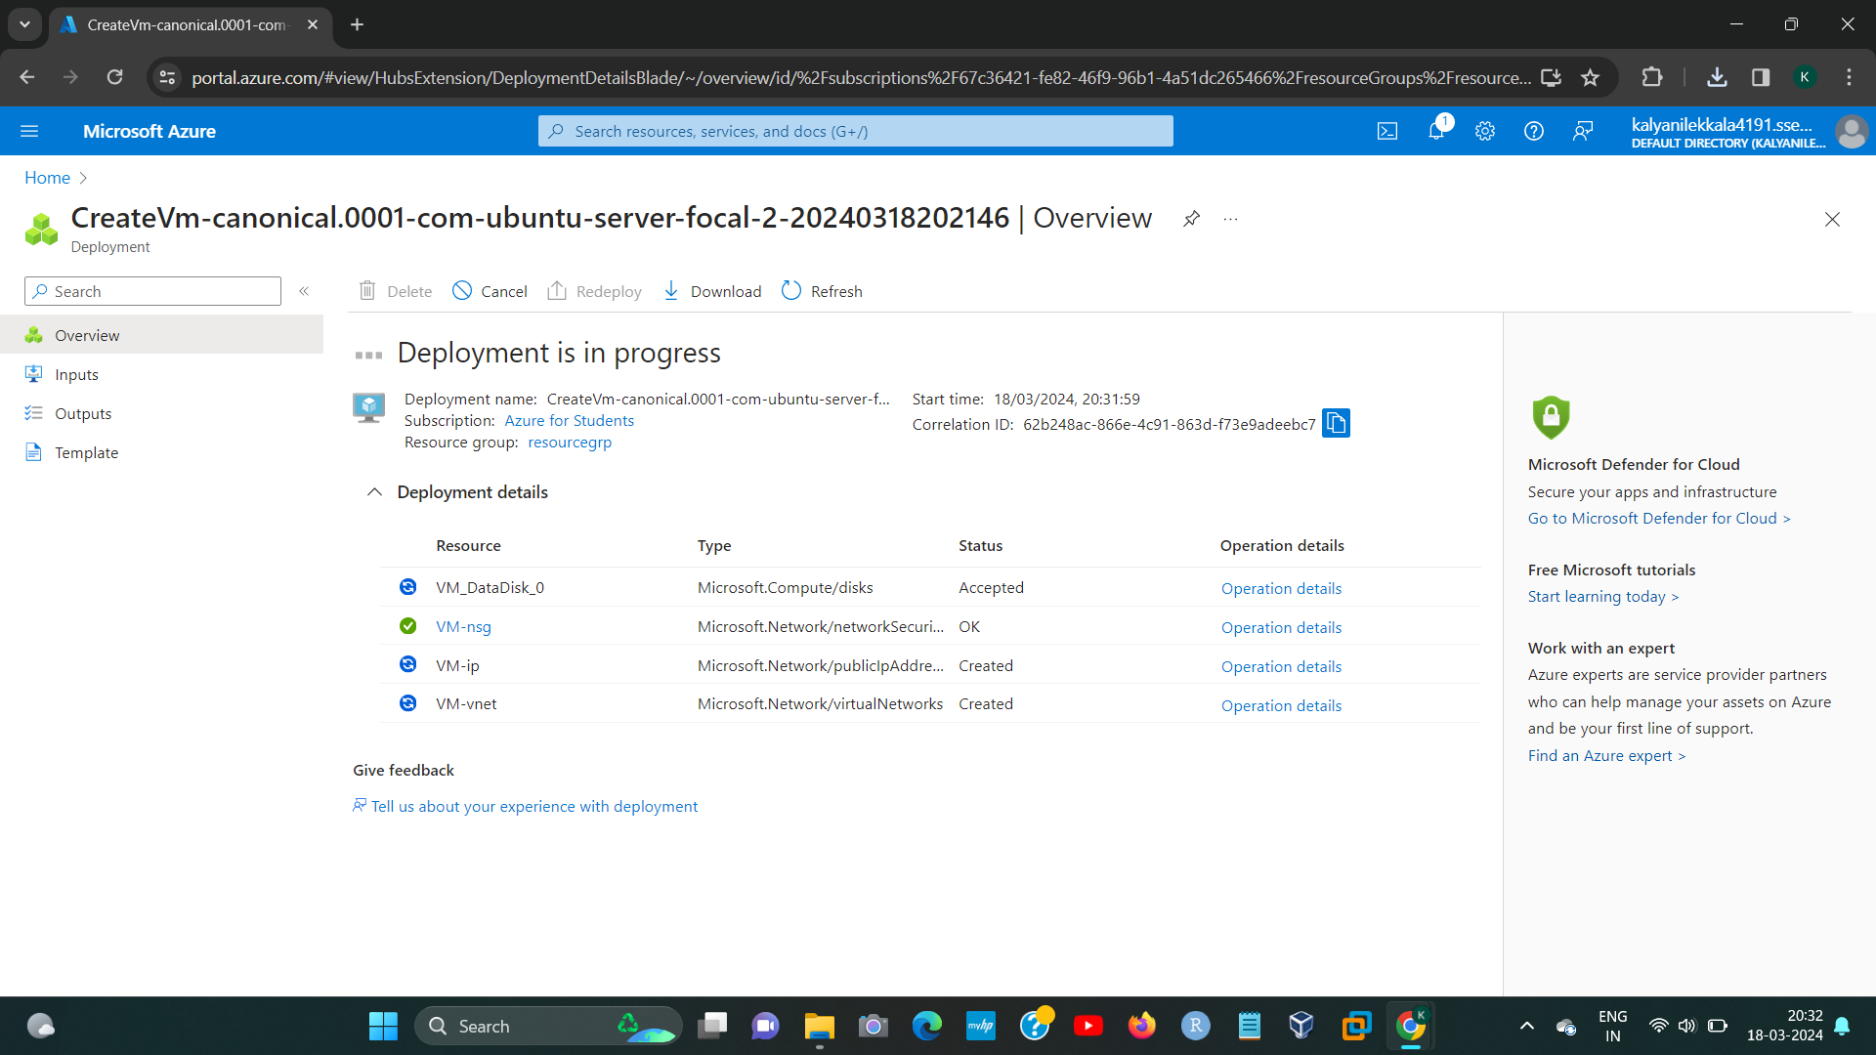

STEP12:

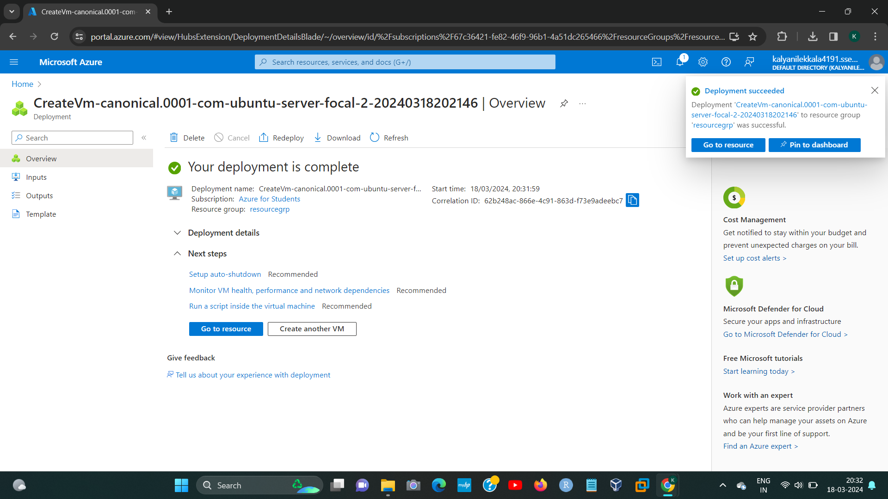

192224191 L.KALYANI