**14. Demonstrate Infrastructure as a Service (IaaS) by establishing the remote connection, launch the created VM image and run in your desktop.**

STEP1:

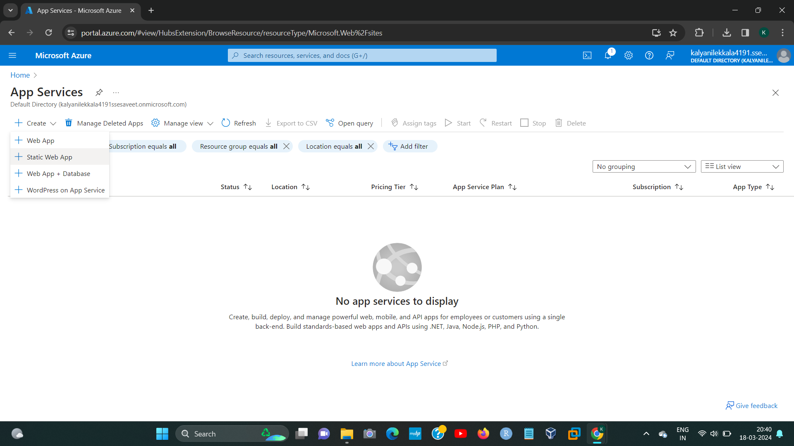

STEP2:

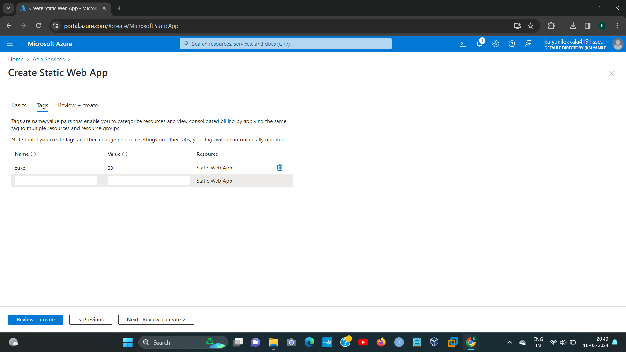

192224191 L.KALYANI

STEP3:

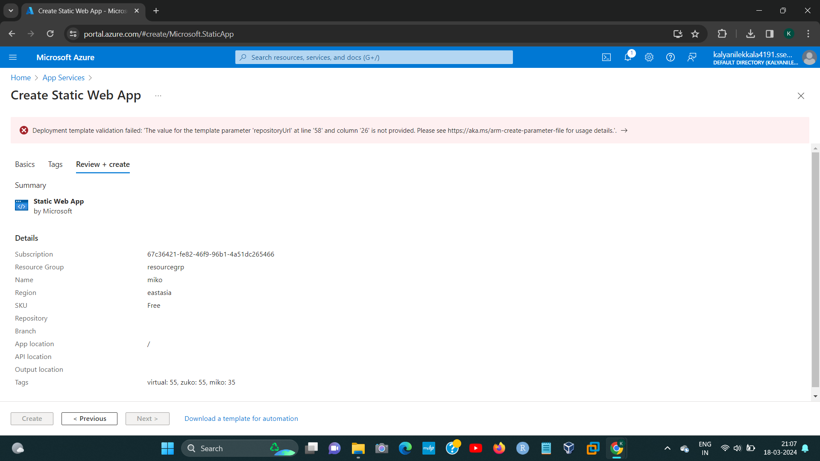

STEP4:

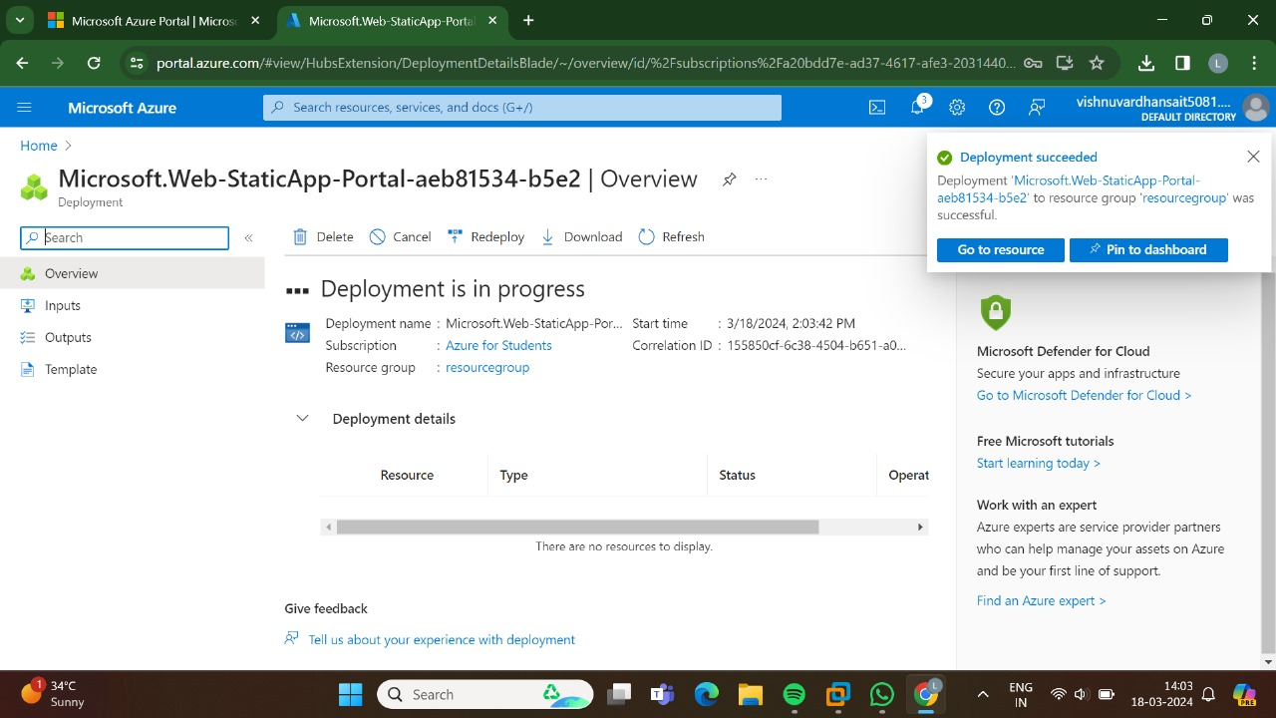

192224191 L.KALYANI

STEP5:

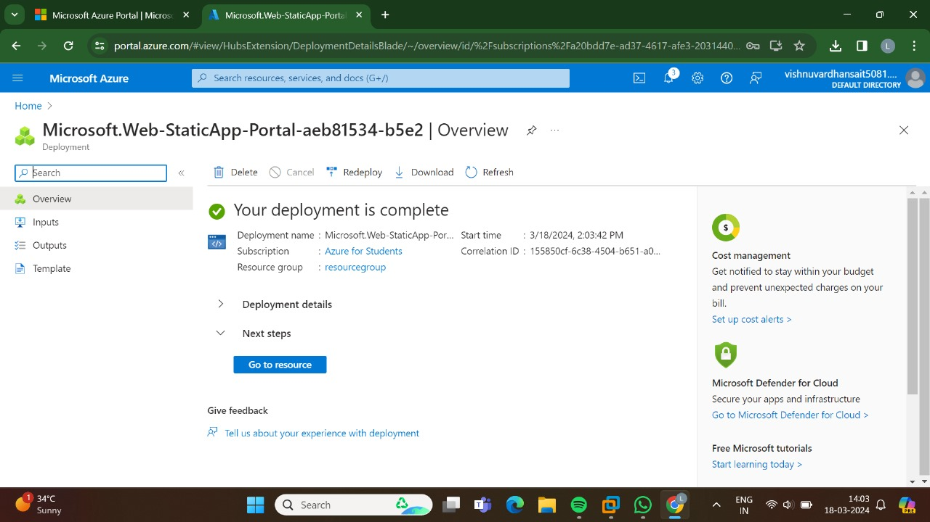

STEP6:

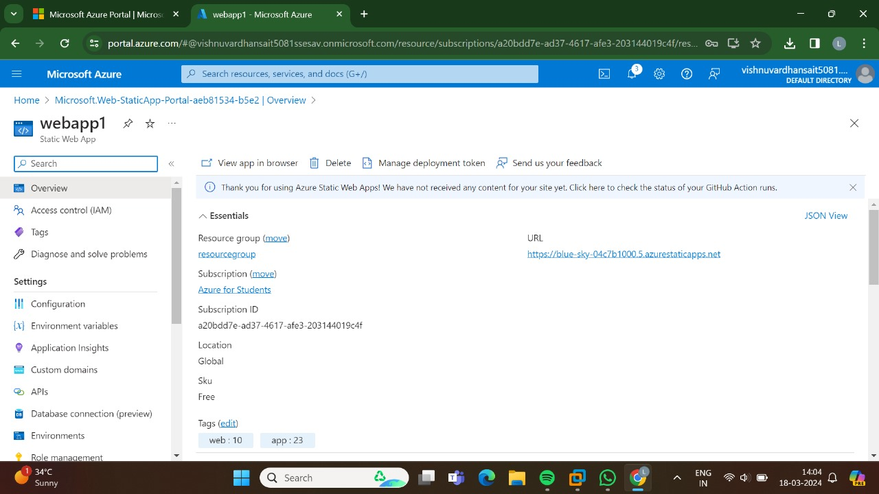

192224191 L.KALYANI

STEP7:

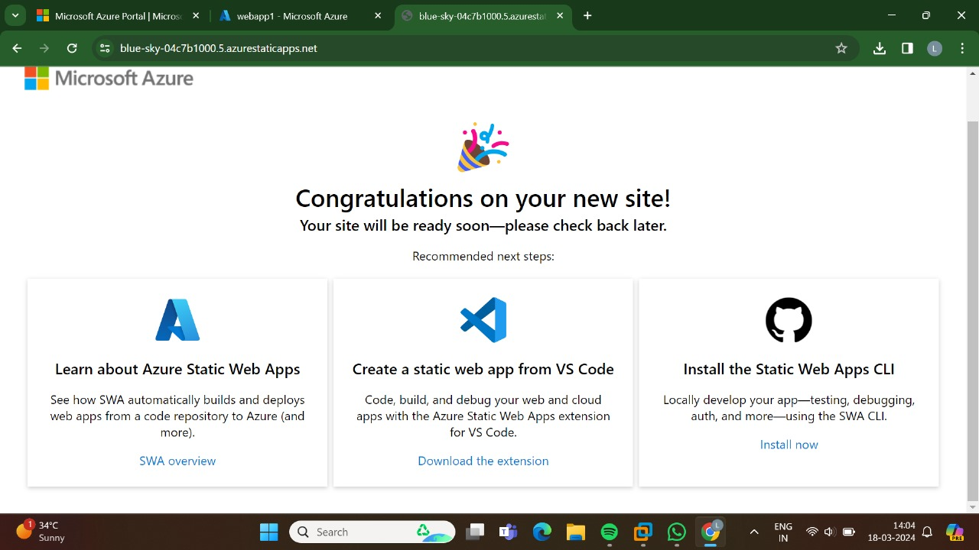

192224191 L.KALYANI