**16.Create a Simple Web Application using Java or Python and host it in any Public Cloud Service Provider (Azure/GCP/AWS) to demonstrate Platform as a Service (PaaS).**

STEP1:

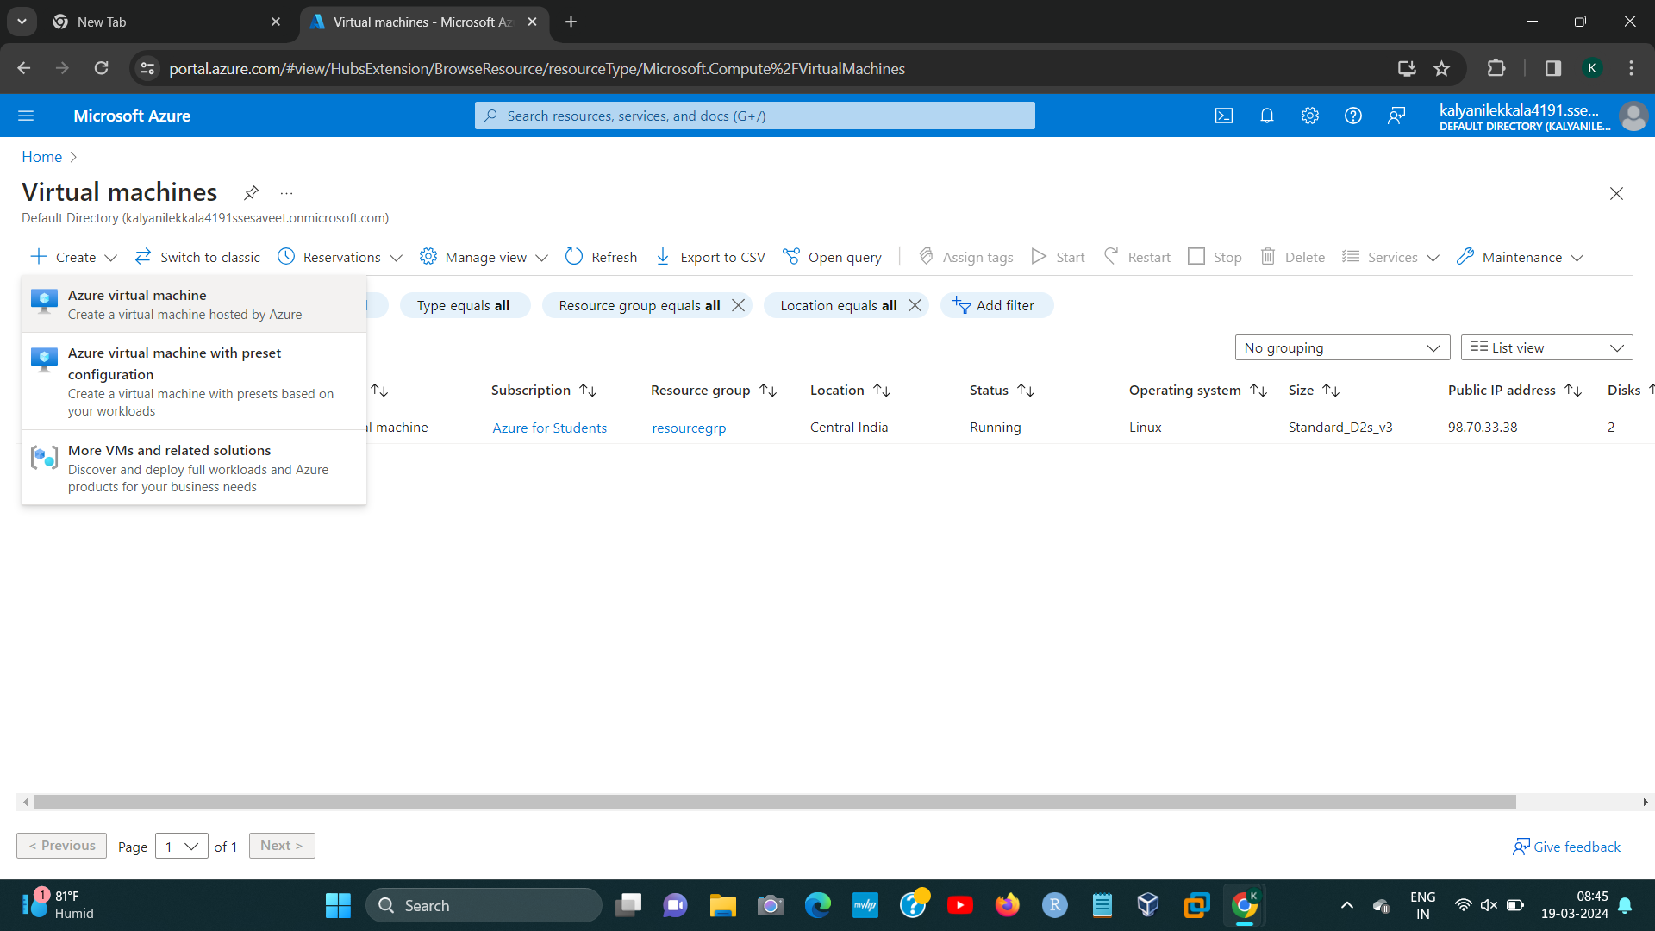

STEP2:

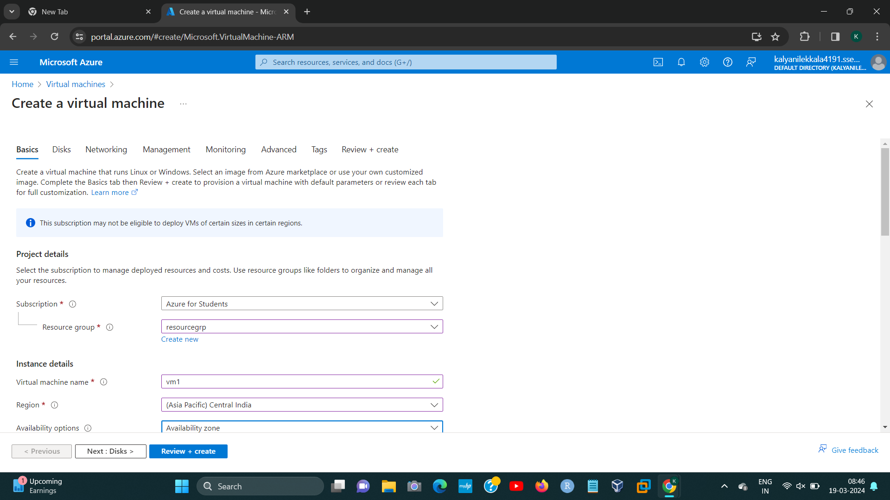[1]

STEP3:

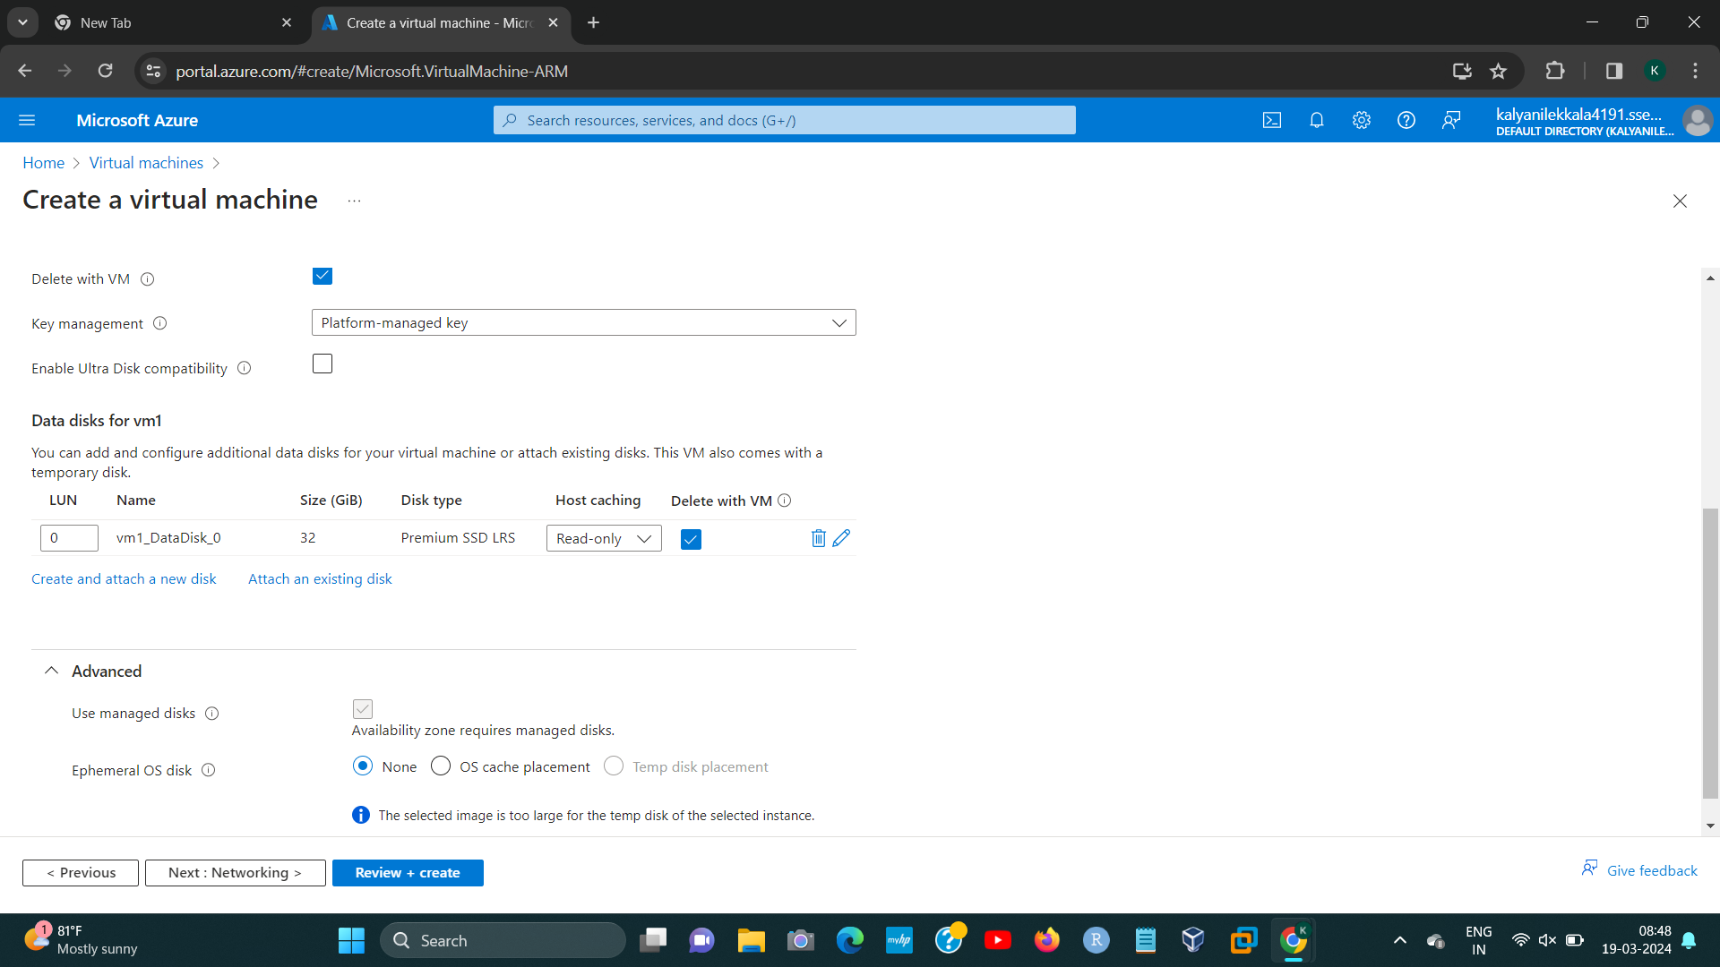

STEP4:

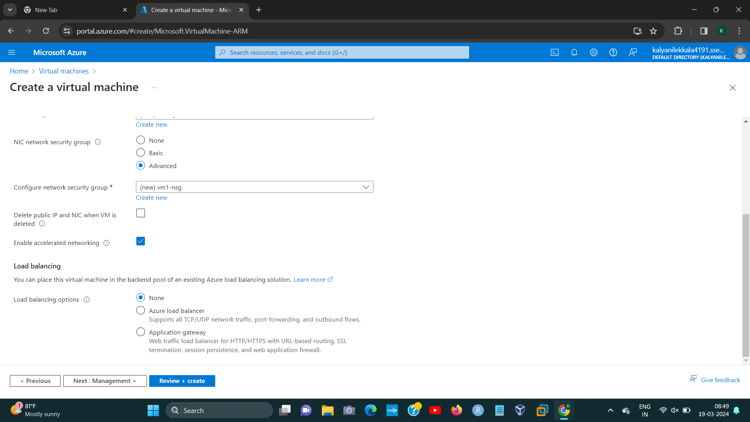[2]

STEP5:

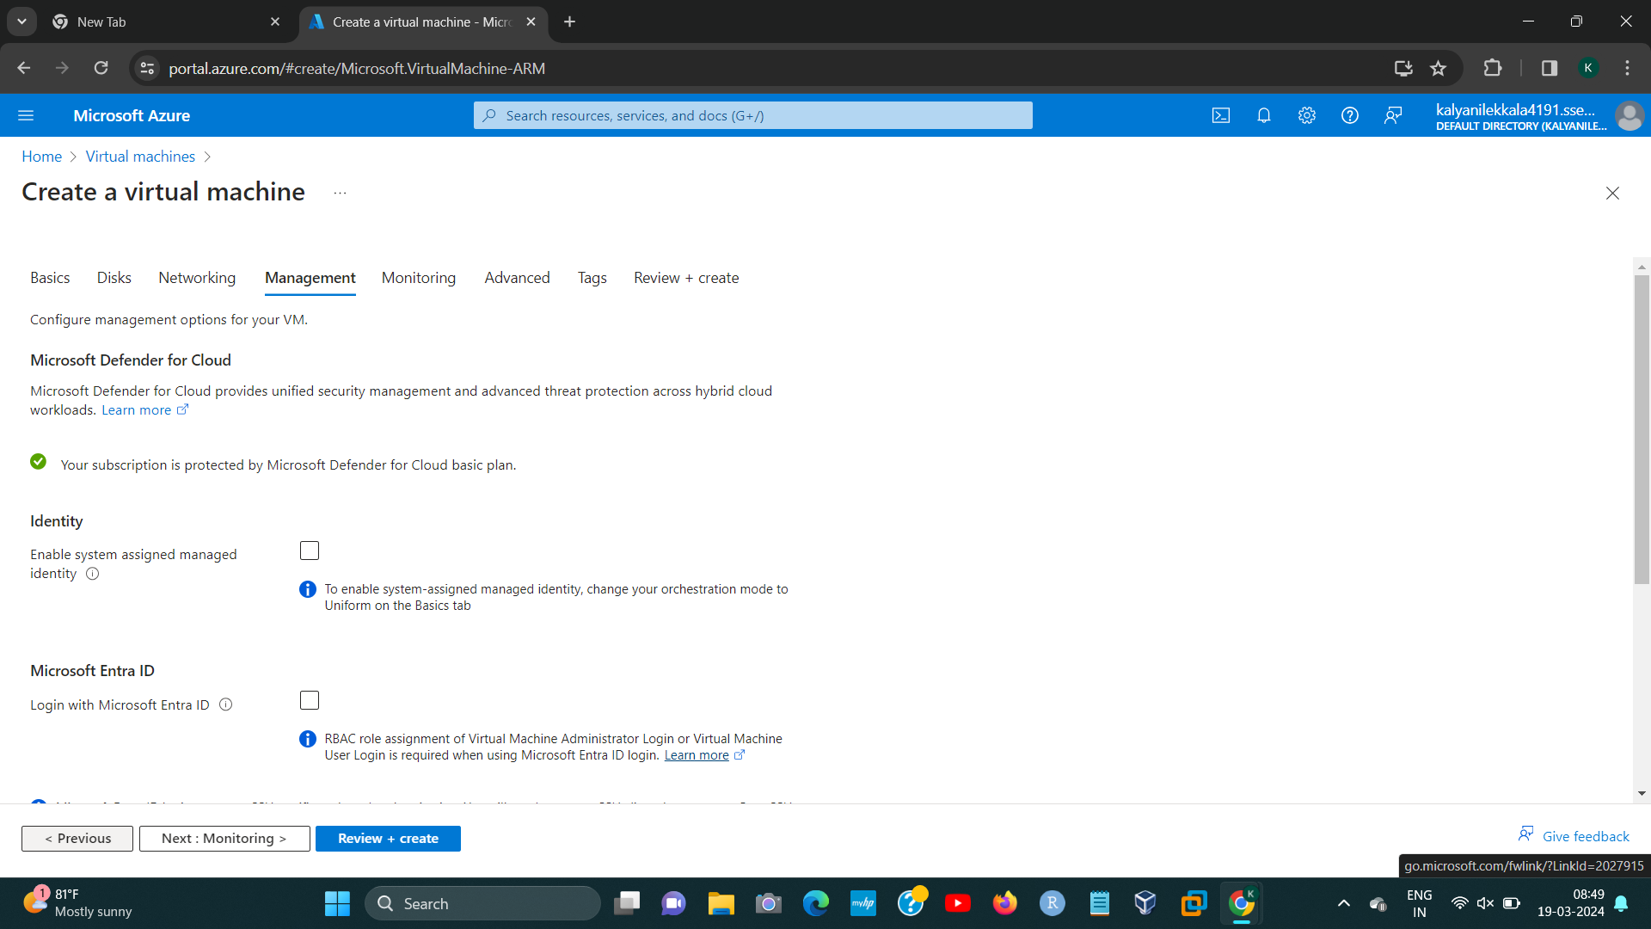

STEP6:

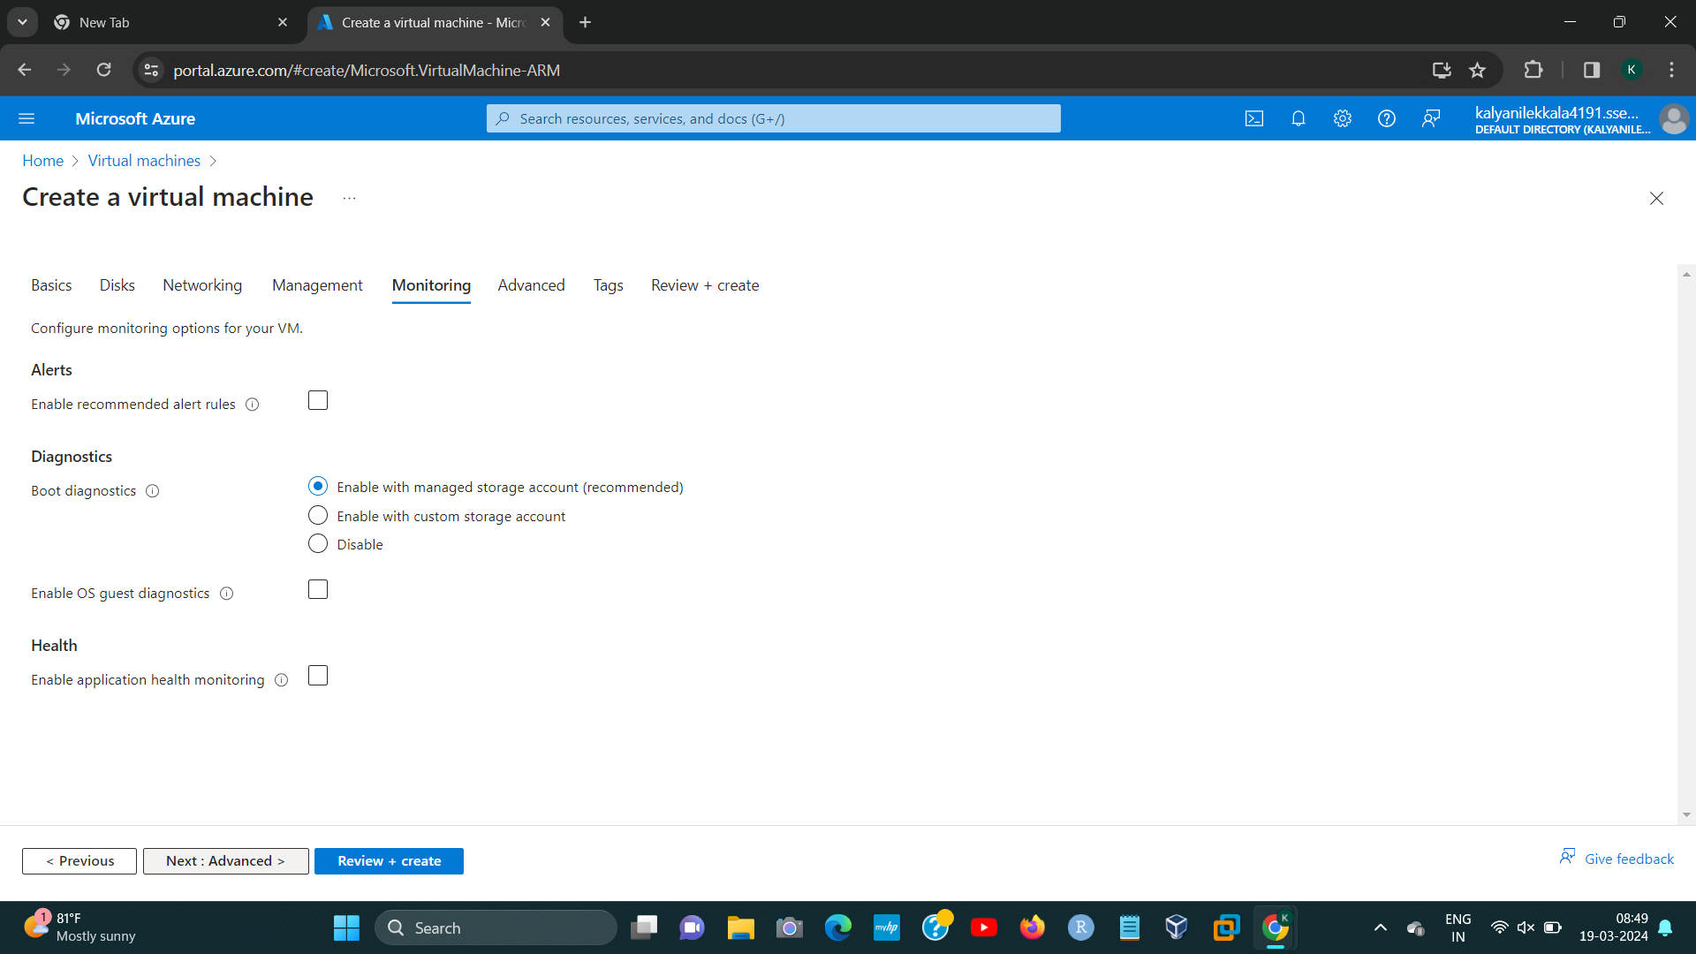

[3]

STEP7:

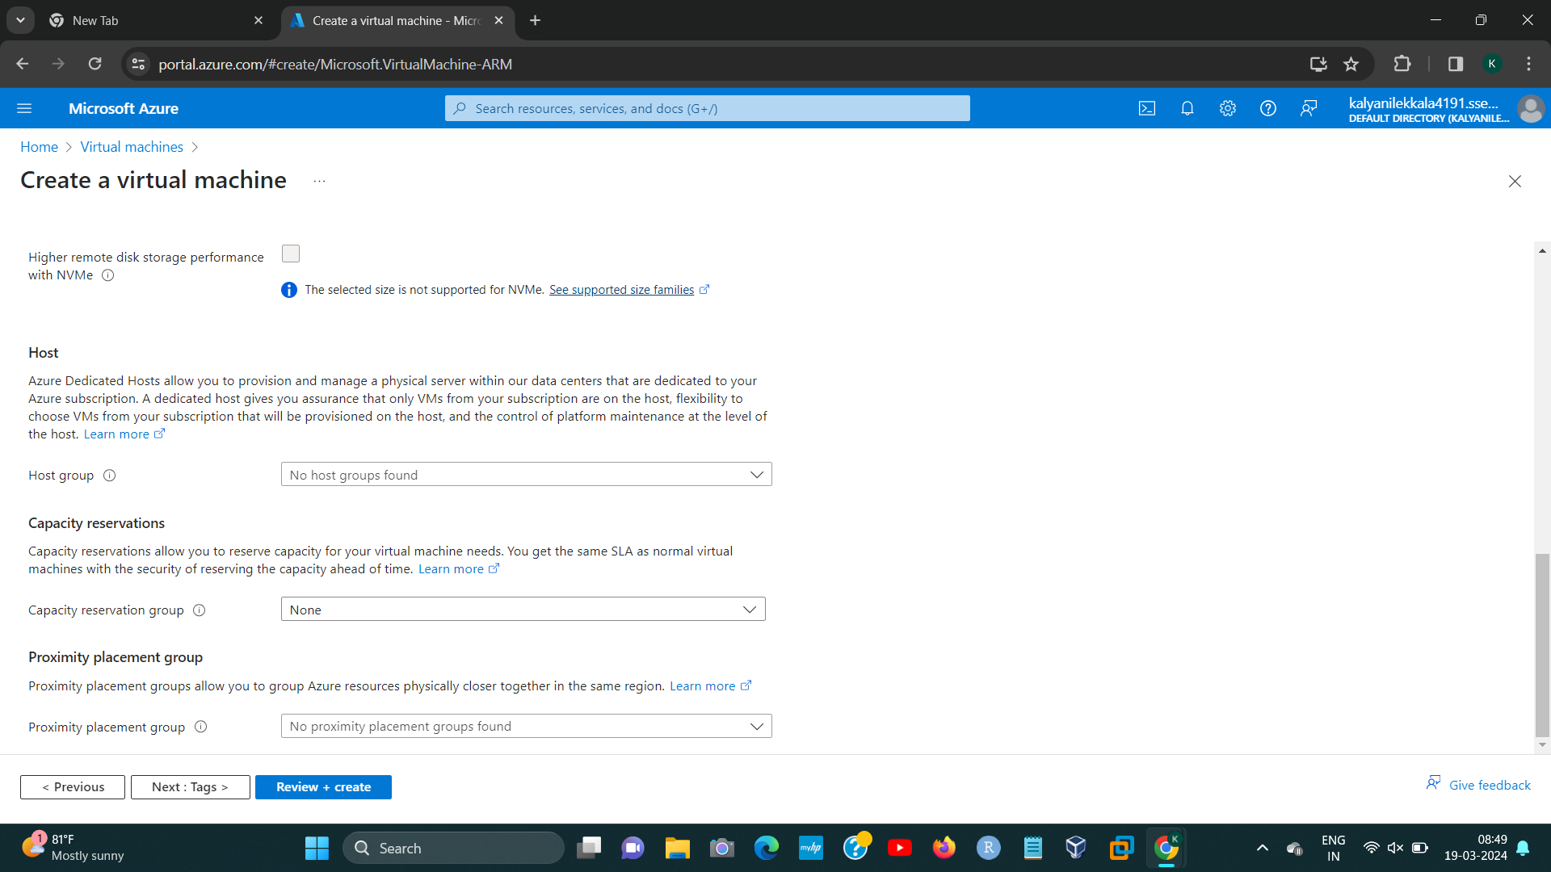

STEP8:

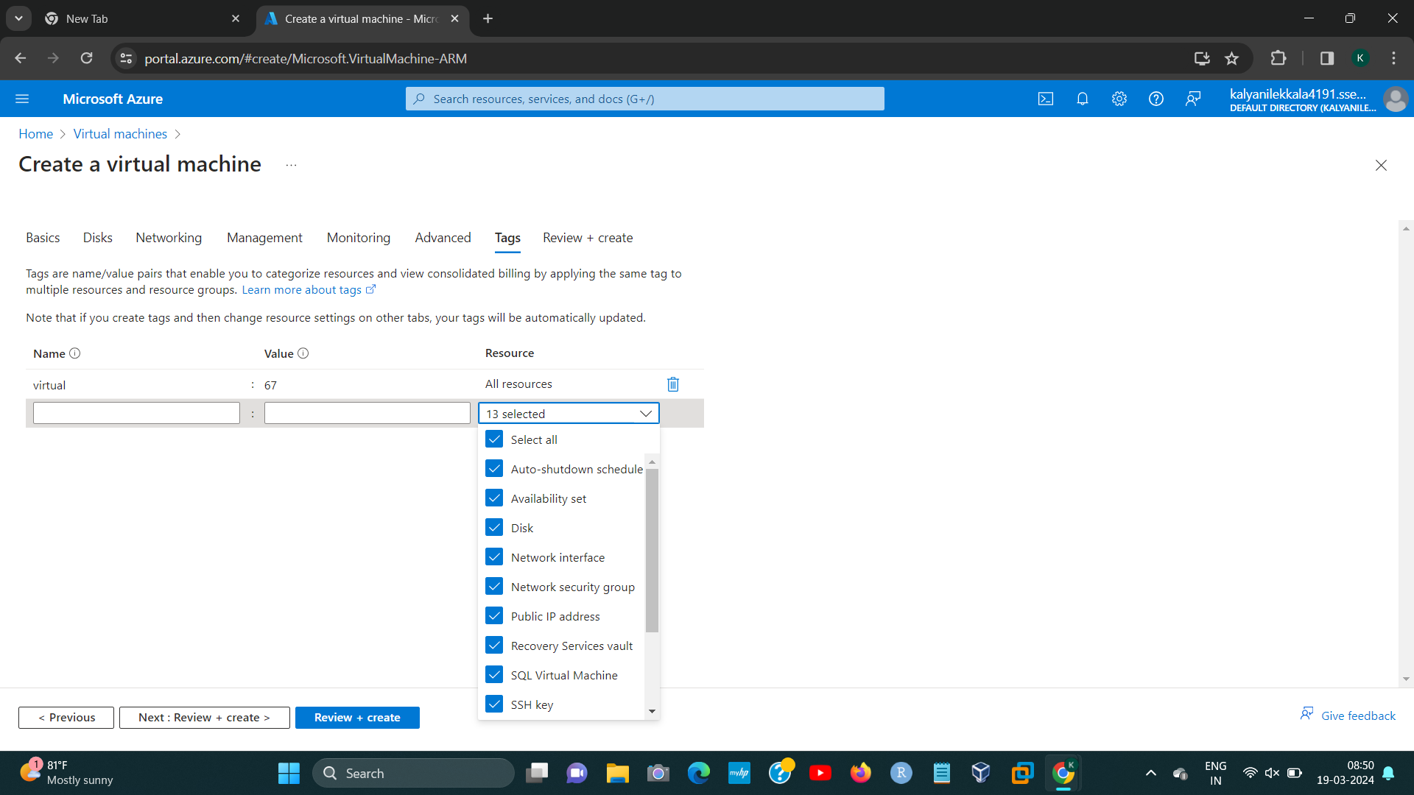[4]

STEP9:

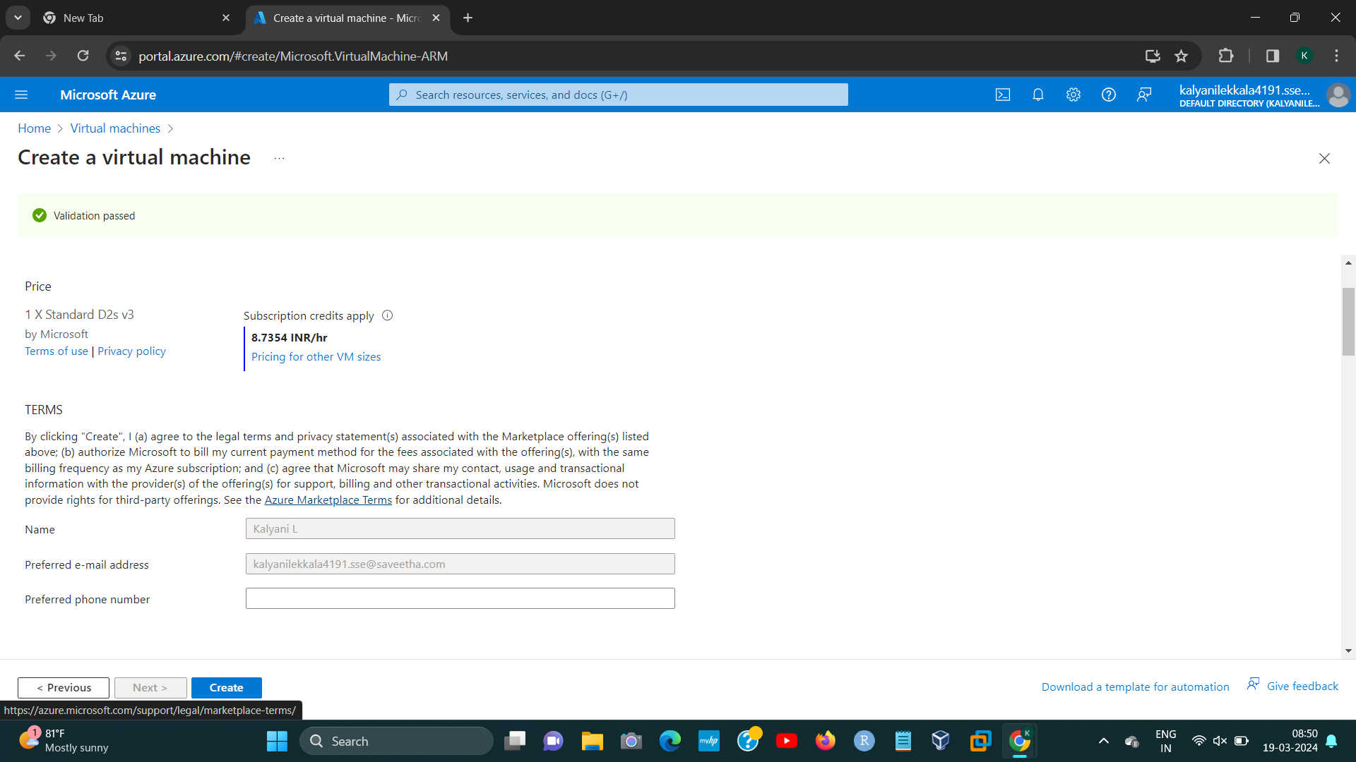[5]

1. 192224191 L.KALYANI
2. 192224191 L.KALYANI
3. 192224191 L.KALYANI
4. 192224191 L.KALYANI
5. 192224191 L.KALYANI