**19. Database as a Service (DaaS) create and configure a new VM Image in any Public Cloud Service Provider.**

STEP1:

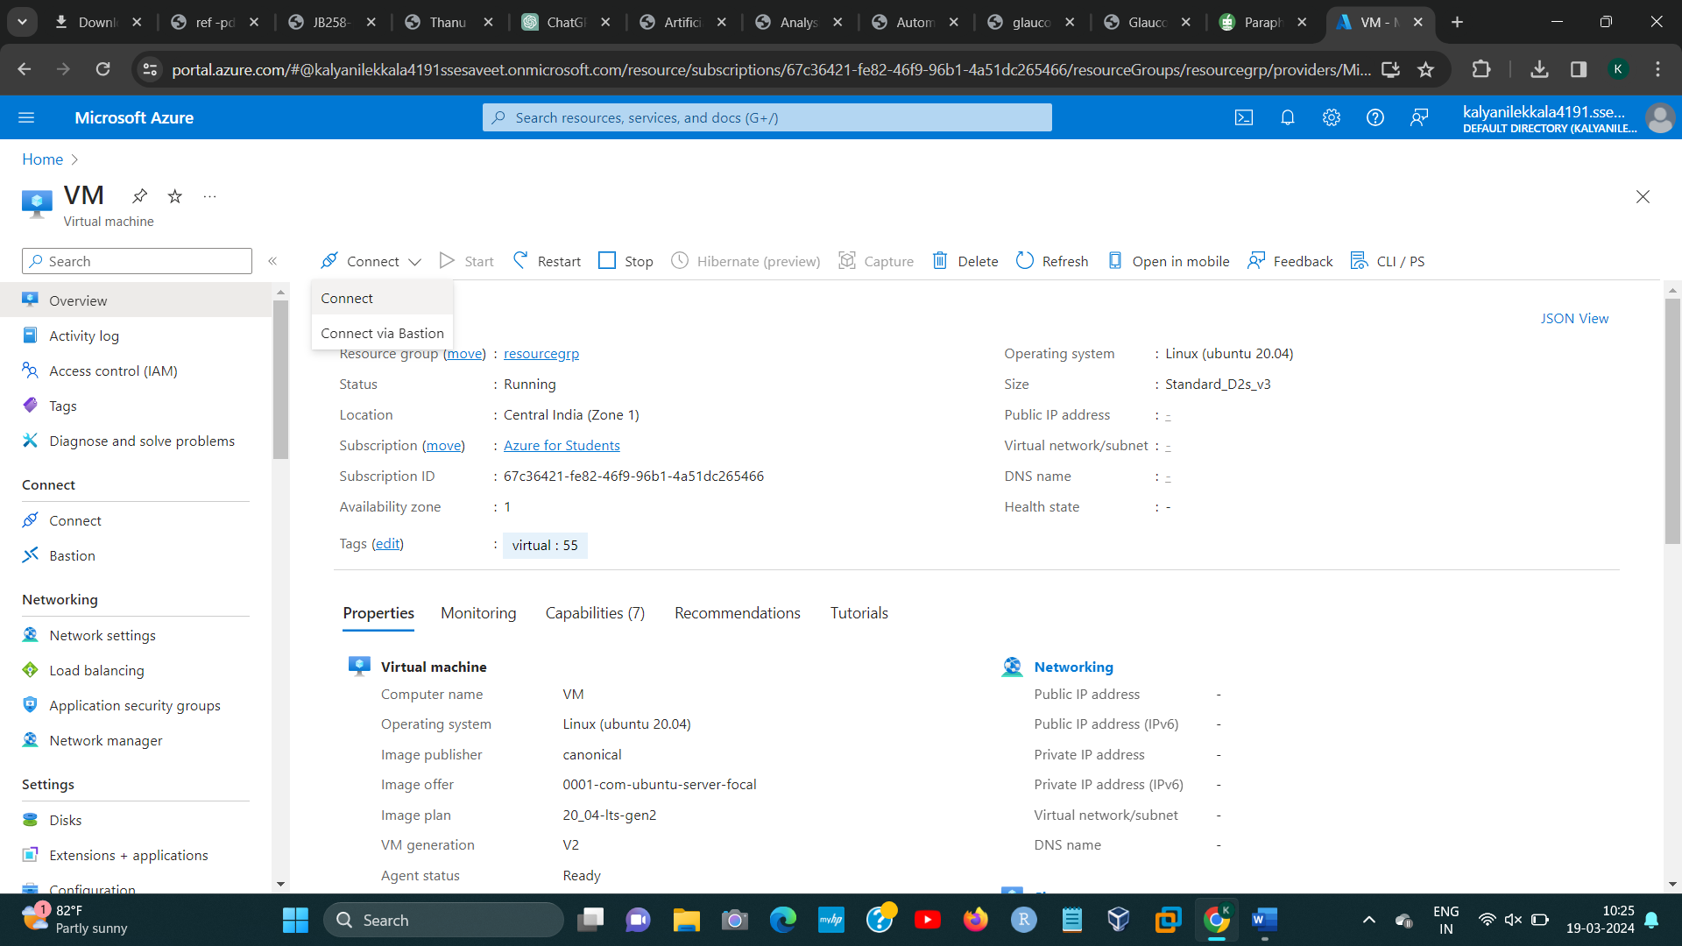

STEP2:

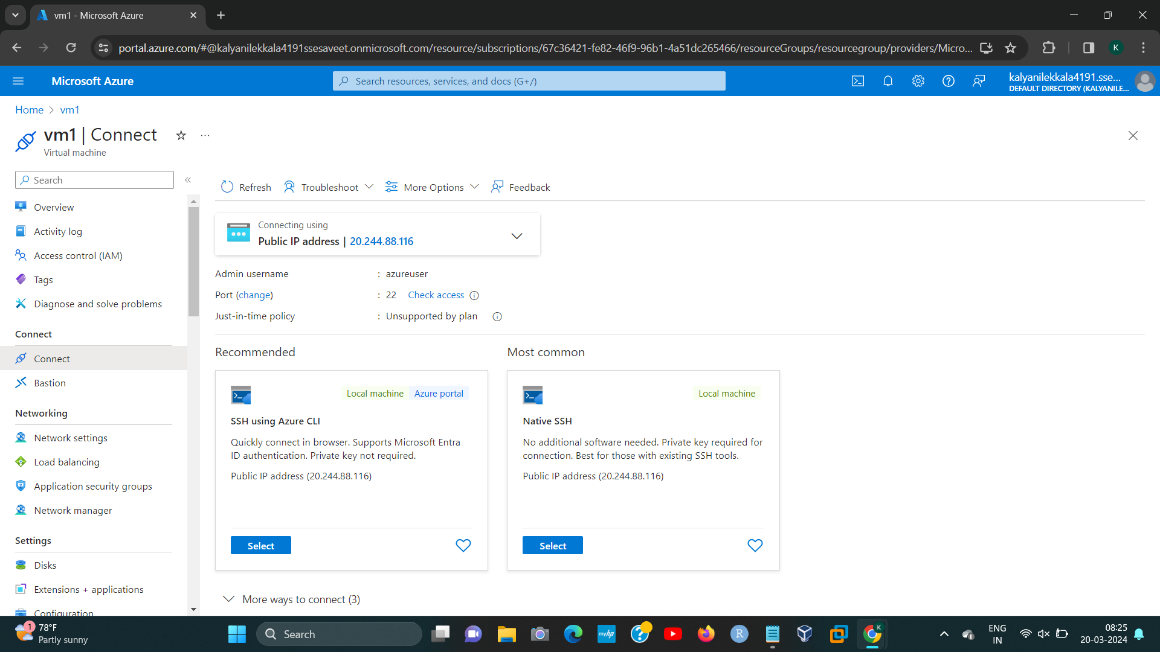[1]

STEP3:

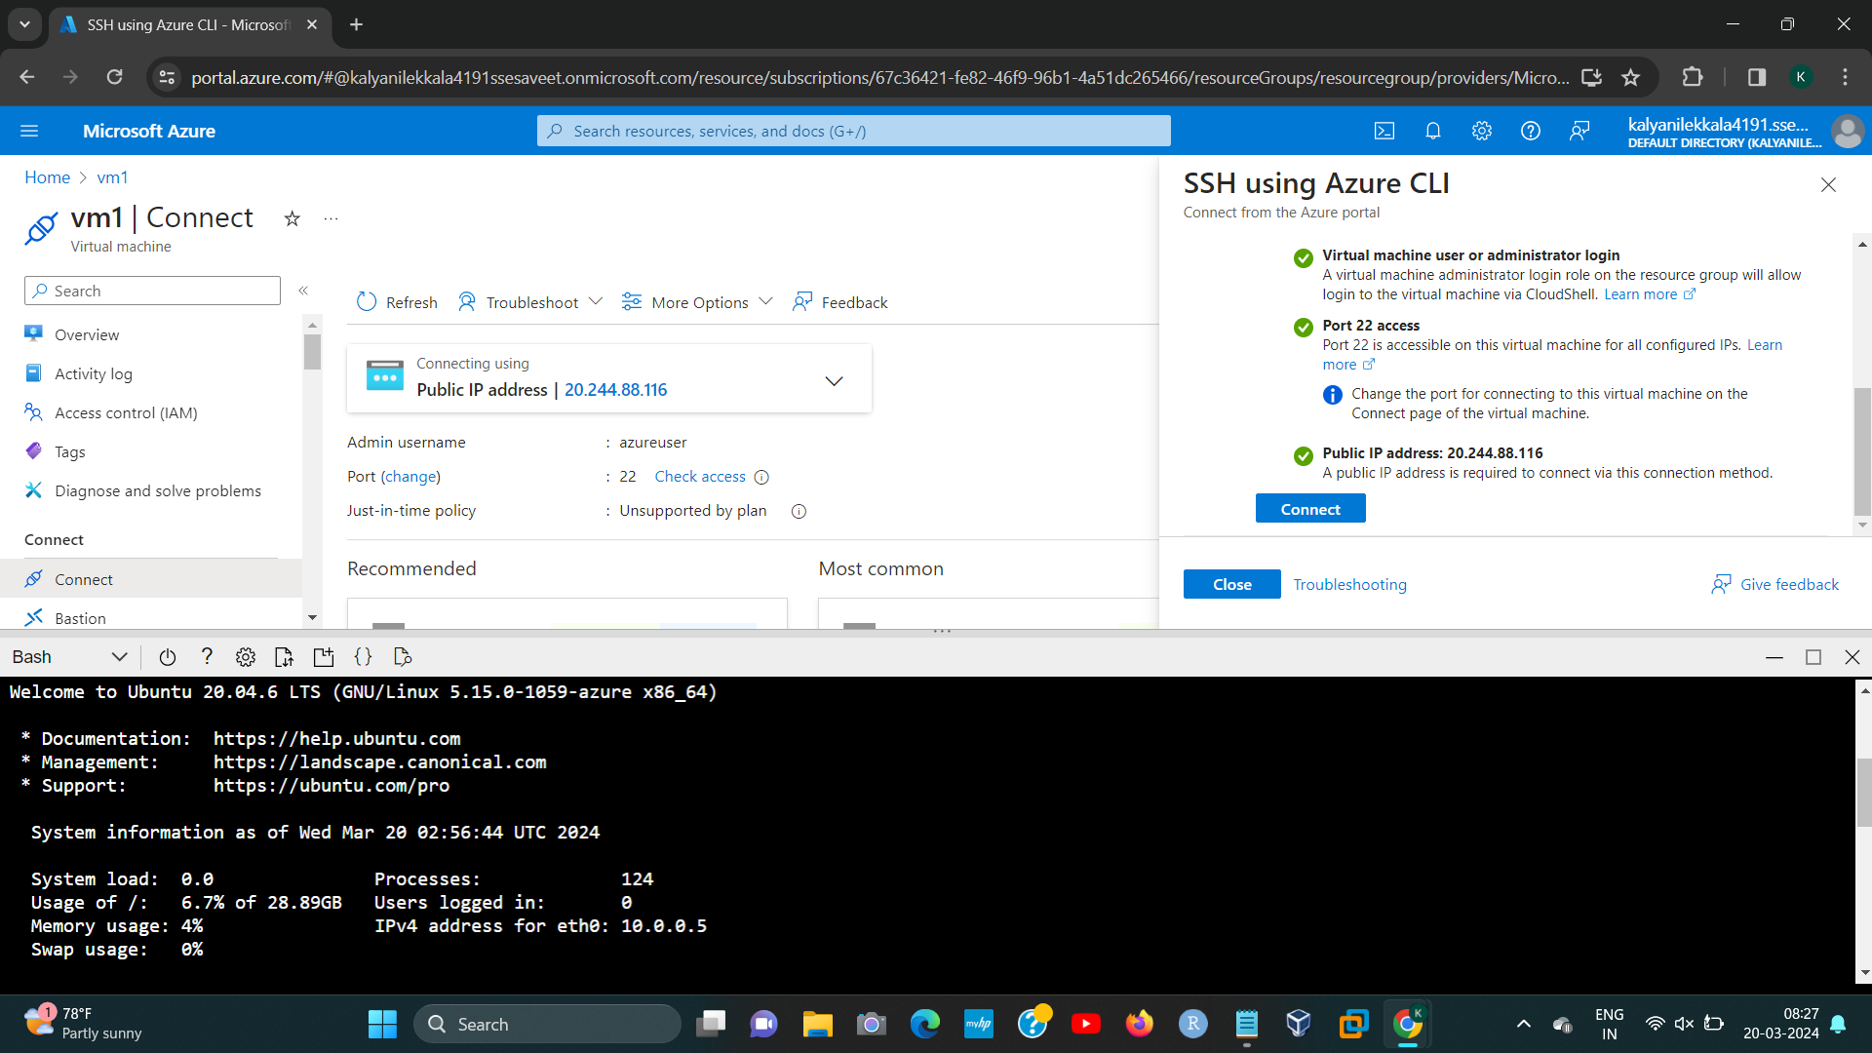[2]

1. 192224191 L.KALYANI
2. 192224191 L.KALYANI