**VV7: Create a Virtual Machine with 1 CPU, 2GB RAM and 15GB storage disk using a Type 2 Virtualization Software**

STEP1:

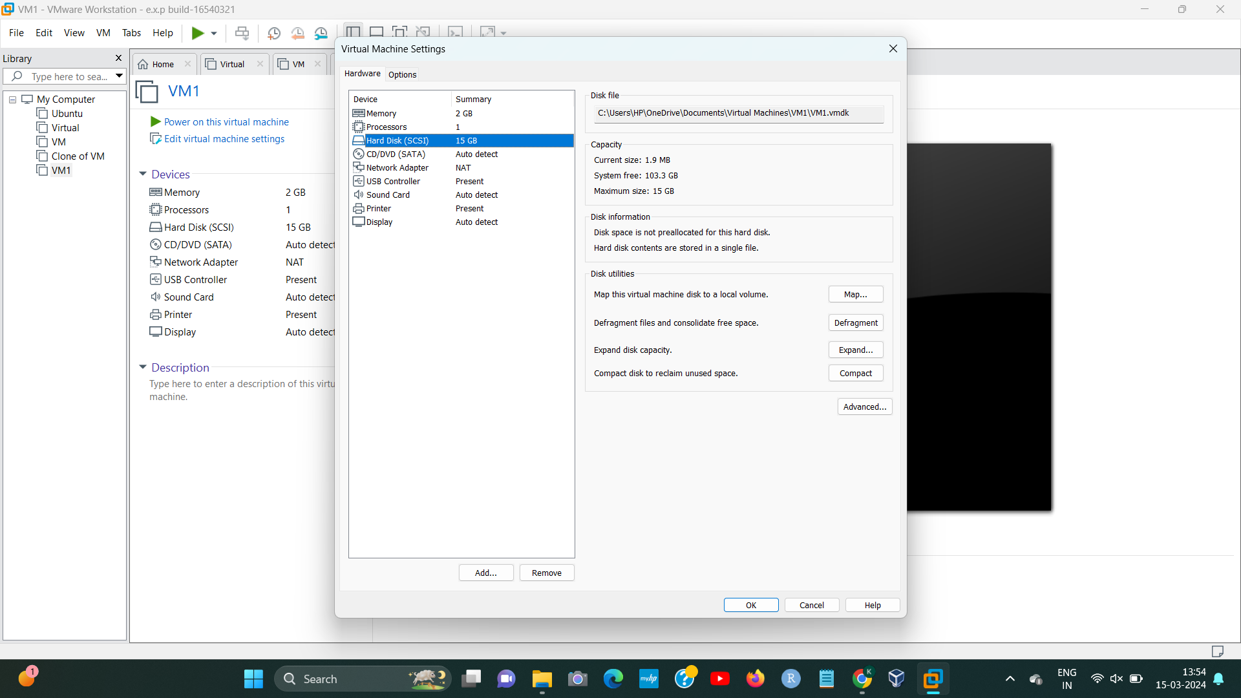

STEP2:

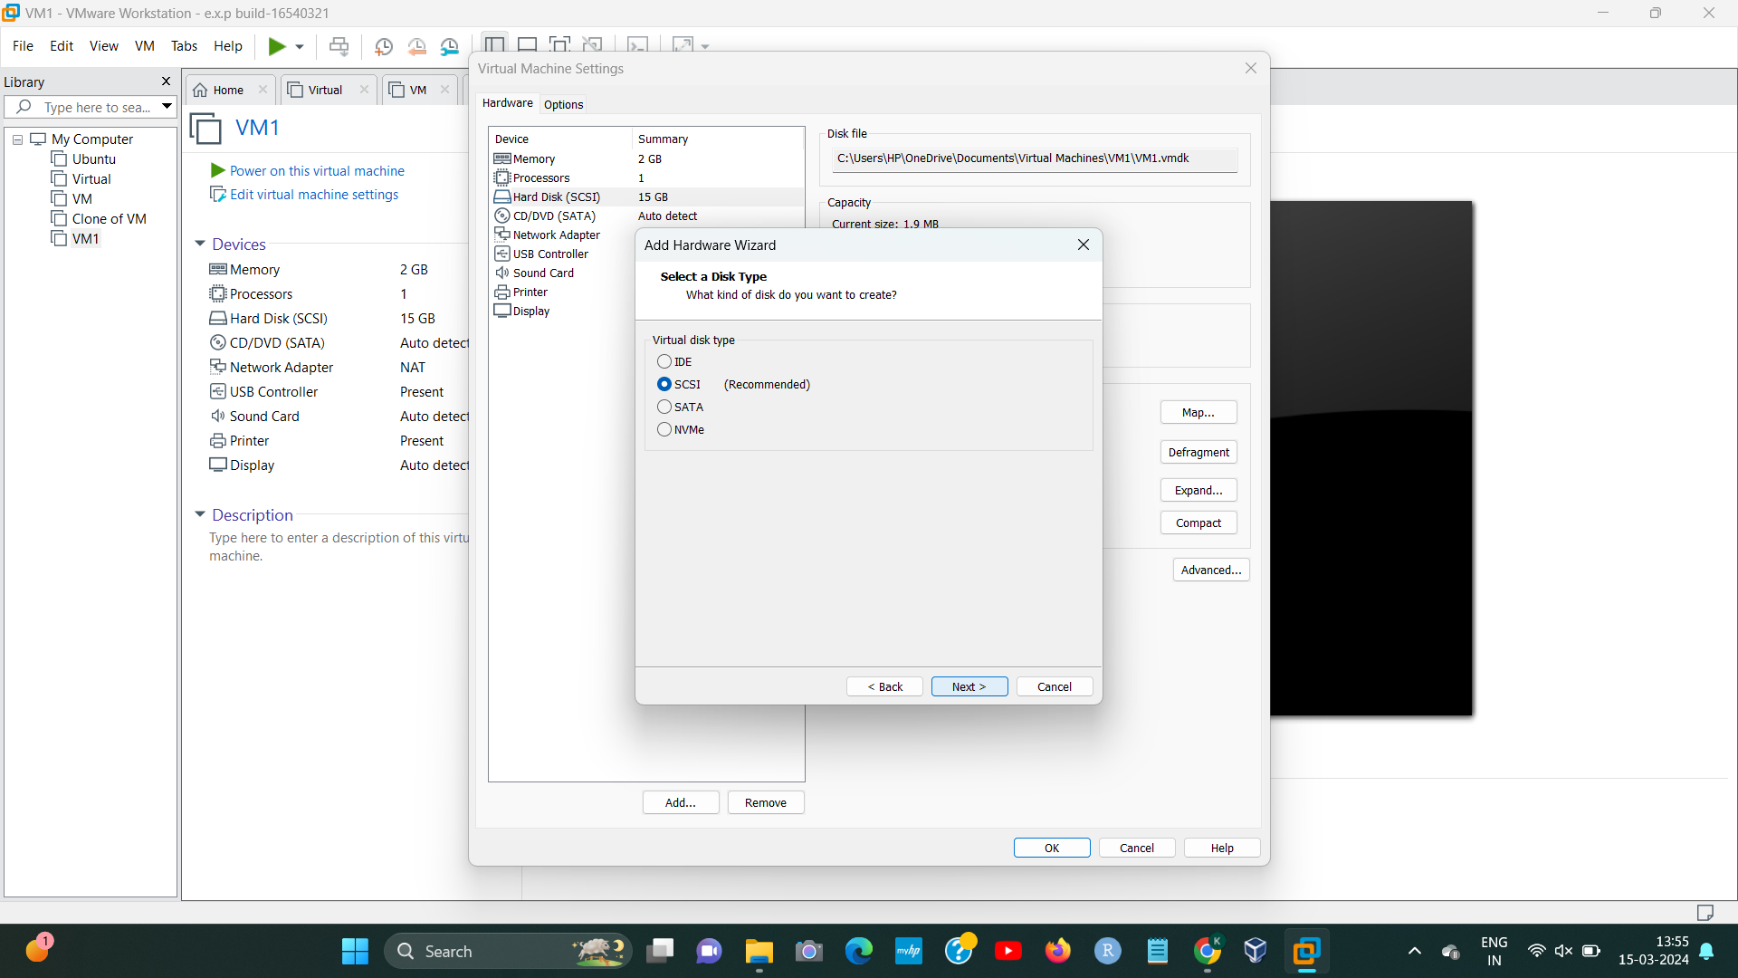

STEP3:

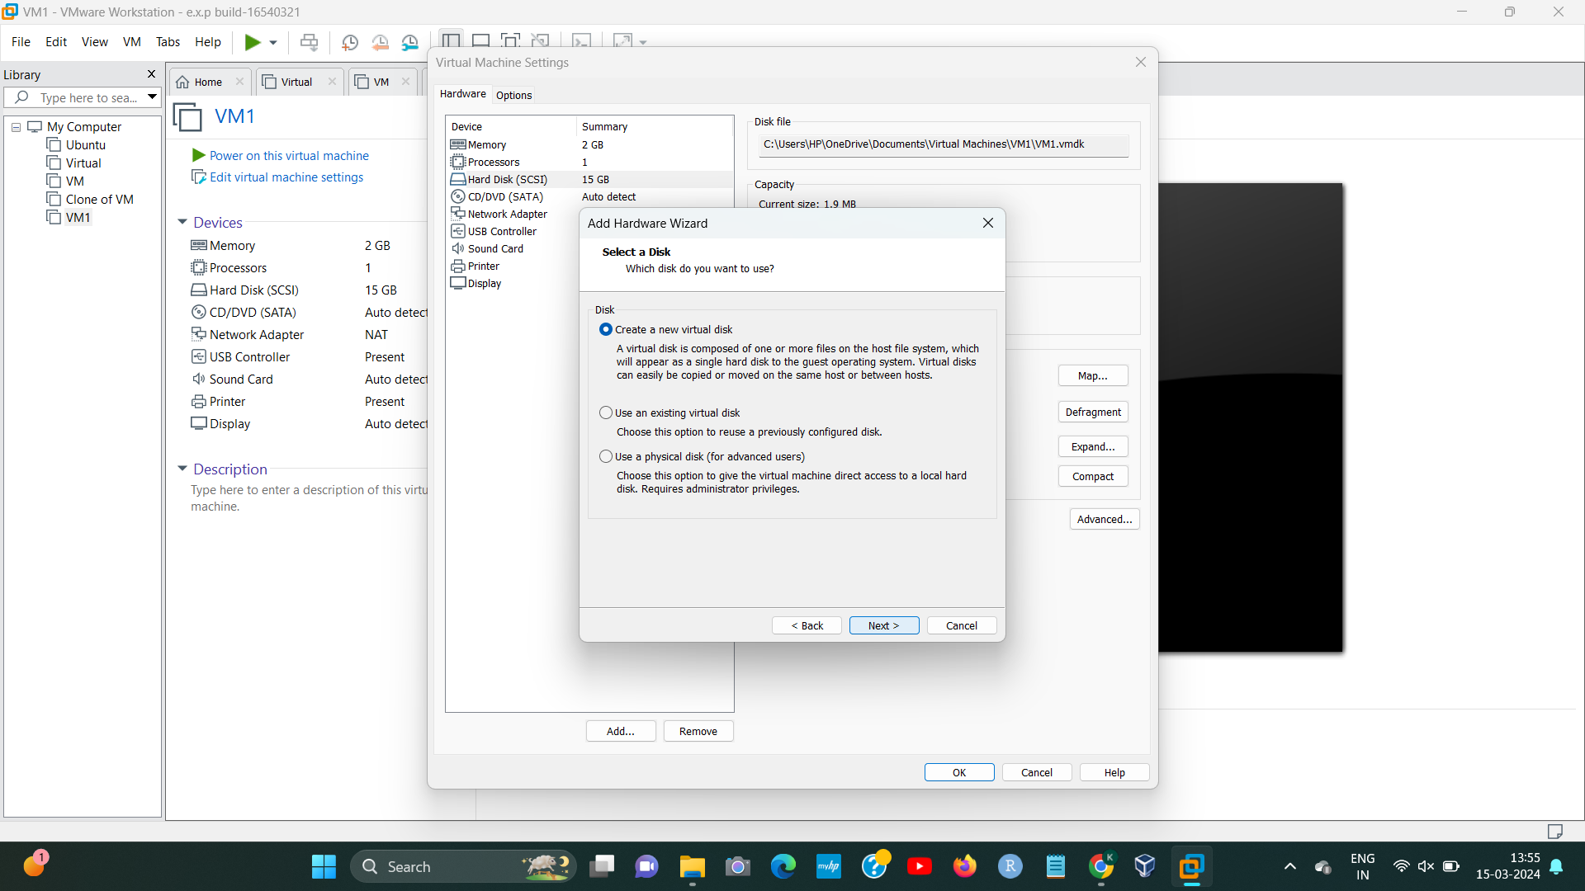

STEP4:

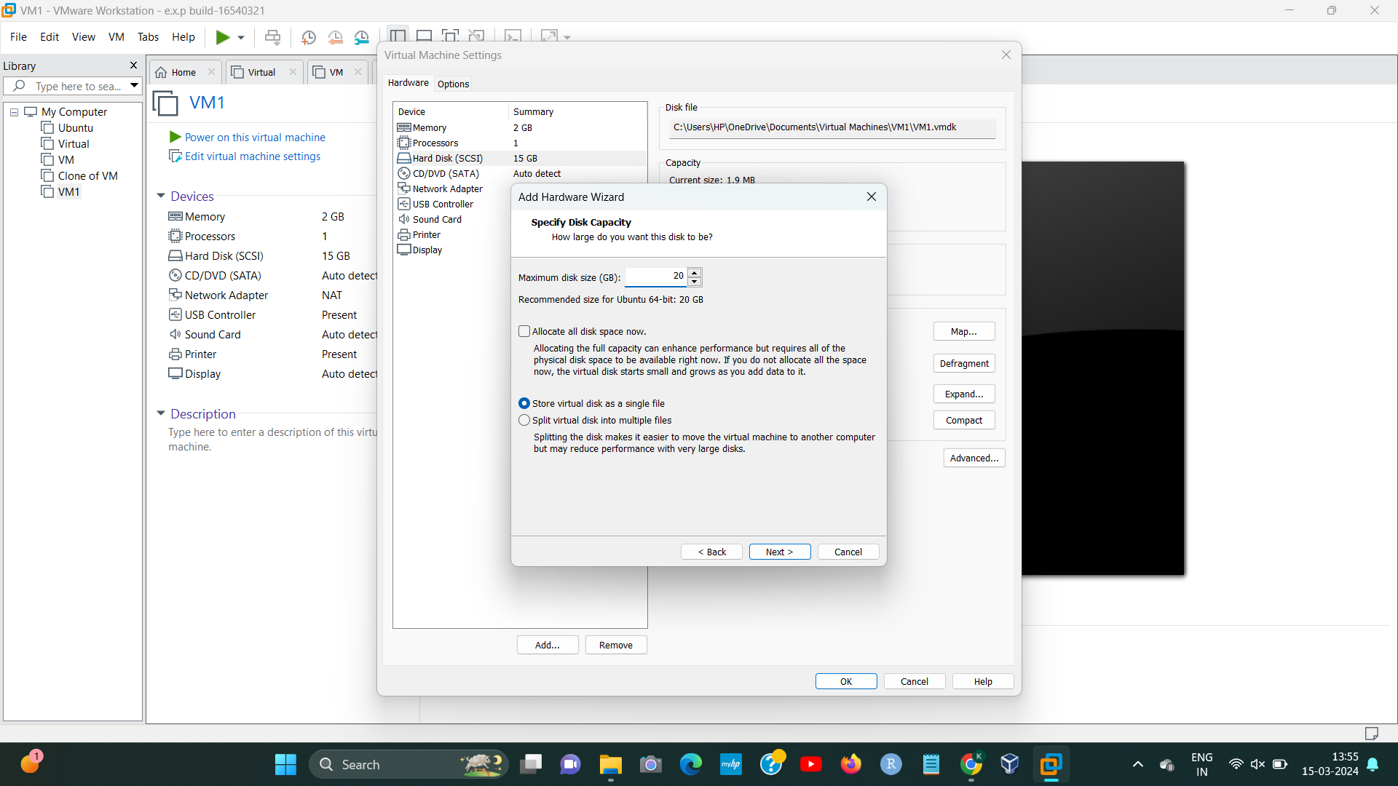

STEP5:

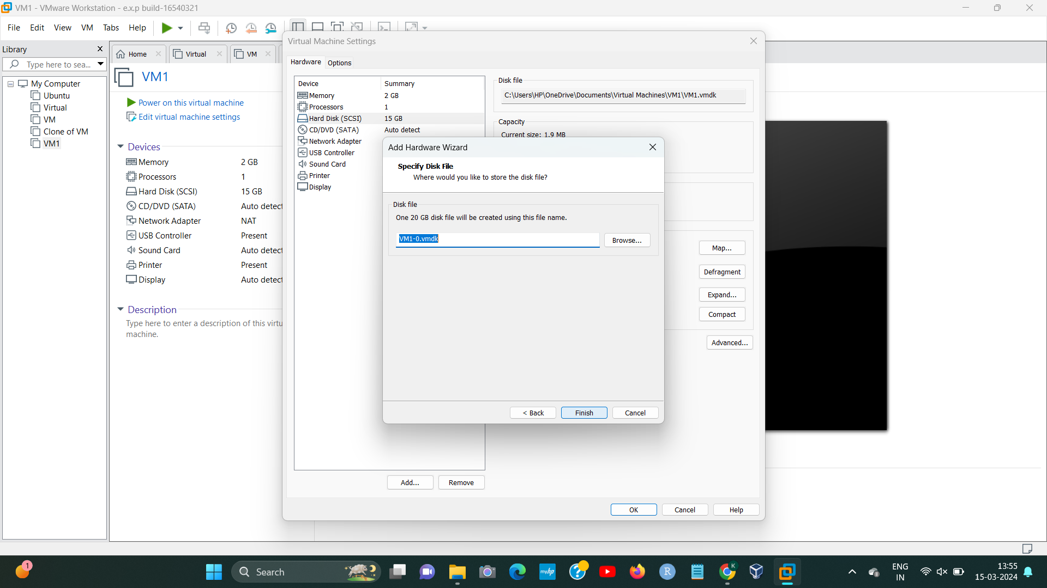

STEP6:

