Cyber Fraud Analytics Dashboard
BharatCares Internship Final Project

Submitted by: Kalyani Sukhdeo Samrit
Course: Bachelor of Computer Applications (BCA)
Project Domain: Data Analytics

Table of Contents
- Abstract
- Introduction
- Problem Statement
- Project Objectives
- Dataset and Data Source
- Tools and Technologies
- Methodology and Project Workflow
- SQL Analysis
- Python Data Analysis
- Data Visualizations
- Power BI Dashboard
- Key Findings and Insights
- Business Recommendations
- Conclusion
- References

Abstract
This project focuses on analyzing cyber fraud data to identify important trends, financial losses, and differences across States/UTs. The analysis uses year-wise digital payment fraud data for 2020-21 to 2024-25 and State/UT-wise cyber fraud data related to the National Cybercrime Reporting Portal (NCRP).
Python, SQL, and Power BI were used for data preparation, analysis, visualization, and dashboard development. The analysis covers fraud cases, amount involved, reported amount, lien amount, refunded amount, and calculated recovery-related percentages.
The findings help identify high-incident regions, areas with higher financial exposure, changes in fraud trends, and differences in financial recovery indicators. An interactive Power BI dashboard was developed to present the major findings in a simple and understandable format.
The project demonstrates how data analytics can convert raw cyber fraud data into meaningful insights that can support better monitoring, fraud prevention, financial recovery, and cyber-awareness activities.

1.Introduction
The rapid growth of digital payments and online financial services has made digital transactions an important part of everyday life. At the same time, the increasing use of digital platforms has also created opportunities for cyber fraud and financial crimes.
Cyber fraud can affect individuals, businesses, and financial institutions and may result in significant financial losses. Therefore, analyzing available cyber fraud data is important for understanding the scale of the problem, identifying trends, and recognizing regions where fraud incidents and financial losses are higher.
This project analyzes cyber fraud data using Python, SQL, and Power BI. The analysis includes year-wise digital payment fraud data from 2020-21 to 2024-25 and State/UT-wise cyber fraud data related to the National Cybercrime Reporting Portal (NCRP).
The project follows a data analytics approach in which raw data is organized, cleaned, analyzed, and converted into meaningful insights. Python is used for data analysis and visualization, SQL is used for querying and analyzing data, and Power BI is used to create an interactive dashboard.
The main purpose of this project is to understand cyber fraud trends, compare incidents and financial amounts across States/UTs, analyze lien and refunded amounts, and present the findings in a simple and useful dashboard. These insights can support better monitoring, fraud prevention, financial recovery, and cyber-awareness activities.

2.Problem Statement
Cyber fraud is increasing with the growing use of digital payment platforms and online services. Large amounts of data are generated through cyber fraud reporting systems, but raw data alone does not provide an easy understanding of fraud patterns and financial impact.
The main problem addressed in this project is to analyze cyber fraud data and identify important patterns related to fraud cases, financial losses, State/UT-wise incidents, reported amounts, lien amounts, and refunded amounts.
The project aims to transform raw cyber fraud data into meaningful information that can help understand major trends, identify regions with higher incident volumes or financial exposure, and support data-driven monitoring and prevention activities.

3.Project Objectives
- To analyze year-wise cyber fraud cases.
- To analyze the amount involved in cyber fraud.
- To compare cyber fraud incidents across States/UTs.
- To analyze reported, lien, and refunded amounts.
- To calculate lien and refunded percentages.
- To identify important trends and high-incident regions.
- To create meaningful visualizations using Python.
- To develop an interactive Power BI dashboard.
- To generate useful insights and business recommendations from the analysis.

4. Dataset and Data Source
This project uses two complementary datasets to analyze cyber fraud trends from both yearly and State/UT perspectives.
4.1 Year-wise Dataset
The year-wise dataset contains digital payment fraud information for the financial years 2020-21 to 2024-25. It includes the number of fraud cases involving amounts of Rs. 1 lakh and above and the total amount involved in Rs. Crore.
4.2 State/UT-wise Dataset
The State/UT-wise dataset contains cyber fraud information related to the National Cybercrime Reporting Portal (NCRP). It includes total incidents, amount reported, lien amount, and refunded amount for States and Union Territories.
Additional percentage measures were calculated during the analysis, including Lien Percentage and Refunded Percentage.
4.3 Data Source
The State/UT-wise data was taken from the Ministry of Home Affairs, Government of India, Rajya Sabha Unstarred Question No. 1517, answered on 12 March 2025.
The relevant Annexure is titled:
"State-wise statistics on NCRP related to cyber fraud cases since inception to 28.02.2025."
The datasets were prepared and organized for analysis using Python and Power BI.

5. Tools and Technologies
The following tools and technologies were used to complete the project:
- Python: Used for data preparation, cleaning, analysis, calculations, and visualization.
- Pandas: Used for creating and manipulating tabular datasets.
- NumPy: Used for numerical operations and calculations.
- Matplotlib: Used to create charts and visualizations in Python.
- SQL / MySQL: Used for querying the year-wise cyber fraud dataset and performing analytical calculations.
- Power BI: Used to create the interactive Cyber Fraud Analytics Dashboard.
- Jupyter Notebook: Used to develop and execute the Python analysis.
- Microsoft Word: Used to prepare the final project report.

6. Methodology and Project Workflow
The project follows a structured data analytics workflow to convert raw cyber fraud data into meaningful insights.
6.1 Data Collection
The required year-wise and State/UT-wise cyber fraud datasets were collected from the available government data sources and prepared for analysis.
6.2 Data Preparation and Cleaning
The datasets were organized into structured tables. Duplicate records were removed and calculated columns were created for Lien Percentage and Refunded Percentage.
6.3 Data Analysis
Python and SQL were used to perform calculations and identify important patterns. The analysis included total fraud cases, financial amounts, yearly changes, State/UT-wise comparisons, and top-performing categories.
6.4 Data Visualization
Matplotlib was used to create visualizations for year-wise trends and State/UT comparisons. These visualizations helped in understanding changes and differences in the data.
6.5 Power BI Dashboard
The analyzed State/UT-wise data was presented through an interactive Power BI dashboard. The dashboard includes KPI cards, State/UT comparisons, percentage-based analysis, and a State/UT filter.
6.6 Insights and Recommendations
The final stage involved identifying important findings from the analysis and preparing recommendations related to fraud monitoring, prevention, financial recovery, and cyber awareness.
Project Workflow
Raw Data → Data Cleaning → Data Analysis → Visualization → Insights → Business Recommendations

7. SQL Analysis
SQL was used to analyze the year-wise cyber fraud dataset and obtain important statistical and comparative insights.
The analysis included:
- Checking the total number of records in the dataset.
- Retrieving year-wise fraud cases and financial amounts.
- Calculating minimum, maximum, total, and average fraud cases.
- Calculating total and average amount involved.
- Identifying the year with the highest and lowest number of fraud cases.
- Identifying the year with the highest financial amount involved.
- Calculating average amount involved per fraud case.
- Calculating year-over-year percentage changes in fraud cases and financial amounts.
- Comparing years based on fraud cases and amount involved.
7.1 Sample SQL Query
The following query was used to retrieve year-wise fraud cases and the amount involved:
SELECT
`Year-wise`,
`Number of Frauds (Amount Involved Rs. 1 Lakh and Above)` AS fraud_cases,
`Total Amount Involved in Rs. Crore` AS amount_crore
FROM digital_payment_fraud
ORDER BY `Year-wise`;
7.2 SQL Analysis Result
The year-wise analysis showed that the highest number of fraud cases and the highest amount involved in the dataset were recorded during 2023-24.
Across the five financial years analyzed, the dataset contains 55,306 fraud cases and a total amount involved of Rs. 2,542 crore.

8. Python Data Analysis
Python was used to clean, analyze, calculate, and visualize the cyber fraud datasets. Pandas was used for data manipulation, NumPy for numerical operations, and Matplotlib for creating visualizations.
8.1 Data Cleaning
The datasets were checked for duplicate records and the required columns were organized for analysis. Calculated columns were created for Lien Percentage and Refunded Percentage.
8.2 Year-wise Analysis
The year-wise dataset was analyzed to identify total fraud cases, total amount involved, average values, highest values, and year-over-year changes.
The analysis showed that:
- Total fraud cases across the five financial years were 55,306.
- Total amount involved was Rs. 2,542 crore.
- The highest number of fraud cases was recorded in 2023-24.
- The highest amount involved was also recorded in 2023-24.
- Fraud cases decreased by 53.98% in 2024-25 compared with 2023-24.
8.3 State/UT-wise Analysis
The State/UT-wise dataset was analyzed to identify regions with higher incident volumes and financial exposure.
The analysis showed that:
- Uttar Pradesh recorded the highest number of incidents.
- Maharashtra recorded the highest amount reported.
- Maharashtra recorded the highest lien amount.
- Gujarat recorded the highest refunded amount.
- Puducherry recorded the highest calculated refunded percentage among the listed States/UTs.

9. Data Visualizations
Visualizations were created using Matplotlib to understand year-wise trends and State/UT-wise differences in cyber fraud data.
The following visualizations were prepared as part of the analysis:
- Year-wise Cyber Fraud Cases
- Year-wise Amount Involved in Cyber Fraud
- Top 5 States/UTs by Cyber Fraud Incidents
- Top 5 States/UTs by Amount Reported

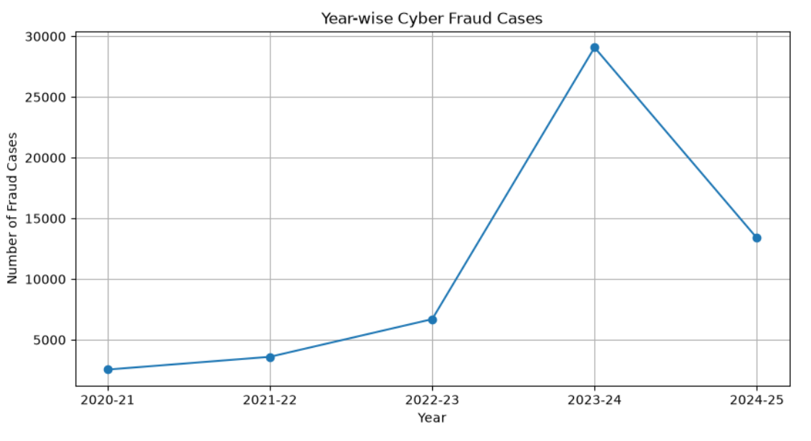

Figure 1: Year-wise Cyber Fraud Cases

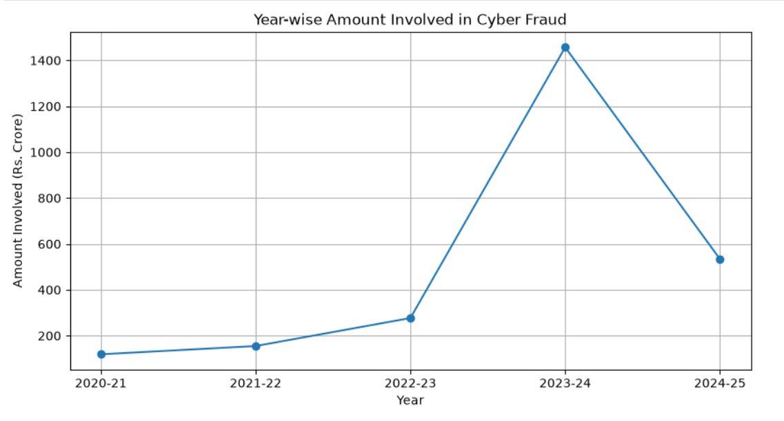
Figure 2: Year-wise Amount Involved in Cyber Fraud

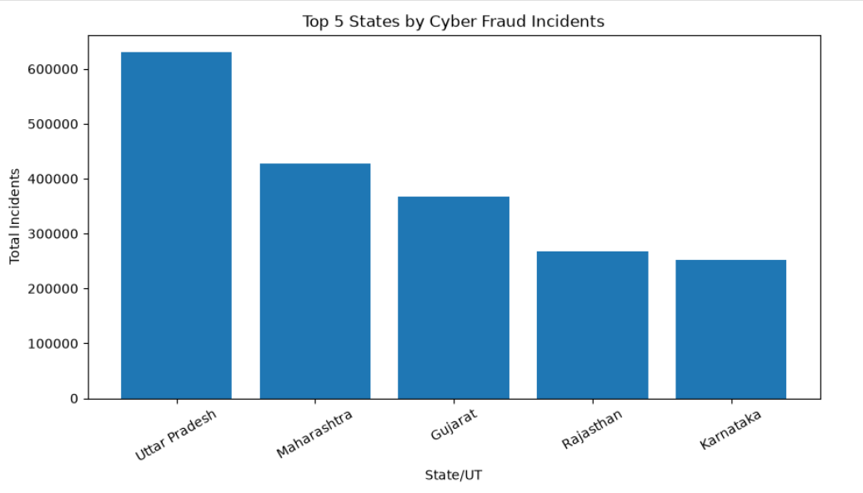
Figure 3: Top 5 States/UTs by Cyber Fraud Incidents

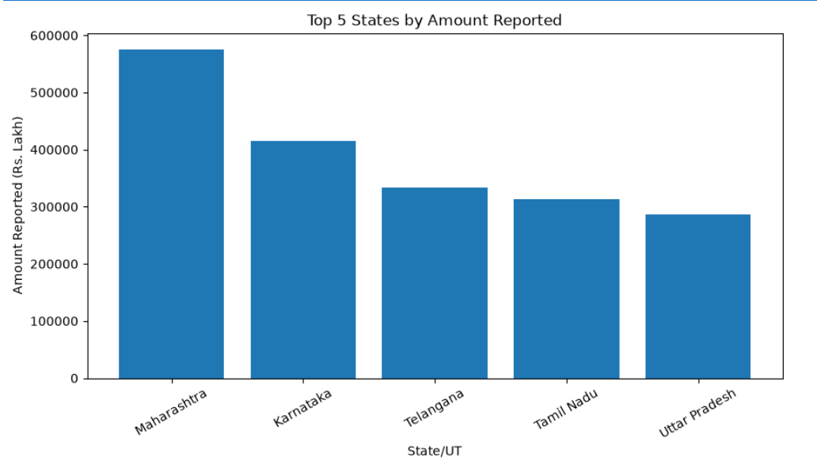
Figure 4: Top 5 States/UTs by Amount Reported

10. Power BI Dashboard
An interactive Power BI dashboard was developed to present the major findings of the cyber fraud analysis in a simple and user-friendly format.
The dashboard provides key performance indicators and State/UT-wise visualizations. It allows users to compare the number of incidents, financial amounts, lien amounts, and refunded amounts.
Dashboard Components
- Total Incidents
- Amount Reported
- Lien Amount
- Refunded Amount
- Total Incidents by State/UT
- Amount Reported by State/UT
- Lien Percentage by State/UT
- Refunded Percentage by State/UT
- State/UT selection filter
The dashboard helps users quickly identify regions with higher incident volumes and financial exposure and compare financial recovery-related indicators across States/UTs.
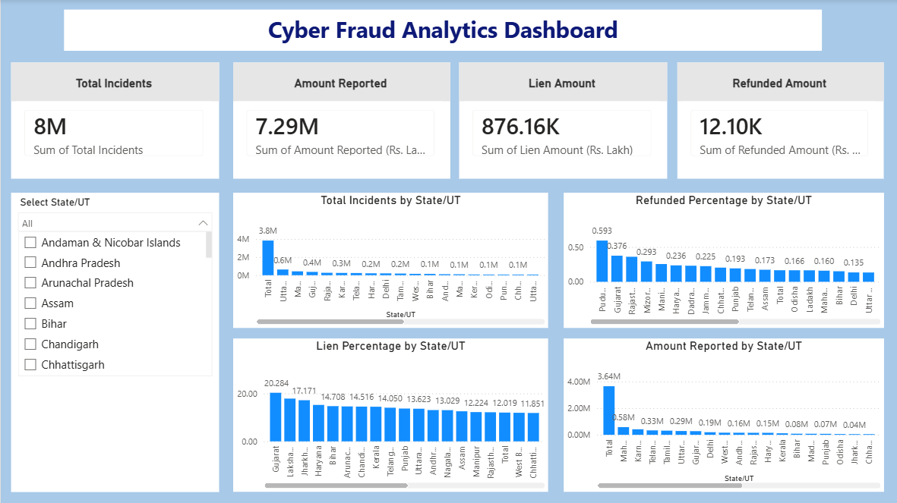
Figure 5: Cyber Fraud Analytics Power BI Dashboard

11. Key Findings and Insights
The analysis of year-wise and State/UT-wise cyber fraud data produced the following important findings:
- The year-wise dataset contains 55,306 fraud cases across the five financial years analyzed.
- The total amount involved in the year-wise dataset was Rs. 2,542 crore.
- 2023-24 recorded the highest number of fraud cases as well as the highest amount involved among the five financial years.
- Fraud cases decreased by 53.98% in 2024-25 compared with 2023-24.
- Uttar Pradesh recorded the highest number of cyber fraud incidents among the analyzed States/UTs.
- Maharashtra recorded the highest amount reported and the highest lien amount among the analyzed States/UTs.
- Gujarat recorded the highest refunded amount among the analyzed States/UTs.
- Puducherry recorded the highest calculated refunded percentage among the listed States/UTs.
- The State/UT analysis shows substantial variation in incident volumes, reported financial amounts, lien amounts, and refunded amounts.
- The results indicate the importance of data-driven monitoring, timely intervention, financial recovery mechanisms, and public awareness for addressing cyber fraud.

12. Business Recommendations
Based on the analysis, the following recommendations can be considered for better cyber fraud monitoring and prevention:
- Focus on high-incident regions: Regions with higher numbers of cyber fraud incidents should receive focused monitoring and awareness activities.
- Prioritize financial-risk areas: States/UTs reporting higher financial amounts can be given greater attention for fraud detection and response.
- Strengthen early intervention: Faster identification and reporting of suspicious transactions can help reduce potential financial losses.
- Improve lien mechanisms: Effective coordination between banks, financial institutions, and law-enforcement agencies can support timely action on suspected fraudulent funds.
- Improve financial recovery: Continuous monitoring of reported, lien, and refunded amounts can help identify opportunities to improve recovery processes.
- Increase public awareness: Regular awareness programs can educate citizens about safe digital payment practices, suspicious links, fraudulent calls, and online scams.
- Use data-driven monitoring: Regular analysis of fraud trends can help identify changing patterns and emerging risk areas.
- Strengthen collaboration: Better coordination among cybercrime reporting systems, banks, law-enforcement agencies, and other stakeholders can support faster response to cyber fraud.

13. Conclusion
This project presented a data-driven analysis of cyber fraud using year-wise and State/UT-wise datasets. Python, SQL, and Power BI were used together to perform data preparation, analysis, visualization, and dashboard development.
The analysis identified important trends in fraud cases and financial amounts across the five financial years. It also highlighted differences between States/UTs in terms of incident volumes, reported amounts, lien amounts, and refunded amounts.
The Power BI dashboard provides an interactive and simple way to explore the State/UT-wise results. The analysis demonstrates how data analytics can transform raw cyber fraud information into meaningful insights.
Overall, the project shows that data-driven analysis can support better understanding of cyber fraud patterns and can assist in monitoring, prevention, financial recovery, and awareness activities.

14. References
- Ministry of Home Affairs, Government of India, Rajya Sabha Unstarred Question No. 1517, "Cyber Fraud and Awareness", answered on 12 March 2025.
- Ministry of Home Affairs, Government of India, Annexure: "State-wise statistics on NCRP related to cyber fraud cases since inception to 28.02.2025."
- National Cybercrime Reporting Portal (NCRP), Government of India.
- Python Documentation — Python programming language and libraries used for data analysis.
- Pandas Documentation — Data manipulation and analysis.
- Matplotlib Documentation — Data visualization and plotting.
- Microsoft Power BI Documentation — Dashboard development and data visualization.
- MySQL Documentation — SQL queries and database analysis.

