EFS(elastic file system)

1. Create 3 intance

Server 1,2,3

Connect all those instance

1. Create efs (costomize)
2. Name->standard ->enhanced->elastic-next

Select subnet in wich instance are created->security group with ports ssh,http,https,nfs(22,80,443,2049)->next->create

1. Go to attach

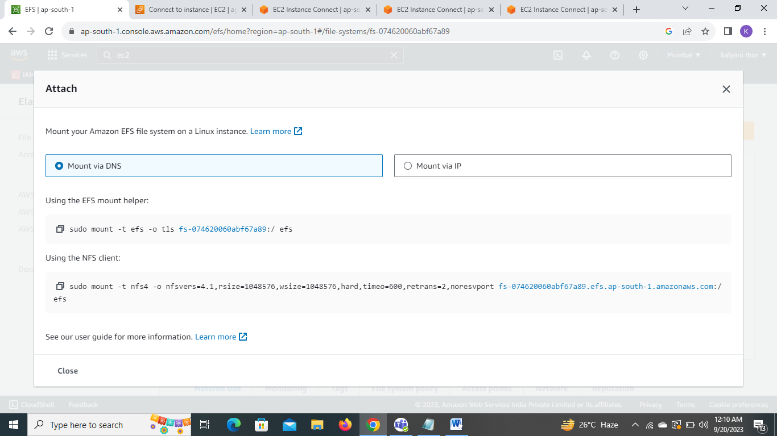

1. Go to server1 copy nfs clientlink an paste In the instance last edit /mnt instead of /efs

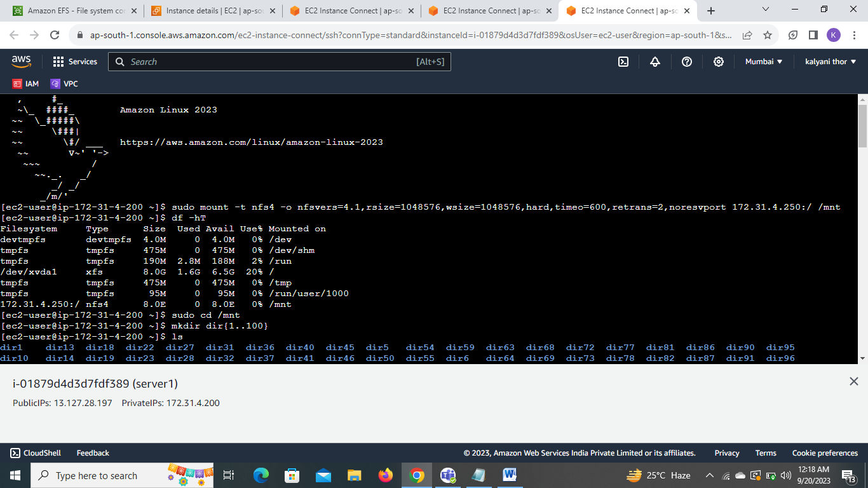

Now go to server2

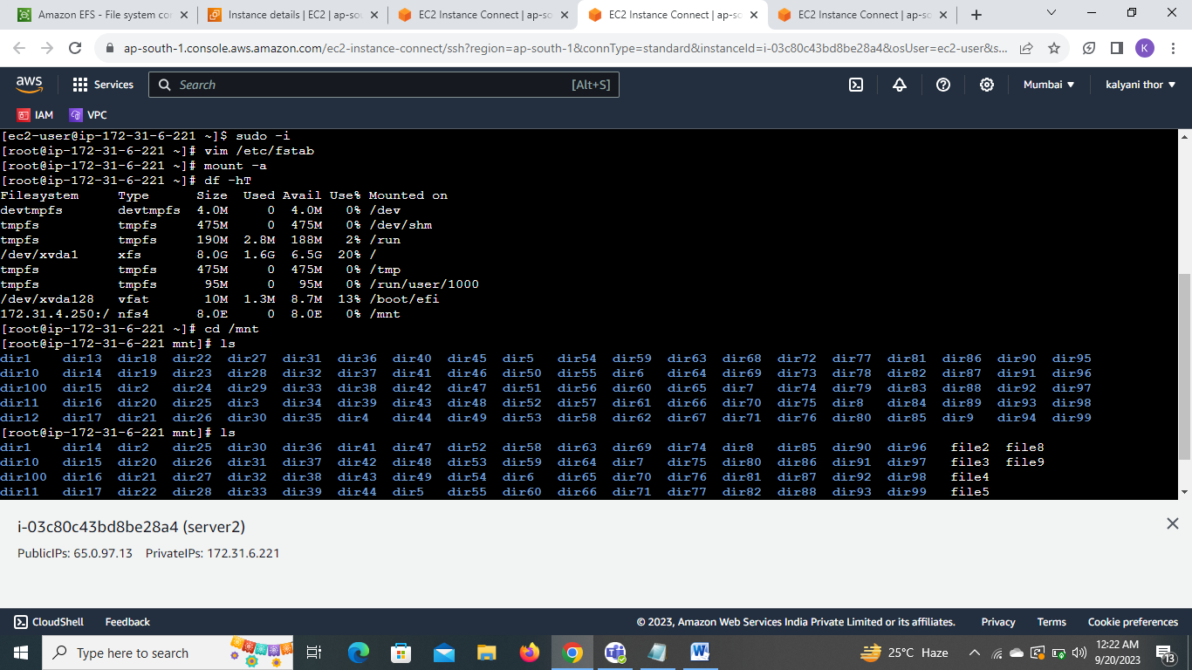

Edit vim /etc/fstab add ip In nfs client link

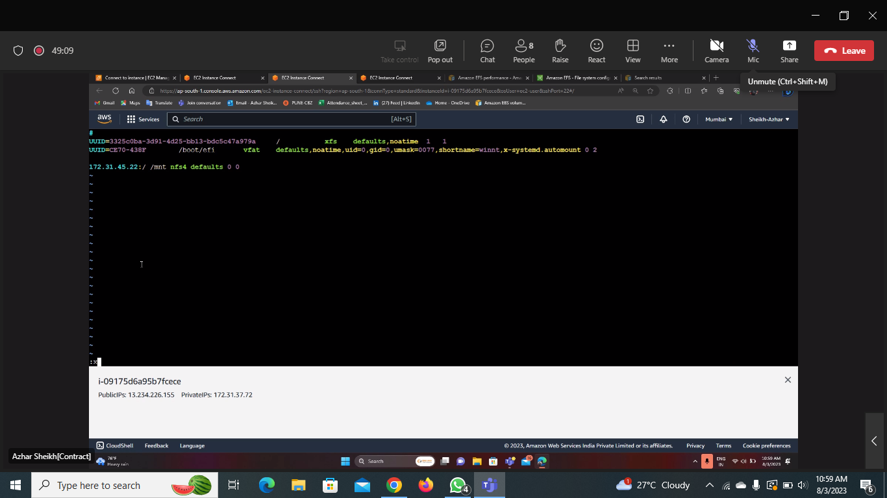

Mount –a and check the files

1. Do the same in server 3 using the DNS blue link

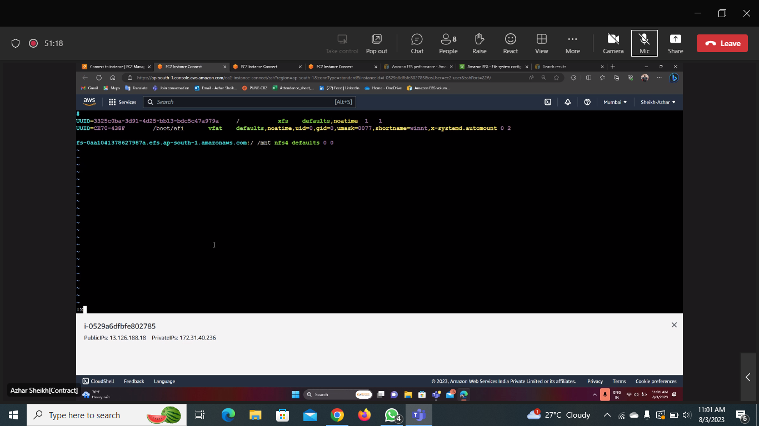

Mount –a and check the files

