T
Requirement Analysis Document

Medicine Shop Automation (MSA)

Team: Team_11

Name | Roll_No | Mail Id
J. Kalyan Chakravarthi | R141080 | r141080@rguktrkv.ac.in
M. Vamshi | R141536 | r141536@rguktrkv.ac.in
G. Venkatesh | R141426 | r141426@rguktrkv.ac.in
K. Lakshmaiah | R141900 | r141900@rguktrkv.ac.in
CH. Prabhakar | R141142 | r141142@rguktrkv.ac.in

Table of Contents
Introduction: 3
Purpose: 3
Intended Audience: 3
Stakeholders: 3
Product Vision 3
Vision Statement: 3
Technologies: 3
System in Context: 3
Requirements 4
Non-Functional Requirements: 6
Reliability: 6
Usability: 6
Availability: 6
Accessibility: 6
Performance: 6
Security: 6
Platform Compatibility: 6

Introduction:

This document has the requirements of Medicine Shop Automation tool. The MSA tool is used by Customer , Shop keeper, manager, vendor. By using the MSA Tool, provide services to their customers.

Purpose:
The purpose of this document is to gather the requirements that are needed for implementing the Medicine Shop Automation tool. It also focuses on various key features, the medicine, customer vision and scope, medicine overview.
The purpose of MSA tool is to provide online solutions to customers.

Intended Audience:
The intended audience will be the customers who want to get online medicines through Pharmacies.

Stakeholders:
Client: Pharmacies – Lynn Robert Carter
Users: individuals who needs medicines.

Product Vision

Vision Statement:
The product vision is to develop a MSA Tool, which is user friendly and easily accessible. This MSA Tool helps to provide online purchase of medicines for the customer problems.

Technologies:
HTML, PHP, MYSQL, JAVA SCRIPT and XAMPP

System in Context:
MSA Tool is a multi user system which provides online purchase of medicines for the customer problems. It takes orders from customers and provide order id to customer. It assigns order request to support manager. The manager will assign the order to the shop-keeper by using shop-keeper id's. He delivers the ordered medicines to the respective customer according to order id and after the delivery he can change the order status. MSA tool helps to check the status and support personnel to change help request status.
Context Diagram
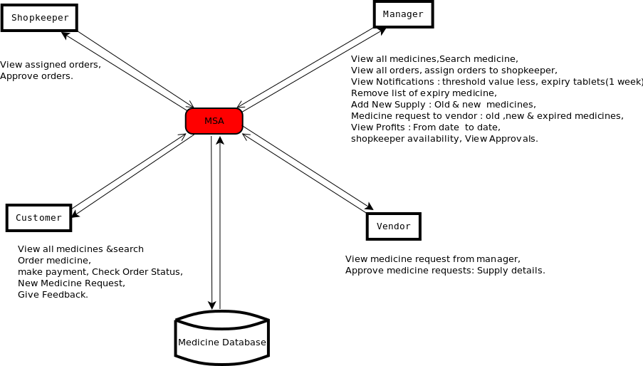

Requirements:
- System (Medicine Shop Automation) supports four types of people.
  - Customer: Views all medicines, send medicine orders, check order status, make payments.
  - Manager: View all orders, Assign orders to shopkeeper, check notifications, add supply,
send medicine request to vendor, check profits, approved orders.
  - Shopkeeper: View assigned orders, approve orders.
d. Vendor: View medicine requests, approve medicine requests, supply details.
- User posts the “help request” with the following details:
  - What the problem is.
  - How much impact it has on the product.
  - When it needs to be fixed.
  - Does the user have any ideas about resolving it?
  - What the user has done so far to resolve the problem?
- System accepts the help request and sends an immediate email to user with a generated unique incident id as a subject line. User can use this id for further reference.
- System adds status of the help request, id and email address of support person after assigning the help request to one of the support personnel.
- System provides a web page to administrator to view all the posted unresolved help requests. The web page contains.
  - Help request submitted time
  - Support person id/name - who has been assigned to the particular request.
  - User name - the person’s name, who posted the help request.
  - User email address
  - Link – This displays actual help request form of the user.
- Privileges given by system.
  - To Administrator
    - Assign a support person to a help request.
    - Provide additional data to a support person to resolve the help request.
    - Update the status of the help request.
  - To Support personnel
    - Update the status of the help request.
- When the status of help request is changed, an email is sent to the support person (Who has been assigned to the help request) and the user (Who posted the help request) by the system.
- The email which is sent to user and support person should have a link to view the current status of the help request.
- The HLST system provides different ways of searching the stored help requests.
  - By entering user name/id and options (opened or closed) - shows particular user help requests.
  - By entering support person id/name options (opened or closed) – shows particular assigned support person’s help requests.
- Support person updates often the information about the work which has been done so far on a particular item, helps him to go further process on that item.

Non-Functional Requirements:

Reliability:
User should get appropriate information about his complaint

Usability:
This tool should has user friendly GUI. User can use it effectively.

Availability:
Using should get information 24x7. User can access at any time with this tool

Accessibility:
This tool support multi user accessing. Any user can access the system from different
places to use the tool

Performance:
User should have fast access to get the information from the help center. User should
retrieve the information from help center database very quickly.

Security:
As it is a web based application it should be more secure in order to save help centers
confidential data from hackers.

Platform Compatibility:
This tool has to work on any kind of operating system without modifying it.

