Team – 11

Medicine Shop Automation

ER-Diagrams:
Attributes

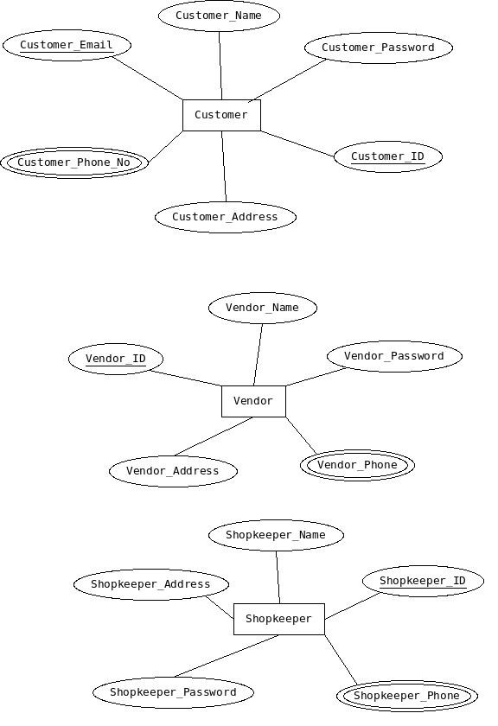

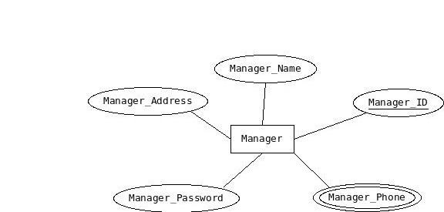

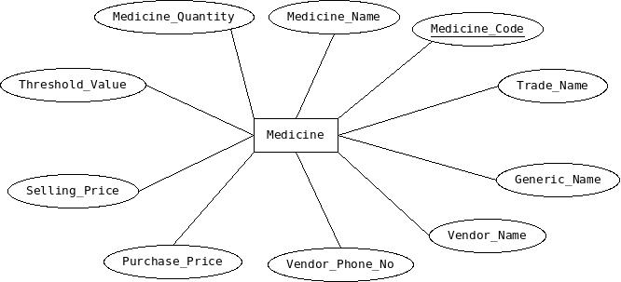

ER_Diagram

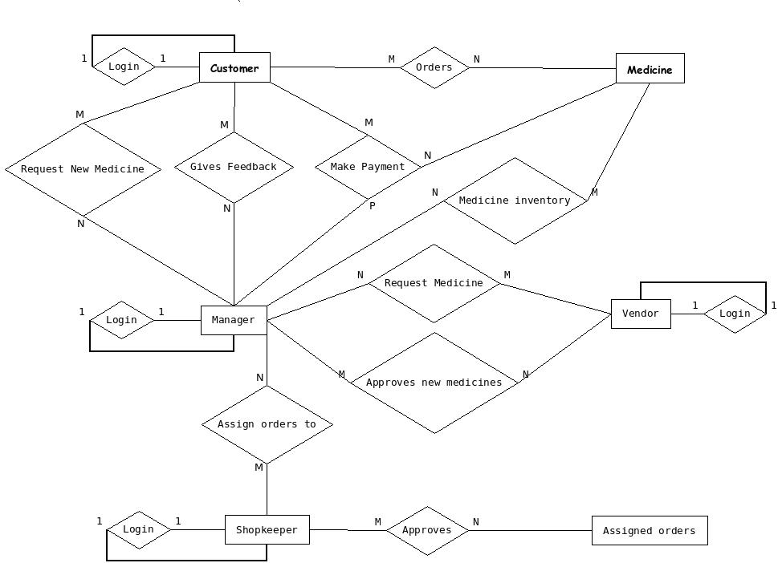
Schemas:

Customer(
cid int(11),
cmail varchar(100),
cname varchar(100),
cphone int(11),
caddress varchar(100),
cpassword varchar(100)
);

Medicine(
mcode int(11),
mname varchar(100),
mquantity int(11),
mprice int(11),
vendor_name varchar(100),
);

Order(
cid int(11),
order_id int(11),
mcode int(11)
);

Request_new_medicine(
cid int(11),
rid int(11),
mid int(11),
nm_name varchar(100)
);

Feedback(
cid int(11),
mid int(11),
f_msg varchar(100)
);

Make_payment(
cid int(11),
order_id int(11),
mid int(11),
total_price int(11)
);

Manager(
mid int(11),
mname varchar(100),
mphone int(11),
maddress varchar(100),
password varchar(100)
);

Medicine_inventory (
mcode int(11),
mid int(11),
trade_name varchar(100),
generic_name varchar(100),
vendor_name varchar(100),
expiray_date date,
selling_price int(11),
purchase_price int(11),
threshold_value int(11),
quantity int(11)
);

Request_medicine (
rm_id int(11),
mid int(11),
vendor_id int(11),
mcode int(11),
rm_quantity int(11)
);

Approve_medicine_req (
rm_id int(11),
mcode int(11),
a_quantity int(11)
);

Assign_orders(
mid int(11),
sid int(11),
assign_id int(11),
order_id int(11)
);

Approves (
assign_id int(11),
order_id int(11)
);

Vendor(
vendor_id int(11),
vendor_name int(11),
vphone int(11),
vaddress varchar(100),
password int(11)
);

Shop_keeper(
sid int(11),
sname varchar(100),
saddress varchar(100),
sphone int(11),
password varchar(100)
);

