***WeedSense - Empowering Precision Agriculture with Computer Vision***

**Introduction**

Early detection and monitoring of weeds play a critical role in effective agricultural management. With the deployment of deep weed detectors in the field, farmers gain the ability to monitor weed populations in real-time, allowing them to identify emerging weed infestations before they escalate into widespread problems. This proactive approach empowers farmers to take timely intervention measures, thereby preventing potential crop yield losses. By leveraging computer vision technology, these detectors can swiftly and accurately identify weeds amidst crop plants, enabling farmers to respond promptly to localized weed outbreaks and apply targeted management strategies.

Moreover, the adoption of image-based weed detection systems offers significant potential for lowering production costs in agriculture. Traditional weed management methods, such as manual labor or blanket herbicide application, are often associated with high costs and inefficiencies. However, by implementing precision weed management techniques facilitated by deep weed detectors, farmers can minimize the need for excessive herbicide use or labor-intensive weed control measures. By accurately identifying and targeting specific weed-infested areas within fields, farmers can optimize resource allocation and reduce wastage, leading to cost savings and improved overall efficiency in crop production. This shift towards precision weed management not only reduces operational expenses but also contributes to environmentally sustainable farming practices by minimizing chemical inputs and mitigating the risk of herbicide resistance in weed populations.

The main aim of this study is to build an image classifier capable of detecting the weed species when weed plant is provided as an input.

**Methods**

This study [1] addresses the gap in research on robotic weed control in rangeland environments by introducing the DeepWeeds dataset, the first large, publicly available multiclass image dataset of weed species from Australian rangelands. With 17,509 labeled images covering eight nationally significant weed species across eight locations in northern Australia, this dataset enables the development of robust classification methods essential for effective robotic weed control. The study employs benchmark deep learning models, namely Inception-v3 and ResNet-50, to establish a baseline for classification performance on the dataset. Results indicate high accuracy rates, with Inception-v3 achieving an average classification accuracy of 95.1% and ResNet-50 achieving 95.7%. Additionally, real-time performance of the ResNet-50 architecture is demonstrated, showcasing an average inference time of 53.4 milliseconds per image. These promising findings suggest a strong potential for the future implementation of robotic weed control methods in Australian rangelands, addressing critical challenges in weed management for stock farmers.

This paper [2] investigates the efficacy of five state-of-the-art deep neural networks—VGG16, ResNet-50, Inception-V3, Inception-ResNet-v2, and MobileNetV2—for recognizing weeds from images, crucial for developing automatic weed management systems in agriculture. By employing various experimental settings and dataset combinations, including a large weed-crop dataset created by amalgamating smaller datasets and mitigating class imbalance through data augmentation, the study evaluates model performance. Transfer learning techniques, utilizing pre-trained weights for feature extraction, and fine-tuning on crop and weed datasets, are explored. Results indicate that VGG16 outperforms others on small-scale datasets, while ResNet-50 excels on larger combined datasets. The study underscores the significance of data augmentation and fine-tuning in enhancing deep learning model performance for crop and weed image classification.

**Results and Analysis**

To effectively classify weeds using image as an input, pretrained convolution neural networks have been used. This can be called as a transfer learning. For the initial experimentation, VGG16 has been used. This has given me the following results.

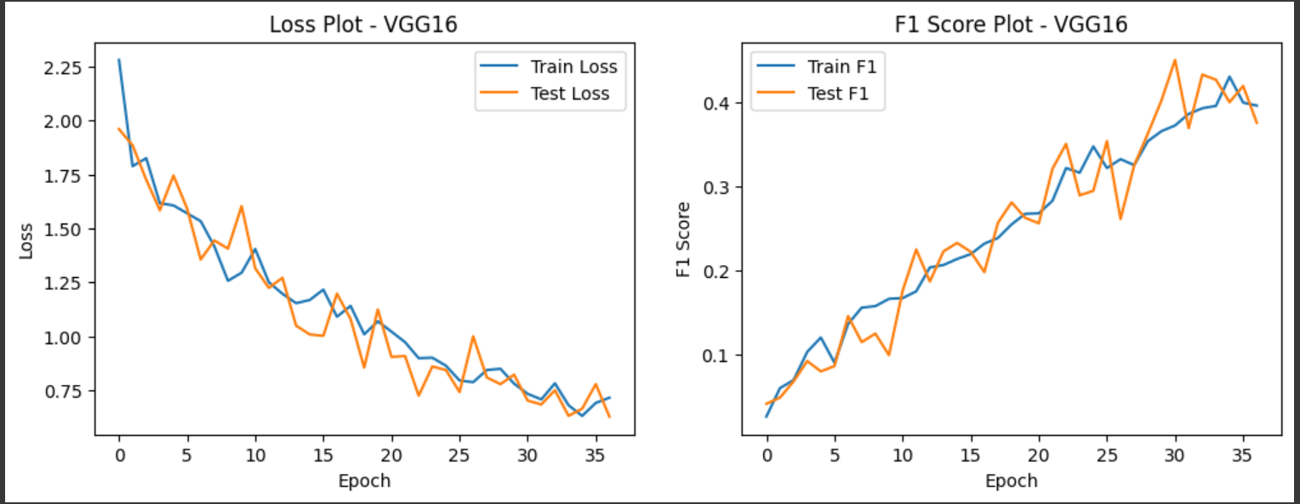

At the convergence, @39 epochs

Initial Learning Rate – 0.0001

Optimizer – Adam

Total params - 15799192 (60.27 MB)

Trainable params - 15799192 (60.27 MB)

Non-trainable params - 0 (0.00 Byte)

|  |  |  |
| --- | --- | --- |
|  | *Train* | *Test* |
| *Loss* | 0.699 | 0.6819 |
| *AUC* | 0.9871 | 0.9885 |

Here AUC has been chosen as the performance metric because there is huge imbalance in the dataset as below. Therefore, choosing accuracy as the performance is not a wise choice.

The AUC (Area Under the Receiver Operating Characteristic Curve) score is advantageous when dealing with class imbalance because it provides a robust evaluation metric that is less affected by skewed distributions.

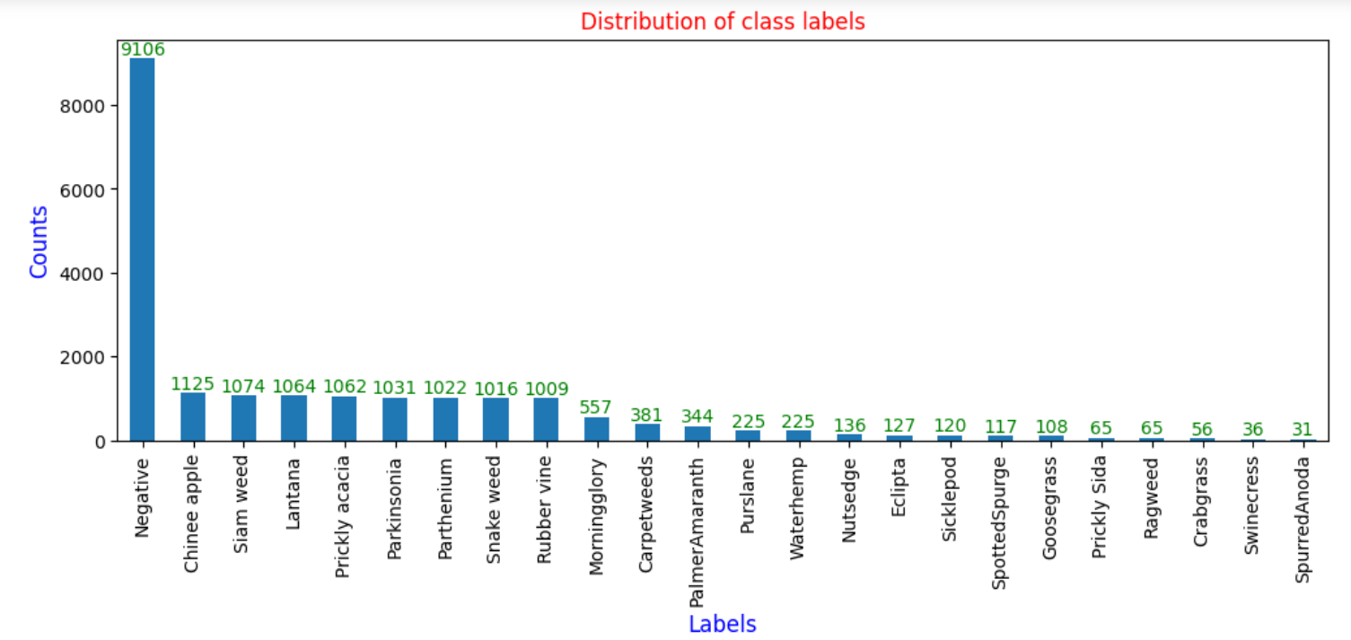

I have trained InceptionV3 model last week and found below results.

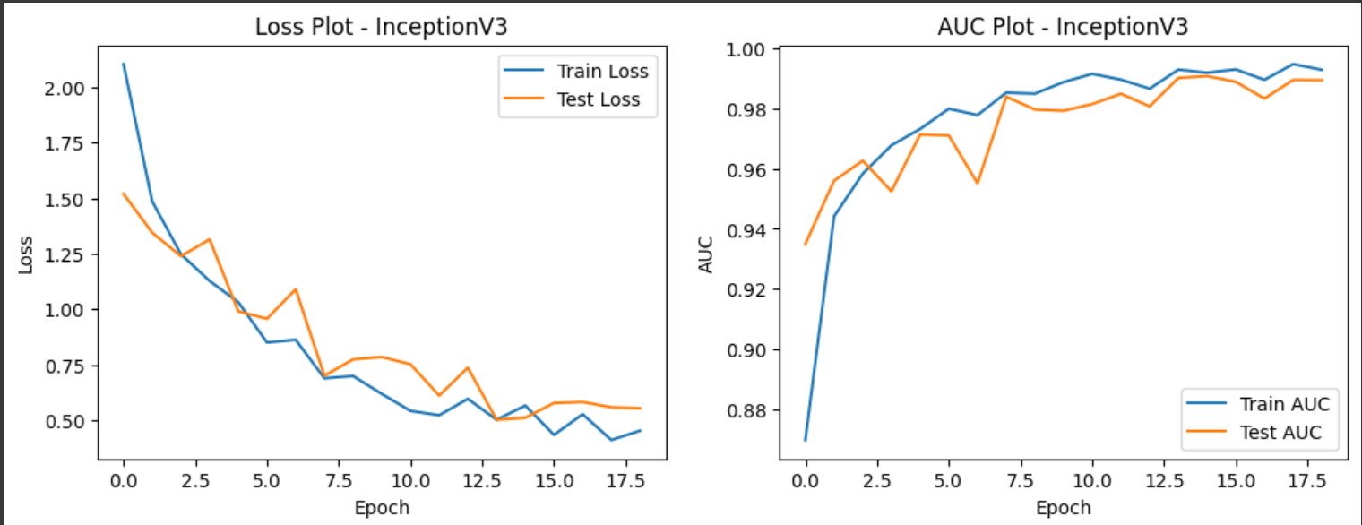

At the convergence, @19 epochs

Initial Learning Rate – 0.0001

Optimizer – Adam

Total params: 24460152 (93.31 MB)

Trainable params: 24425720 (93.18 MB)

Non-trainable params: 34432 (134.50 KB)

|  |  |  |
| --- | --- | --- |
|  | *Train* | *Test* |
| *Loss* | 0.5666 | 0.5115 |
| *AUC* | 0.9919 | 0.9908 |

**Conclusion**

Based on the above results it is observed that the Test AUC obtained using InceptionV3 is better than VGG16.

**References**

Olsen, A., Konovalov, D. A., Philippa, B., Ridd, P., Wood, J. C., Johns, J., ... & White, R. D. (2019). DeepWeeds: A multiclass weed species image dataset for deep learning. *Scientific reports*, *9*(1), 2058.

[*https://arxiv.org/abs/1810.05726*](https://arxiv.org/abs/1810.05726)

Hasan, A. M., Sohel, F., Diepeveen, D., Laga, H., & Jones, M. G. (2022). Weed recognition using deep learning techniques on class-imbalanced imagery. *Crop and Pasture Science*.[*https://www.publish.csiro.au/cp/pdf/CP21626*](https://www.publish.csiro.au/cp/pdf/CP21626)

**Appendices**

Appendix A: Training Details

- VGG16

- Epochs: 39

- Learning Rate: 0.0001

- Optimizer: Adam

- Parameters: 15,799,192

- InceptionV3

- Epochs: 19

- Learning Rate: 0.0001

- Optimizer: Adam

- Parameters: 24,460,152

Appendix B: Performance Metrics

- VGG16

- Train Loss: 0.699

- Test Loss: 0.6819

- Train AUC: 0.9871

- Test AUC: 0.9885

- InceptionV3

- Train Loss: 0.5666

- Test Loss: 0.5115

- Train AUC: 0.9919

- Test AUC: 0.9908

Appendix C: Class Distribution

- A bar chart showing the number of images per class, illustrating the dataset imbalance.

Appendix D: Convergence Graphs

- Loss and AUC plots for both VGG16 and InceptionV3 models.