Movie Success Factors in the Flim Industry (2000-2024): A CRISP-DM Analysis of Budget, Revenue, Genre, and Language
Kalyan Kankanala, Student ID: 250551284
2026-07-30

Introduction

Context
The global movie industry earns quite a significant amount of money through movies being watched at theaters or streamed online. It is therefore important for us to know what makes a movie successful. This report will make use of TMDb movies data between the years 2000 and 2024 to analyze factors influencing a movie’s success using the CRISP-DM framework in two cycles (Bemthuis et al., 2025).

Research Objectives
First Cycle
- To identify overall patterns in movie release volume, ratings, and revenue between 2000 and 2024.
- To examine the relationship between a movie’s budget and the revenue it generates
- To identify which movies achieved the highest revenue and the highest ratings, and to understand which features are most associated with movie success
Second Cycle
- To examine how a movie’s genre relates to its ratings and commercial success
- To examine how a movie’s orginal language relates to its ratings and commercial success

First CRISP-DM Cycle

Business Understanding
Rising production costs and tighter budgest have made financial sustainability an ongoing challenge for the film industry.Understanding how budget relates to a film’s eventual success is therefore a key business question. Thos cycle focuses on that business context from the perspective of a specific stakeholder, breaking the overall question down into the sub-questions addressed below.

Stakeholder
This analysis is framed for a streaming platform content-acquisition team, responsible for deciding which types of films to license, promote, or commission This stakeholder needs to understand which factors reliably predict commercial success (revenue) and critical/audience reception (rating), so that acquisition and production-partnership decisions can be prioritized accordingly.

Success Criteria
This analysis would be deemed a success if the following three factors were achieved: (1) identification of consistent patterns in the relationship between budget, genre, release timing, and both rating and revenue; (2) determining whether high ratings consistently correlate with high revenue or whether the two are relatively independent of each other; and (3) practical advice based on the data analysis for the stakeholder.

Research Questions
- What are the key patterns of the success factors of movies in the dataset used?
- How is the movie budget connected to the movie revenue in the film industry?
- What type of changes have the movies experienced over time in terms of release, revenue and rating patterns?
- Which movies have received the highest ratings and have generated the highest revenue?

Data Understanding
The dataset comprises 25 years’ worth of yearly CSV files (from 2000-2024), containing the same set of features like id, title, genre, release year, budget, revenue, and votes. The datasets have been combined row-wise into one single file. These features have been selected since they are relevant to the requirements of the stakeholder: budget, revenue, profit, votes, genre, and release year.
## Number of rows: 670208
## Number of columns: 25
Sample of Raw Merged Data
id | title | vote_average | vote_count | release_date | revenue | budget | runtime | original_language
98 | Gladiator | 8.209 | 16962 | 2000-05-04 | 465361176 | 1.03e+08 | 155 | en
77 | Memento | 8.188 | 13723 | 2000-10-11 | 39723096 | 9.00e+06 | 113 | en
8358 | Cast Away | 7.662 | 10531 | 2000-12-22 | 429632142 | 9.00e+07 | 143 | en
36657 | X-Men | 6.996 | 10530 | 2000-07-13 | 296339527 | 7.50e+07 | 104 | en
1359 | American Psycho | 7.400 | 9797 | 2000-04-13 | 34266564 | 7.00e+06 | 102 | en
641 | Requiem for a Dream | 8.027 | 9165 | 2000-10-06 | 7390108 | 4.50e+06 | 102 | en
The new dataset comprise 670,208 rows and 25 columns. The high number of observations over a 25-year period makes it possible to look for consistent patterns rather than just exceptions.

Data Preparation
Column names were standardised and columns were cast into proper data types. Duplicates based on movie id were deleted and now there are 670,072 number of rows in the movies data frame. Variables related to profit, roi, revenue-success, and rating-group were created and movies data frame was subsetted to only include the years 2000 to 2024. Inconsistent entries were replaced by NA instead of being deleted.
Missing Values by Column
Variable | Missing_Count
roi | 627849
homepage | 572950
tagline | 567864
keywords | 468421
backdrop_path | 450480
production_companies | 344332
imdb_id | 343030
production_countries | 273520
spoken_languages | 252551
genres | 239355
runtime | 147612
poster_path | 143665
overview | 110744
title | 4
original_title | 4
revenue | 1
profit | 1
source_file_id | 0
id | 0
vote_average | 0
vote_count | 0
status | 0
release_date | 0
adult | 0
budget | 0
original_language | 0
popularity | 0
release_year | 0
release_month | 0
release_day | 0
revenue_success | 0
rating_group | 0

Modeling

Global Trends
After merging and cleaning the dataset, a simple statistical description offers a preliminary overview of the data to be analyzed further. The mean rating for 670072 movies produced in the period from 2000 to 2024 is 2.050817, while the mean revenue is 894739.4; the average budget equals 351558.2 and the mean duration is 68.77461.
##
## ===== BASIC SUMMARY =====
## Total movies: 670072
## Year range: 2000 to 2024
## Average rating: 2.050817
## Average revenue: 894739.4
## Average budget: 351558.2
## Average runtime: 68.77461
To identify broad patterns before narrowing the focus in Cycle 2, the top-performing movies by revenue and rating were tabulated below, alongside yearly release counts and average revenue, with the corresponding trends examined in the plots that follow.
Top 10 Revenue Generating Movies
title | release_year | revenue | budget | profit | vote_average | popularity
Adventures in Bora Bora | 2023 | 3000000000 | 8.00e+08 | 2200000000 | 0.000 | 0.000
TikTok Rizz Party | 2024 | 3000000000 | 2.50e+08 | 2750000000 | 10.000 | 0.000
Avatar | 2009 | 2923706026 | 2.37e+08 | 2686706026 | 7.573 | 79.932
Avengers: Endgame | 2019 | 2800000000 | 3.56e+08 | 2444000000 | 8.263 | 91.756
Avatar: The Way of Water | 2022 | 2320250281 | 4.60e+08 | 1860250281 | 7.654 | 241.285
Star Wars: The Force Awakens | 2015 | 2068223624 | 2.45e+08 | 1823223624 | 7.293 | 66.772
Avengers: Infinity War | 2018 | 2052415039 | 3.00e+08 | 1752415039 | 8.255 | 154.340
Best Of Joy | 2024 | 2000000000 | 1.00e+03 | 1999999000 | 0.000 | 0.000
Spider-Man: No Way Home | 2021 | 1921847111 | 2.00e+08 | 1721847111 | 7.990 | 186.065
Jurassic World | 2015 | 1671537444 | 1.50e+08 | 1521537444 | 6.682 | 54.089

Top 10 Highest Rated Movies
title | release_year | vote_average | vote_count | revenue | popularity
Prison High Pressure | 2019 | 9.200 | 210 | 0 | 297.563
BTS World Tour: Love Yourself - Japan Edition | 2019 | 9.172 | 306 | 0 | 4.892
Break the Silence: The Movie | 2020 | 9.154 | 175 | 8954945 | 7.198
BTS Permission to Dance On Stage - Seoul: Live Viewing | 2022 | 9.018 | 113 | 32600000 | 6.877
Franco Escamilla: por la anécdota | 2018 | 9.000 | 118 | 0 | 7.013
BTS: Permission to Dance on Stage - LA | 2022 | 8.993 | 148 | 0 | 11.480
The Three Deaths of Marisela Escobedo | 2020 | 8.904 | 215 | 0 | 8.083
Metallica & San Francisco Symphony: S&M2 | 2019 | 8.759 | 110 | 0 | 6.698
Chivas: The Movie | 2018 | 8.655 | 113 | 0 | 5.148
BLACKPINK: Arena Tour 2018 ‘Special Final in Kyocera Dome Osaka’ | 2019 | 8.652 | 141 | 0 | 4.811

Count of Movies Per Year
release_year | n
2000 | 9066
2001 | 10171
2002 | 11326
2003 | 12743
2004 | 14262
2005 | 15771
2006 | 17704
2007 | 18407
2008 | 19175
2009 | 20145
2010 | 21016
2011 | 22658
2012 | 24751
2013 | 27283
2014 | 29207
2015 | 30837
2016 | 32551
2017 | 36088
2018 | 38511
2019 | 42386
2020 | 41658
2021 | 45030
2022 | 46518
2023 | 47190
2024 | 35618

Average Revenue Per Year
release_year | avg_revenue | total_movies
2000 | 1421973.1 | 9066
2001 | 1537335.3 | 10171
2002 | 1575080.9 | 11326
2003 | 1524395.7 | 12743
2004 | 1350951.7 | 14262
2005 | 1179745.8 | 15771
2006 | 1174869.8 | 17704
2007 | 1233752.5 | 18407
2008 | 1256332.4 | 19175
2009 | 1306485.2 | 20145
2010 | 1209525.3 | 21016
2011 | 1273173.2 | 22658
2012 | 1153215.4 | 24751
2013 | 1096160.9 | 27283
2014 | 1041021.4 | 29207
2015 | 1020166.7 | 30837
2016 | 1043425.5 | 32551
2017 | 943972.4 | 36088
2018 | 856827.6 | 38511
2019 | 759689.7 | 42386
2020 | 215126.1 | 41658
2021 | 378676.5 | 45030
2022 | 549097.4 | 46518
2023 | 574136.8 | 47190
2024 | 435081.4 | 35618
The number of movies produced every year increased gradually from 9,066 in the year 2000 to reach its highest point of 47,190 in the year 2023, followed by a decrease to 35,618 movies in 2024. A slight decrease can be observed in the year 2020 (41,658 movies compared to 46,518 in 2019). This might be due to a decline in the production and release of movies in the year 2020 due to the pandemic outbreak of COVID-19, as it recovered by the year 2021-2023. The steep fall after 2023 is much more than the fall observed in 2020.
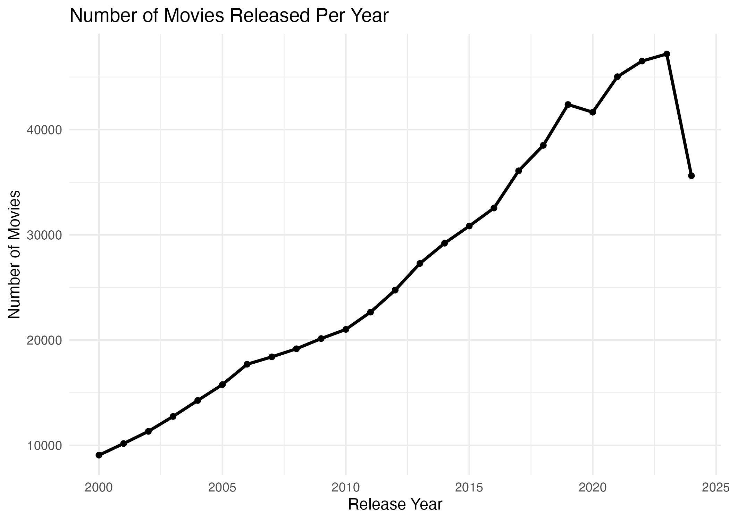
Average movie rating has dropped from 2.47 in the year 2000 to 0.50 in the year 2024, with the largest drop recorded after the year 2020 (from 2.15 in 2020 to 1.18 in 2023, and further down to 0.50 in 2024). Nevertheless, it would be better to interpret the above finding cautiously and not take it as direct evidence of declining movie quality. According to the Movies by Rating Group graph presented below, most of the movies in the dataset belong to the Low Rated group, and the TMDb’s bulk data contains numerous low engagement or incomplete entries – some of which definitely indicate data quality problems rather than the release of new movies (see Study Limitations). Thus, the above mentioned decline in average ratings may indicate a growing share of these low-quality data among the more recent data.
Average Ratings Per Year
release_year | avg_rating | n_movies
2000 | 2.4696467 | 9066
2001 | 2.4384116 | 10171
2002 | 2.3999282 | 11326
2003 | 2.3516138 | 12743
2004 | 2.3511642 | 14262
2005 | 2.2663757 | 15771
2006 | 2.2740765 | 17704
2007 | 2.2808919 | 18407
2008 | 2.3112832 | 19175
2009 | 2.3740385 | 20145
2010 | 2.4015279 | 21016
2011 | 2.4173915 | 22658
2012 | 2.3827337 | 24751
2013 | 2.3801407 | 27283
2014 | 2.3662825 | 29207
2015 | 2.4030771 | 30837
2016 | 2.3432501 | 32551
2017 | 2.3160067 | 36088
2018 | 2.1949464 | 38511
2019 | 2.1285562 | 42386
2020 | 1.9348973 | 41658
2021 | 1.8033391 | 45030
2022 | 1.8064311 | 46518
2023 | 1.1804539 | 47190
2024 | 0.4960628 | 35618
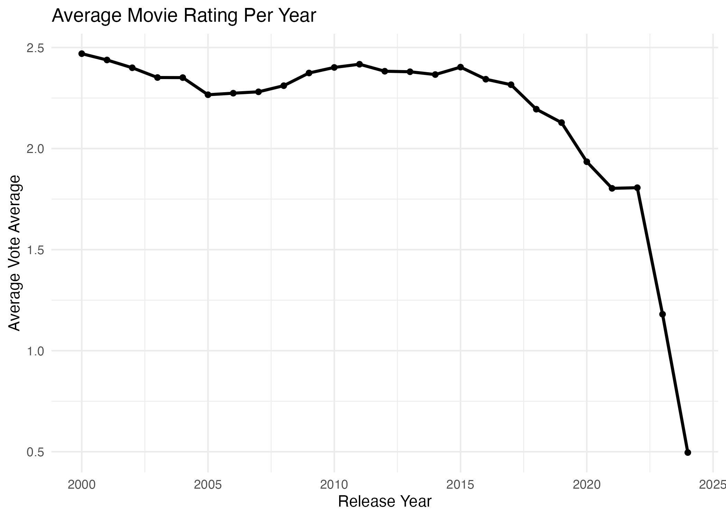
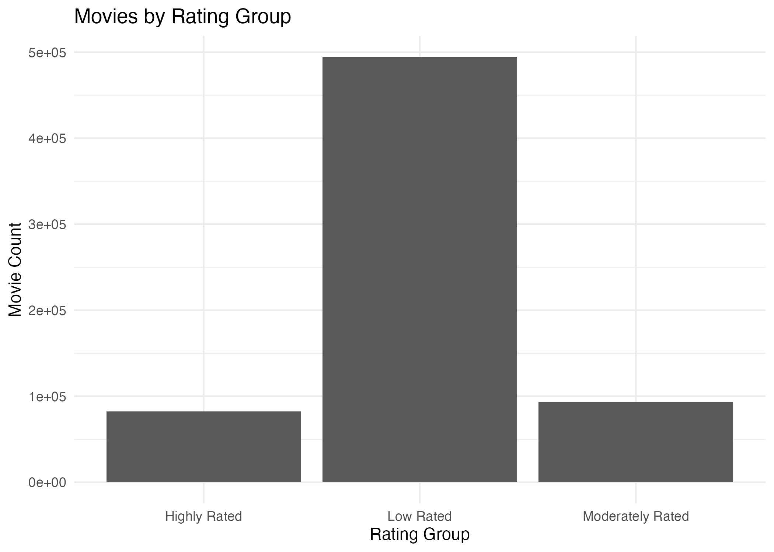
In line with the above trend, low-rated films greatly outweigh films that are of medium and high ratings, collectively making up about three-quarters of the entire dataset. This provides additional evidence that the decrease in the average rating with time is an indication of an increasing proportion of low-engagement and low-quality films.
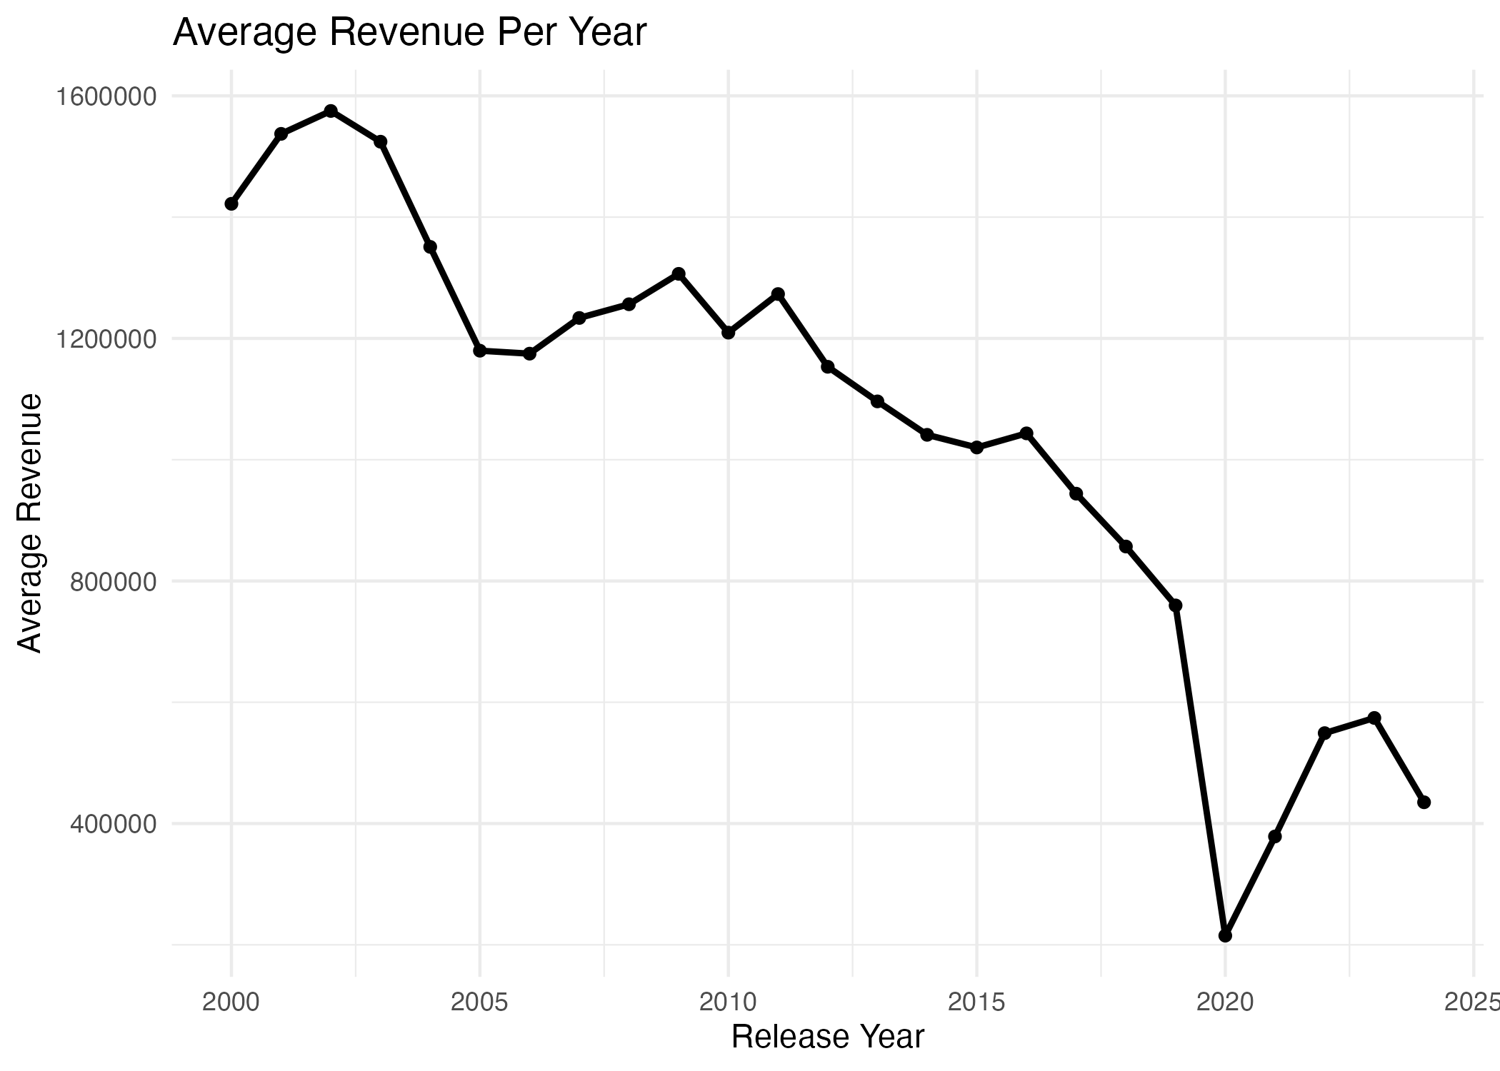
The average annual revenues went up from 1,421,973 in 2000 to 1,575,081 in 2002 and then fell steadily to 759,690 in 2019. There was a sudden fall in 2020 to 215,126, which can be attributed to the pandemic-driven closure of movie theatres, after which there was a slight bounce back in 2023 to 574,137 and then another fall to 435,081 in 2024.
On the whole, the long-run trend throughout the entire period depicts falling average revenue, in line with the trend witnessed in the ratings presented above.
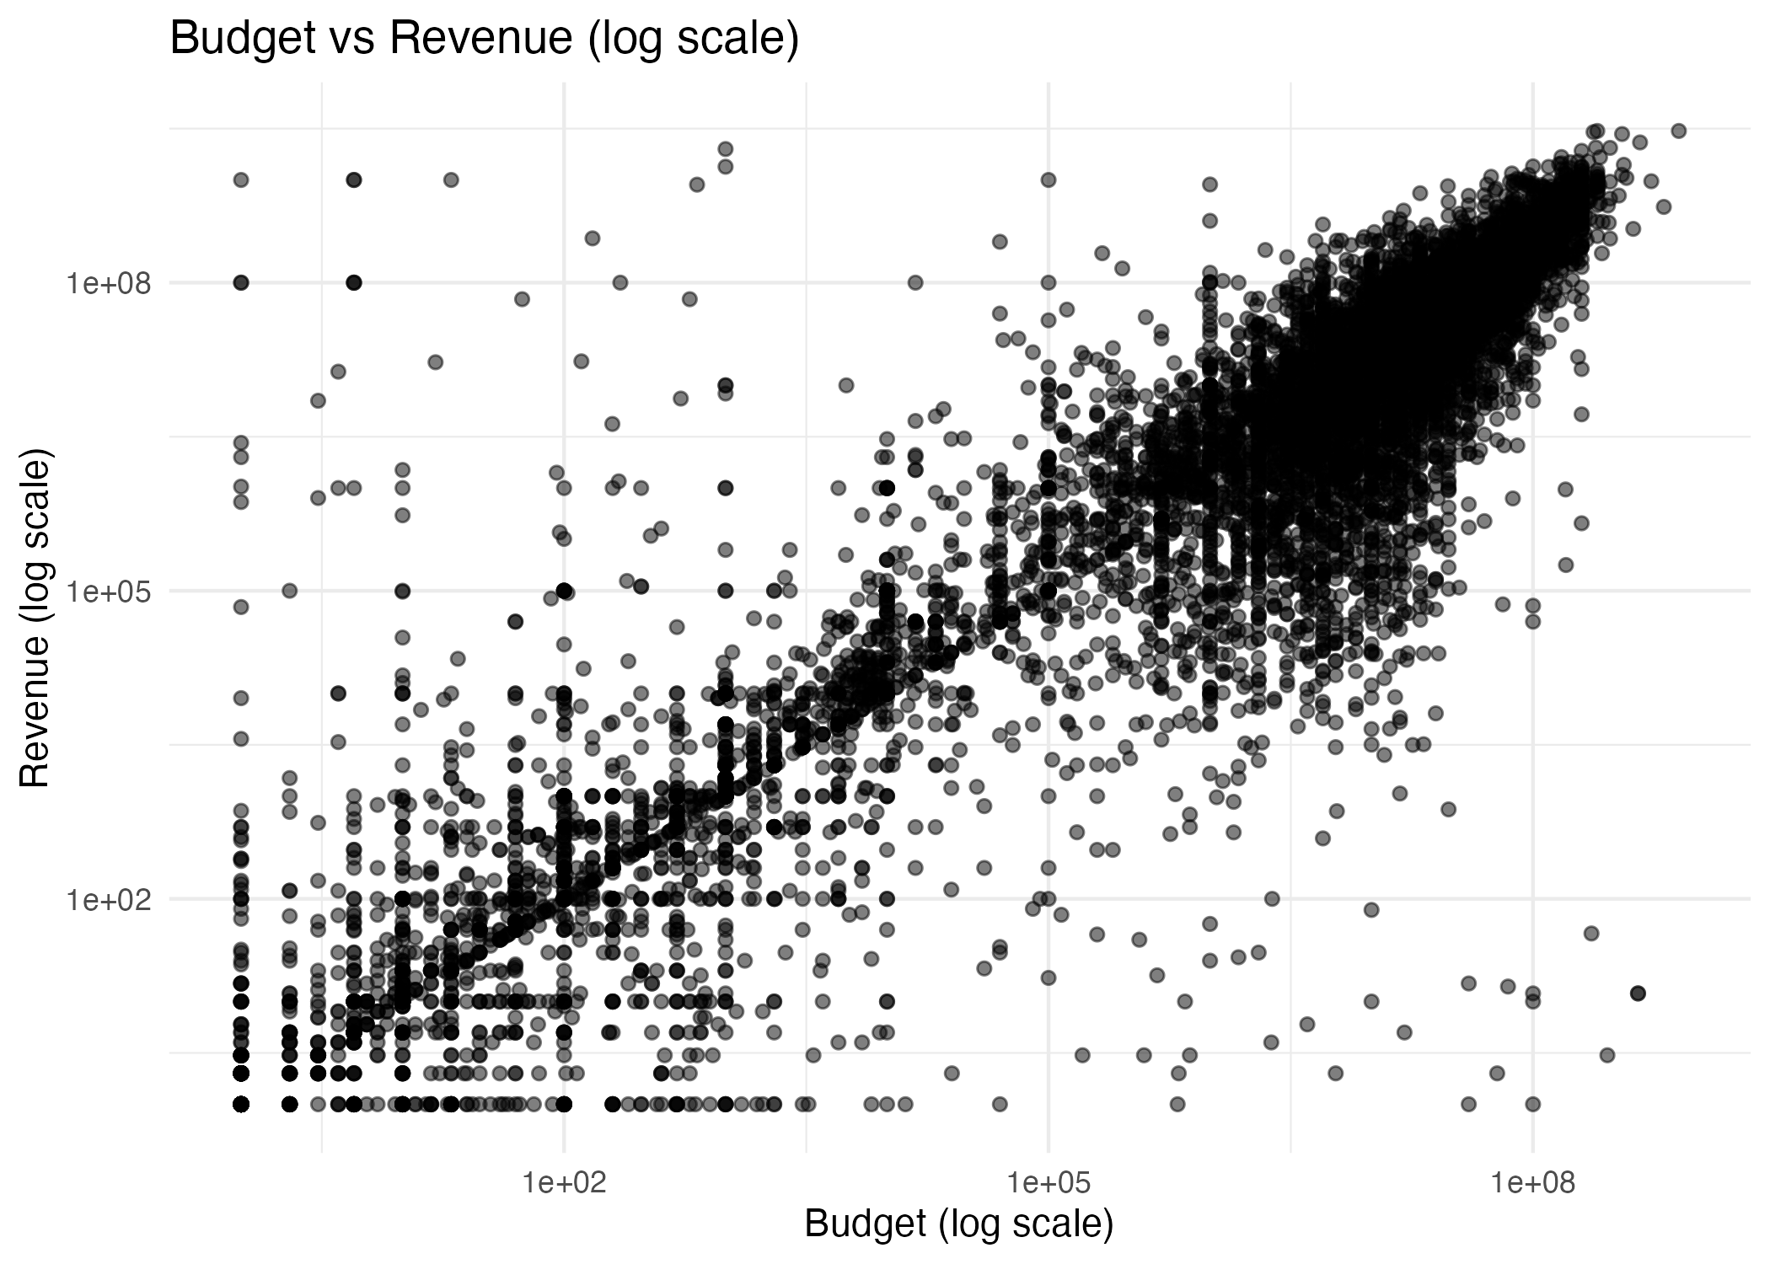
Drama, Documentary, and Comedy are the three most common genres by movie count, together accounting for a substantial share of all releases in the dataset. This indicates that recent film production continues to concentrate heavily on these established genres. Whether this high production volume translates into stronger commercial or critical performance is examined further in Cycle 2.
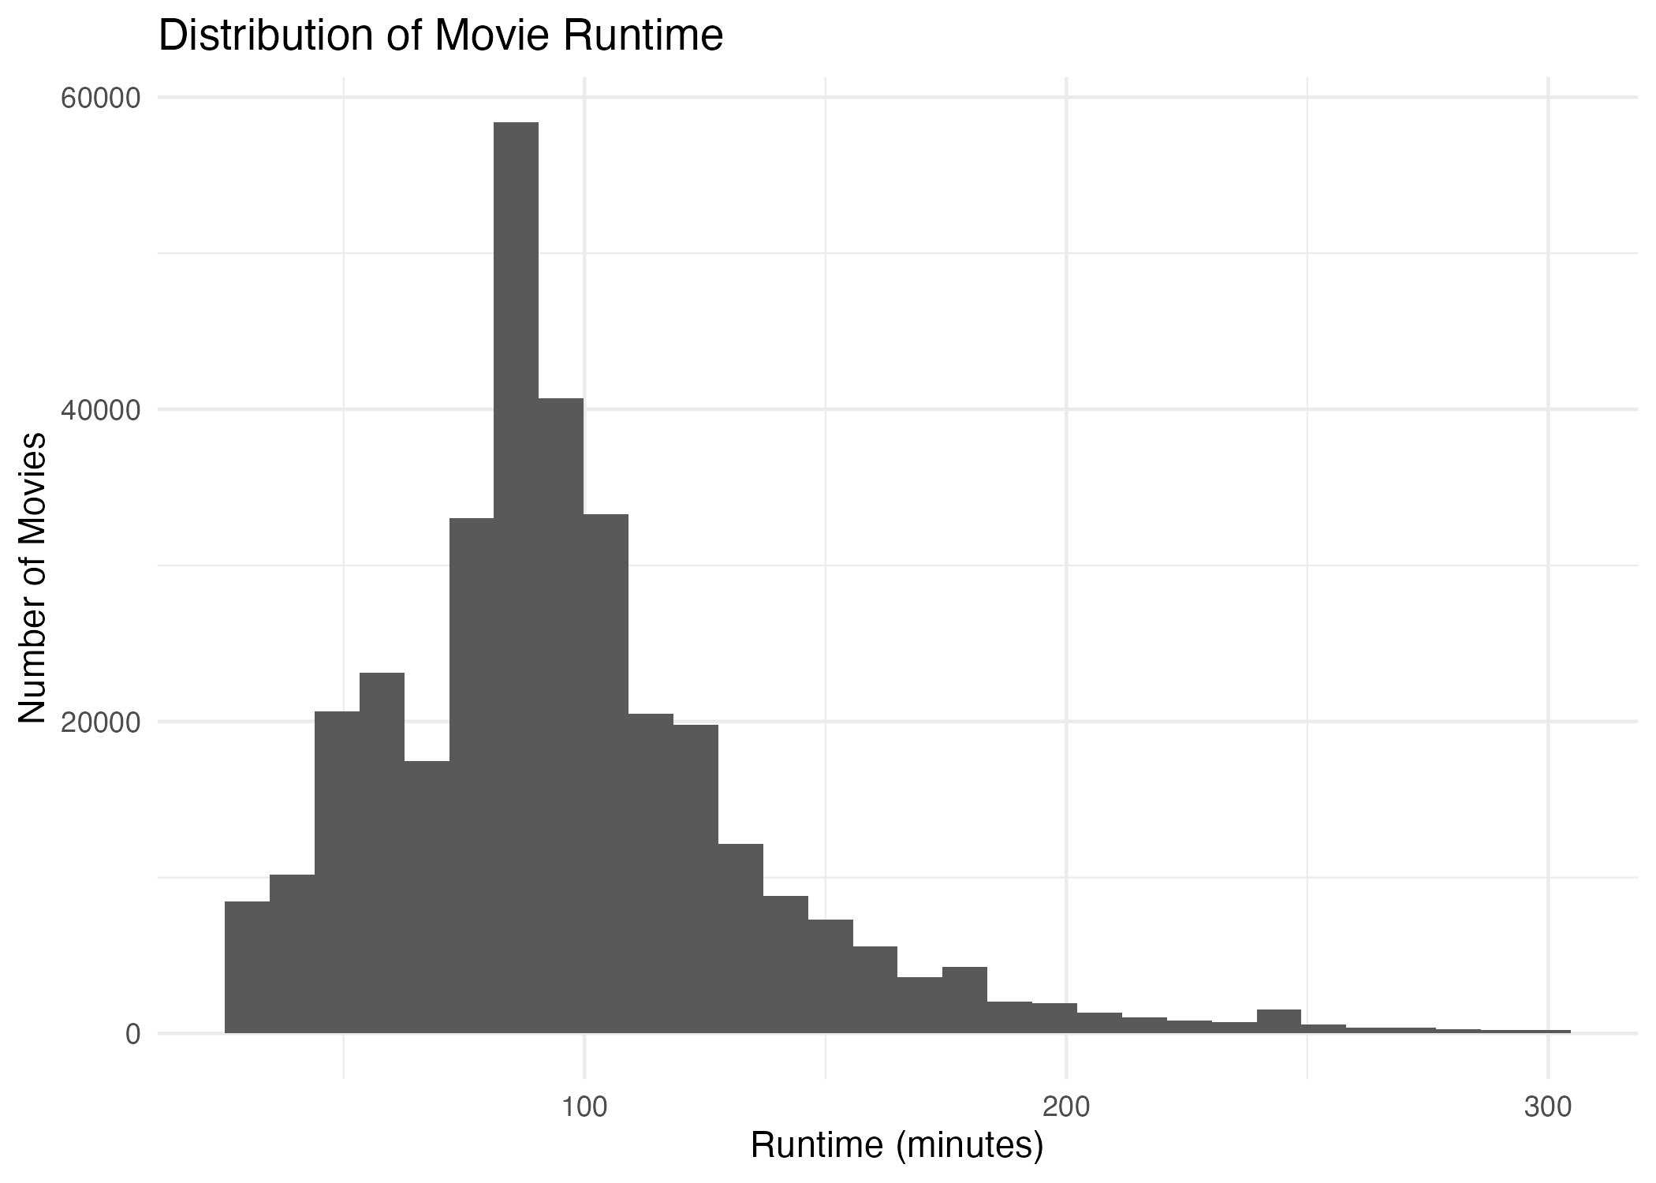
Most films have their duration distributed around a region between approximately 80 and 120 minutes, reflecting feature films’ durations. Some films are much longer than this interval and constitute the tail of longer durations.
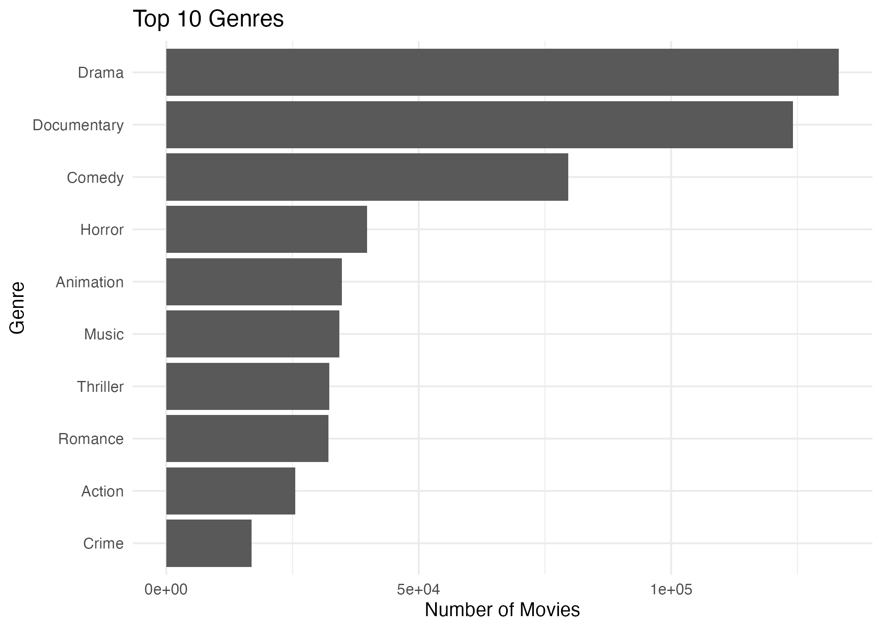
The correlation between revenue and profit is extremely high (0.97), which is understandable because profit is calculated from revenue. The correlation between the number of votes and revenue is also quite high (0.73), as well as the number of votes and the budget of the movie (0.64). However, this refers to the number of people who saw or voted for the movie, and not to how good the movie was because the correlation between the average value of the rating (vote_average), on the one hand, and revenue (0.06), budget (0.08) and profit (0.05), on the other hand, is extremely low. This means that the success and popularity of the movie are largely independent of its reception: a high rating does not necessarily lead to a high revenue and vice versa. Popularity is positively correlated with revenue (0.22) and the number of votes (0.23).
Correlation Matrix
 | vote_average | vote_count | revenue | runtime | budget | popularity | profit | roi
vote_average | 1.0000000 | 0.0958849 | 0.0596094 | 0.1538229 | 0.0756965 | 0.1006427 | 0.0469618 | -0.0071292
vote_count | 0.0958849 | 1.0000000 | 0.7300981 | 0.0456980 | 0.6356562 | 0.2327055 | 0.6729876 | -0.0016258
revenue | 0.0596094 | 0.7300981 | 1.0000000 | 0.0346697 | 0.7195390 | 0.2229483 | 0.9724761 | 0.0817757
runtime | 0.1538229 | 0.0456980 | 0.0346697 | 1.0000000 | 0.0498787 | 0.0416310 | 0.0256571 | -0.0087336
budget | 0.0756965 | 0.6356562 | 0.7195390 | 0.0498787 | 1.0000000 | 0.2459807 | 0.5379253 | -0.0019635
popularity | 0.1006427 | 0.2327055 | 0.2229483 | 0.0416310 | 0.2459807 | 1.0000000 | 0.1881045 | -0.0009876
profit | 0.0469618 | 0.6729876 | 0.9724761 | 0.0256571 | 0.5379253 | 0.1881045 | 1.0000000 | 0.0999519
roi | -0.0071292 | -0.0016258 | 0.0817757 | -0.0087336 | -0.0019635 | -0.0009876 | 0.0999519 | 1.0000000
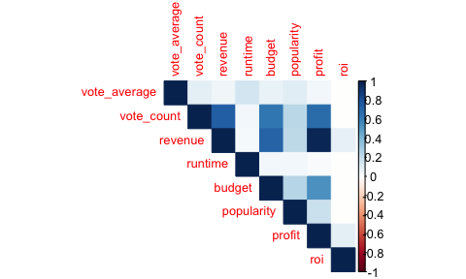

Evaluation - Cycle 1

Key Findings
- The number of releases increased from 9,066 (2000) to 47,190 (2023), but then decreased to 35,618 (2024).
- The average rating went down from 2.47 to 0.50 due to an increase in low-quality films.
- The average revenues have dropped throughout the years, especially since 2019.
- The budget and revenue show high correlation (0.72).
- The vote count is correlated with both revenue and budget, while the rating is not.

Link to Success Criteria
This data is directly linked to the success criteria where the budget and revenue relationship was determined to be (0.72 correlation), while the ratings-revenue relationship was confirmed as being negligible, thus making it independent from each other. This is the first step towards acquisition decisions, but more detailed information will be provided in Cycle 2.

Limitations
- There is low correlation among the vast majority of individual factors (except for budget and revenue) and the success of the movies, meaning that there are fewer conclusions that can be made on the basis of Cycle 1.
- There is an abundance of missing data for several columns (for example, homepage, tagline, keywords, production company details); however, the columns with the core variables utilized in this cycle have virtually zero missing data.

Questions for Cycle 2
- Which genre of movies makes the most money and has high ratings?
- Is there any specific effect of genre and language on movies’ success, apart from the budget itself?

Second CRISP-DM Cycle

Refined Business Understanding
In Cycle 1, budget was found to be an important determinant of revenue generation; however, ratings were not found to be so. In this cycle, two additional variables that emerge from the findings in Cycle 1 and stakeholders’ interest have been studied: genre and language.

Research Questions
- What movie genre is known to have high average revenue and ratings?
- How does the original language of a movie affect its revenue and ratings?

Enhanced Data Preparation
The dataset was limited to include id, title, genres, original_language, vote_average, and revenue. Missing data in the genre was dropped. As a movie can belong to many genres, each movie-genre combination was expanded to one line per genre in order for it to make its own contribution to the calculation of the average per genre separately.

Advanced Modeling and Final Evaluation

Influence of Genre on Movie Success
Adventure performs on both average earnings and ranking (second behind the small TV Movie subcategory). Drama has the largest number of movies, but is not a leader on either performance metric, indicating a possible overabundance compared to its value – meaning that Adventure-type films could yield better results..
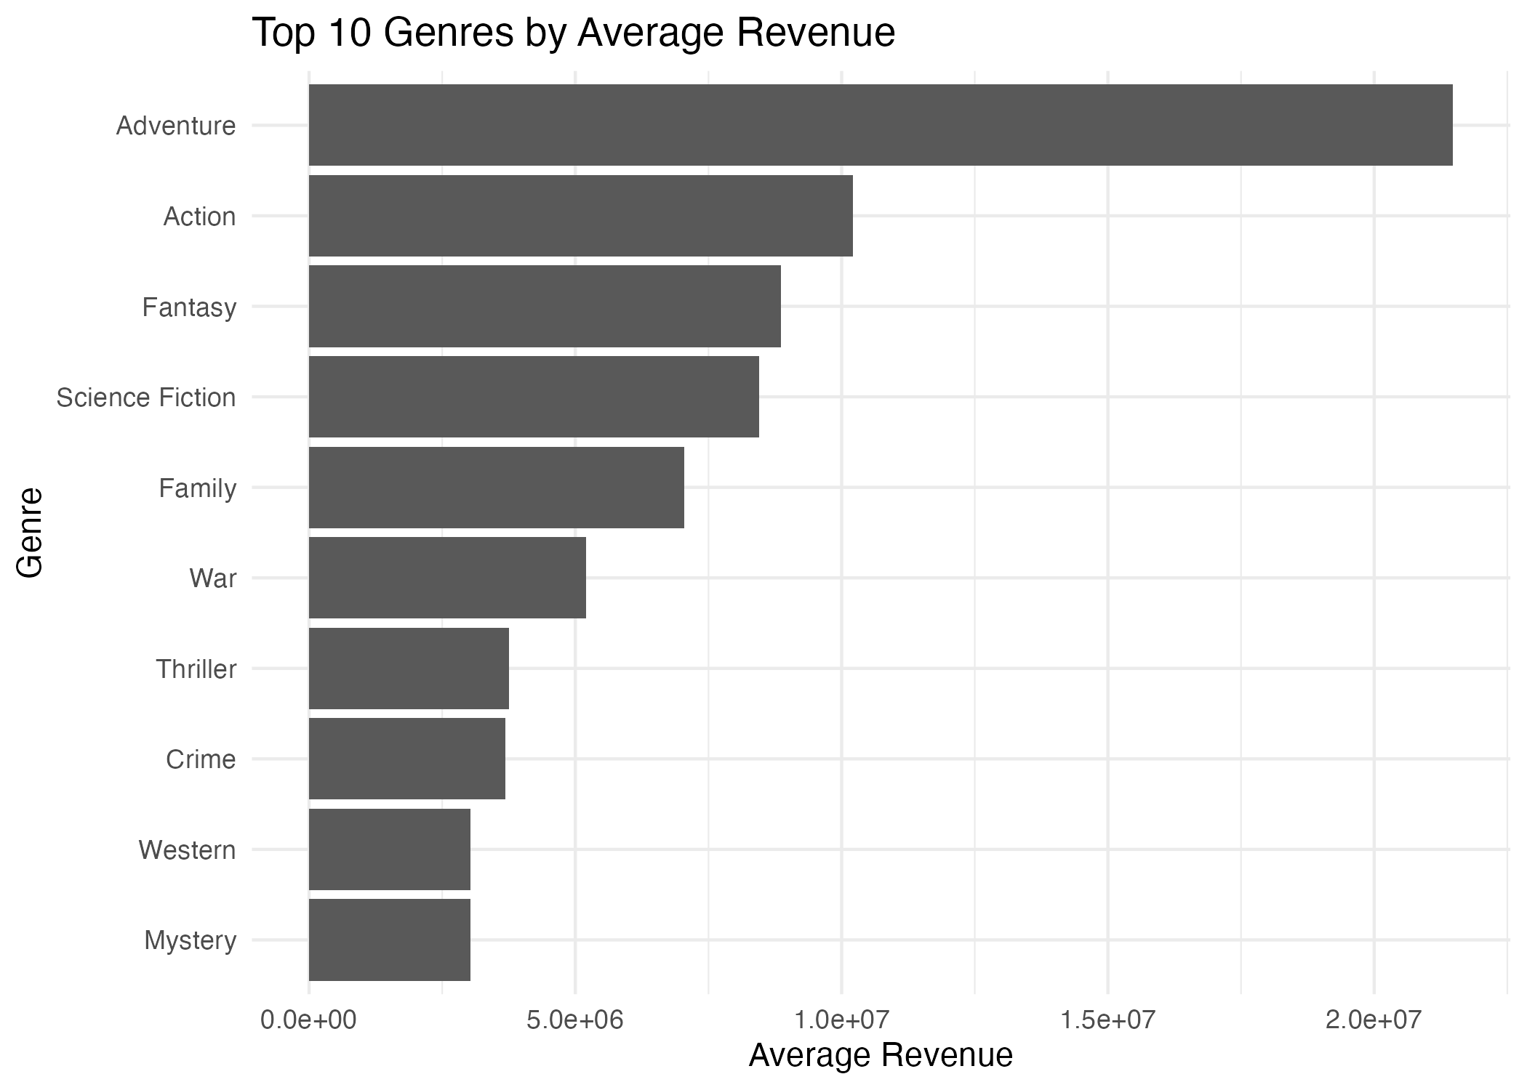
Genres were arranged based on revenue and rating because of the different importance of each factor for the content-acquisition team - revenue is important as the return, rating as reception.
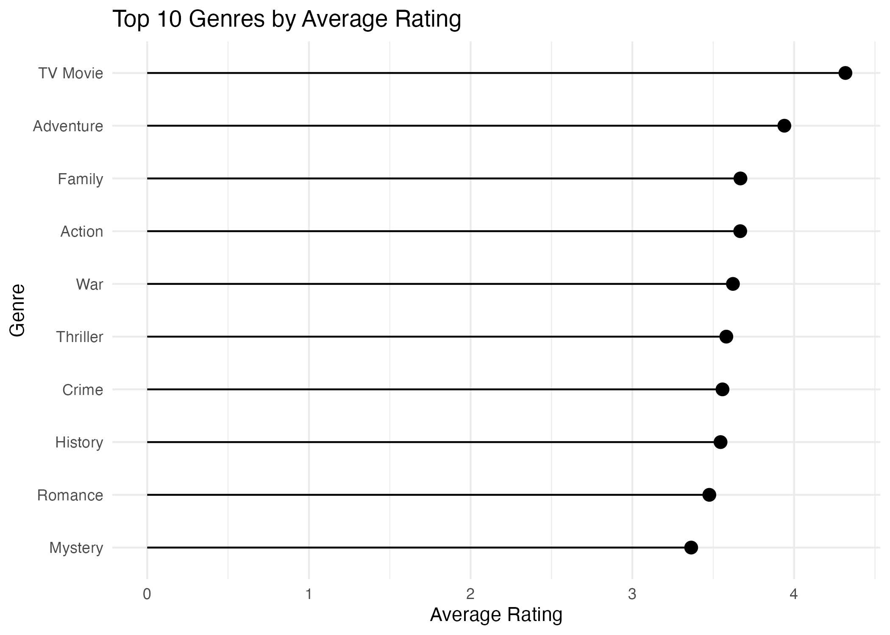
Most Movies are distributed around a low to moderate ROI (0-5x), with a long tail past 40x – which implies that even an industry with a high average income might have been due to a few outstanding Movies.
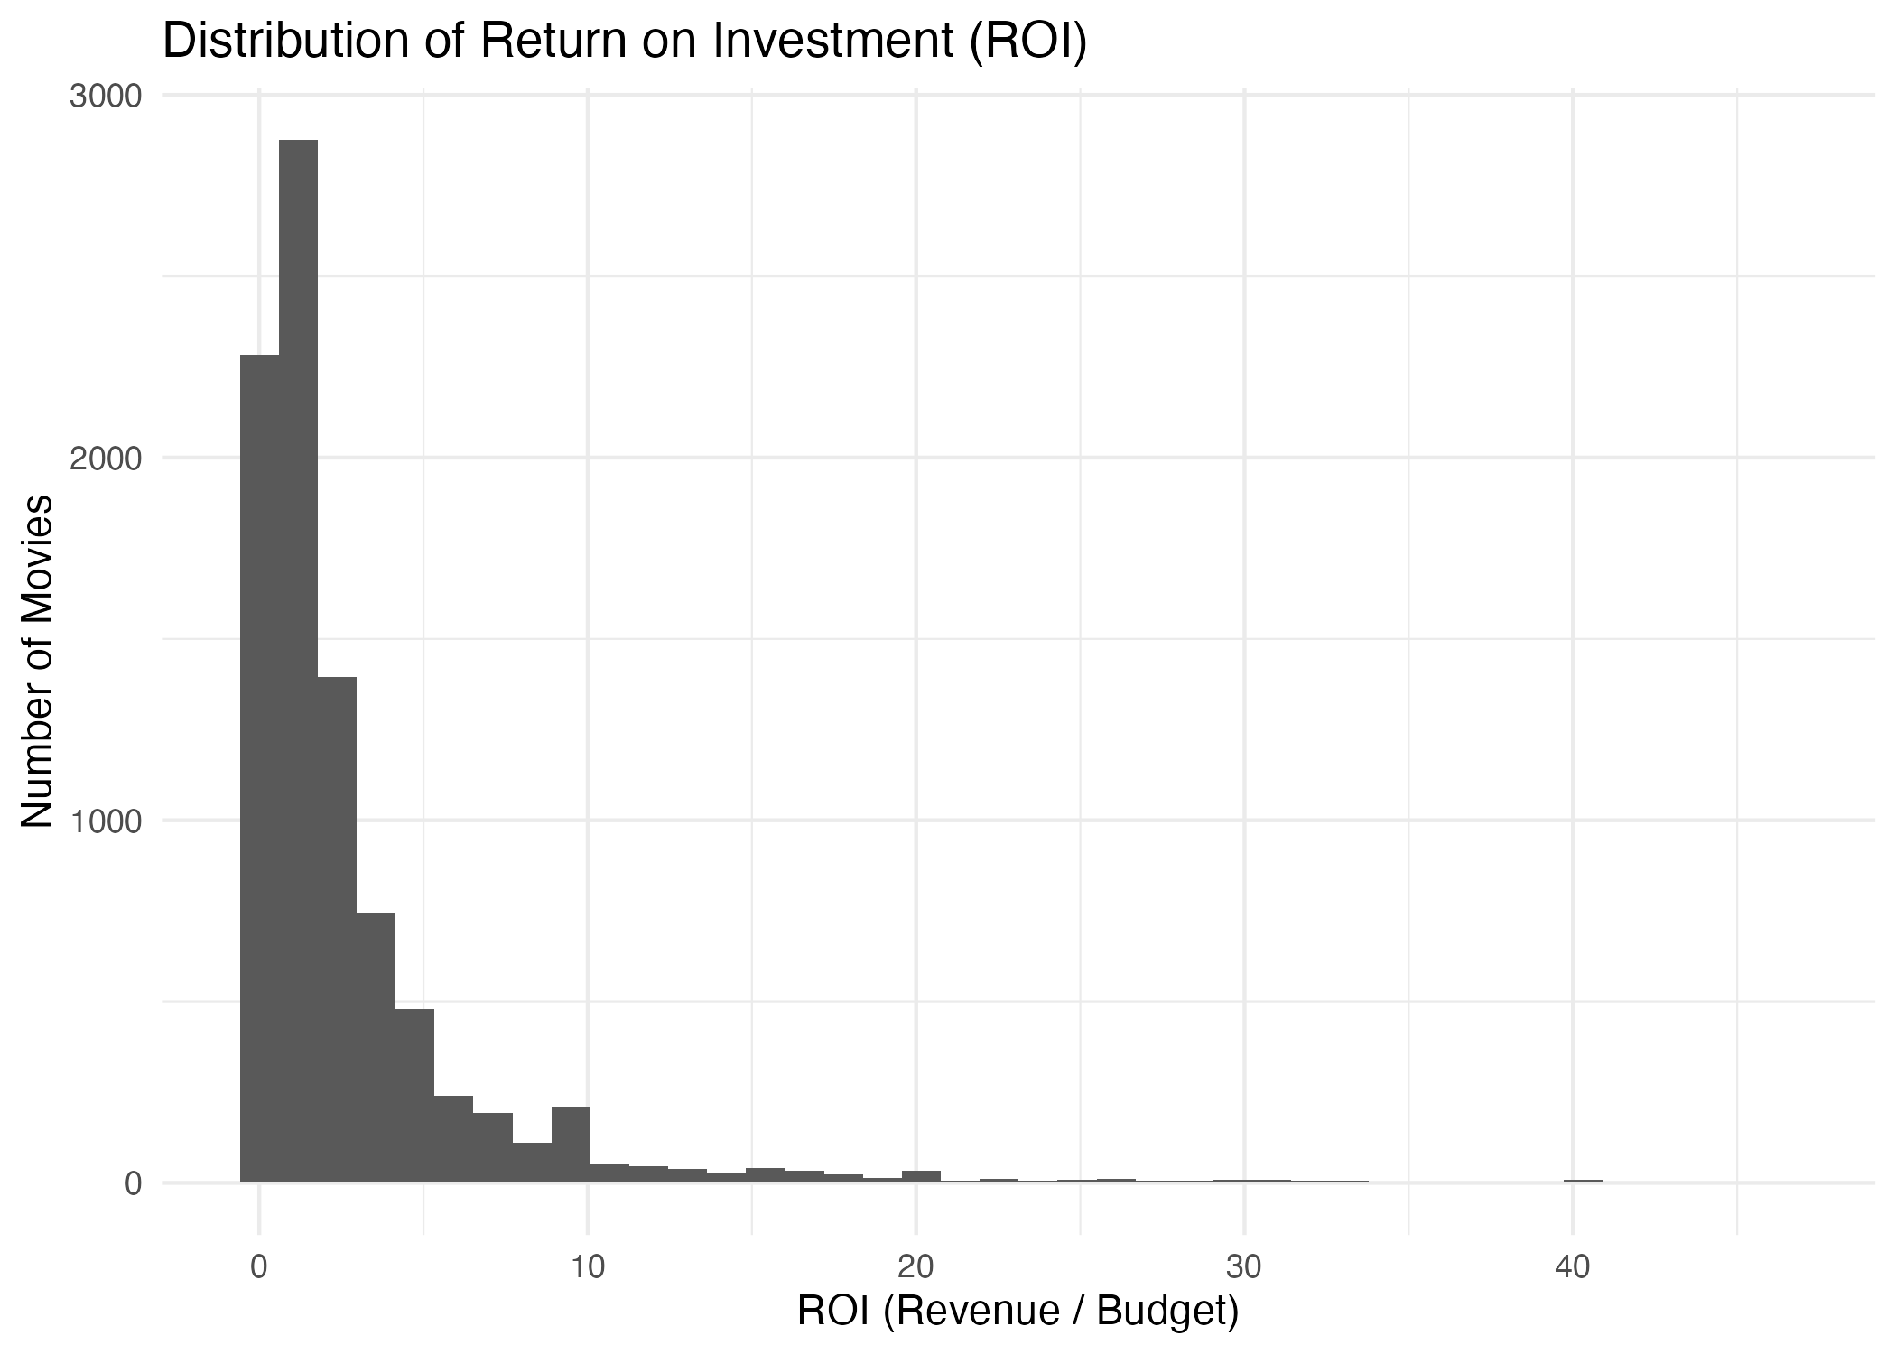

Influence of Language on Movie Success
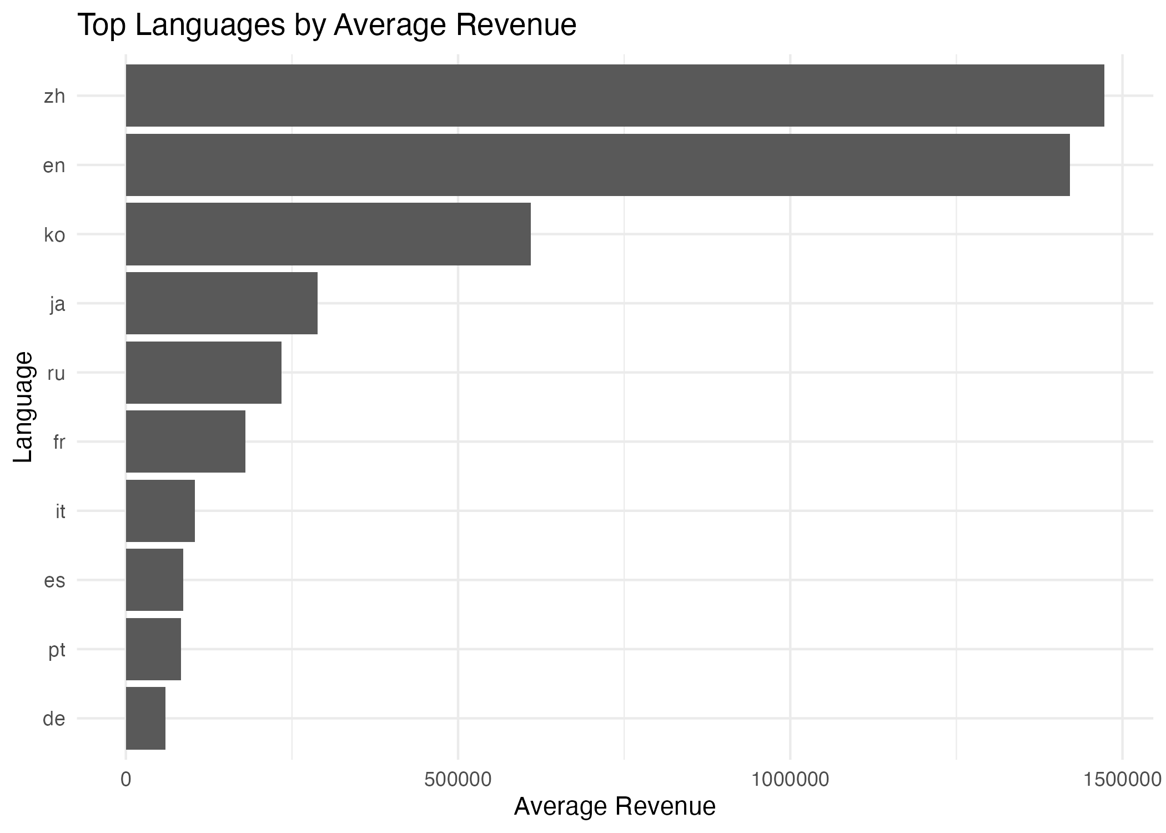
Between the top 10 languages, it has been found that Chinese and English earn maximum average income, with Chinese earning slightly more than English. This could imply that there are other options for English-only approaches that have been overlooked.

Connection between language and ratings
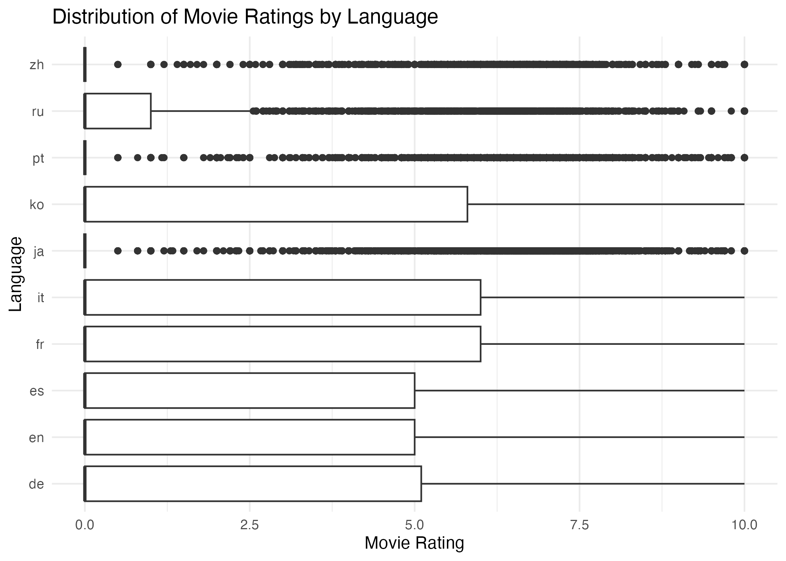 Italian and French rank highest in median ratings among common languages, a pattern distinct from the revenue pattern, demonstrating that there is no necessary link between success as a language and success in terms of money or praise.

Evaluation - Cycle 2

Key Findings
- Adventure performs better than others on average revenue and rating.
- Drama has the largest number of movies but does not perform well on either of these two criteria, implying surplus in relation to reward.
- Chinese and English produce the highest average revenue, whereas Italian and French have the highest ratings.
- There is no significant correlation between revenue and rating – high revenue movies do not necessarily have the highest ratings.

Link to Success Criteria
These results meet the success criteria: a clear pattern emerged (Adventure and languages other than English both correlate with increased reception), and the correlation between revenue and ratings was shown to be largely independent. This provides a practical approach to decision making regarding content – emphasizing Adventure to generate revenue, and multilingual content for increased ratings.

Limitations
- “Genre” and “Language” are categorical variables that could misclassify subtle groups within the audience.
- There is no adjustment made for other variables, such as marketing budget or release date.

Next Steps
Future research may consider joint modeling of revenue and rating (such as through regression) in order to tease out the genre and language effects while controlling for the budget and year of release.
Future cycles would benefit from a separate indicator of success, independent of the revenue/rating thresholds.

Final Evaluation

Major Findings
- Chinese and English language films earn the most money.
- The genre that earns most money is adventure.
- Italian and French have the highest ratings among common languages.
- Rating and revenue are independent – the most revenue and highest rated films are different.

Implications for Film Production Industry
- The diversification to several languages can prove helpful in creating a good balance between the two aspects of earning and rating as well.
- The selection of Adventure as the genre for making the product would definitely prove helpful in achieving revenue.
- The use of Italian and French languages can prove helpful in increasing the rating.
- As high ratings cannot assure high earnings, the importance of quality and language cannot be ignored.

Study Limitations
- There are many missing values in some columns in the dataset, but the deletion of such observations wasn’t performed in order not to reduce the number of cases, but that is the reason why there are several analyzes conducted on partially incomplete data.
- The results are drawn from one dataset (TMDb).
- There’s no specific success variable in the source data – it was derived using the revenue/rating criteria. There are also certain observations with poor data quality characteristics instead of being real movies (unrealistic revenue in contrast with almost zero budgets and votes).

Conclusions
In both CRISP-DM Cycles, budget is revealed to be the most significant determinant of revenues, and ratings have little relationship with commercial success. Adventure is the best-performing genre in both categories, while Italian and French-language movies receive the most successful ratings even though there are fewer of them produced. It seems clear for the content acquisition team that adventure movies should be acquired for maximum revenue generation, while attention to other languages will improve ratings.

Methodological Notes
- The analysis was performed with the help of the CRISP-DM framework, implemented in two iterative rounds.
- The project relies on the ProjectTemplate framework for replicability.
- Round one analyzed global trends for the whole dataset; round two concentrated on genre and language.
- All data wrangling and analyses were performed in R with the help of dplyr.
- Visualizations were created with the help of ggplot2, apart from the correlation matrix that uses corrplot.

References
Bemthuis, R. H., Govers, R. R., & Asadi, A. (2025). A CRISP-DM-based methodology for assessing agent-based simulation models using process mining [Review of A CRISP-DM-based methodology for assessing agent-based simulation models using process mining]. Journal of Simulation, 1-22. https://doi.org/10.1080/17477778.2025.2508245
Singh, P., & Asthana, S. (2025). Financial Sustainability in the Film Industry: Challenges, Strategies, and Future Directions. International Journal on Science and Technology (IJSAT) IJSAT25033691, 16(3). https://www.ijsat.org/papers/2025/3/3691.pdf

