3) Gives access to menu and area wise covid case details.

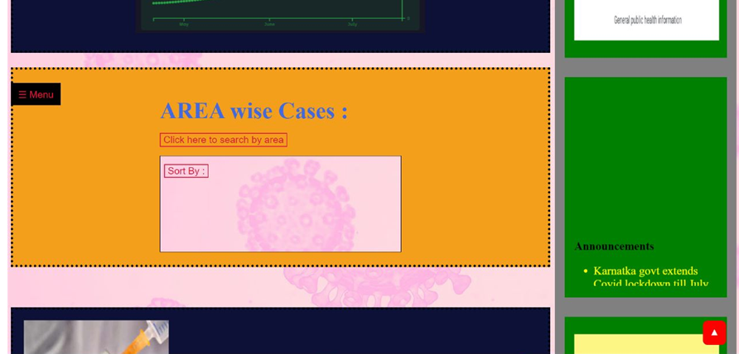

4)It gives access to the user to the vaccine registration page.

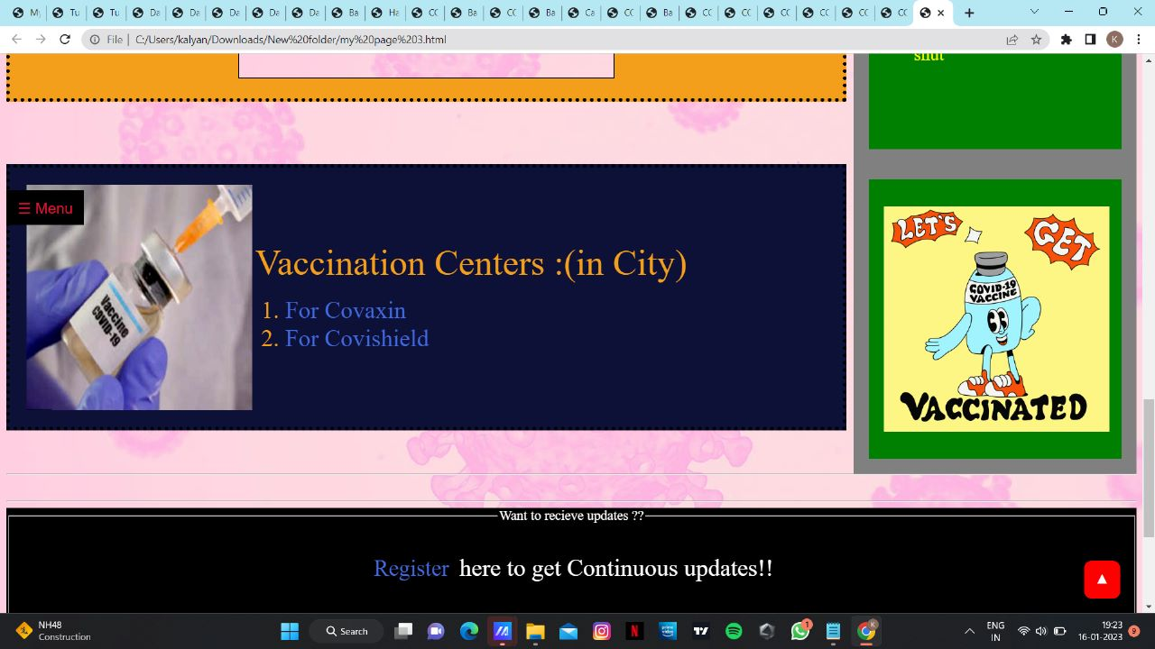

5)It gives the user access to the registration page and access to the social media handles and details about the web page developers.

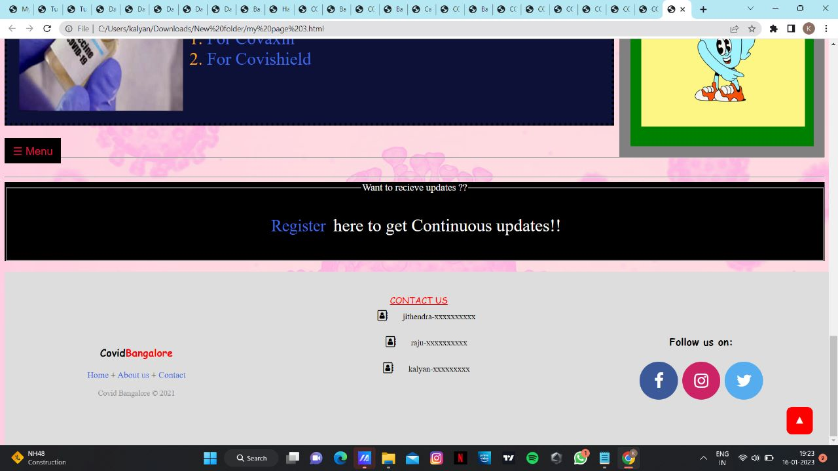

2. VACCINE REGISTRATION PAGE.

Helps the users to register themselves for the vaccine of their choice

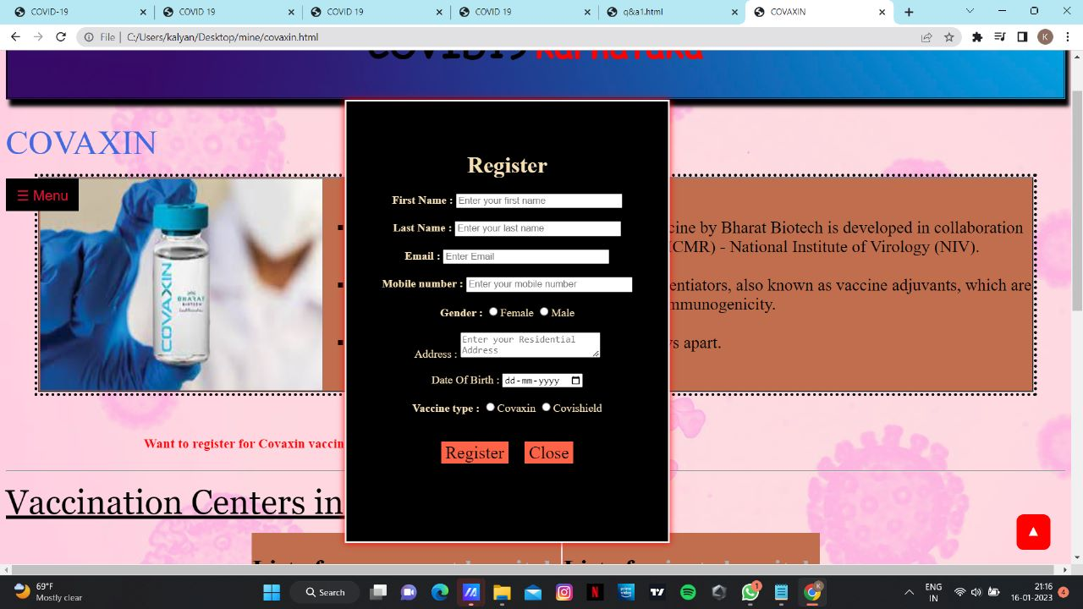

3. REGISTRATION PAGE.

Helps the users to register to the website,so that they can receive updates.

