GCP E-COMMERCE DATA ENGINEERING PROJECT

Project flow in simple words
DummyJSON API → Python → Pub/Sub topic → Cloud Storage Bronze → Spark processing → Silver data → Cloud Spanner / BigQuery → Gold analytics. Cloud Composer and Airflow are used to schedule and coordinate tasks when the workflow is configured.

What each service does
- DummyJSON API: provides sample e-commerce cart and product data.
- Python: calls the API, checks the response, adds metadata, and prepares JSON events.
- Pub/Sub: receives messages from Python and separates the producer from downstream consumers.
- Cloud Storage Bronze: stores the original raw messages before transformation.
- Dataproc / Spark: processes and cleans data in a distributed processing job.
- Silver: stores cleaned and structured data, commonly in Parquet format.
- Cloud Spanner: stores structured records when required by the solution.
- BigQuery: runs SQL for analytics and creates business-ready summaries.
- Cloud Composer / Airflow: schedules and coordinates pipeline tasks.
Accuracy note: DummyJSON is a sample API. This project is a learning/demo pipeline, so describe it as a near-real-time simulation rather than a production live-order system. Only claim a stage is fully working after confirming its output and logs.

Screenshot 1: Connecting to the e-commerce API
What I did: I used Python to connect to the DummyJSON e-commerce API. The API is the source of the sample data. I checked the response so I could confirm that the request worked before processing the data.
Technical terms: REST API, HTTP request, response status, source system.
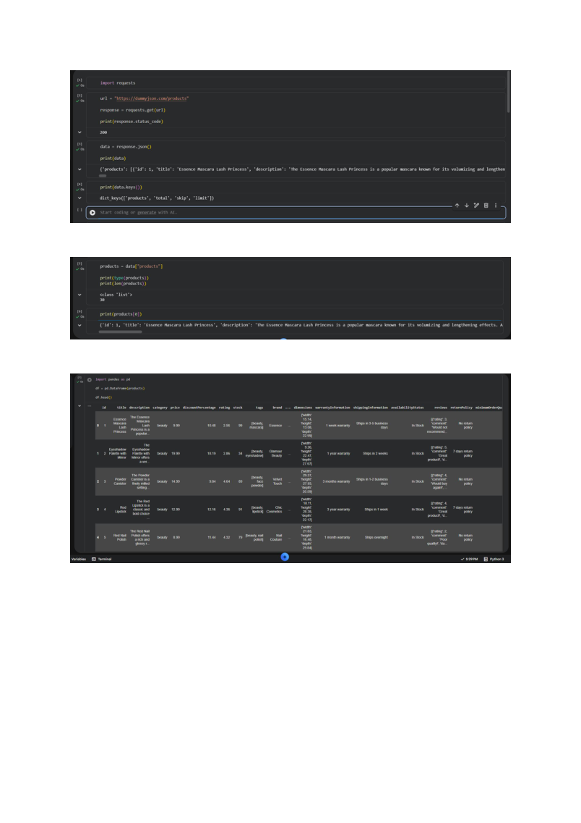

Screenshot 2: Checking the data returned by the API
What I did: I looked at the records returned by the API to understand what information was available. This helps me identify the fields and structure before sending the data to Google Cloud.
Technical terms: JSON, source fields, schema inspection, data profiling.
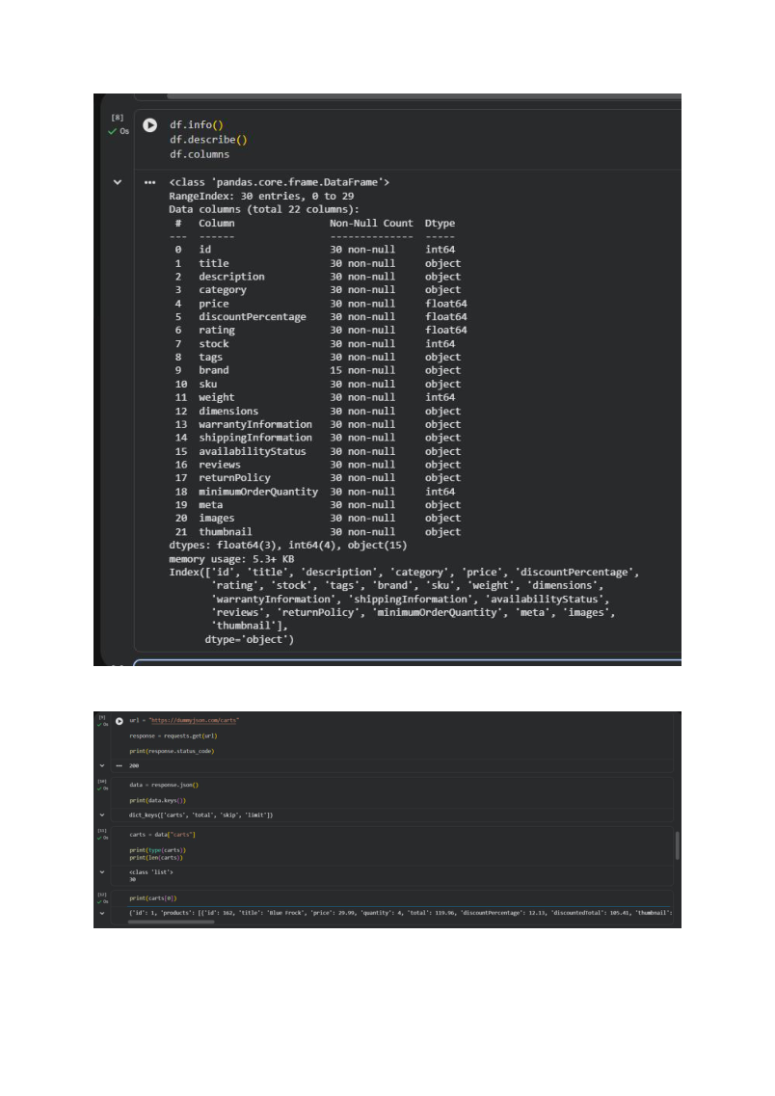

Screenshot 3: Understanding the source data structure
What I did: I reviewed the sample records and their nested fields. This is important because cart information can contain a list of products, so I need to understand the structure before transforming it.
Technical terms: nested JSON, records, attributes, source-to-target mapping.
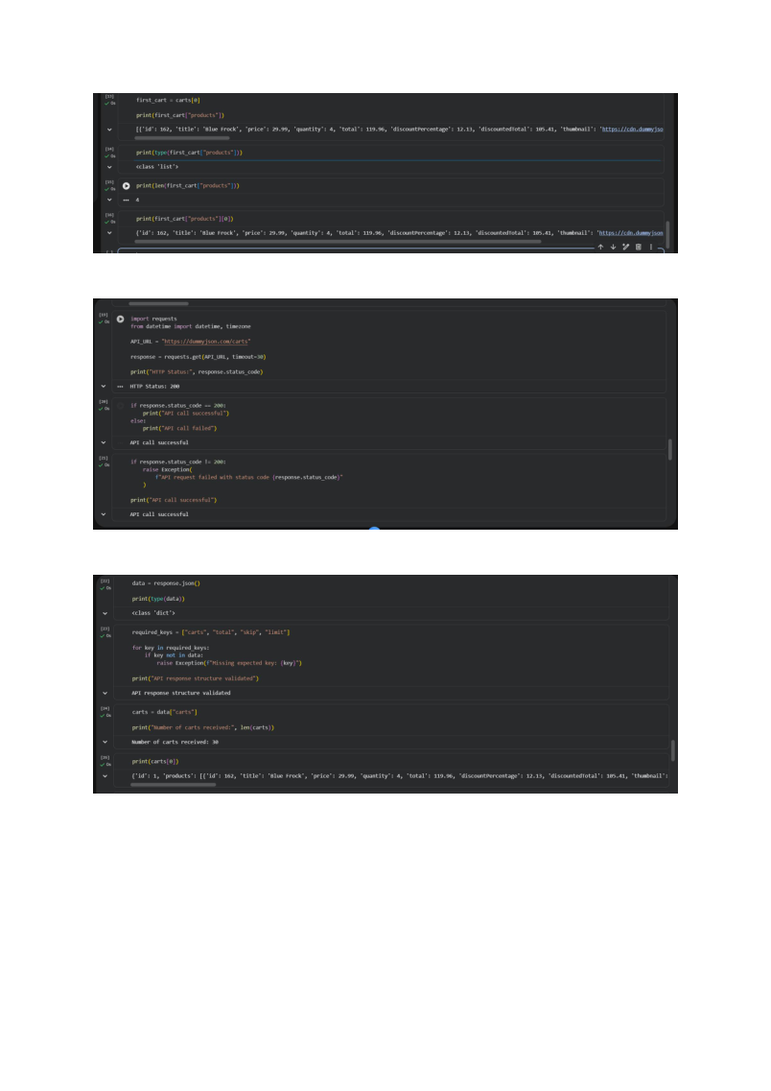

Screenshot 4: Preparing event records in Python
What I did: I used Python to create an event for each cart record. I added an event type, the source name, an ingestion timestamp, and the original API data. The timestamp helps identify when the record entered the pipeline.
Technical terms: event payload, metadata, ingestion timestamp, UTC, JSON serialization.
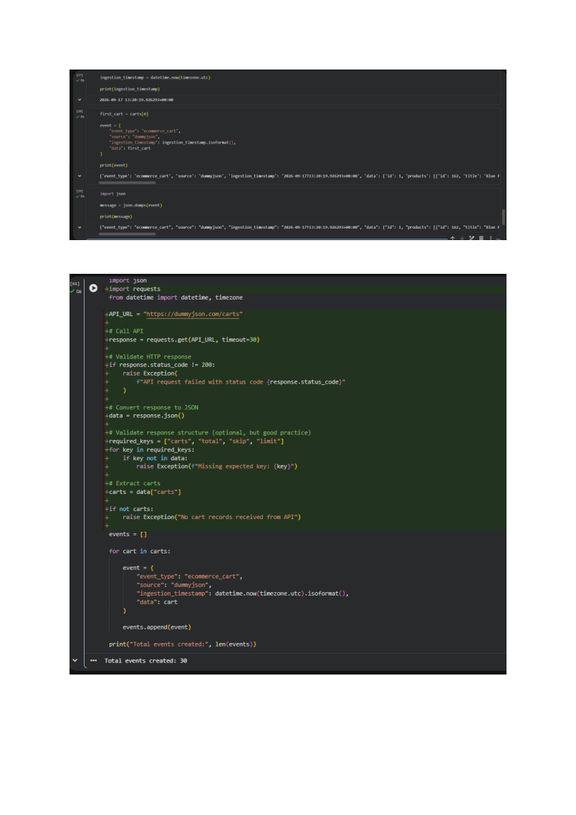

Screenshot 5: Checking the number of records
What I did: I checked the API response and prepared the returned cart records for publishing. In this sample run, the API returned 30 cart records. This is a controlled test batch, not a production-scale data volume.
Technical terms: validation, batch, record count, error handling.
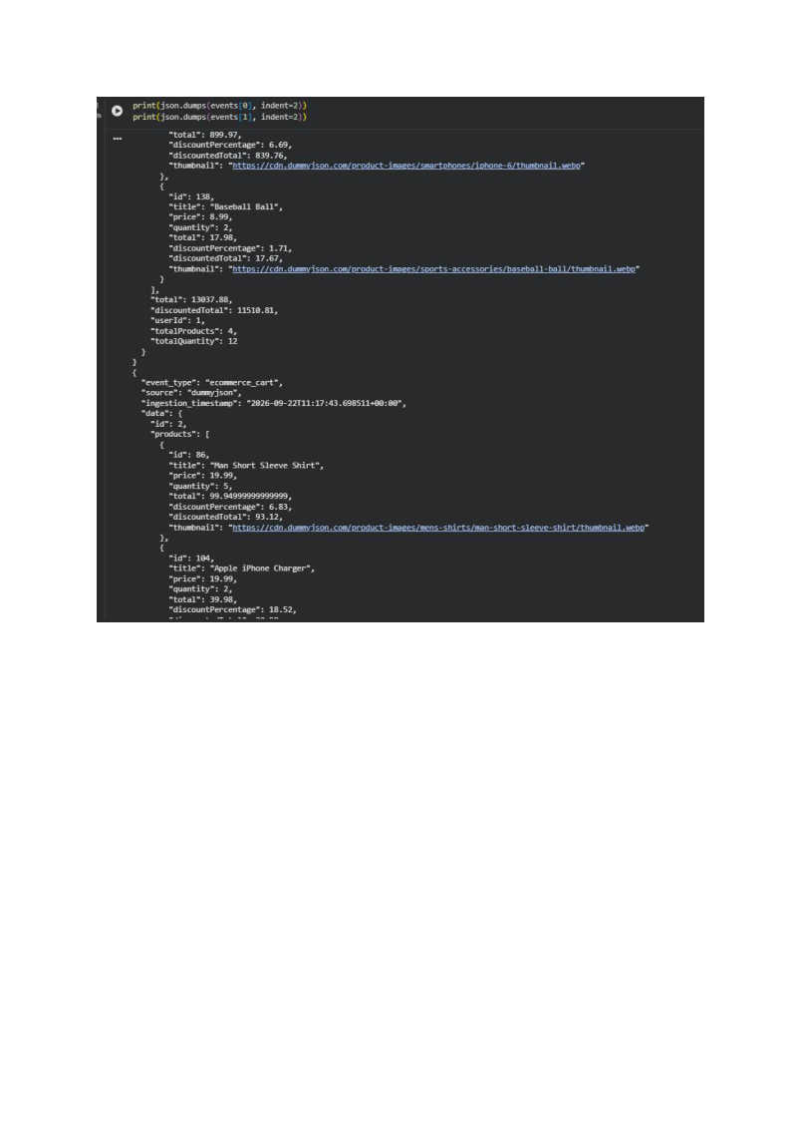

Screenshot 6: Preparing messages for Pub/Sub
What I did: I prepared the event data as JSON messages. JSON keeps the original fields and nested product details together, making it suitable for sending messages through Pub/Sub and storing raw data.
Technical terms: JSON message, producer, serialization, raw payload.
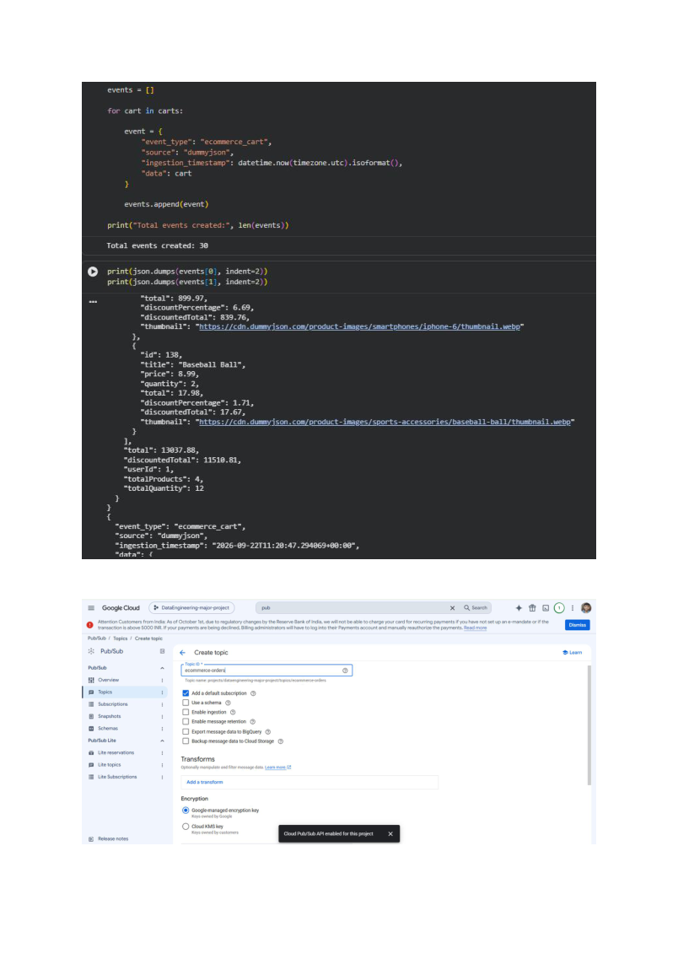

Screenshot 7: Opening the Google Cloud project
What I did: I used the Google Cloud Console and selected the project used for this work: dataengineering-major-project. Keeping the correct project selected ensures that the resources I create belong to the intended environment.
Technical terms: Google Cloud Console, project ID, cloud resources.
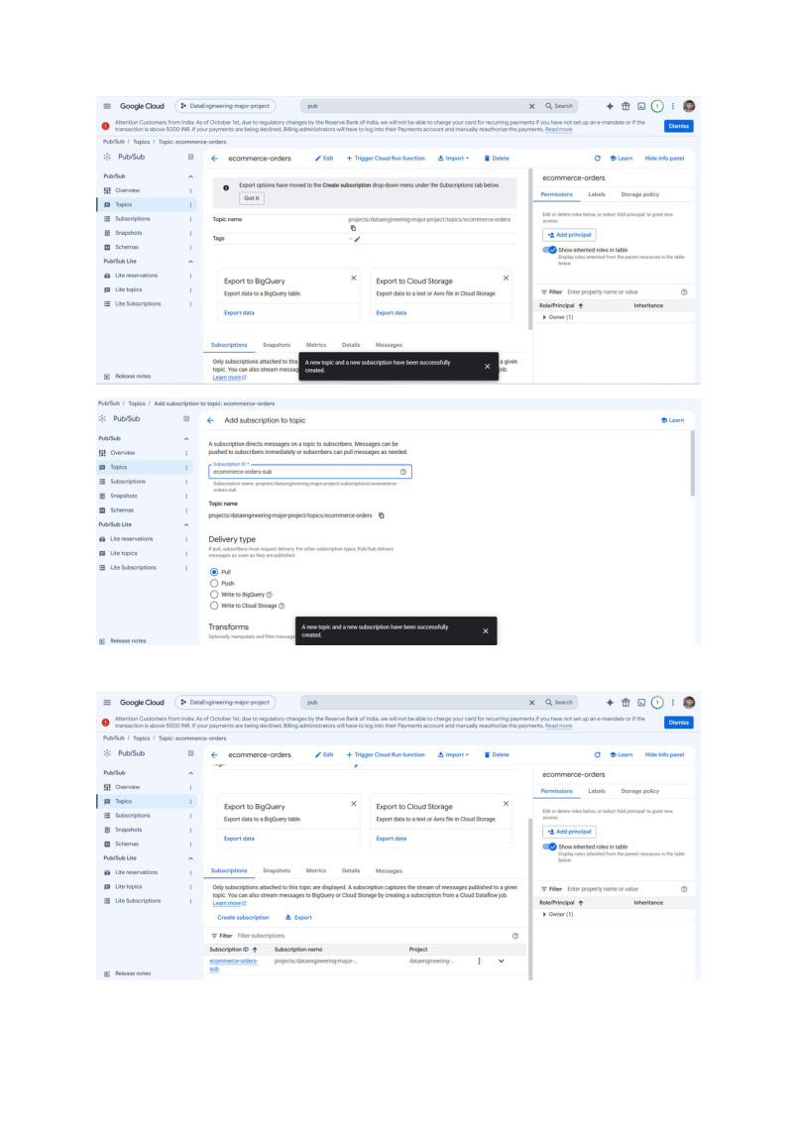

Screenshot 8: Creating the Bronze storage bucket
What I did: I created a Cloud Storage bucket to hold the original incoming messages. This is the Bronze layer: the place where I keep raw data before applying cleaning or business transformations.
Technical terms: Cloud Storage, bucket, Bronze layer, raw data, object storage.
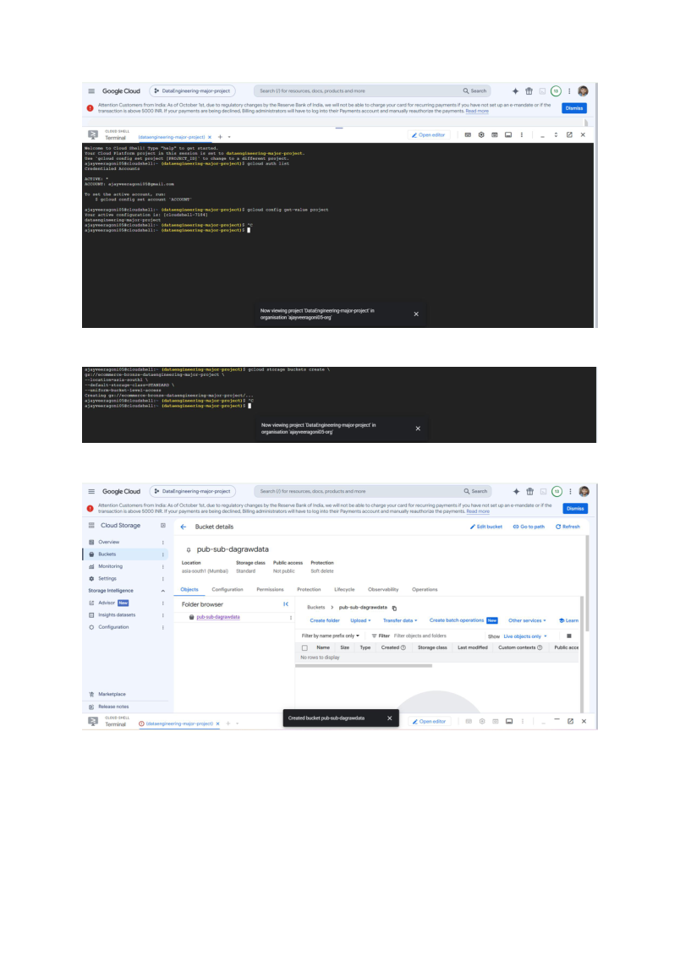

Screenshot 9: Reviewing bucket settings
What I did: I reviewed the bucket configuration and access settings. These settings control where the data is stored and which identities are allowed to access it.
Technical terms: bucket location, IAM permissions, access control, storage configuration.
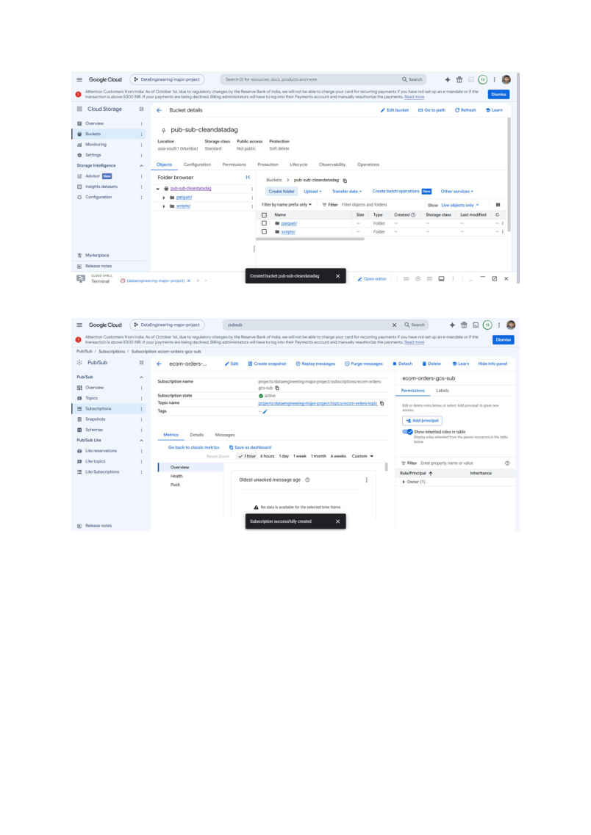

Screenshot 10: Setting up the data storage and analytics services
What I did: I reviewed the setup screens for Cloud Spanner and BigQuery, which are part of the planned downstream architecture. Spanner is used for structured operational data, while BigQuery is used for analytics and SQL-based reporting.
Technical terms: Cloud Spanner, BigQuery, database, analytical warehouse.
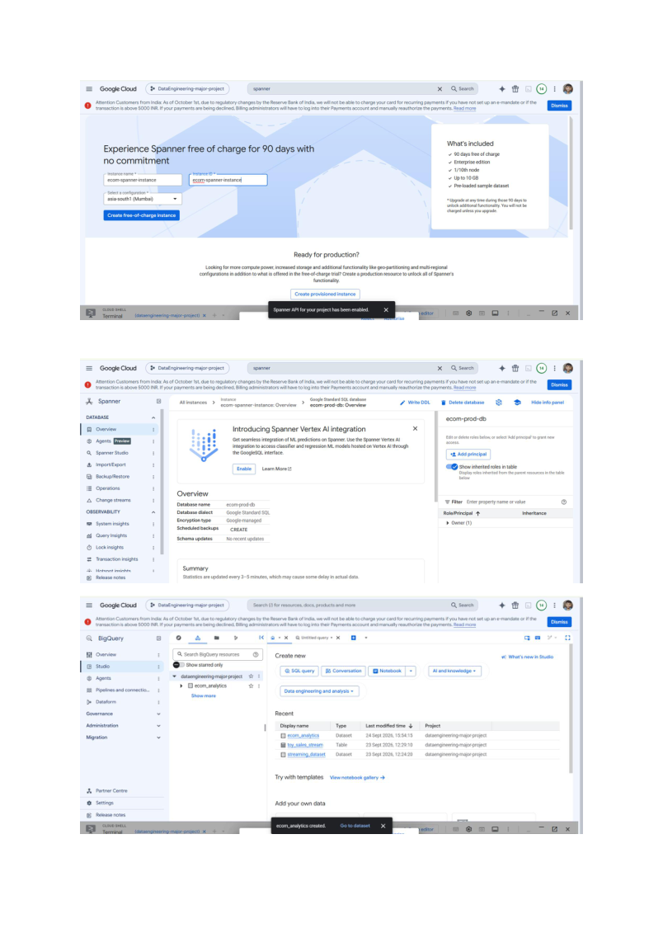

Screenshot 11: Checking the database and dataset areas
What I did: I opened the database and BigQuery areas to check the resources and prepare for later data loading and querying. Creating a resource is only the setup step; I still need to verify that data is loaded and queries return the expected results.
Technical terms: database, dataset, table, schema, query validation.
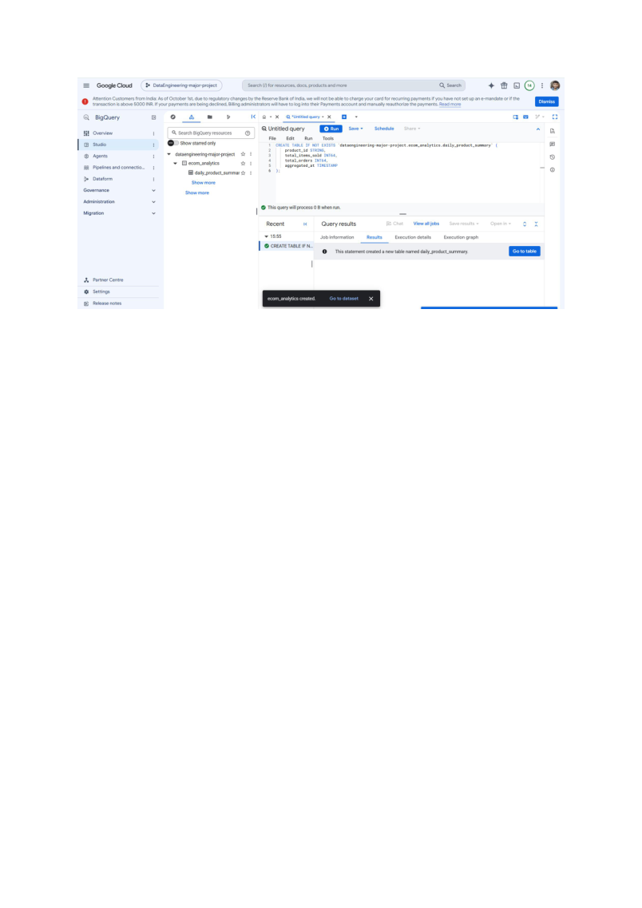

Screenshot 12: Preparing the BigQuery workspace
What I did: I reviewed the BigQuery workspace where analytical SQL will be run. This is where I can inspect data, test queries, and create a business-ready summary after the upstream data is available.
Technical terms: BigQuery console, SQL editor, analytical query, Gold layer.
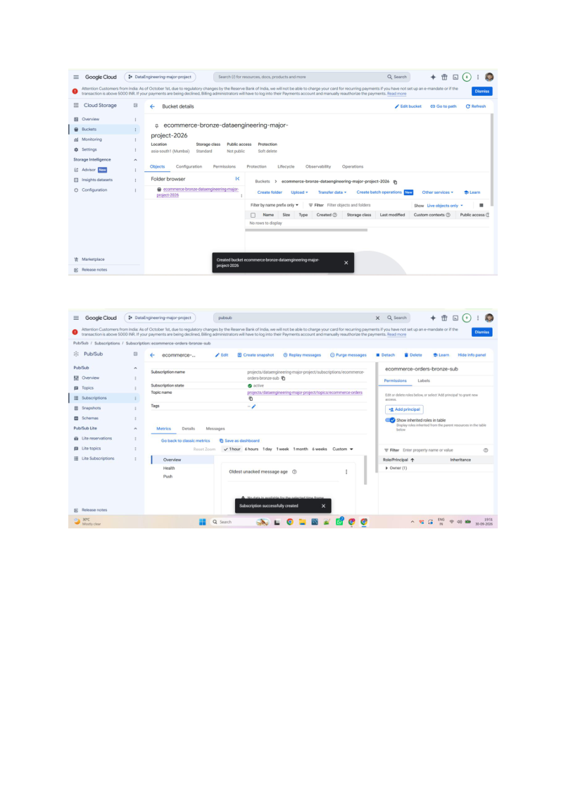

Screenshot 13: Reviewing the Python ingestion logic
What I did: I reviewed the Python code used to retrieve and prepare the API data. Keeping ingestion code separate from cloud configuration makes it easier to understand and troubleshoot each part of the pipeline.
Technical terms: Python, API ingestion, validation, reusable code.
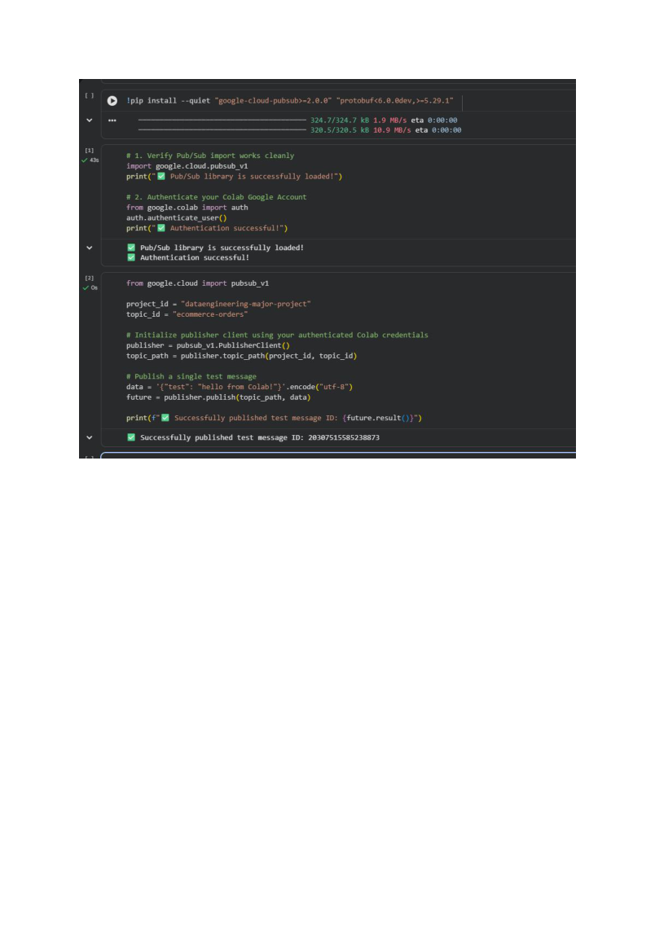

Screenshot 14: Building the event payload
What I did: I used Python to wrap each cart record with event metadata and prepare it for publishing. The original source data remains inside the event so it can be inspected or processed later.
Technical terms: event envelope, source metadata, payload, traceability.
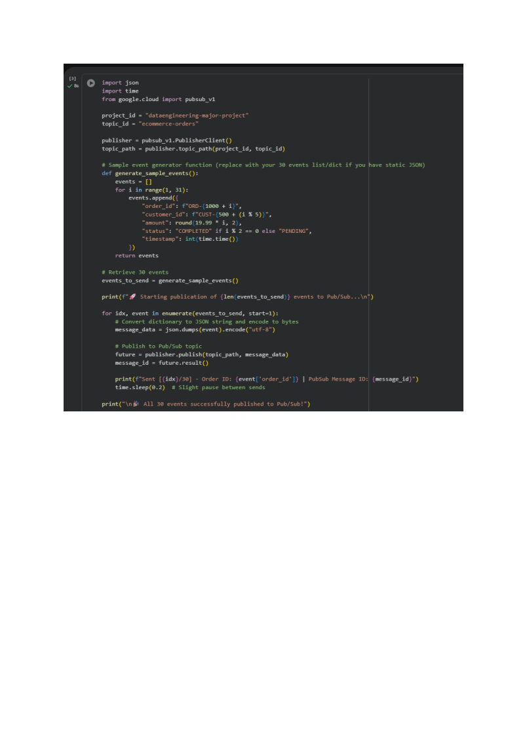

Screenshot 15: Inspecting the sample records and publishing setup
What I did: I reviewed the sample records and the publishing output. This helps me check that the messages contain the expected fields before I rely on Pub/Sub to deliver them to the next stage.
Technical terms: message publishing, sample validation, event structure.
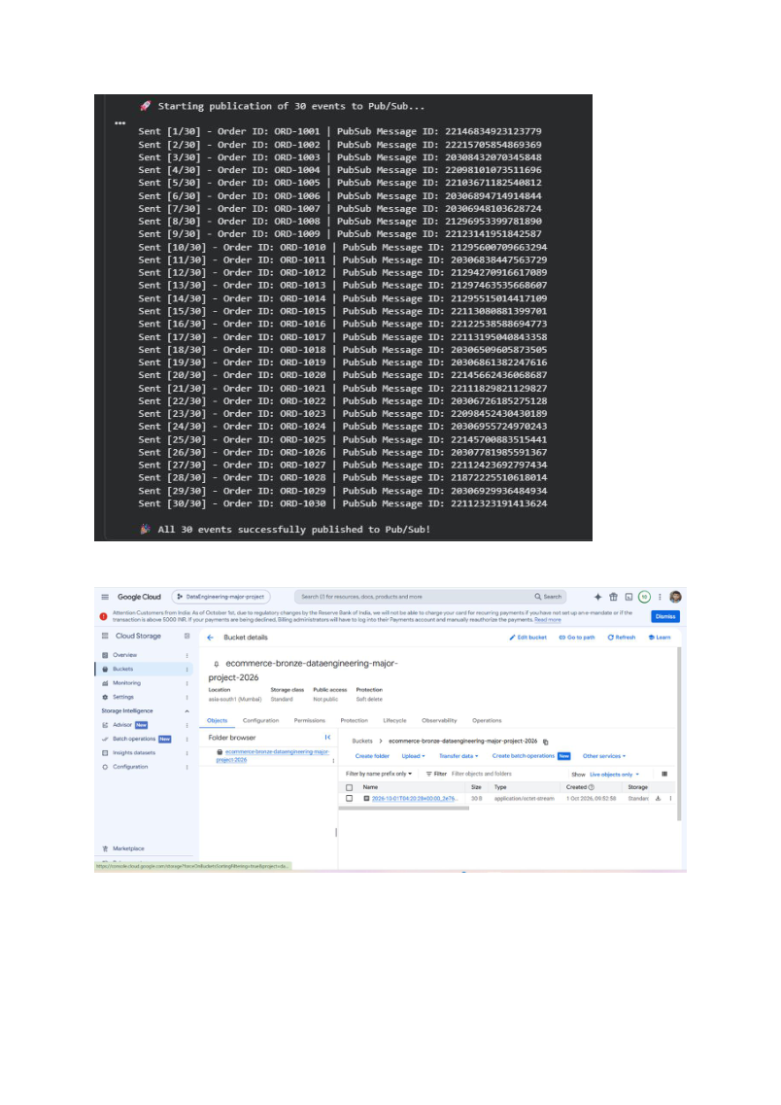

Screenshot 16: Checking the cloud resources after publishing
What I did: I checked the Google Cloud Console after the publishing step. A successful publish means Pub/Sub accepted a message; I also need to check the Bronze bucket to confirm that the storage subscription wrote an object.
Technical terms: Pub/Sub topic, subscription, delivery confirmation, end-to-end validation.
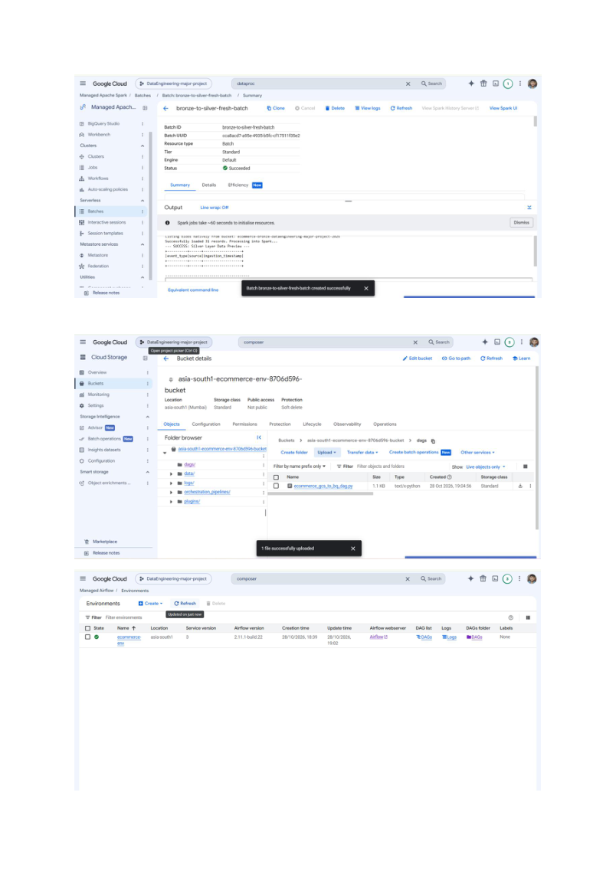

Screenshot 17: Reviewing the Airflow workflow
What I did: I used the Airflow interface to review the workflow (DAG) that is intended to coordinate the pipeline tasks. Airflow controls the order in which tasks run; the data transformation itself is performed by the processing job.
Technical terms: Cloud Composer, Apache Airflow, DAG, task dependency, orchestration.
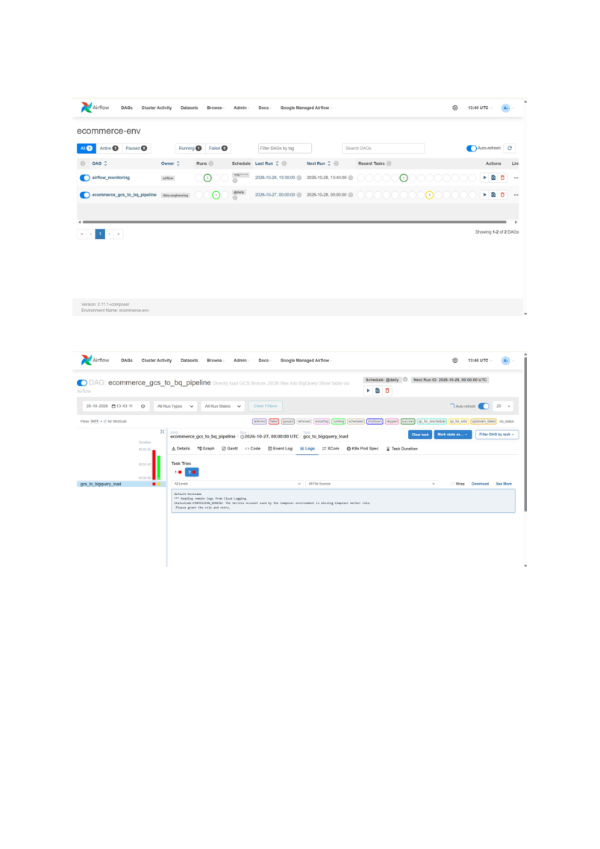

Screenshot 18: Checking a workflow run and its logs
What I did: I reviewed the DAG run and task logs to understand whether tasks started, completed, or failed. Logs help identify where an issue occurred and what needs to be corrected.
Technical terms: DAG run, task status, execution log, monitoring, troubleshooting.

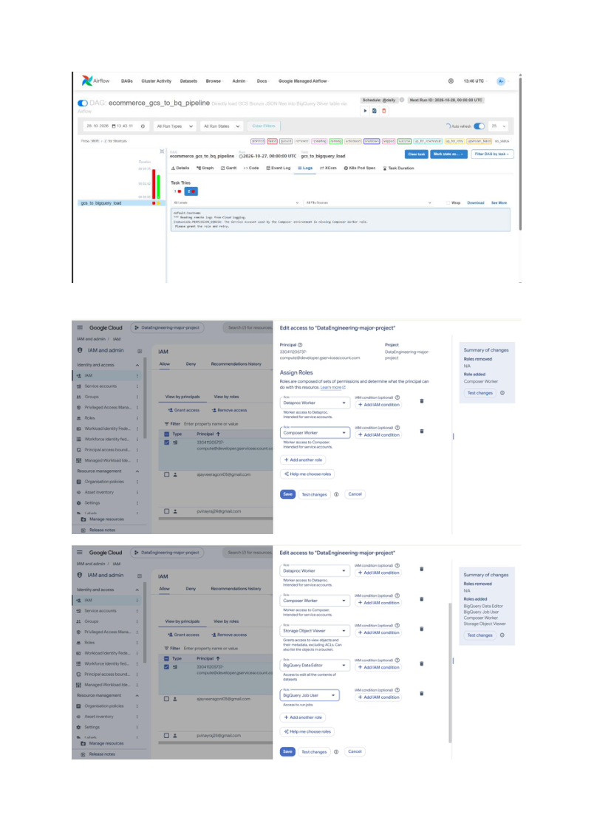

Screenshot 19: Reviewing output and data records
What I did: I inspected the displayed output to understand the records produced or returned at this stage. I use these results to compare the data structure with what the next pipeline step expects.
Technical terms: output validation, schema consistency, record inspection.
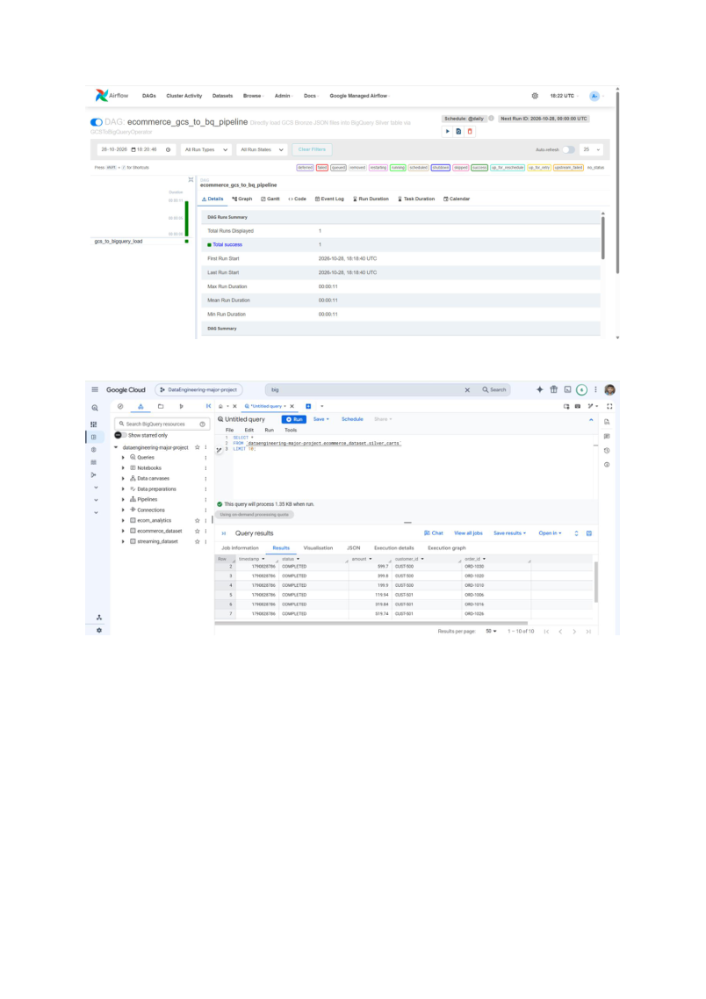

Screenshot 20: Checking the pipeline resources
What I did: I reviewed the resource and workflow screens as part of checking the overall setup. For a complete validation, I need evidence from each stage rather than relying only on a resource being visible in the console.
Technical terms: resource verification, pipeline monitoring, validation checklist.
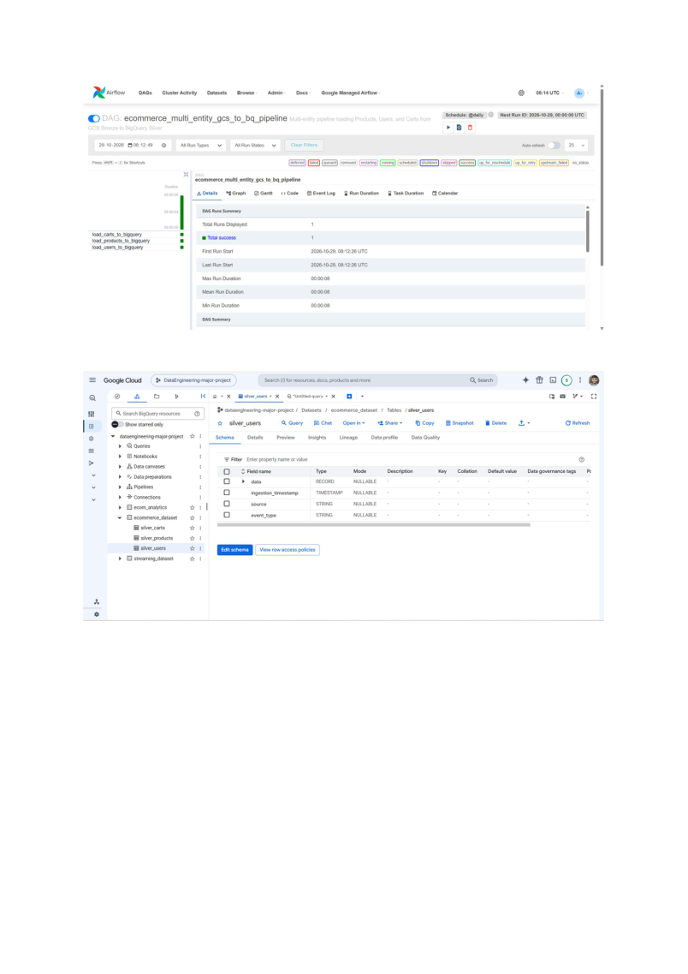

Screenshot 21: Inspecting BigQuery and data outputs
What I did: I reviewed the BigQuery screen and available output to prepare for analytical validation. The next check is to run a query and confirm that the results match the expected data and business rules.
Technical terms: SQL query, result set, analytical validation, business logic.
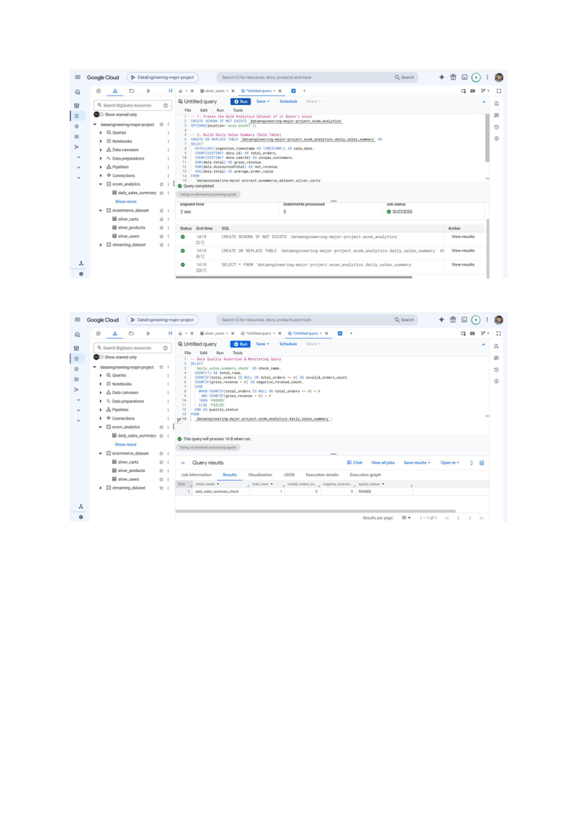

Screenshot 22: Reviewing the final query and workflow evidence
What I did: I reviewed the final screenshots showing the query or workflow interface. These screenshots help document the steps taken, while successful completion should be confirmed from task status and actual output data.
Technical terms: query execution, workflow status, evidence, reconciliation.
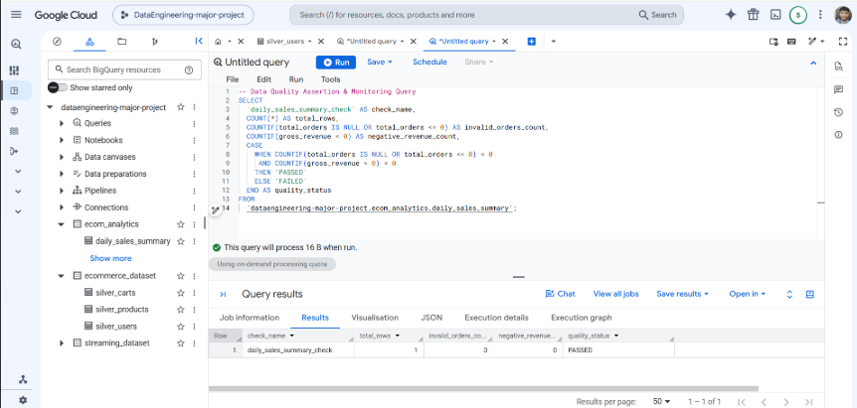

Interview explanation
I built a sample e-commerce data pipeline using Python to retrieve data from a REST API, validate the response, add ingestion metadata, and publish JSON events to Google Cloud Pub/Sub. I configured Cloud Storage as the Bronze landing layer for raw messages. The downstream design uses Spark processing to clean and structure the data, Cloud Storage for the Silver layer, Cloud Spanner for selected structured records, and BigQuery for SQL-based analytics and Gold summaries. Cloud Composer with Apache Airflow is used to coordinate tasks and monitor workflow runs. I validate the pipeline by checking message delivery, files, schemas, record counts, query results, and task logs.

Checklist before saying the pipeline is complete
- A fresh Pub/Sub message is visible as an object in the Bronze bucket.
- The raw JSON object contains the expected event metadata and source payload.
- The Spark job completes and writes cleaned data to the Silver location.
- Spanner contains the expected records and schema.
- The BigQuery external query runs and returns the expected rows.
- The Gold summary has been created and checked against business rules.
- The Airflow DAG run and its tasks show successful status.

