**What is AWS Billing Conductor?**

AWS Billing Conductor is a **custom billing service** designed for AWS Marketplace Channel Partners and organizations with chargeback requirements.

**Key Features of AWS Billing Conductor**

* **Custom Pricing Rules** – Define global, service-specific, or SKU-based pricing rules for billing groups.
* **Billing Groups** – Organize accounts into billing groups for aggregated cost visibility.
* **Pro Forma Costs** – Generate a second version of costs to match internal financial models.
* **Cost & Usage Reports (CUR)** – Create detailed reports for each billing group.
* **Custom Line Items** – Add credits or fees to billing statements for better cost allocation

**What are AWS Budgets and different types of budget. Create 4 different Budgets and share snippet of the same**

AWS Budgets is a **cost management tool** that helps users track and control their AWS spending. It allows businesses to set **custom budgets** for cost, usage, and reservations, ensuring they stay within financial limits.

### ****Types of AWS Budget**** **Cost Budgets**

* Set spending limits for AWS services.
* Receive alerts when costs approach or exceed the defined threshold.

2️ **Usage Budgets**

* Establish usage limits for specific AWS services.
* Get notified when usage exceeds the set threshold.

3️ **Reserved Instance (RI) Utilization Budgets**

* Define a utilization threshold for Reserved Instances.
* Receive alerts when RI usage falls below the set percentage.

4️ **Reserved Instance (RI) Coverage Budgets**

* Track the percentage of instance hours covered by RIs.
* Get notified when coverage drops below the defined level.

5️ **Savings Plans Utilization Budgets**

* Monitor Savings Plan utilization to ensure cost efficiency.
* Receive alerts when usage falls below the set threshold.

6️ **Savings Plans Coverage Budgets**

* Track how much of your eligible usage is covered by Savings Plans.
* Get notified when coverage drops below the defined level.

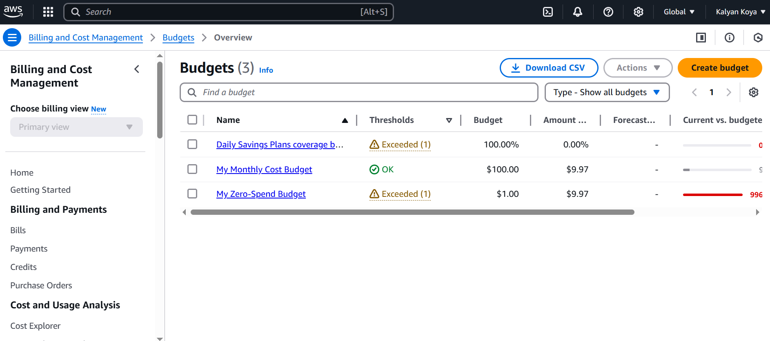

**What is AWS Cost and Usage Report and demo on the same?**

The **AWS Cost and Usage Report (CUR)** provides detailed insights into your AWS spending and resource usage.

### ****Key Features of AWS Cost and Usage Report****

* **Comprehensive Cost Data** – Includes detailed breakdowns of AWS service usage, pricing, and reservations.
* **Customizable Reports** – Allows users to filter data by **hour, day, or month** for better cost tracking.
* **Integration with Analytics Tools** – Supports **Amazon Athena, Redshift, and QuickSight** for deeper analysis.
* **Automated Delivery** – Reports are sent to an **Amazon S3 bucket** daily for easy access.
* **Cost Optimization Insights** – Helps identify **unused resources** and **cost-saving opportunities**.

**What is AWS Cost Explorer, share screenshot of Cost Explorer?**

AWS Cost Explorer is a **cost management tool** that helps users visualize, analyse, and optimize their AWS spending.

### ****Key Features of AWS Cost Explorer****

* **Interactive Graphs & Reports** – Visualize cost and usage data with customizable charts.
* **Filtering & Grouping** – Break down costs by **service, region, account, or tags**.
* **Cost Forecasting** – Predict future AWS expenses based on historical trends.
* **Reserved Instance (RI) & Savings Plan Analysis** – Identify potential savings opportunities.
* **API Access**

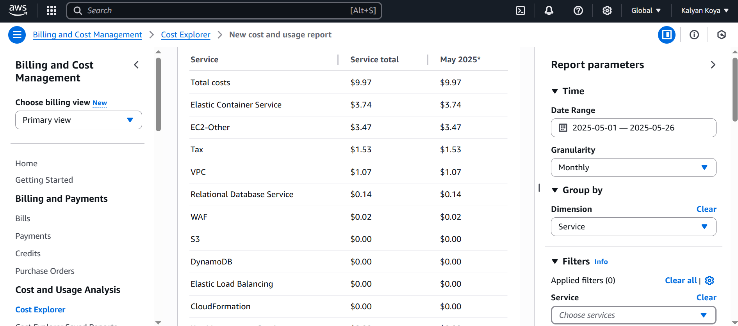

**What is AWS Marketplace?**

AWS Marketplace is a **digital Catalog** where businesses can find, buy, deploy, and manage **third-party software, data, and services** that run on AWS. It offers a wide range of solutions, including **security tools, business applications, machine learning models, and industry-specific software**.

### ****Key Features of AWS Marketplace****

* **Curated Software Listings** – Thousands of products from **independent software vendors (ISVs)** and AWS partners.
* **Flexible Pricing Models** – Supports **pay-as-you-go, subscription-based, and contract pricing**.
* **Easy Deployment** – Preconfigured software solutions that integrate seamlessly with AWS services.
* **Centralized Billing & Cost Management** – Consolidates third-party software costs into AWS invoices for better financial tracking.
* **Security & Compliance** – Offers solutions that meet **industry security standards** and compliance requirements