**Demo on AWS Cloud Trail?**

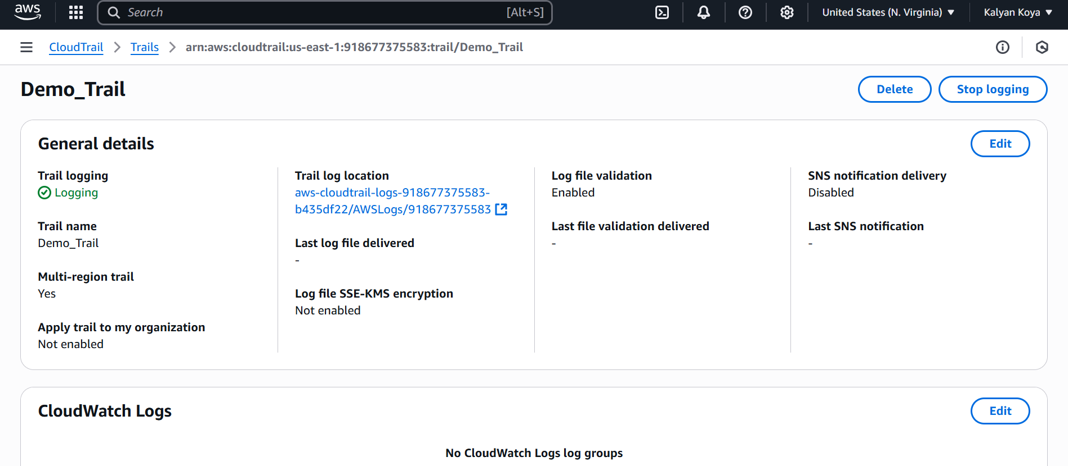

**What is AWS Compute Optimizer?**

* AWS Compute Optimizer analyses your AWS resources configuration and utilization metrics to provide **rightsizing recommendations**.
* It helps optimize costs and improve performance by suggesting better instance types, storage configurations, and scaling options

**Demo is AWS Config?**

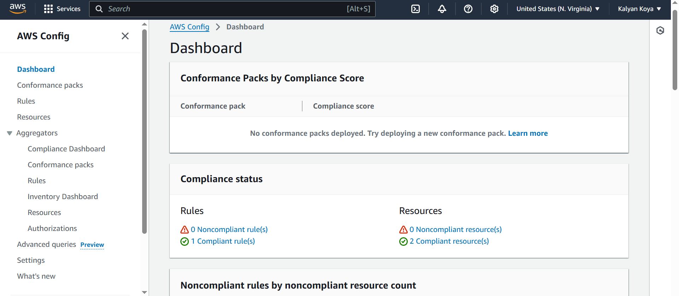

**What is AWS Control Tower?**

* AWS Control Tower simplifies setting up and governing a **multi-account AWS environment**.
* It provides automation, built-in governance, and security controls to help organizations maintain compliance and best practices

**What is AWS Health Dashboard ++ Console Snippets?**

* AWS Health Dashboard provides **real-time updates** on AWS service health and account-specific events.
* It helps users monitor outages, scheduled maintenance, and security notifications

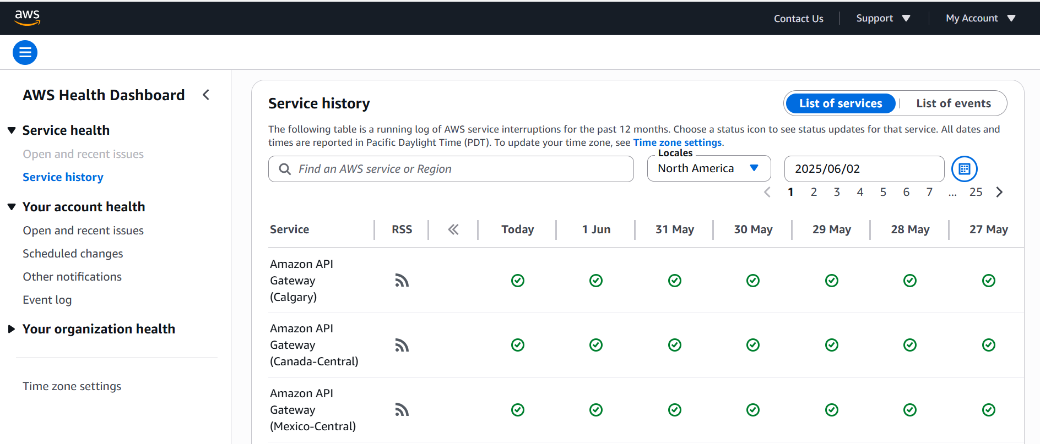

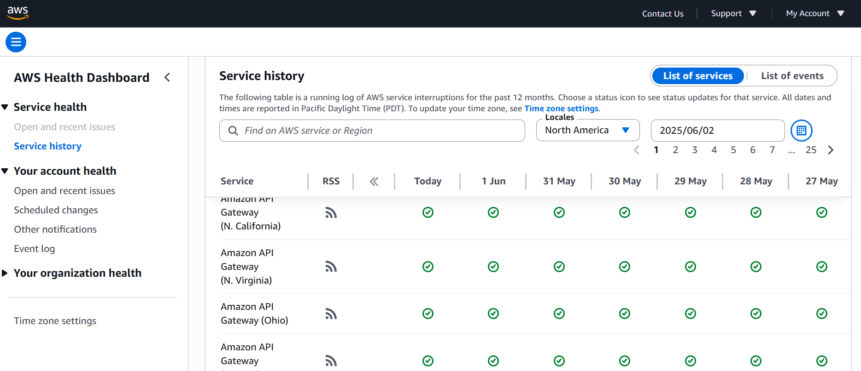

**What is AWS License Manager?**

* AWS License Manager helps organizations **track, manage, and optimize software licenses** across AWS and on-premises environments.
* It reduces compliance risks and ensures efficient license usage

**Demo on AWS Resource Groups and Tag Editor?**

* AWS Resource Groups allow users to **organize AWS resources** based on tags, making management easier.
* The **Tag Editor** enables bulk tagging and searching for resources across AWS accounts

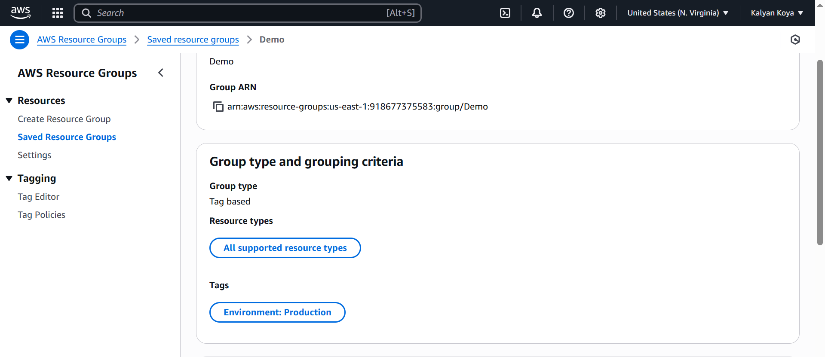

**What is AWS Service Catalog?**

* AWS Service Catalog enables organizations to **create and manage catalogs of approved IT services**.
* It helps standardize deployments, enforce governance, and provide self-service access to cloud resources

**What is AWS Systems Manager + Demo**

* AWS Systems Manager provides a **centralized hub** for managing AWS resources, automating tasks, and improving operational efficiency.
* It includes tools for patch management, remote access, and configuration tracking

**What are AWS Trusted Advisor?**

* AWS Trusted Advisor offers **best practice recommendations** to optimize costs, improve security, and enhance performance.
* It continuously evaluates AWS environments and provides actionable insights

**What are AWS Well-Architected Tool + Demo**

* AWS Well-Architected Tool helps organizations **assess and improve their cloud architectures** based on AWS best practices.
* It provides structured guidance across six pillars: **security, reliability, performance, cost optimization, operational excellence, and sustainability**

