1. Create AWS Account

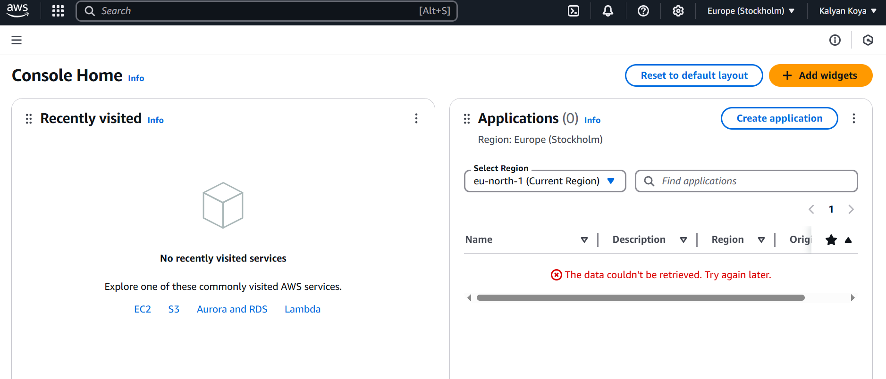

1. Enable any 5 AWS Regions

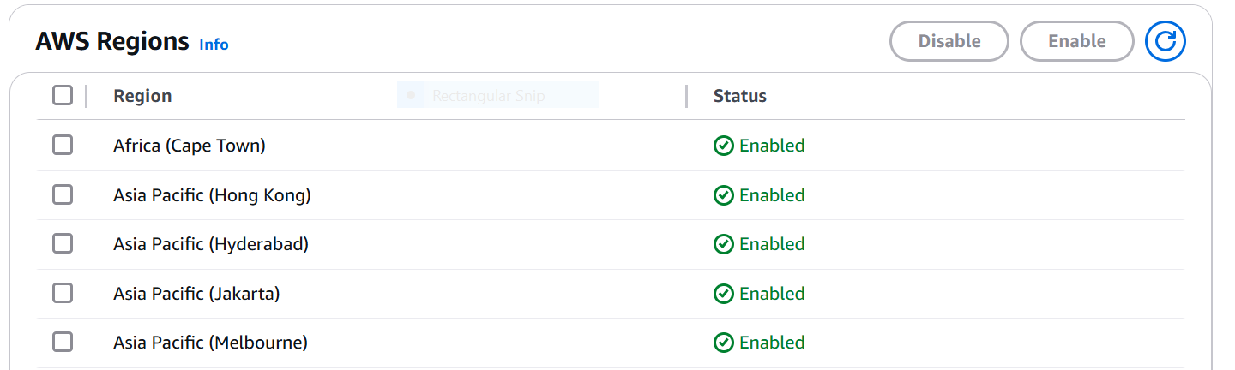

1. Check number of Availability zones, Local zones and Wavelength Zones in North Virginia, Ohio, Mumbai, Singapore, Sydney, Oregon and update it in the excel sheet.

|  |  |  |  |  |  |  |  |  |
| --- | --- | --- | --- | --- | --- | --- | --- | --- |
| Regions |  |  |  |  |  |  |  |  |
| North Virginia | Availability-Zones | us-east-1a | us-east-1b | us-east-1c | us-east-1d | us-east-1e | us-east-1f | 6 |
| Ohio | Availability-Zones | us-east-2a | us-east-2b | us-east-2c |  |  |  | 3 |
| Mumbai | Availability-Zones | ap-south-1a | ap-south-1b | ap-south-1c |  |  |  | 3 |
| Singapore | Availability-Zones | ap-southeast-1a | ap-southeast-1b | ap-southeast-1c |  |  |  | 3 |
| Sydney | Availability-Zones | ap-southeast-2a | ap-southeast-2b | ap-southeast-2c |  |  |  | 3 |
| Oregon | Availability-Zones | us-west-2a | us-west-2b | us-west-2c | us-west-2d |  |  | 4 |

1. Example of AWS Services for IaaS, PaaS, SaaS.

* **Infrastructure as a Service (IaaS)**
* **Amazon EC2** – Virtual machines with scalable compute capacity.
* **Amazon S3** – Object storage for files and backups.
* **Amazon VPC** – Isolated cloud environment for networking.
* **Amazon RDS** – Managed database service (supports MySQL, PostgreSQL, etc.).
* **AWS Elastic Load Balancing (ELB)** – Distributes incoming traffic for scalability.
* **Amazon EBS** – Block storage for EC2 instances.
* **Software as a Service (SaaS)**
* **AWS Workspaces** – Cloud-based virtual desktops.
* **AWS Backup** – Automated backup service.
* **Amazon Connect** – Cloud-based customer contact centre.
* **AWS Managed Services** – Fully managed infrastructure and operations support.
* **AWS Chime** – Video conferencing and chat solution.
* **Amazon Quick Sight** – Business intelligence (BI) tool for data visualization.
* **Platform as a Service (PaaS)**
* **AWS Elastic Beanstalk** – Deploy and manage web apps with minimal configuration.
* **AWS Lambda** – Serverless function execution for event-driven computing.
* **AWS Faregate** – Managed container service for ECS/EKS.
* **Amazon API Gateway** – Create and manage APIs easily.
* **AWS Step Functions** – Orchestrate serverless workflows.
* **Amazon Aurora Serverless** – Auto-scaling database service.
* **What are the benefits of Cloud Computing.**
* **Cost Efficiency** – No need for expensive hardware; pay only for what you use.
* **Scalability** – Easily scale resources up or down based on demand.
* **Flexibility** – Access applications from anywhere, anytime.
* **Security** – Leading cloud providers offer robust security measures and compliance.

**Difference Between Private Cloud and Public Cloud**

| **Feature** | **Private Cloud** | **Public Cloud** |
| --- | --- | --- |
| **Ownership** | Owned by an organization | Managed by third-party providers (AWS, Azure, etc.) |
| **Security** | Higher security & customization | Shared infrastructure with strong security |
| **Scalability** | Limited by internal resources | Virtually unlimited scalability |
| **Cost** | Expensive (hardware & maintenance) | Pay-as-you-go model, cost-effective |
| **Accessibility** | Restricted to authorized users | Accessible over the internet from anywhere |
| **Customization** | Fully customizable | Limited customization options |

**Factors to consider when selecting an AWS Region.**

**Latency and Performance**: Choose a region closest to your target users or infrastructure to minimize latency and maximize speed.

**Compliance and Data Residency**: Ensure the region complies with local regulations regarding data storage and processing.

**Disaster Recovery and Redundancy**: Select multiple regions or use regions with high reliability for disaster recovery plans and redundancy.

**Cost**: Pricing varies across regions. Compare costs for compute, storage, and data transfer to optimize your budget.

|  |  |  |  |  |  |
| --- | --- | --- | --- | --- | --- |
|  | Athena | AWS Data Exchange | Cloud Search | Amazon Data Exchange | Amazon Data fireHose |
| **Compute** | AWS App Runner | Batch | EC2 | Lambda | AWS Outposts |
| **Database** | Aurora and RDS | DynamoDB | Aurora DSQL | Amazon DocumentDB | ElastiCache |
| **Developer Tools** | AWS App Studio | AWS AppConfig | Cloud9 | CloudShell | CodeBuild |
| **Migration & Transfer** | Application Discovery Service | Database Migration Service | DataSync | AWS Migration Hub | Amazon Elastic VMware Service |
| **Networking & Content Delivery** | API Gateway | AWS App Mesh | CloudFront | AWS Cloud Map | VPC |
| **Security, Identity, Compliance** | AWS Artifact | AWS Audit Manager | Certificate Manager | IAM | Key Management Service |
| **Storage** | AWS Backup | EFS | S3 | Storage Gateway | FSx |

**List any 5 services from Analytics, Compute, Database, Developer Tools, Migration & Transfer, Networking & Content Delivery, Security, Identity, & Compliance, Storage**

**What are local zones, Wavelength zones and Edge locations.**

**Local Zones**:

* Local Zones are extensions of AWS Regions that place compute, storage, and other services closer to major population and industry centres.
* They help achieve ultra-low latency for applications
* Example: If a business operates in a location far from a standard AWS Region, a Local Zone can bring the cloud infrastructure nearer to that location.

### ****Wavelength Zones****:

* Wavelength Zones are specialized zones designed for ultra-low latency applications running on **5G networks**.
* Use cases include real-time gaming, video streaming
* They embed AWS infrastructure directly into telecom providers' data centres at the edge of the 5G network.

### ****Edge Locations****:

* Edge locations are part of AWS's **Content Delivery Network (CDN)**, known as **Amazon CloudFront**.
* They are strategically placed data centres used to deliver cached content, such as videos, web pages, or files, to users with minimal latency.
* These locations play a critical role in improving performance and enabling fast content delivery to users worldwide.