**Launch RHEL Instance and connect to it.**

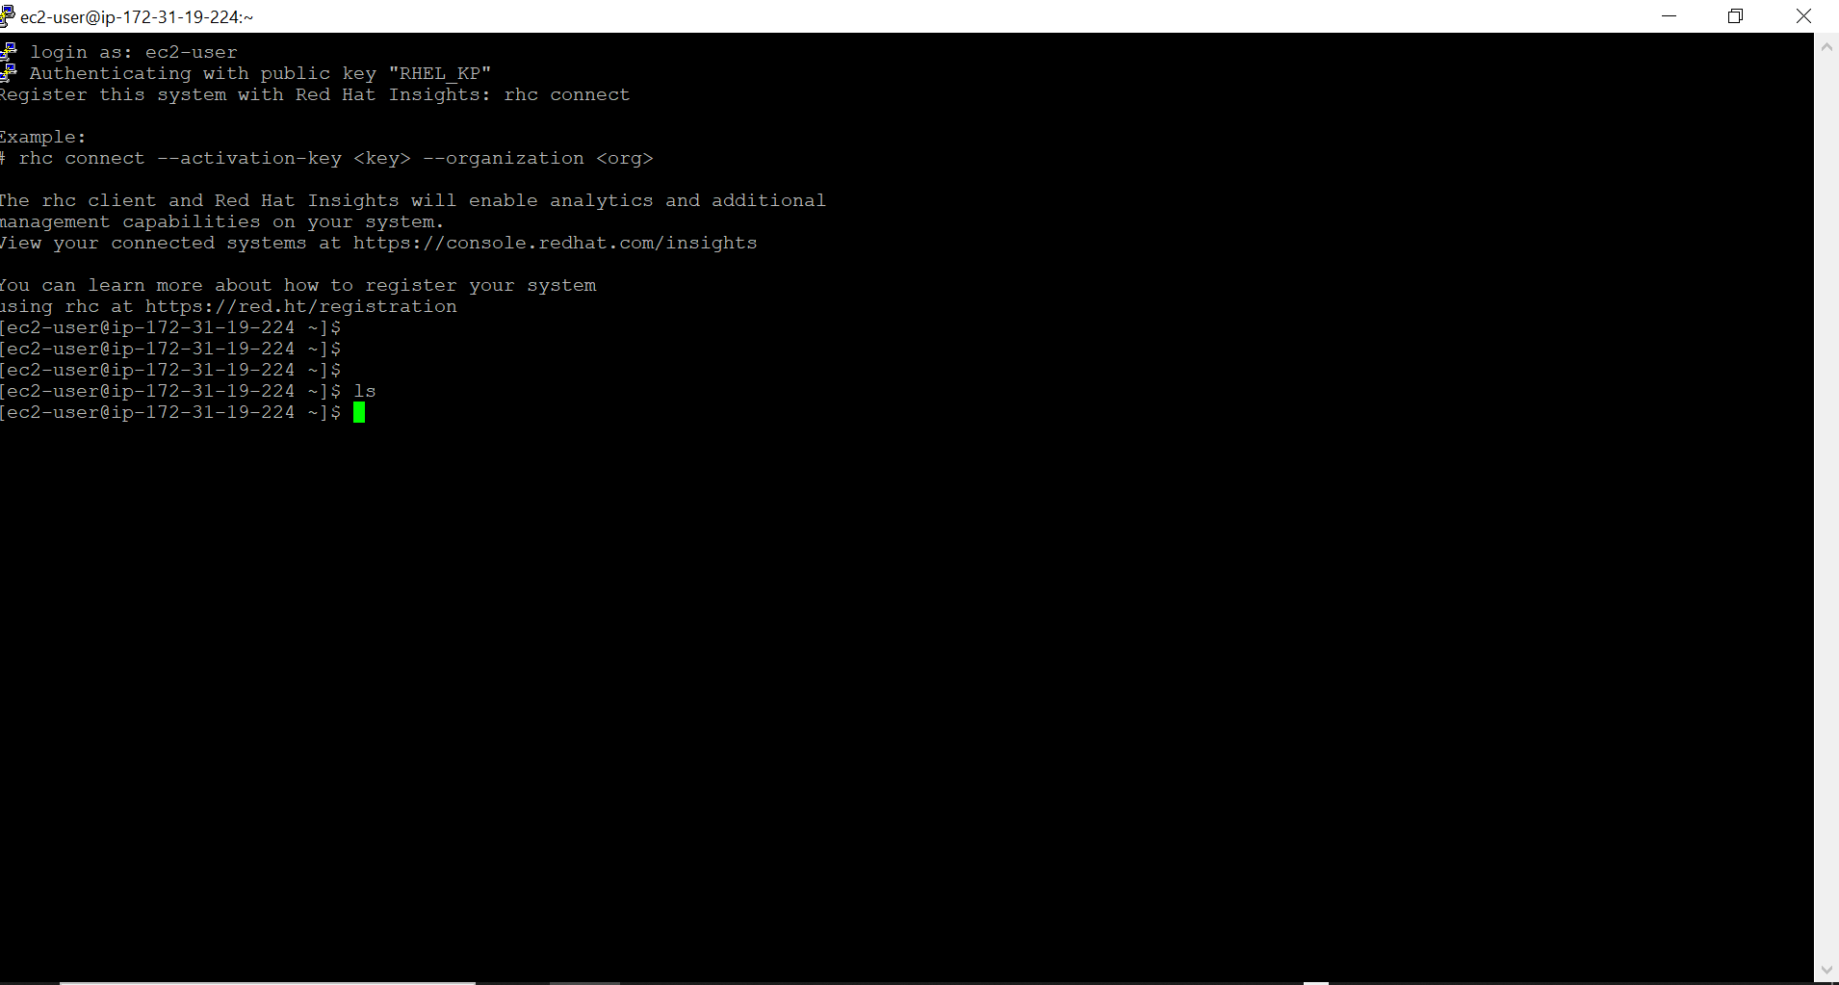

**Launch Ubuntu Instance and RHEL Instance and connect to it.**

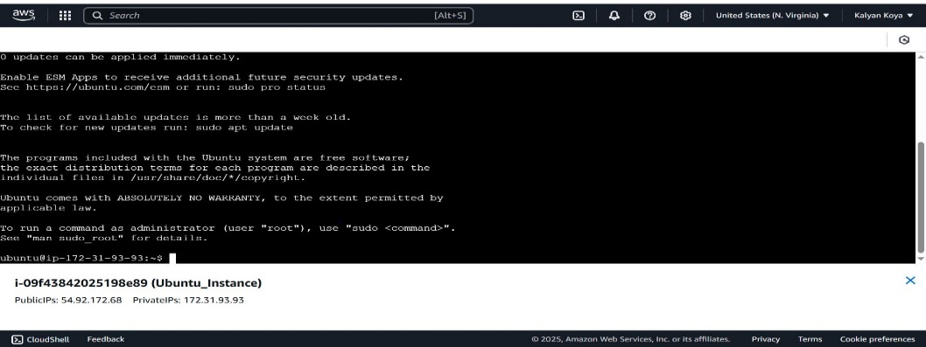

**Launch Amazon Linux Instances at time and terminate it immediately**

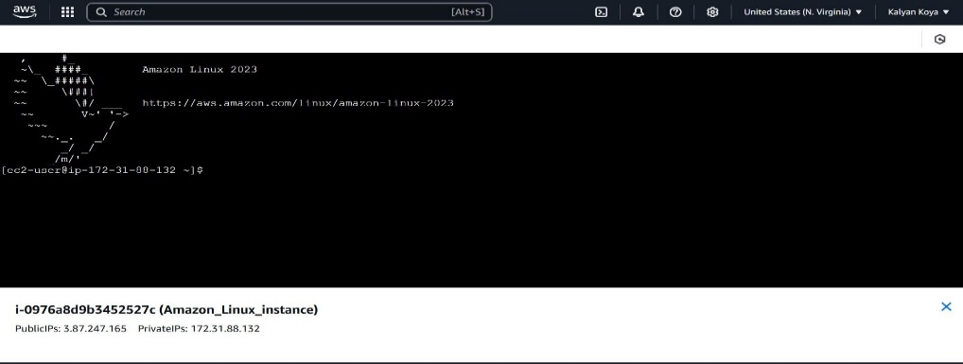

**Launch Windows Instances and connect to it.**

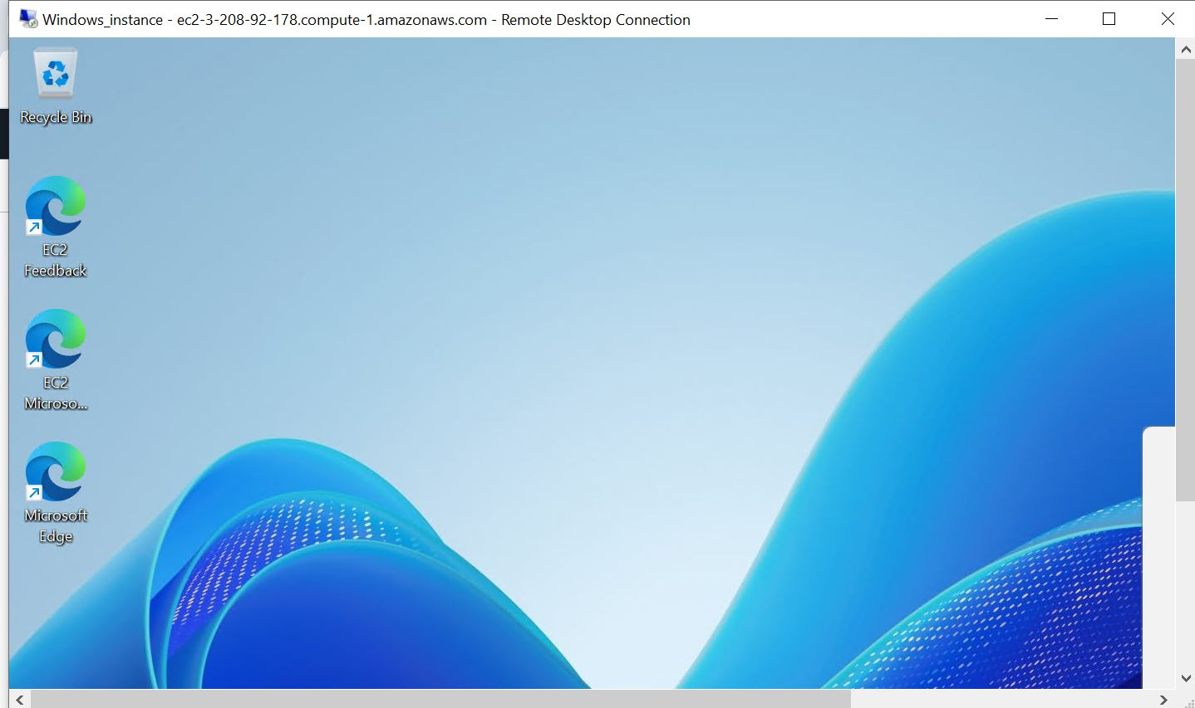

**6. Attach IAM Role to EC2 Instance and access S3 Resources.**

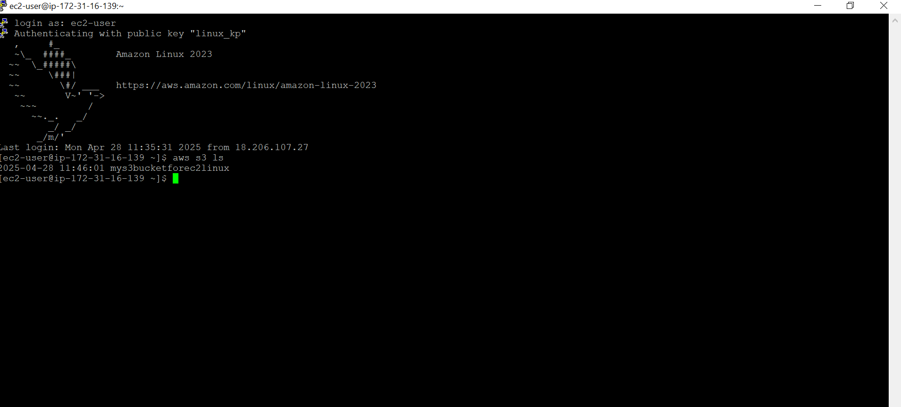

**7. Try to stop and start and reboot EC2 instance --> Observe changes in Public IP.**

s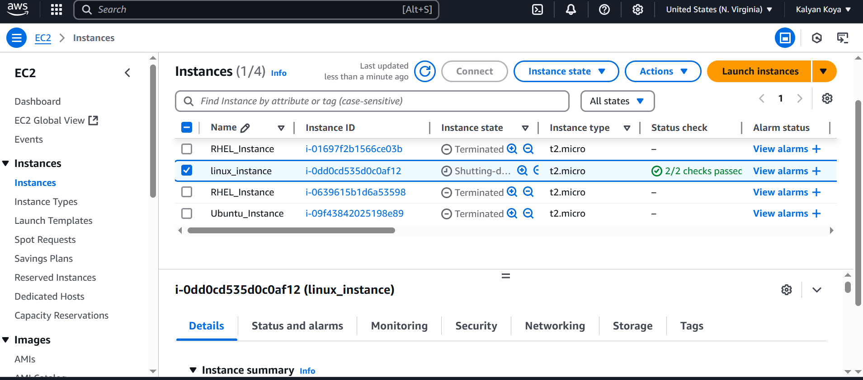

**8. Deploy a webserver on Linux EC2 Instance. (Custom HTML Page)**

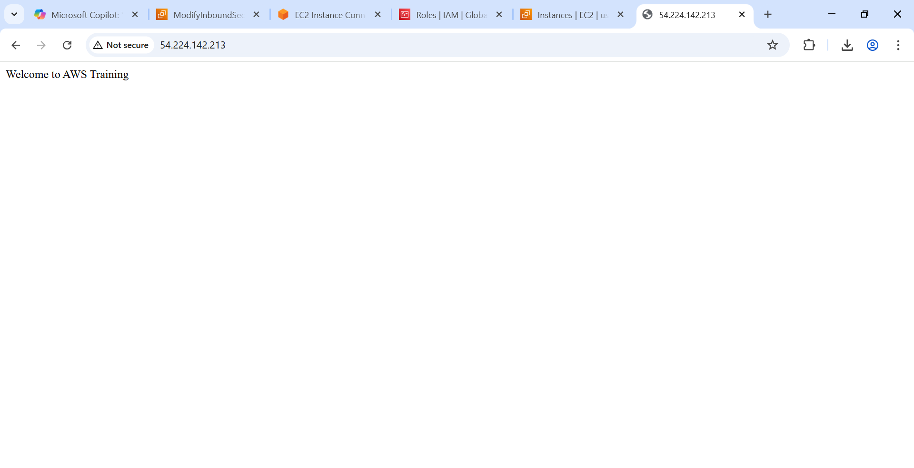

**9. Access S3 Buckets from EC2 Instances -- Create this with IAM user and not with AWS Root Account.**

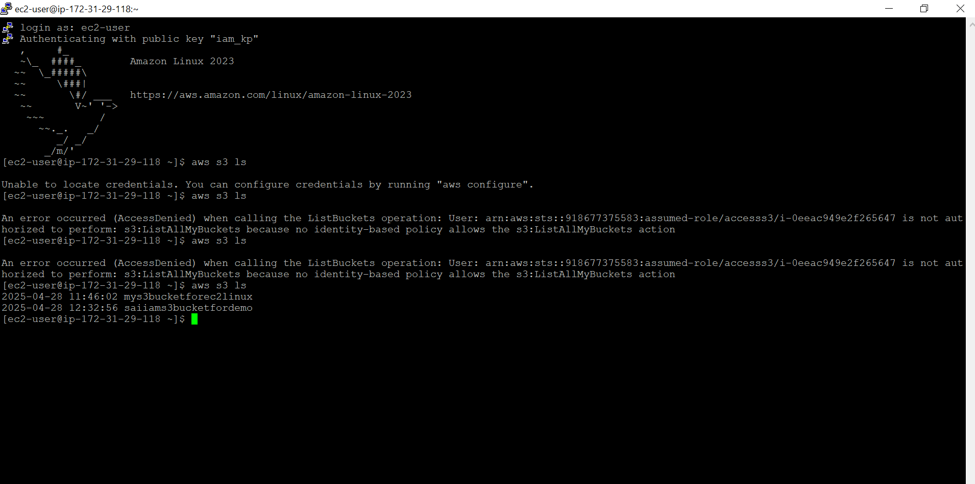

**10. What is difference between Dedicated Instance and Dedicated Host. (3 to 4 points no Copy paste from Documentation)**

* **Dedicated Instance**:

Isolated environment- you don’t share hardware.

Simplifies pricing - less flexibility in server management.

Suited for general workloads requiring dedicated resources.

* **Dedicated Host**:

Complete control of physical server configuration.

Provides visibility into hardware like cores and sockets.

Let’s you optimize placement of instances on the host.

**11. Assign an EIP to Webserver and release it.**

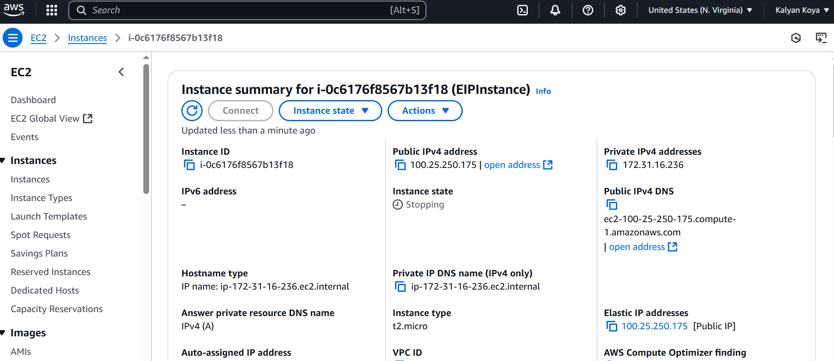

**12. What are Pricing Options in AWS (No Copy paste from Documentation, only bullets points/definition which are simple to understand)**

* **On-Demand**: Pay for resources by the second or hour, with no upfront costs or long-term commitments. Flexible but more expensive.
* **Reserved Instances**: Commit to a 1- or 3-year term to save up to 75% over on-demand pricing. Good for predictable workloads.
* **Savings Plans**: Flexible pricing model that provides discounts in exchange for a commitment to a specific usage (e.g., $10/hour).
* **Spot Instances**: Purchase unused capacity at significant discounts. Ideal for fault-tolerant and flexible workloads.
* **Dedicated Hosts**: Rent a physical server for regulatory compliance, software licensing, or isolation.
* **Free Tier**: Offers limited free usage of AWS services for 12 months and some services always free.
* **Pay-as-you-go**: Only pay for the compute, storage, or other services you use without minimum commitments.
* **Cost Explorer Budgets**: AWS tools to analyse and manage costs, helping optimize your pricing selection.

**13. Create a Volume, create a Snapshot of it, copy the volume to different region and create a Volume form the copied snapshot**

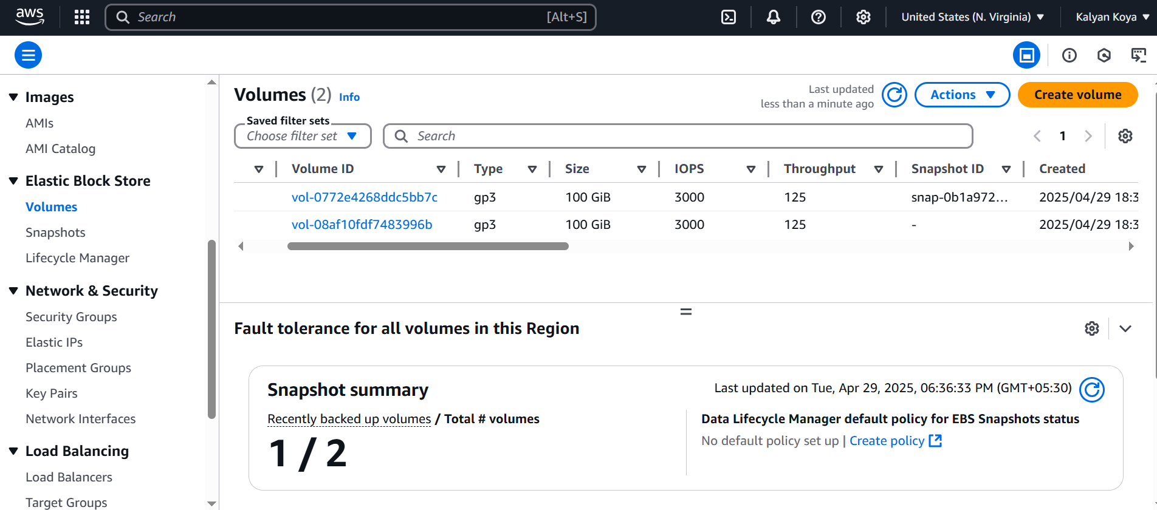

**16. Difference between EBS volumes and Instance store volumes**

**EBS Volumes:**

1. Persistent storage—data is retained even if the instance is stopped or terminated (unless explicitly deleted).
2. Can be attached to or detached from an EC2 instance and reattached to another instance.
3. Provides durability and reliability by storing data in multiple locations (within the same availability zone).
4. Suitable for use cases like databases, logs, or file systems.
5. Backups can be created using **Snapshots**.
6. Slightly higher latency compared to instance store.
7. Chargeable based on provisioned size and IOPS.

**Instance Store Volumes:**

1. Ephemeral storage—data is lost when the instance stops, terminates, or the host fails.
2. Tied to the physical hardware hosting the instance; cannot be detached or reattached.
3. Best for temporary data like caches, buffers, and scratch space.
4. Cannot create backups—no snapshot support.
5. Offers low-latency, high-speed storage compared to EBS.
6. Included in the cost of certain EC2 instance types (e.g., some high-performance instances).

**What is AWS Batch and AWS LightSail (only bullet points, no copy pastes)**

### AWS Batch

* **Fully managed batch processing service**: Simplifies running batch computing workloads across multiple computing resources.
* **Automated job execution**: Dynamically provisions compute capacity based on job requirements.
* **Integration with AWS ecosystem**: Works seamlessly with services like Amazon ECS, AWS Lambda, and AWS CloudWatch.
* **Cost optimization**: Supports Spot Instances to reduce costs.
* **Scalability**: Handles workloads ranging from a few jobs to millions of batch processes.

### AWS LightSail

* **Simplified cloud hosting**: Designed for small-scale applications, websites, and projects.
* **Predictable pricing**: Offers pre-configured plans with fixed monthly costs.
* **Easy setup**: Includes templates for web applications like WordPress, Joomla, and more.
* **Built-in features**: Provides DNS management, static IPs, storage, and backups.
* **Developer-friendly**: Ideal for beginners needing straightforward cloud solutions without managing complex configurations.