1)Host a static website on AWS S3 (Please do not use same html page which was used in session)

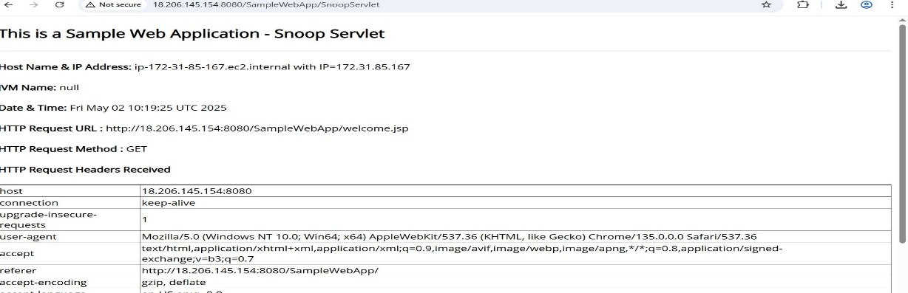  
2)Demo on Cross Region Replication

**Source Bucket**

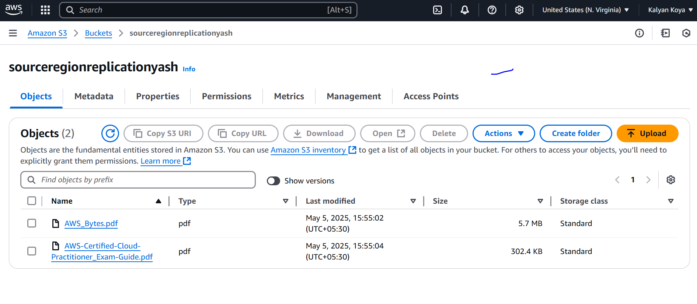

**Destination Bucket**

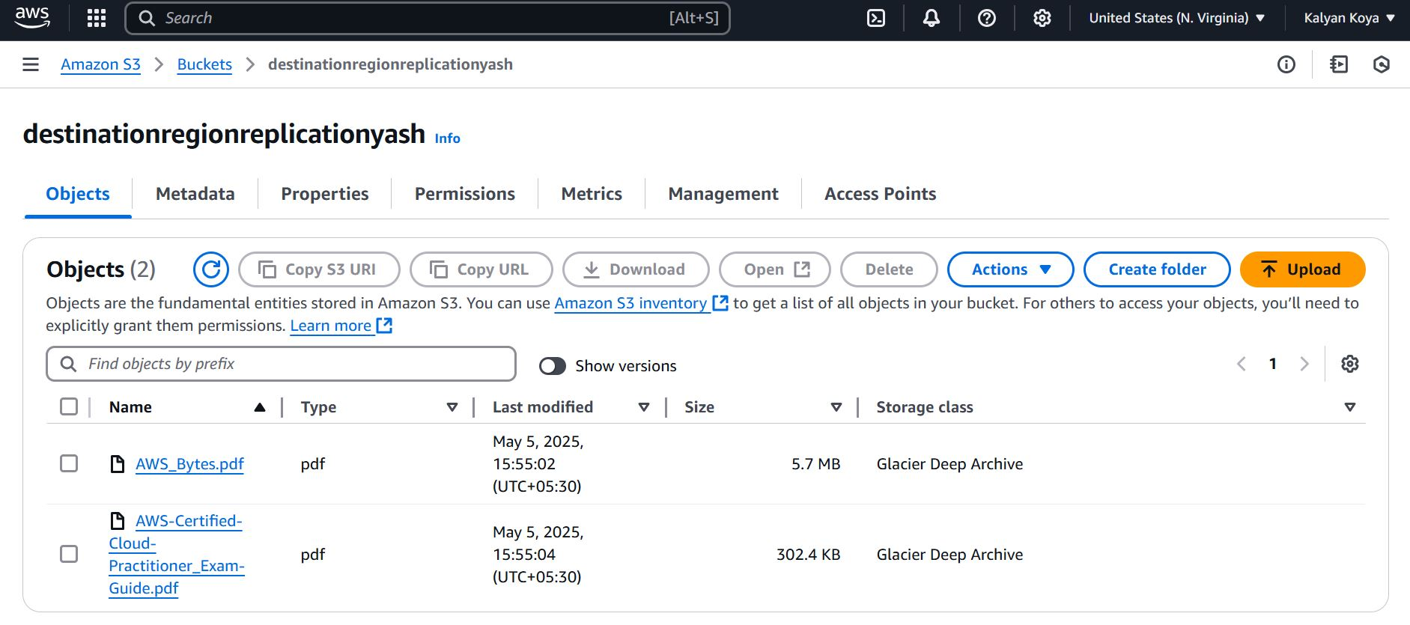

3)Demo on Event Notification

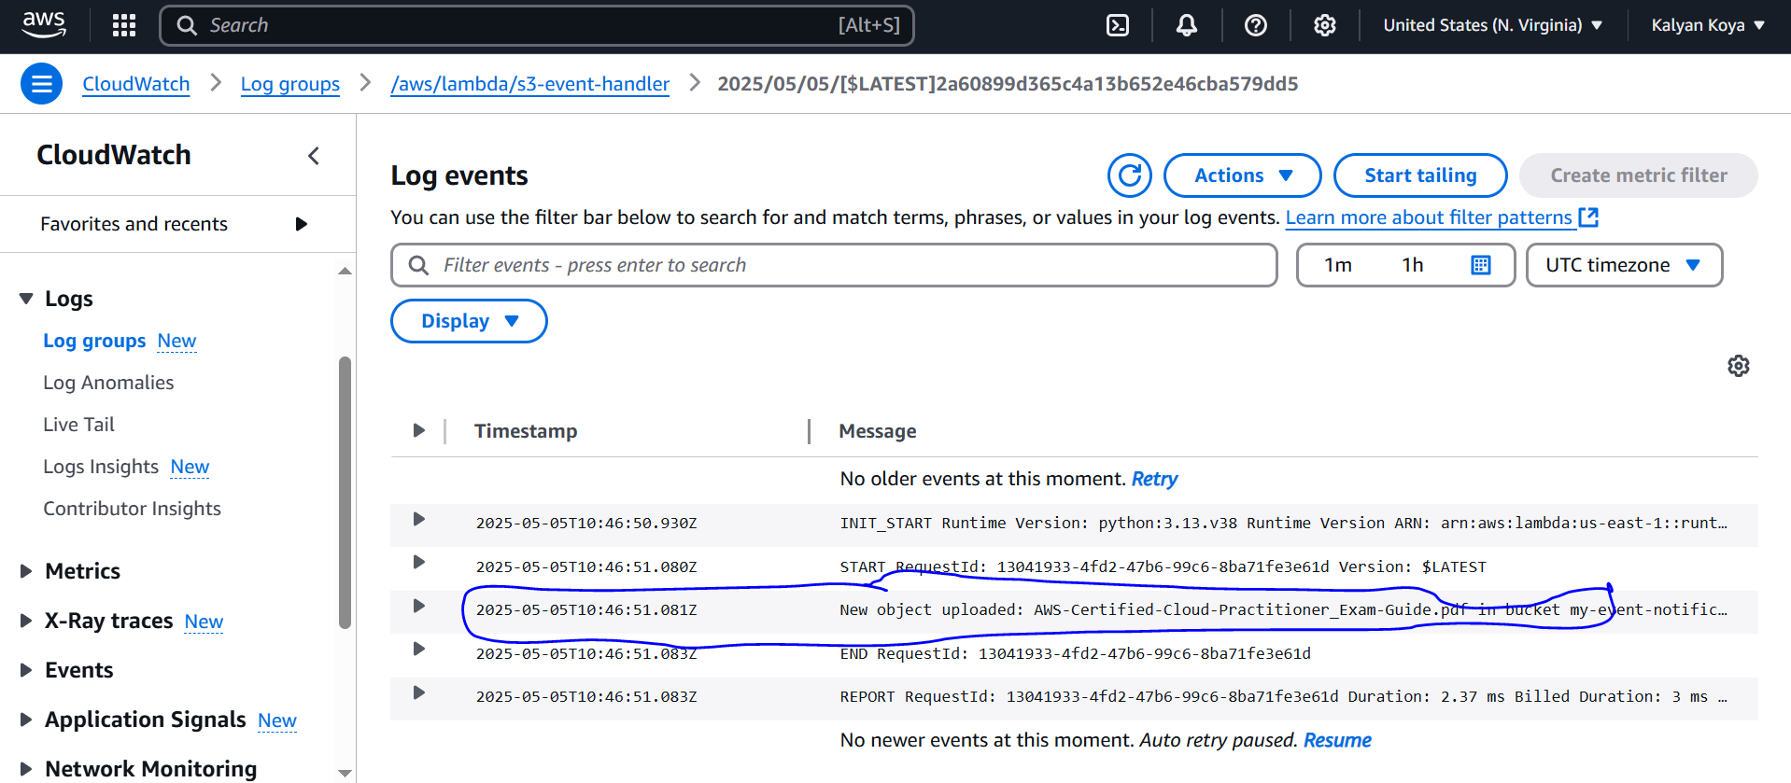

4)Enable Transfer Acceleration

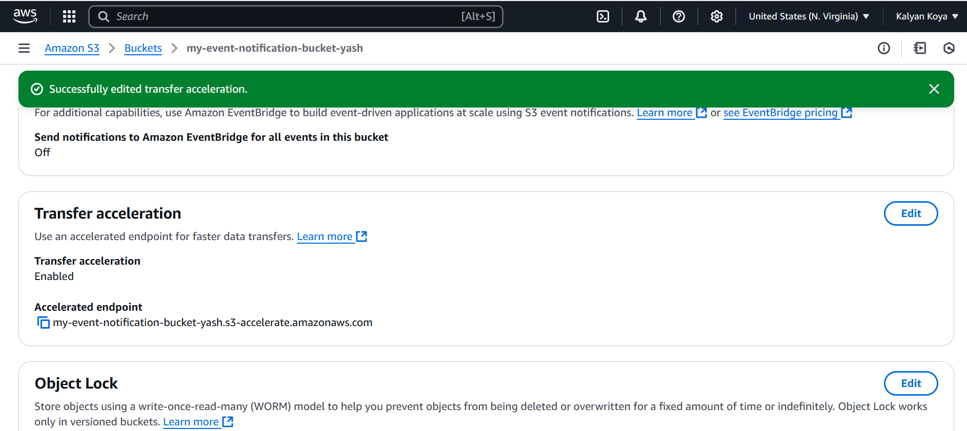  
5)AWS Pricing Calculator demo for AWS S3 and EC2

**PRICING_EC2**

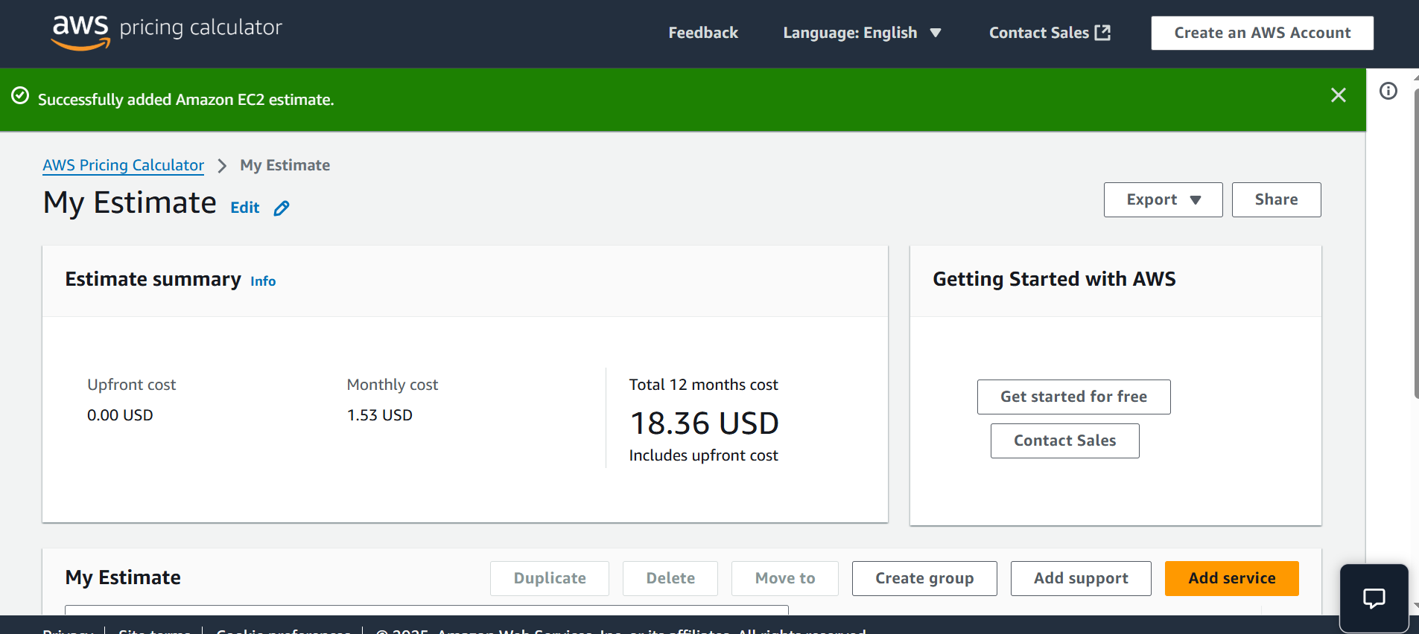

**S3 Pricing**

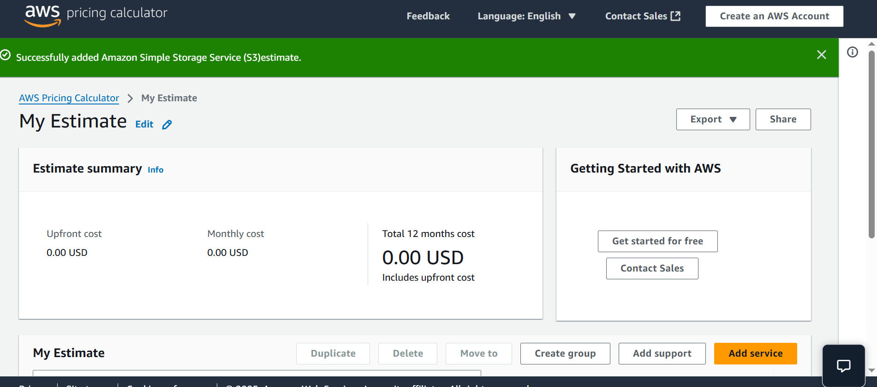

6)What is difference between SSE-S3 and SSE-KMS

**SSE-S3 (Server-Side Encryption with Amazon S3 Managed Keys)**

* **Key Management:** Amazon S3 fully manages the encryption keys.
* **Encryption Strength:** Uses AES-256 encryption.
* **Access Control:** Access is controlled via IAM permissions on the S3 bucket/object.
* **Use Case:** Best for simple encryption needs without additional key management.

**SSE-KMS (Server-Side Encryption with AWS KMS Keys)**

* **Key Management:** Encryption keys are stored and managed in **AWS Key Management Service (KMS)**.
* **Encryption Strength:** Uses AES-256 encryption, similar to SSE-S3.
* **Access Control:** Requires IAM permissions **both** for S3 access **and** KMS key usage.
* **Auditing:** AWS KMS provides detailed logs of key usage.
* **Use Case:** Ideal when you need **fine-grained access control**, auditing, or integration with AWS KMS.

7)Demo on Lifecycle policies

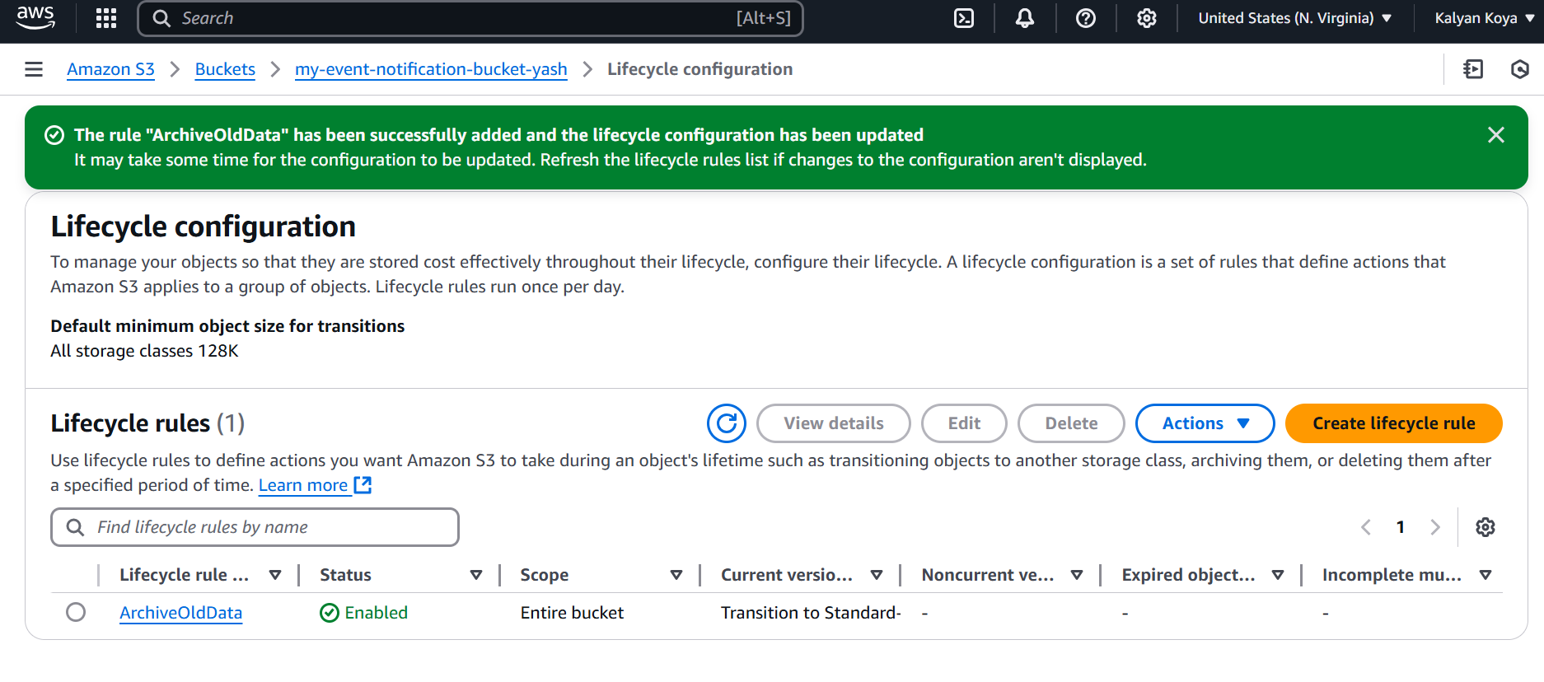

8)Demo on S3 versioning

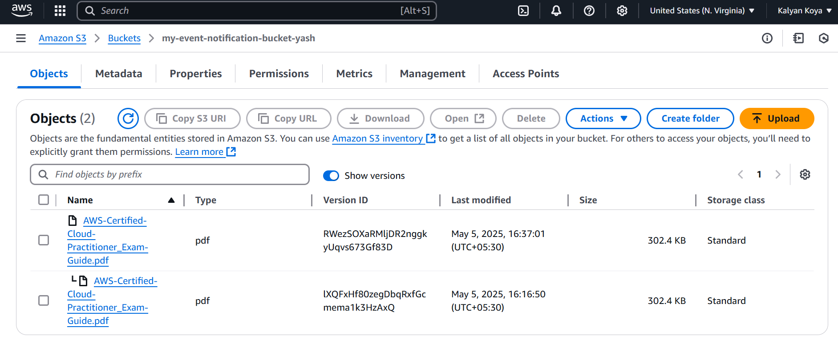

9)What are different storage classes in S3

| **Use Case** | **Best Storage Class** |
| --- | --- |
| Frequent access (apps, websites) | **S3 Standard** |
| Uncertain access pattern | **S3 Intelligent-Tiering** |
| Backup/archival (occasional access) | **S3 Standard-IA** |
| Cost-sensitive backups | **S3 One Zone-IA** |
| Fast retrieval archive | **S3 Glacier Instant Retrieval** |
| Deep cold storage | **S3 Glacier / Deep Archive** |

10) What is cross-origin resource sharing (CORS)

* When a web page makes a request to another domain (e.g., fetching data from an API), the server **must include CORS headers** in its response to allow the request.
* The browser **checks these headers** before deciding whether to grant access.

**11) Demo 7 S3 CLI commands ( create bucket , remove bucket) refer link :--**

[ec2-user@ip-172-31-22-60 ~]$ aws s3 mb s3://koyakalyanbucket

make_bucket: koyakalyanbucket

[ec2-user@ip-172-31-22-60 ~]$ aws s3 ls

2025-05-05 11:18:03 koyakalyanbucket

2025-05-05 10:39:15 my-event-notification-bucket-yash

[ec2-user@ip-172-31-22-60 ~]$ echo "This is a test file" > myfile.txt

[ec2-user@ip-172-31-22-60 ~]$ ls -l myfile.txt

-rw-r--r--. 1 ec2-user ec2-user 20 May 5 11:28 myfile.txt

[ec2-user@ip-172-31-22-60 ~]$ aws s3 cp myfile.txt s3://koyakalyanbucket/

upload: ./myfile.txt to s3://koyakalyanbucket/myfile.txt

[ec2-user@ip-172-31-22-60 ~]$ aws s3 ls s3://koyakalyanbucket/

2025-05-05 11:28:22 20 myfile.txt

[ec2-user@ip-172-31-22-60 ~]$ aws s3 rm s3://koyakalyanbucket/myfile.txt

delete: s3://koyakalyanbucket/myfile.txt

[ec2-user@ip-172-31-22-60 ~]$ aws s3 rm s3://koyakalyanbucket --recursive

[ec2-user@ip-172-31-22-60 ~]$ aws s3 rb s3://koyakalyanbucket --force

remove_bucket: koyakalyanbucket

[ec2-user@ip-172-31-22-60 ~]$ aws s3 ls s3://koyakalyanbucket/

An error occurred (NoSuchBucket) when calling the ListObjectsV2 operation: The specified bucket does not exist

<https://docs.aws.amazon.com/cli/latest/userguide/cli-services-s3-commands.html>