1. Deploy a WebServer in Custom VPC.

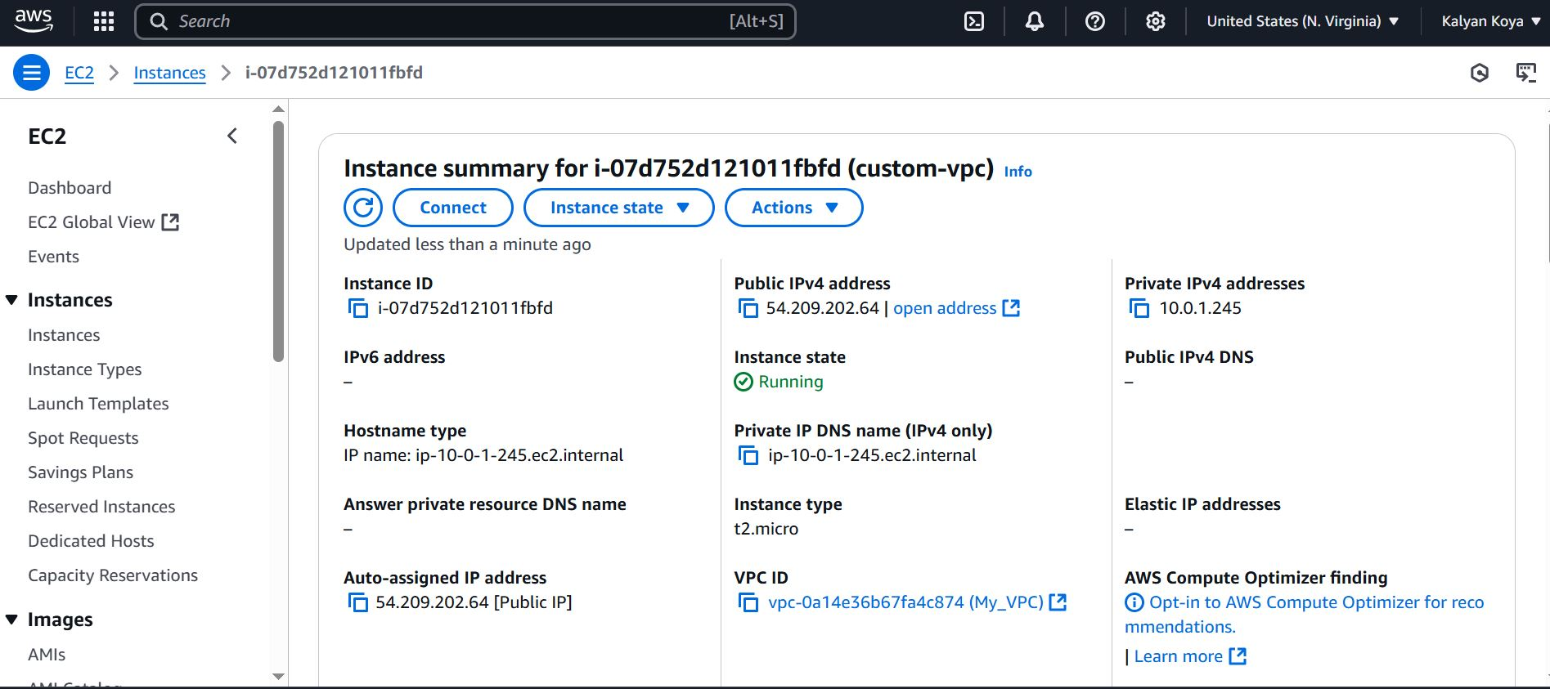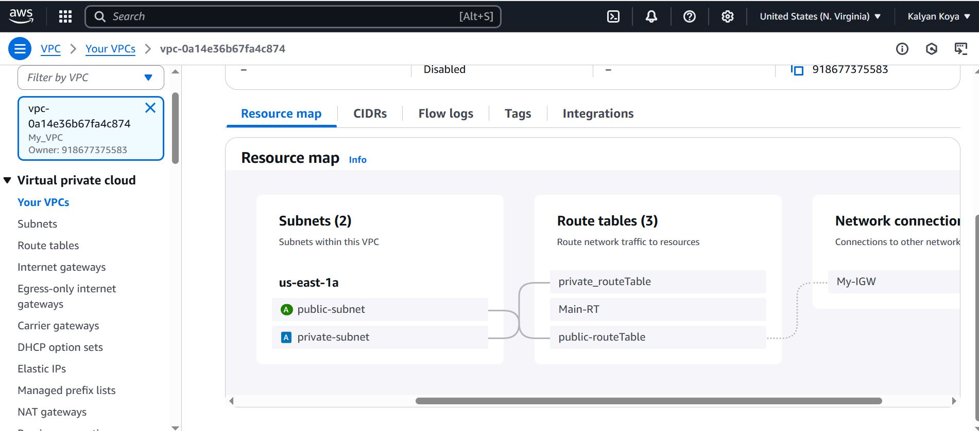

1. Ping google.com from Private EC2 Instance (No public IP)

Public -EC2

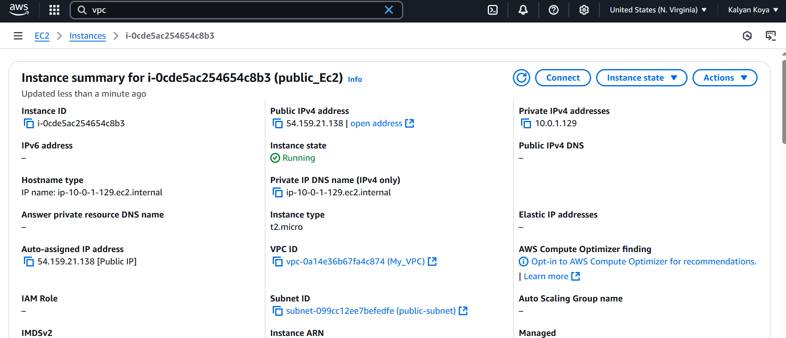

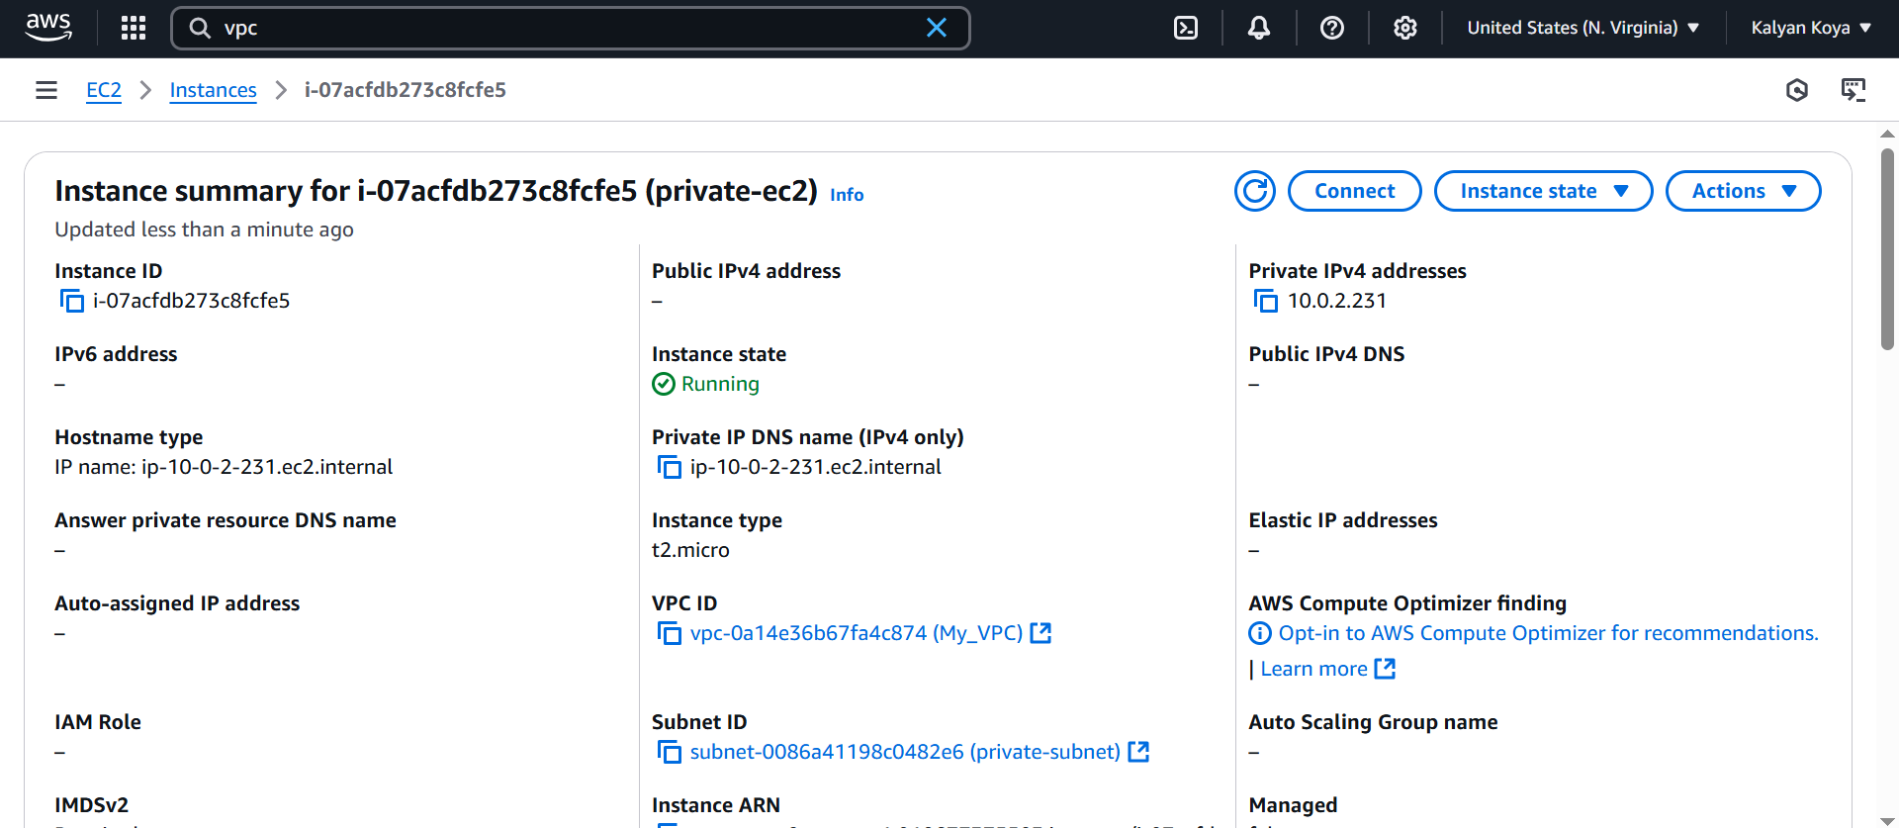

[root@ip-10-0-1-129 ec2-user]# vi privateKp.pem

[root@ip-10-0-1-129 ec2-user]# vi privateKp.pem

[root@ip-10-0-1-129 ec2-user]# chmod 400 "privateKp.pem"

[root@ip-10-0-1-129 ec2-user]# ssssh -i "privateKp.pem" ec2-user@10.0.2.231

The authenticity of host '10.0.2.231 (10.0.2.231)' can't be established.

ED25519 key fingerprint is SHA256:2GacJmcoUHr7RjxT+TOvhmTLF0CrR7FLVXC0pY+YcSU.

This key is not known by any other names

Are you sure you want to continue connecting (yes/no/[fingerprint])? yes

Warning: Permanently added '10.0.2.231' (ED25519) to the list of known hosts.

, #_

~\_ ####_ Amazon Linux 2023

~~ \_#####\

~~ \###|

~~ \#/ ___ https://aws.amazon.com/linux/amazon-linux-2023

~~ V~' '->

~~~ /

~~._. _/

_/ _/

_/m/'

[ec2-user@ip-10-0-2-231 ~]$

[ec2-user@ip-10-0-2-231 ~]$

[ec2-user@ip-10-0-2-231 ~]$

[ec2-user@ip-10-0-2-231 ~]$ ping google.com

PING google.com (142.251.16.139) 56(84) bytes of data.

64 bytes from bl-in-f139.1e100.net (142.251.16.139): icmp_seq=1 ttl=105 time=3.03 ms

64 bytes from bl-in-f139.1e100.net (142.251.16.139): icmp_seq=2 ttl=105 time=2.44 ms

64 bytes from bl-in-f139.1e100.net (142.251.16.139): icmp_seq=3 ttl=105 time=3.07 ms

64 bytes from bl-in-f139.1e100.net (142.251.16.139): icmp_seq=4 ttl=105 time=2.48 ms

64 bytes from bl-in-f139.1e100.net (142.251.16.139): icmp_seq=5 ttl=105 time=2.49 ms

64 bytes from bl-in-f139.1e100.net (142.251.16.139): icmp_seq=6 ttl=105 time=2.55 ms

64 bytes from bl-in-f139.1e100.net (142.251.16.139): icmp_seq=7 ttl=105 time=2.40 ms

64 bytes from bl-in-f139.1e100.net (142.251.16.139): icmp_seq=8 ttl=105 time=2.15 ms

64 bytes from bl-in-f139.1e100.net (142.251.16.139): icmp_seq=9 ttl=105 time=2.79 ms

64 bytes from bl-in-f139.1e100.net (142.251.16.139): icmp_seq=10 ttl=105 time=2.63 ms

64 bytes from bl-in-f139.1e100.net (142.251.16.139): icmp_seq=11 ttl=105 time=2.16 ms

64 bytes from bl-in-f139.1e100.net (142.251.16.139): icmp_seq=12 ttl=105 time=2.16 ms

64 bytes from bl-in-f139.1e100.net (142.251.16.139): icmp_seq=13 ttl=105 time=2.17 ms

64 bytes from bl-in-f139.1e100.net (142.251.16.139): icmp_seq=14 ttl=105 time=2.34 ms

64 bytes from bl-in-f139.1e100.net (142.251.16.139): icmp_seq=15 ttl=105 tim