1. **Launch RDS Instance and connect to it. (Free Tier)**

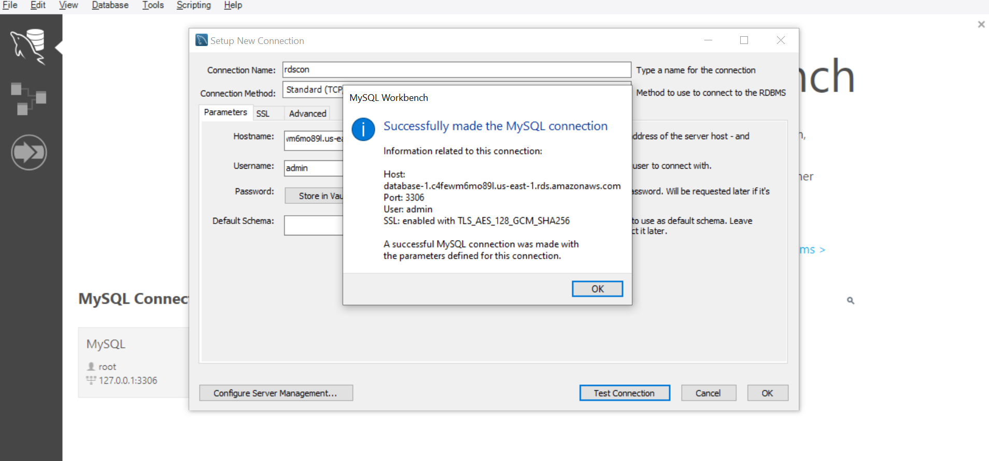

**2)What are the different Engines supported by RDS.**

**Different Engines Supported by RDS** Amazon RDS supports multiple database engines, including:

* IBM Db2
* MariaDB
* Microsoft SQL Server
* MySQL
* Oracle Database
* PostgreSQL

**3)What is Multi-AZ and Read Replicas**.

**Multi-AZ and Read Replicas**

* **Multi-AZ**: Provides high availability by automatically replicating data across multiple Availability Zones.
* **Read Replicas**: Improve performance by creating read-only copies of your database, allowing read-heavy workloads to be distributed

**4)What are benefits of running Database on RDS compared to EC2 and On Premises.**

**Benefits of Running a Database on RDS vs. EC2 and On-Premises**

* **RDS**: Fully managed, automated backups, scaling, and maintenance.
* **EC2**: Requires manual setup and maintenance but offers full control.
* **On-Premises**: High upfront costs, manual scaling, and maintenance

**5)Create and DynamoDB table and insert items inside it and send screenshot of items inside a table**

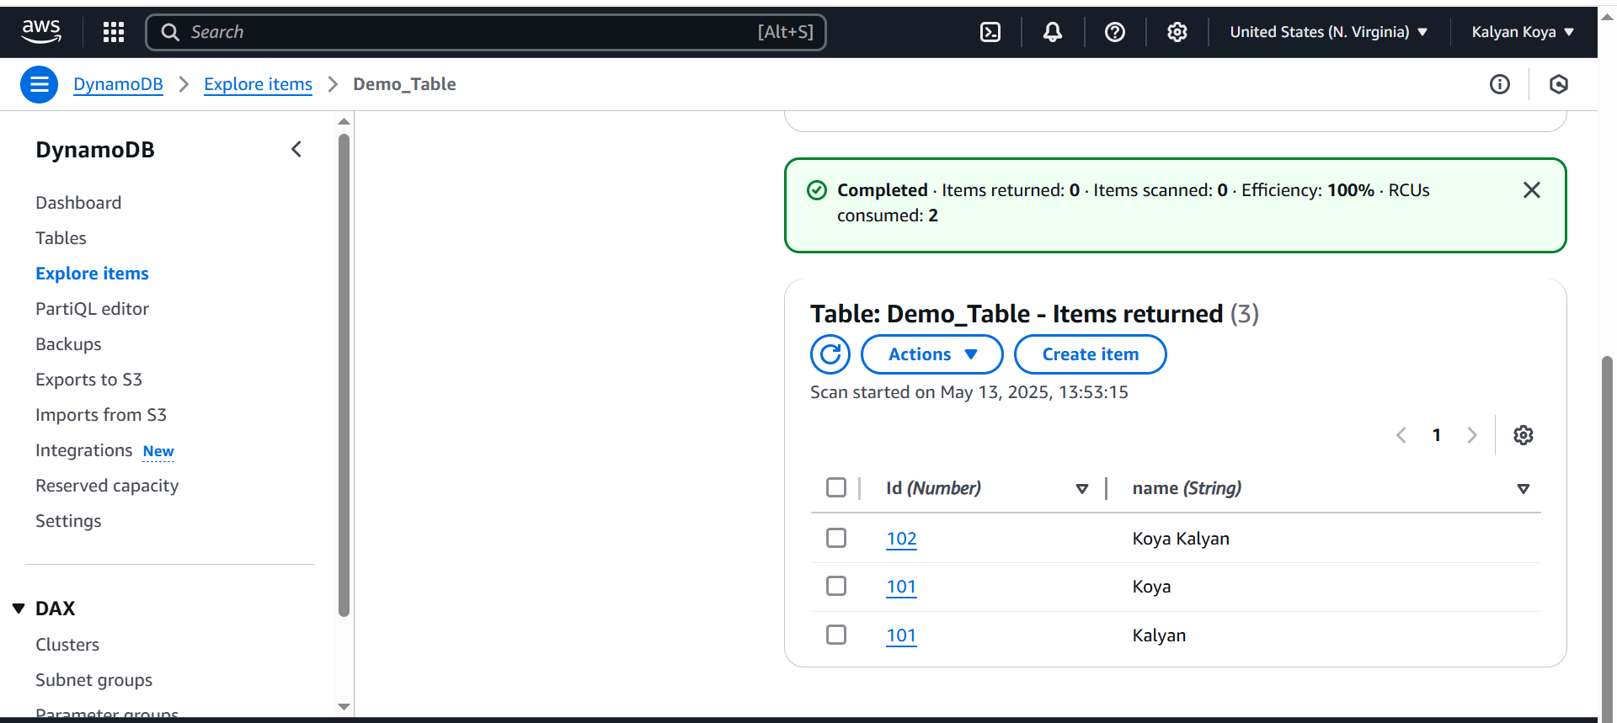

**6)What is importance of below AWS Services, 1-line answer**

**Importance of AWS Services**

* **Neptune**: Managed graph database service for relationships and connected data.
* **EMR**: Big data processing using Hadoop, Spark, and Presto.
* **Redshift**: Cloud data warehouse optimized for analytics.
* **Kinesis**: Real-time data streaming for analytics and processing.
* **QuickSight**: Business intelligence and visualization tool.
* **Glue**: ETL service for data preparation and transformation.
* **Athena**: Serverless query service for analysing data in S3