1)Deploy an Application on ECS using Hosting mode as Fargate

ECS-Running

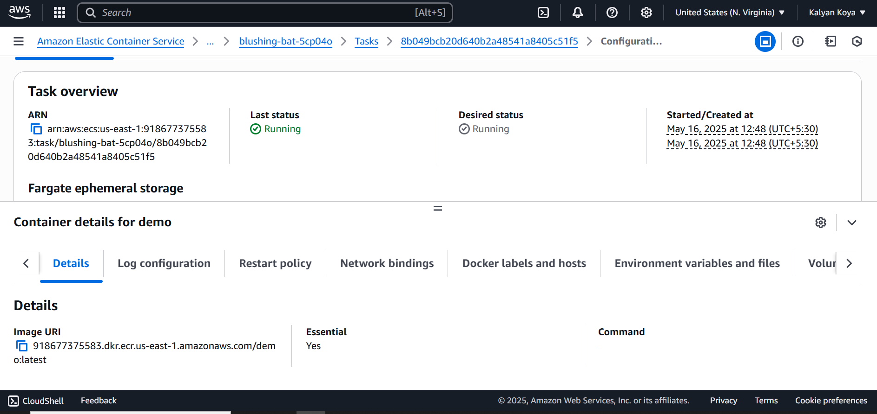

ECS-Task Definitions

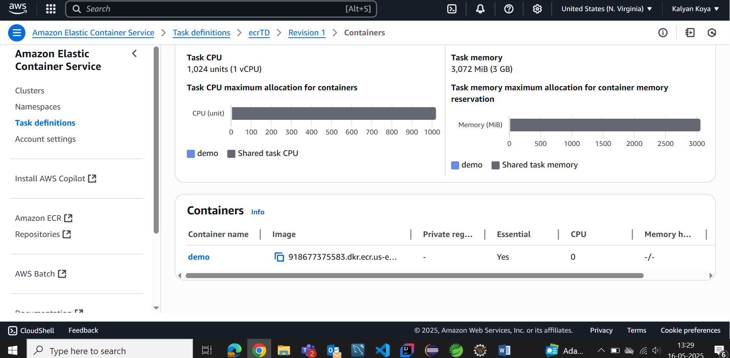

Docker-Build Images

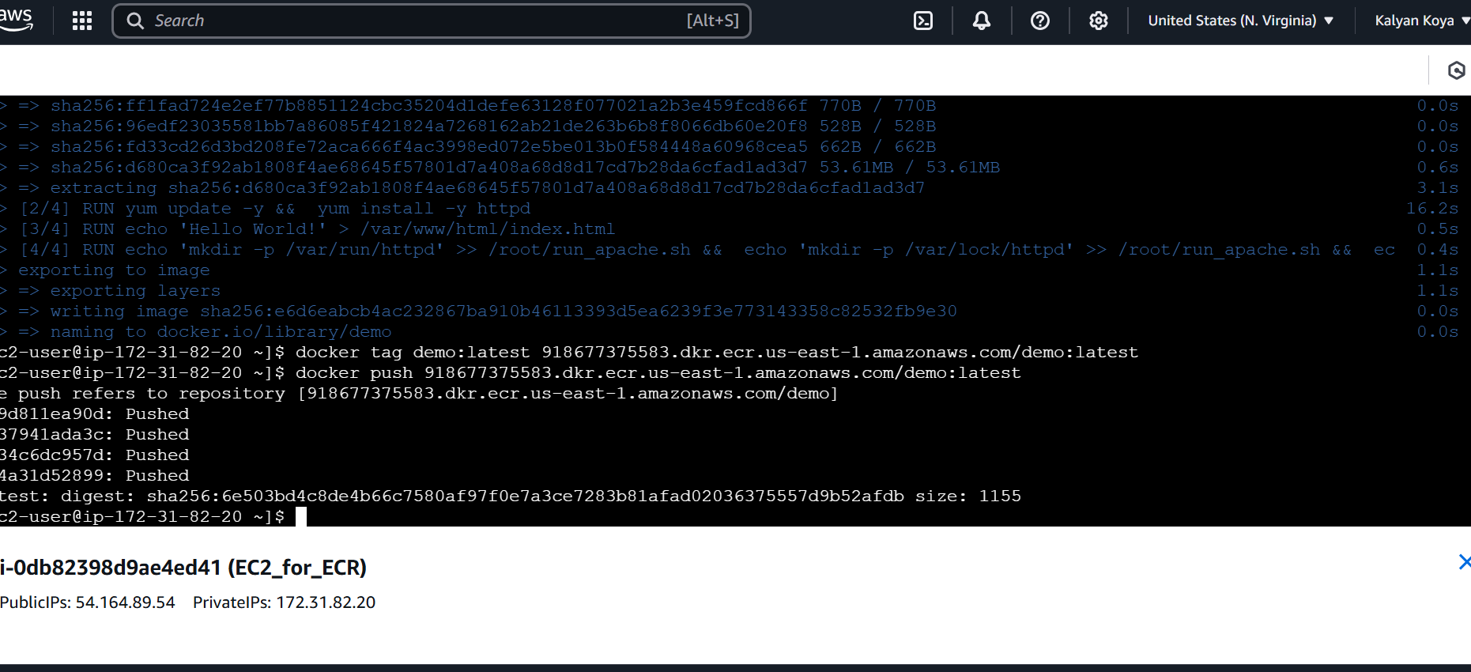

Docker-push image

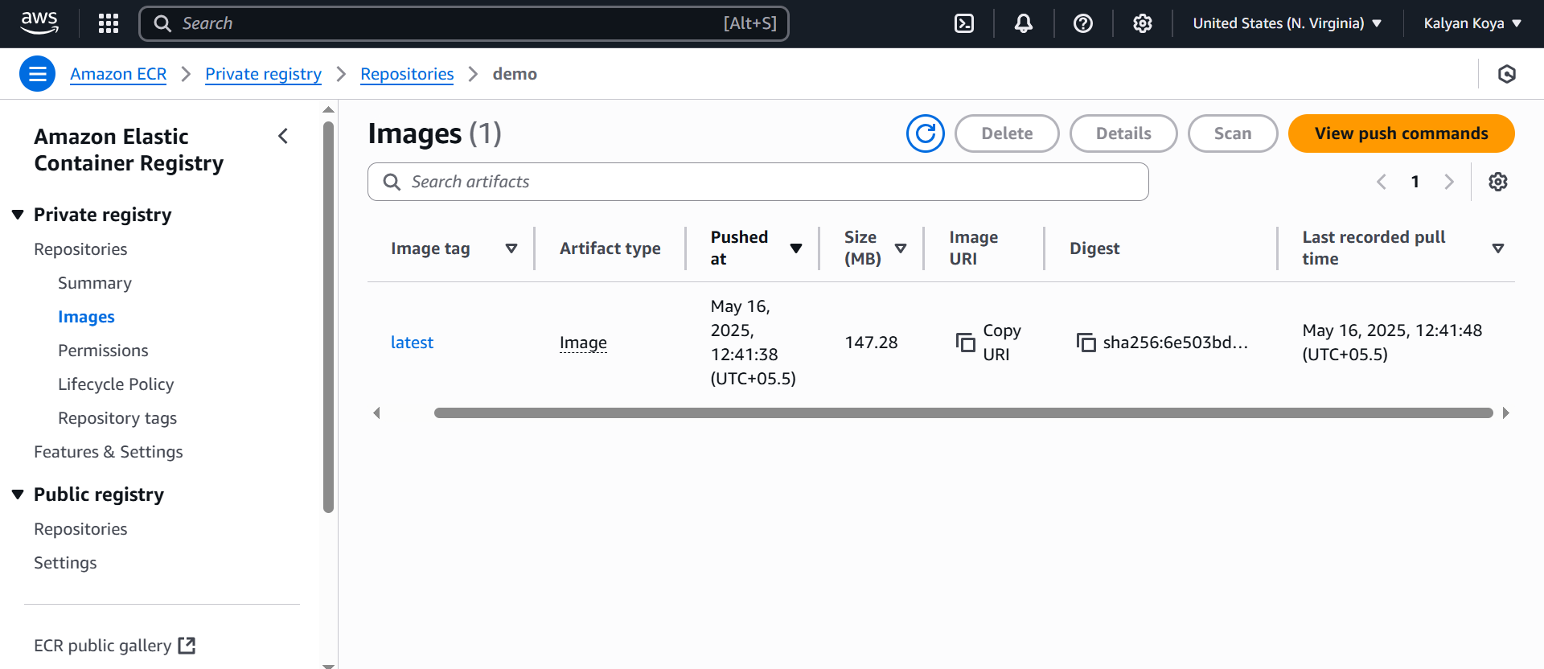

2)Create a PowerPoint presentation on ECS and its hosting types (Detailed PPT)