# Name: __________________________________________

**Midterm #1 Review**

# CS 480

**ID: _____________ Database Systems Fall 2019**

**Complete By: at your leisure**

**Submission: no submission, discuss answers on Piazza**

**Database Domain Design**

Suppose you are keeping track of the database for a shipping company.

The company has a number of customers, trucks, drivers, and supplier warehouses. Packages are taken from warehouses by trucks and delivered to customers. A shipment is a set of packages which must all be delivered to the same customer. A customer places an order for shipment. Drivers are assigned to trucks in shifts.

1. Construct an Entity Relationship diagram representing the shipping domain, able to represent and store all the information described on the previous page. You may either draw the diagram on the page or include a picture taken of a physical drawing or image created by another program such as lucidchart like we did in class.

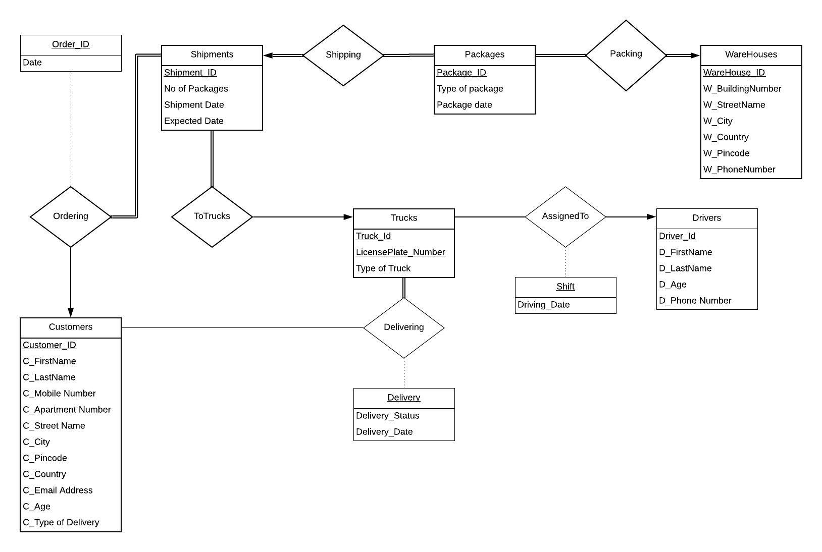

1. Now convert your Entity Relationship diagram into a relational schema following the guidelines in chapter 7. Be sure to include foreign keys where relevant. Write the schema out in the form of

TableName(primary key fields, other attributes) attributes foreign key referencing other tables

like we did in class. You may include a schema diagram for clarity, but we will be grading the text version.

Write relational algebra to answer each of the following questions.

1. What are the package ids of all packages at the warehouse at 1137 Harbor Lane?

ΠPackage_Id(σ W_Address = “1137 Harbor Lane”(packing))

1. What are the license plate numbers of the truck(s) that driver Joe Emmerson has driven in?

ΠLicensePlate_Number(σ D_FirstName = “Joe” ^ D_LastName = “Emmerson”(AssignedTo))

1. What are the license plate numbers of the truck(s) that driver Joe Emmerson was driving on July 17th, 2019?

ΠLicensePlate_Number(σ Driving_Date = “07-17-2019”(σ D_FirstName = “Joe” ^ D_LastName = “Emmerson”(AssignedTo)))

1. What are the addresses of the warehouses that the customer with the name Erin Southerland has received packages from?

ΠW_Address(σ C_FirstName = “Erin” ^ C_LastName = “Southerland”(Ordering ⋈ (Shipping ⋈ Packing))

1. What are the license plate numbers of the trucks that have made deliveries from the warehouse at 1137 Harbor Lane?

ΠLicensePlate_Number(σ W_Address = “1137 Harbor Lane”( (ToTrucks ⋈ (σ Delivery_Status = “Yes”(Delivering))) ⋈ (Shipping ⋈ Packing))

1. What are the license plate numbers of the trucks that have made deliveries to the customer with the name Miles Edgeworth?

ΠLicensePlate_Number(σ C_FirstName = “Miles” ^ C_LastName = “Edgeworth”(σ Delivery_Status = “Yes”(Delivering)))

1. What are the package ids of all the packages along with the first and last names of the drivers who delivered them to the customer at address 123 Sesame Street?

ΠPackage_Id, D_FirstName, D_LastName(σ C_Apartment Number= “123” ^ C_Street Name = “Sesame Street”(Shipping ⋈ ((ToTrucks ⋈ (σ Delivery_Status = “Yes”(Delivering))) ⋈ Driving)))

1. What is the first and last name of all the customers on Bengal Avenue?

Π C_FirstName, C_LastName(σ C_Street_name = “Bengal Avenue”(Customers))

1. For the warehouse with address A, what are the package ids of all packages delivered from that warehouse?

ΠPackage_Id((σ W_Address = “A”(Packing) ⋈ Shipping)) ⋈ (ToTrucks ⋈ (σ Delivery_Status = “Yes”(Delivering))))

1. What are the package ids, customer addresses, and warehouse addresses of all packages which were delivered within the same city?

Let t = ((Packing ⋈ Shipping) ⋈ (ToTrucks ⋈ (σ Delivery_Status = “Yes”(Delivering))))

ΠPackage_Id, Mail Address, W_Address(σ D_City = x.D_City(t x *ρ* x(t)))

Or

ΠPackage_Id, Mail Address, W_Address(σ D_City = x.D_City(((Packing ⋈ Shipping) ⋈ (ToTrucks ⋈ (σ Delivery_Status = “Yes”(Delivering)))) x *ρ* x(((Packing ⋈ Shipping) ⋈ (ToTrucks ⋈ (σ Delivery_Status = “Yes”(Delivering)))))))

1. What are the package ids, customer addresses, and warehouse addresses of all packages which were delivered to a different city?

Let t = ((Packing ⋈ Shipping) ⋈ (ToTrucks ⋈ (σ Delivery_Status = “Yes”(Delivering))))

ΠPackage_Id, Mail Address, W_Address(σ D_City  ≠ x.D_City(t x *ρ* x(t)))

Or

ΠPackage_Id, Mail Address, W_Address(σ D_City  ≠ x.D_City(((Packing ⋈ Shipping) ⋈ (ToTrucks ⋈ (σ Delivery_Status = “Yes”(Delivering)))) x *ρ* x(((Packing ⋈ Shipping) ⋈ (ToTrucks ⋈ (σ Delivery_Status = “Yes”(Delivering)))))))

1. What are the names of customers who have received a shipment from more than one warehouse?
2. What are the license plate numbers of the trucks which have only delivered complete shipments (no package in a shipment was delivered by another truck)?

And for some questions on the University database, whose ER diagram and schema can be found in the slides

1. The name and salary of each instructor whose salary is more than 80,000.
2. The title of prerequisite courses for Database System Concepts course.
3. The of names of all instructors and students in the CS department. Put all the names in one column, do not distinguish between instructors and students.
4. The course title, classroom number, and sec_id for every section in the database.
5. The pairs of names of instructors and students where the instructor is the advisor to the student and they belong to the same department
6. The pairs of names of instructors and students where the instructor is the advisor to the student and they belong to different departments.
7. The pairs of titles of courses with the names of students who have taken that course.
8. The pairs of titles of courses with the names of instructors who taught them.
9. The pairs of department names and salaries of instructors employed in that department.