**Ridge and Lasso Regression: L1 and L2 Regularization**

**Complete Guide Using Scikit-Learn**

[](https://towardsdatascience.com/@saptashwa?source=post_page-----e20e34bcbf0b----------------------)

[Saptashwa Bhattacharyya](https://towardsdatascience.com/@saptashwa?source=post_page-----e20e34bcbf0b----------------------)

[Sep 26, 2018](https://towardsdatascience.com/ridge-and-lasso-regression-a-complete-guide-with-python-scikit-learn-e20e34bcbf0b?source=post_page-----e20e34bcbf0b----------------------) · 8 min read

Moving on from a very important unsupervised learning technique that I have discussed [last week,](https://towardsdatascience.com/dive-into-pca-principal-component-analysis-with-python-43ded13ead21) today we will dig deep in to supervised learning through linear regression, specifically two special linear regression model — Lasso and Ridge regression.

As I’m using the term linear, first let’s clarify that linear models are one of the simplest way to predict output using a linear function of input features.



Linear model with n features for output prediction

In the equation (1.1) above, we have shown the linear model based on the n number of features. Considering only a single feature as you probably already have understood that *w[0]* will be slope and *b* will represent intercept. Linear regression looks for optimizing *w* and *b* such that it minimizes the cost function. The cost function can be written as

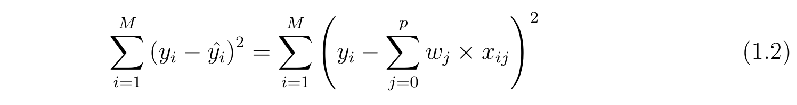

Cost function for simple linear model

In the equation above I have assumed the data-set has M instances and p features. Once we use linear regression on a data-set divided in to training and test set, calculating the scores on training and test set can give us a rough idea about whether the model is suffering from over-fitting or under-fitting. The chosen linear model can be just right also, if you’re lucky enough! If we have very few features on a data-set and the score is poor for both training and test set then it’s a problem of under-fitting. On the other hand if we have large number of features and test score is relatively poor than the training score then it’s the problem of over-generalization or over-fitting. **Ridge and Lasso regression are some of the simple techniques to reduce model complexity and prevent over-fitting which may result from simple linear regression**.

***Ridge Regression :***In ridge regression, the cost function is altered by adding a penalty equivalent to square of the magnitude of the coefficients.

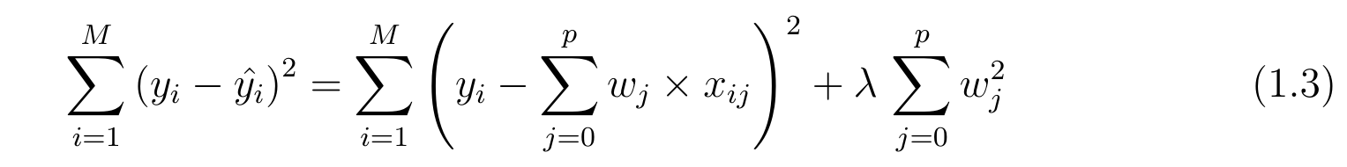

Cost function for ridge regression

This is equivalent to saying minimizing the cost function in equation 1.2 under the condition as below

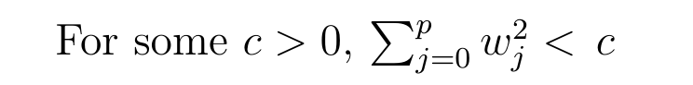

Supplement 1: Constrain on Ridge regression coefficients

So ridge regression puts constraint on the coefficients *(w).* The penalty term (lambda) regularizes the coefficients such that if the coefficients take large values the optimization function is penalized. So**, ridge regression shrinks the coefficients and it helps to reduce the model complexity and multi-collinearity.** Going back to eq. 1.3 one can see that when λ → 0 , the cost function becomes similar to the linear regression cost function (eq. 1.2). So *lower the constraint (low λ) on the features, the model will resemble linear regression model.* Let’s see an example using Boston house data and below is the code I used to depict linear regression as a limiting case of Ridge regression-

import matplotlib.pyplot as plt  
import numpy as np   
import pandas as pd  
import matplotlib  
matplotlib.rcParams.update({'font.size': 12})from sklearn.datasets import load_boston  
from sklearn.cross_validation import train_test_split  
from sklearn.linear_model import LinearRegression  
from sklearn.linear_model import Ridgeboston=load_boston()  
boston_df=pd.DataFrame(boston.data,columns=boston.feature_names)  
#print boston_df.info()# add another column that contains the house prices which in scikit learn datasets are considered as target  
boston_df['Price']=boston.target  
#print boston_df.head(3)newX=boston_df.drop('Price',axis=1)  
print newX[0:3] # check   
newY=boston_df['Price']#print type(newY)# pandas core frameX_train,X_test,y_train,y_test=train_test_split(newX,newY,test_size=0.3,random_state=3)  
print len(X_test), len(y_test)lr = LinearRegression()  
lr.fit(X_train, y_train)rr = Ridge(alpha=0.01) # higher the alpha value, more restriction on the coefficients; low alpha > more generalization, coefficients are barely  
# restricted and in this case linear and ridge regression resembles  
rr.fit(X_train, y_train)rr100 = Ridge(alpha=100) # comparison with alpha value  
rr100.fit(X_train, y_train)train_score=lr.score(X_train, y_train)  
test_score=lr.score(X_test, y_test)Ridge_train_score = rr.score(X_train,y_train)  
Ridge_test_score = rr.score(X_test, y_test)Ridge_train_score100 = rr100.score(X_train,y_train)  
Ridge_test_score100 = rr100.score(X_test, y_test)print "linear regression train score:", train_score  
print "linear regression test score:", test_score  
print "ridge regression train score low alpha:", Ridge_train_score  
print "ridge regression test score low alpha:", Ridge_test_score  
print "ridge regression train score high alpha:", Ridge_train_score100  
print "ridge regression test score high alpha:", Ridge_test_score100plt.plot(rr.coef_,alpha=0.7,linestyle='none',marker='*',markersize=5,color='red',label=r'Ridge; $\alpha = 0.01$',zorder=7) # zorder for ordering the markersplt.plot(rr100.coef_,alpha=0.5,linestyle='none',marker='d',markersize=6,color='blue',label=r'Ridge; $\alpha = 100$') # alpha here is for transparencyplt.plot(lr.coef_,alpha=0.4,linestyle='none',marker='o',markersize=7,color='green',label='Linear Regression')plt.xlabel('Coefficient Index',fontsize=16)  
plt.ylabel('Coefficient Magnitude',fontsize=16)  
plt.legend(fontsize=13,loc=4)  
plt.show()

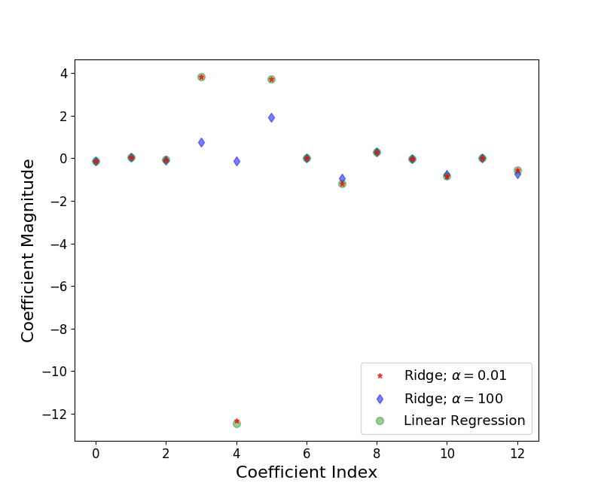

Figure 1: Ridge regression for different values of alpha is plotted to show linear regression as limiting case of ridge regression.

Let’s understand the figure above. In X axis we plot the coefficient index and, for Boston data there are 13 features (for Python 0th index refers to 1st feature). For low value of α (0.01), when the coefficients are less restricted, the magnitudes of the coefficients are almost same as of linear regression. For higher value of α (100), we see that for coefficient indices 3,4,5 the magnitudes are considerably less compared to linear regression case. This is an example of *shrinking* coefficient magnitude using Ridge regression.

**Lasso Regression :** The cost function for Lasso (least absolute shrinkage and selection operator) regression can be written as

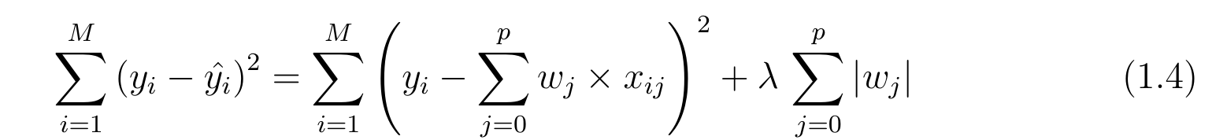

Cost function for Lasso regression

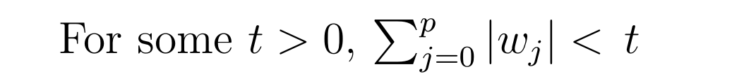

Supplement 2: Lasso regression coefficients; subject to similar constrain as Ridge, shown before.

Just like Ridge regression cost function, for lambda =0, the equation above reduces to equation 1.2. *The only difference is instead of taking the square of the coefficients, magnitudes are taken into account.* This type of regularization (L1) can lead to zero coefficients i.e. some of the features are completely neglected for the evaluation of output. **So Lasso regression not only helps in reducing over-fitting but it can help us in feature selection.** Just like Ridge regression the regularization parameter (lambda) can be controlled and we will see the effect below using cancer data set in sklearn. Reason I am using cancer data instead of Boston house data, that I have used before, is, cancer data-set have 30 features compared to only 13 features of Boston house data. So feature selection using Lasso regression can be depicted well by changing the regularization parameter.

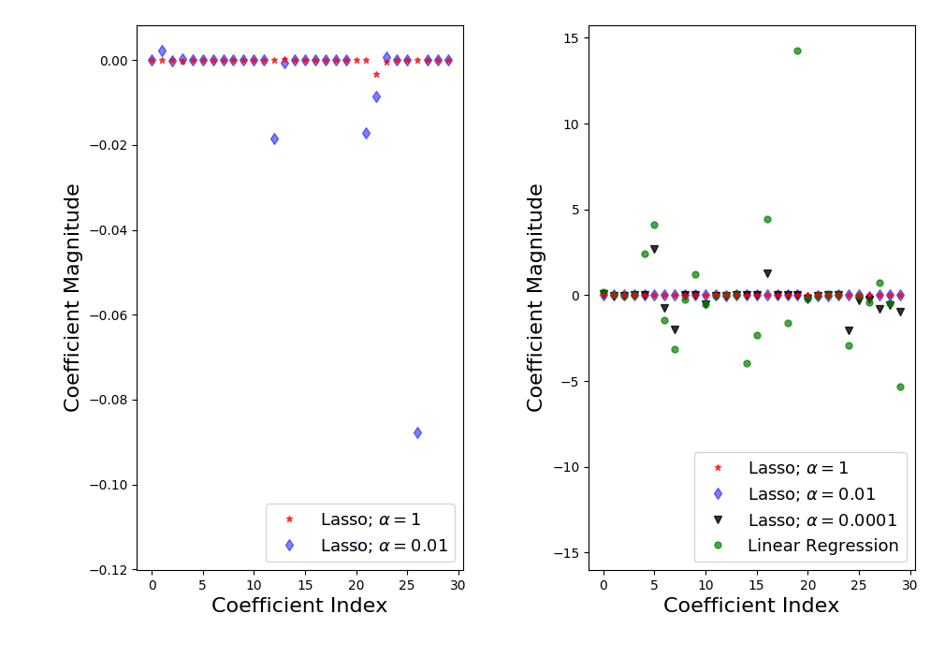

Figure 2: Lasso regression and feature selection dependence on the regularization parameter value.

The code I used to make these plots is as below

import math   
import matplotlib.pyplot as plt   
import pandas as pd  
import numpy as np# difference of lasso and ridge regression is that some of the coefficients can be zero i.e. some of the features are   
# completely neglectedfrom sklearn.linear_model import Lasso  
from sklearn.linear_model import LinearRegression  
from sklearn.datasets import load_breast_cancer  
from sklearn.cross_validation import train_test_splitcancer = load_breast_cancer()  
#print cancer.keys()cancer_df = pd.DataFrame(cancer.data, columns=cancer.feature_names)#print cancer_df.head(3)X = cancer.data  
Y = cancer.targetX_train,X_test,y_train,y_test=train_test_split(X,Y, test_size=0.3, random_state=31)lasso = Lasso()  
lasso.fit(X_train,y_train)  
train_score=lasso.score(X_train,y_train)  
test_score=lasso.score(X_test,y_test)  
coeff_used = np.sum(lasso.coef_!=0)print "training score:", train_score   
print "test score: ", test_score  
print "number of features used: ", coeff_usedlasso001 = Lasso(alpha=0.01, max_iter=10e5)  
lasso001.fit(X_train,y_train)train_score001=lasso001.score(X_train,y_train)  
test_score001=lasso001.score(X_test,y_test)  
coeff_used001 = np.sum(lasso001.coef_!=0)print "training score for alpha=0.01:", train_score001   
print "test score for alpha =0.01: ", test_score001  
print "number of features used: for alpha =0.01:", coeff_used001lasso00001 = Lasso(alpha=0.0001, max_iter=10e5)  
lasso00001.fit(X_train,y_train)train_score00001=lasso00001.score(X_train,y_train)  
test_score00001=lasso00001.score(X_test,y_test)  
coeff_used00001 = np.sum(lasso00001.coef_!=0)print "training score for alpha=0.0001:", train_score00001   
print "test score for alpha =0.0001: ", test_score00001  
print "number of features used: for alpha =0.0001:", coeff_used00001lr = LinearRegression()  
lr.fit(X_train,y_train)  
lr_train_score=lr.score(X_train,y_train)  
lr_test_score=lr.score(X_test,y_test)print "LR training score:", lr_train_score   
print "LR test score: ", lr_test_scoreplt.subplot(1,2,1)  
plt.plot(lasso.coef_,alpha=0.7,linestyle='none',marker='*',markersize=5,color='red',label=r'Lasso; $\alpha = 1$',zorder=7) # alpha here is for transparency  
plt.plot(lasso001.coef_,alpha=0.5,linestyle='none',marker='d',markersize=6,color='blue',label=r'Lasso; $\alpha = 0.01$') # alpha here is for transparency  
  
plt.xlabel('Coefficient Index',fontsize=16)  
plt.ylabel('Coefficient Magnitude',fontsize=16)  
plt.legend(fontsize=13,loc=4)plt.subplot(1,2,2)plt.plot(lasso.coef_,alpha=0.7,linestyle='none',marker='*',markersize=5,color='red',label=r'Lasso; $\alpha = 1$',zorder=7) # alpha here is for transparency  
plt.plot(lasso001.coef_,alpha=0.5,linestyle='none',marker='d',markersize=6,color='blue',label=r'Lasso; $\alpha = 0.01$') # alpha here is for transparency  
plt.plot(lasso00001.coef_,alpha=0.8,linestyle='none',marker='v',markersize=6,color='black',label=r'Lasso; $\alpha = 0.00001$') # alpha here is for transparency  
plt.plot(lr.coef_,alpha=0.7,linestyle='none',marker='o',markersize=5,color='green',label='Linear Regression',zorder=2)plt.xlabel('Coefficient Index',fontsize=16)  
plt.ylabel('Coefficient Magnitude',fontsize=16)  
plt.legend(fontsize=13,loc=4)  
plt.tight_layout()  
plt.show()  
#output training score: 0.5600974529893081  
test score: 0.5832244618818156  
number of features used: 4training score for alpha=0.01: 0.7037865778498829  
test score for alpha =0.01: 0.664183157772623  
number of features used: for alpha =0.01: 10training score for alpha=0.0001: 0.7754092006936697  
test score for alpha =0.0001: 0.7318608210757904  
number of features used: for alpha =0.0001: 22LR training score: 0.7842206194055068  
LR test score: 0.7329325010888681

Let’s understand the plot and the code in a short summary.

* The default value of regularization parameter in Lasso regression (given by α) is 1.
* With this, out of 30 features in cancer data-set, only 4 features are used (non zero value of the coefficient).
* Both training and test score (with only 4 features) are low; conclude that the model is under-fitting the cancer data-set.
* Reduce this under-fitting by reducing alpha and increasing number of iterations. Now α = 0.01, non-zero features =10, training and test score increases.
* Comparison of coefficient magnitude for two different values of alpha are shown in the left panel of figure 2. For alpha =1, we can see most of the coefficients are zero or nearly zero, which is not the case for alpha=0.01.
* Further reduce α =0.0001, non-zero features = 22. Training and test scores are similar to basic linear regression case.
* In the right panel of figure, for α = 0.0001, coefficients for Lasso regression and linear regression show close resemblance.

So far we have gone through the basics of Ridge and Lasso regression and seen some examples to understand the applications. Now, I will try to explain why the Lasso regression can result in feature selection and Ridge regression only reduces the coefficients close to zero, but not zero. An illustrative figure below will help us to understand better, where we will assume a hypothetical data-set with only two features. Using the constrain for the coefficients of Ridge and Lasso regression (as shown above in the supplements 1 and 2), we can plot the figure below

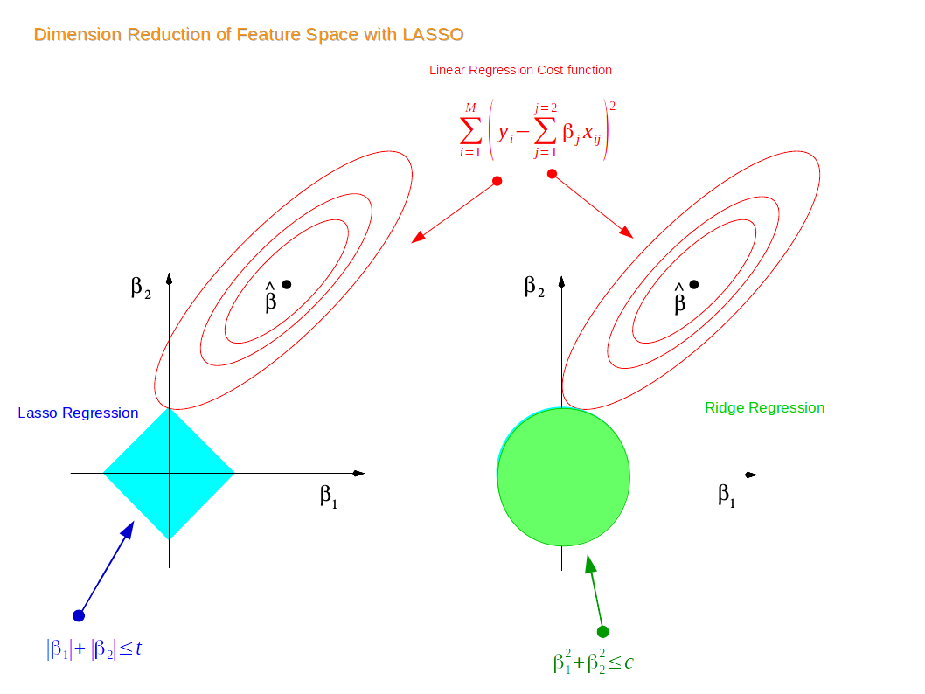

Figure 3: Why LASSO can reduce dimension of feature space? Example on 2D feature space. Modified from the plot used in ‘The Elements of Statistical Learning’ by me.

For a two dimensional feature space, the constraint regions (see supplement 1 and 2) are plotted for Lasso and Ridge regression with cyan and green colours. The elliptical contours are the cost function of linear regression (eq. 1.2). Now if we have relaxed conditions on the coefficients, then the constrained regions can get bigger and eventually they will hit the centre of the ellipse. This is the case when Ridge and Lasso regression resembles linear regression results. Otherwise, **both methods determine coefficients by finding the first point where the elliptical contours hit the region of constraints. The diamond (Lasso) has corners on the axes, unlike the disk, and whenever the elliptical region hits such point, one of the features completely vanishes!** For higher dimensional feature space there can be many solutions on the axis with Lasso regression and thus we get only the important features selected.

Finally to end this meditation, let’s summarize what we have learnt so far

1. Cost function of Ridge and Lasso regression and importance of regularization term.
2. Went through some examples using simple data-sets to understand Linear regression as a limiting case for both Lasso and Ridge regression.
3. Understood why Lasso regression can lead to feature selection whereas Ridge can only shrink coefficients close to zero.