PostgreSQL Point-in-Time Recovery (PITR) using CloudNativePG on Kubernetes
🔍 Objective
To practice and validate PostgreSQL Point-in-Time Recovery (PITR) using:
- Kubernetes (Minikube – single node lab)
- CloudNativePG (CNPG) operator
- Amazon S3 as backup + WAL archive destination
Instead of restoring in-place, a new PostgreSQL cluster was created and restored to a specific timestamp, which is the recommended and safest PITR approach.
🧠 Why CloudNativePG for PITR?
CloudNativePG is purpose-built for PostgreSQL on Kubernetes and offers:
- Native PostgreSQL streaming replication
- Built-in Barman-based backups
- WAL archiving to object storage (S3)
- Declarative recovery (PITR) using Kubernetes CRDs
- No external backup tooling or cron jobs required
👉 Important:
We did not use Helm for the operator — CNPG was installed directly via YAML manifests, which is fully supported and production-grade.

🏗 Architecture (Lab Setup)
⚠️ Note: This is a single-node Minikube lab, used only to learn concepts.
- Kubernetes: Minikube (1 node)
- PostgreSQL version: 16.x
- CNPG instances:
  - PITR source cluster → 1 primary
  - PITR restored cluster → new cluster
- Backups:
  - Base backup → S3
  - WAL files → S3
- Storage:
  - PVC for live data
  - S3 for recovery data
🧩 Step-by-Step: What Was Achieved
1️ Install CloudNativePG Operator
kubectl apply --server-side --force-conflicts \
-f https://raw.githubusercontent.com/cloudnative-pg/cloudnative-pg/release-1.24/releases/cnpg-1.24.0.yaml

Verify:

kubectl get pods -n cnpg-system

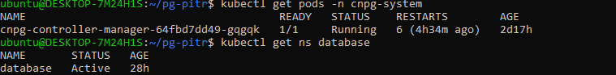

Create PostgreSQL Cluster with S3 Backup + WAL Archiving
Key configuration:
- barmanObjectStore → S3 bucket
- WAL compression enabled
- AWS credentials stored as Kubernetes secret

Apply:

kubectl apply -f pg-ha-pitr.yaml

3️ Verify Cluster & Primary
kubectl get cluster -n database
kubectl get pods -n database

Check primary:

kubectl exec -n database pg-ha-pitr-1 -- \
psql -U postgres -c "SELECT pg_is_in_recovery();"
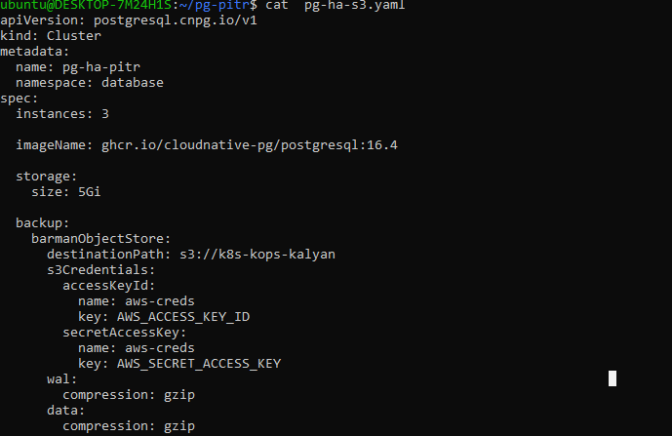

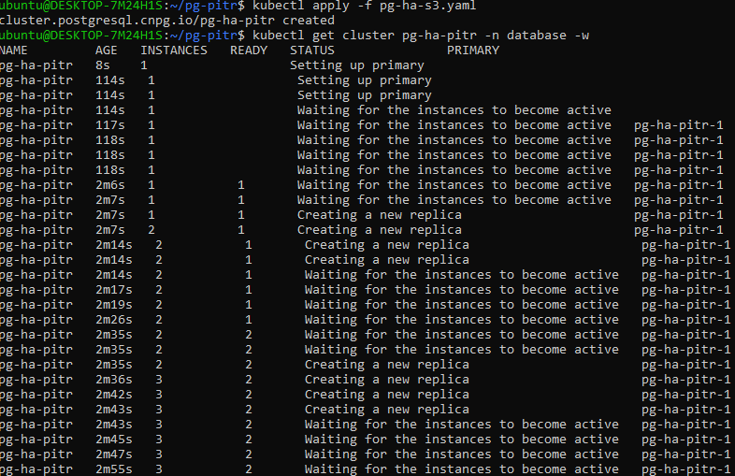
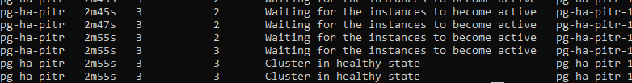

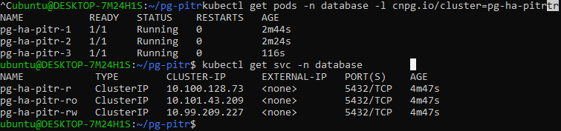

4. Check primary:

kubectl exec -n database pg-ha-pitr-1 -- \
psql -U postgres -c "SELECT pg_is_in_recovery();"

Create Database and Test Data
kubectl exec -n database pg-ha-pitr-1 -- psql -U postgres
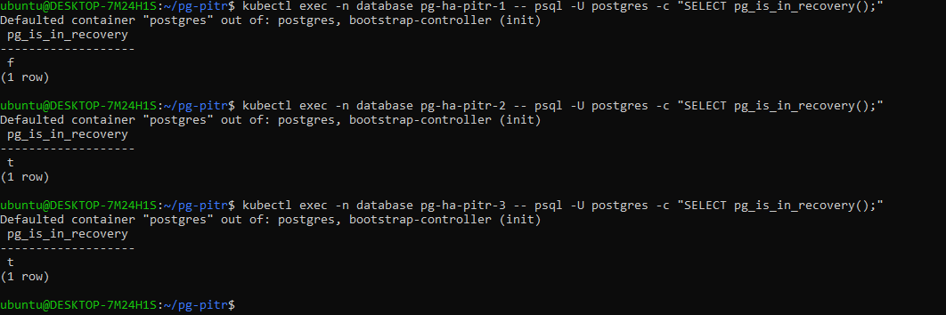

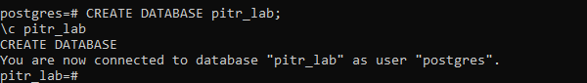

CREATE DATABASE pitr_lab;
\c pitr_lab

CREATE TABLE orders (
id SERIAL PRIMARY KEY,
amount INT,
created_at TIMESTAMP DEFAULT now()
);

INSERT INTO orders (amount) VALUES
(100),(200),(300),(400),(500),(600),(700),(800);

SELECT * FROM orders;
SELECT now();

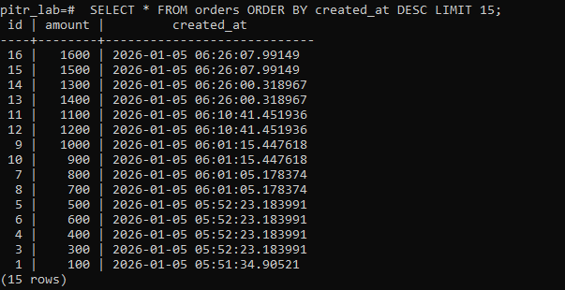

📌 Note the timestamp — this is your PITR target reference.

5. Take Base Backup
kubectl get backups -n database

Example:

NAME CLUSTER METHOD PHASE
pitr-base-backup pg-ha-pitr barmanObjectStore completed

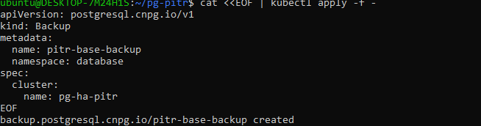

Verify in S3:

aws s3 ls s3://k8s-kops-kalyan/

We can also delete the cluster but, I have created new cluster using based backup and recovered in point in time.

7. Create PITR Restore Cluster
Key PITR config:
- source: s3-backup
- recoveryTarget.time → timestamp before failure
bootstrap:
recovery:
source: s3-backup
recoveryTarget:
time: "2026-01-04 16:16:30+00"
Apply restore cluster YAML.

8. Observe Restore Pods
kubectl get pods -n database -w

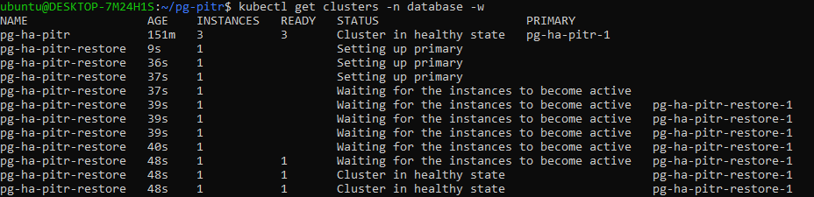

Validate PITR Success
kubectl exec -n database <new-pod> -- \
psql -U postgres -d pitr_lab
SELECT * FROM orders;

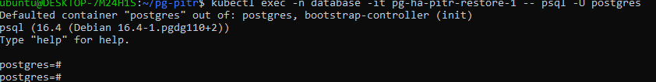

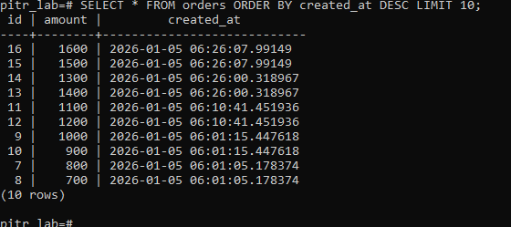

✅ Rows inserted after the recovery timestamp are not present
✅ Database is restored exactly to the desired point in time

🔑 Key Learnings (DBRE Perspective)
- PITR is not just backups — WAL continuity is critical
- CNPG automates:
  - WAL archiving
  - Backup retention
  - Recovery orchestration
- Best practice:
  - Restore into a new cluster
  - Never overwrite production blindly
- Even on single-node Minikube:
  - You can fully simulate enterprise-grade DR

🚀 What This Demonstrates for DBRE Roles
✔ Kubernetes-native PostgreSQL
✔ Backup & disaster recovery design
✔ WAL mechanics & PITR
✔ Object storage integration (S3)
✔ Operator-driven automation
✔ Production-style recovery workflows

