
TRIBHUVAN UNIVERSITY
PROJECT PROPOSAL

Remote Cloud Storage System
Submitted by
Kalyan Kandel (Roll No: 40)
Aayush Subedi (Roll No: 53)
Albert Baral (Roll No: 43)

Submitted to
Department of Computer Science
Birendra Multiple Campus
Bharatpur, Chitwan
Date
February 26, 2026

Contents
Introduction 3
Background of Study 3
Overview of the Topic 4
Why This Project Is Important 4
Problem Statement 4
What Specific Problem Are You Trying to Solve? 4
Why Does This Problem Exist? 4
Objectives 5
General Objective 5
Specific Objectives 5
Literature Review 6
Review of Similar Systems 6
Comparison of Existing Solutions 6
Strengths and Weaknesses 7
Methodology 7
System Architecture 7
Tools & Technologies 8
Encryption Approach 9
Development Model 9
Development Phases (3-Month Timeline) 10
Flow chart diagram 10
Entity-Relationship Diagram (ERD) 12
Testing Strategy 14
Scope and Limitations 15
Scope: What the System Will Cover 15
Limitations: What the System Will NOT Cover 15
Expected Outcome 16
Prototype Features (Final Deliverable) 16
Future Enhancement Possibilities 17
References 17

Introduction
Team Member | Primary Responsibilities | Technologies
Aayush Subedi | Backend API development, Database design, Core file operations, User management, Bonding system logic | Node.js, Express, SQLite/PostgreSQL, JWT, Multer
Albert Baral | Security implementation, Encryption (at rest & in transit), Penetration testing, Unit testing, Integration testing, Performance testing | Crypto libraries, AES-256, TLS/SSL, Jest, Selenium, OWASP tools
Kalyan Kandel | Frontend UI development, Component design, API integration, Responsive layouts, User experience | React, Axios, React Router, Bootstrap/Tailwind

Background of Study
Cloud storage has transformed how individuals and organizations manage data, with services like Google Drive, Dropbox, and OneDrive becoming essential tools for personal and professional use [3]. These platforms enable users to store files remotely, access them from anywhere, and collaborate through sharing mechanisms. However, commercial solutions often involve recurring costs, privacy concerns, and limited user control. The demand for self-hosted, customizable storage solutions has grown as users seek greater control over their data while maintaining cloud accessibility [4].
Security remains a primary concern in cloud storage systems, with data breaches and unauthorized access posing significant risks [5]. Implementing robust encryption mechanisms ensures that user data remains confidential even if storage systems are compromised.

Overview of the Topic
A remote cloud storage system allows users to upload, store, manage, and retrieve files over the internet. Modern systems incorporate user authentication, file sharing, access control, and synchronization [1]. This project proposes developing a collaborative cloud storage platform where users can authenticate securely, create bonded spaces for group access, and share files via links on their data. The system will implement encryption at rest and in transit to ensure data security. The system will be built as a functional prototype within a three-month timeframe.

Why This Project Is Important
This project provides hands-on experience with full-stack development, authentication systems, database design, file management, and security implementation [2]. For potential users, it demonstrates a foundation that can be extended into a production-ready solution with features like payment integration. Understanding how systems handle file chunking, metadata management, secure sharing, and data encryption is valuable knowledge applicable to modern software development [5].

Problem Statement

What Specific Problem Are You Trying to Solve?
Individuals and small groups lack an affordable, self-hosted cloud storage solution that provides both personal file management, collaborative spaces, AND built-in security through encryption [3]. Existing options are either expensive commercial services with recurring costs or complex self-hosted solutions requiring significant technical expertise. Additionally, users have growing concerns about data privacy and want solutions where they control their information with proper encryption [5].

Why Does This Problem Exist?
Commercial cloud storage providers operate on subscription models that become costly over time, especially for groups needing shared storage [4]. Free tiers offer limited space and features. Open-source alternatives often lack user-friendly interfaces, require extensive configuration, or omit collaborative features like shared workspaces and granular access controls [9]. Security features like end-to-end encryption are often absent or complicated to configure. This project addresses these gaps by creating a lightweight, accessible prototype that demonstrates core functionality with built-in security measures.

Objectives

General Objective
To develop a functional remote cloud storage system prototype within three months that enables secure user authentication, personal file management, and collaborative file sharing through bonded user spaces and shareable links, with encryption ensuring data confidentiality.

Specific Objectives
- To design and implement a secure authentication system for user registration, login, and session management using JWT and password hashing [7].
- To develop core file management functionality enabling users to upload, download, update, and delete files.
- To create a bonding mechanism that allows users to form groups with shared storage spaces.
- To implement link-based file sharing enabling users to generate shareable links with optional access controls.
- To implement encryption at rest and in transit to protect user files from unauthorized access [2].
- To design a scalable database schema for storing user data, file metadata, and sharing relationships [1].
- To build a responsive frontend interface providing intuitive access to all core features.
- To prepare structural foundation for payment gateway integration (e.g., eSewa) as an extendable feature.
- To conduct thorough testing including security testing to ensure system reliability and data protection [10].

Literature Review

Review of Similar Systems
Commercial Solutions: Google Drive, Dropbox, and Microsoft OneDrive dominate the market, offering robust features but operating on subscription models with limited user control. These platforms implement encryption, but users must trust the service provider with their data.
Self-Hosted Alternatives: Nextcloud and ownCloud provide open-source, self-hosted platforms with encryption options but require significant technical knowledge for deployment, maintenance, and proper security configuration [6].
Security-Focused Solutions: Services like Tresorit and Sync.com offer end-to-end encryption but at premium prices. Open-source encryption tools like Cryptomator can be layered on top of existing cloud storage but add complexity [5].
Lightweight Implementations: Projects like CloudBoxIO demonstrate that core cloud storage functionality can be achieved with simpler architectures using JWT authentication and basic file operations, though they often lack comprehensive encryption [9].

Comparison of Existing Solutions
Feature | Google Drive | Nextcloud | CloudBoxIO | Proposed System
Self-hosted | No | Yes | Yes | Yes
Authentication | OAuth | Local/LDAP | JWT | JWT + Bcrypt
File Sharing | Yes | Yes | Basic | Link-based + Groups
Collaborative Spaces | Shared Drives | Groups | No | Bonded Users
Encryption | Server-side | Optional | No | AES-256 at rest + TLS
Payment Integration | Subscription | No | No | eSewa Ready
Technical Complexity | Low | High | Medium | Medium

Strengths and Weaknesses
Commercial services excel in user experience but sacrifice control and incur costs [3]. Self-hosted solutions restore control but introduce maintenance burdens and complex security configurations [6]. The proposed system balances these factors by providing essential features with built-in encryption accessible through an intuitive interface, all within a three-month timeline [5].

Methodology
The development of the Remote Cloud Storage System will follow a structured methodology that ensures systematic progress, clear role distribution, and successful delivery of a functional prototype within the three-month timeline. This section details the system architecture, technology stack, development approach, team responsibilities, and testing strategies.

System Architecture
The system will follow a client-server architecture with clear separation between presentation, application, and data layers [1]:
- Frontend (Presentation Layer): React-based single-page application.
- Backend (Application Layer): Node.js/Express REST API
- Database (Data Layer): SQLite/PostgreSQL for metadata; encrypted file system for actual file storage

Tools & Technologies
Backend Development:
- Node.js with Express.js
- JWT for authentication tokens [7]
- bcrypt for password hashing
- Multer for file upload handling
- SQLite/PostgreSQL for database
- File system for storage.
Frontend Development:
- React.js for UI components
- Axios for API communication
- React Router for navigation.
- Bootstrap/Tailwind CSS for styling.
- React Context/Redux for state management [10].
Security & Testing:
- Node.js crypto module for AES-256 encryption [7]
- HTTPS/TLS for data in transit
- Helmet.js for security headers
- Jest for unit testing
- React Testing Library for component testing.
- Postman/Insomnia for API testing
- OWASP ZAP for security scanning [8]
- Selenium for end-to-end testing
Additional Technologies:
- Git/GitHub for version control
- eSewa API structure (preliminary integration) [11]
- Structured directory system with encrypted chunks

Encryption Approach
Encryption at Rest:
- Files will be encrypted using AES-256 algorithm before storage [2].
- Each file receives a unique encryption key.
- File chunks are encrypted individually for efficiency.
- Encrypted metadata stored separately from file content
- Keys managed securely (simplified approach for prototype)
Encryption in Transit:
- HTTPS/TLS for all client-server communication
- API endpoints secured with JWT validation
- Secure session management
Authentication Security:
- Passwords hashed using bcrypt with salt rounds [7]
- JWT tokens with expiration
- Rate limiting on login attempts.
- Input validation and sanitization [8].

Development Model
The project will follow an Agile development methodology with two-week sprints over the three-month period [1]. This approach allows iterative development, regular feedback, and flexibility to adjust requirements based on progress.

Development Phases (3-Month Timeline)

 | Sprint 1 | Sprint 2 | Sprint 3
Project setup, requirements finalization, database design, authentication system
Core file operations, encryption implementation, basic UI
Bonded spaces, link sharing, testing, documentation

Flow chart diagram
The user interface flowchart illustrates the navigation flow and page hierarchy of the Remote Cloud Storage System. It serves as a blueprint for frontend development and ensures a consistent, intuitive user experience. The flowchart covers public pages (home, login, register) and authenticated pages (dashboard, file management, groups, sharing, profile) as well as the public share link access flow.

Group details (host, members, files)
File actions(upload, download, delete, share)
View shared files
Shared with me view
Bonds view
My files view
User choice?
Dashboard
Login/register
User opens website

Entity-Relationship Diagram (ERD)
The ER diagram for the Remote Cloud Storage System is designed to support core functionality: user management, file storage (with encryption), group-based collaboration, and link-based sharing. The schema is normalized to ensure data integrity and efficient queries.
The Entity-Relationship diagram for the Remote Cloud Storage System is designed to support three core functional areas: user management, file storage with encryption, and collaborative features through bonded spaces and link sharing. The schema follows normalized database design principles to eliminate redundancy while maintaining data integrity through primary key (PK) and foreign key (FK) relationships [1]. The diagram consists of five main entities: User, File, Group, GroupMember, and ShareLink, each representing a distinct component of the system with clearly defined attributes and relationships.
The User entity serves as the foundation, storing authentication credentials (username, email, password_hash) and account metadata. This table's primary key (user_id) is referenced as a foreign key in multiple other tables, establishing ownership and permission relationships. The File entity captures all file-related metadata including encryption-specific fields (encryption_key_enc and iv) that Albert's security implementation requires for AES-256 encryption at rest [2]. The user_id foreign key identifies the file owner, while the optional group_id foreign key allows files to belong to shared group spaces, enabling the bonding mechanism that Aayush will implement.
The collaboration features are realized through the Group and GroupMember entities. Group stores basic information about each bonded space, with owner_id linking back to the creating user. The GroupMember junction table uses a composite primary key (group_id, user_id) to establish many-to-many relationships between users and groups, with a role attribute distinguishing between administrators and regular members. This structure allows users to belong to multiple groups while maintaining appropriate access levels. Finally, the ShareLink entity manages external file sharing, using file_id and created_by foreign keys to track which files are shared and who created each link. The token field provides a unique identifier for shareable URLs, while optional password_hash and expiry_date fields support the access control features outlined in the project objectives.

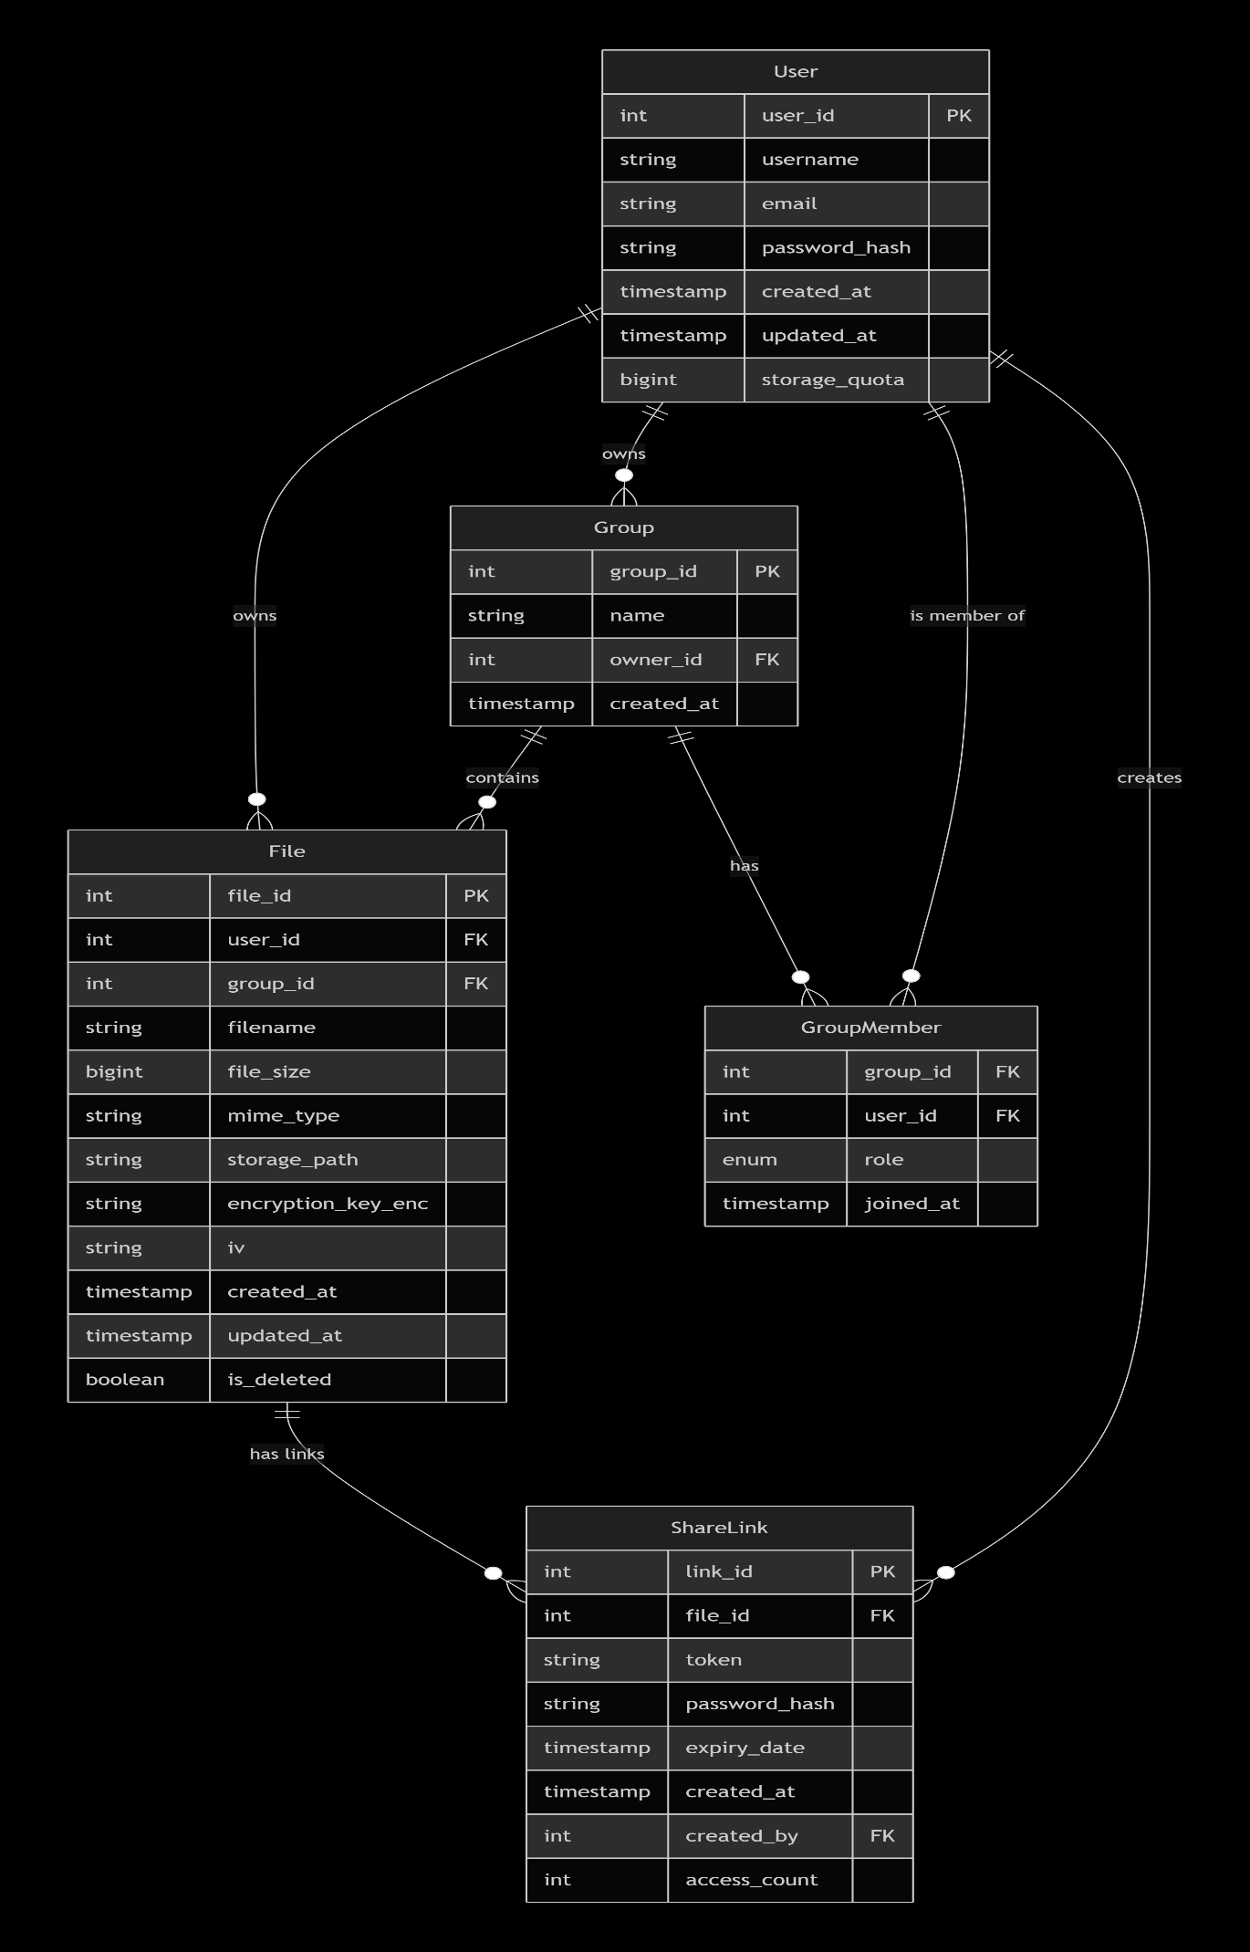

Testing Strategy
Unit Testing:
- Test individual functions and components.
- Authentication functions
- File operation logic.
- Encryption/decryption functions
Integration Testing:
- Test API endpoints.
- Database interactions
- File system operations.
- End-to-end user flows
Security Testing:
- Penetration testing on authentication [8]
- Encryption verification
- Input validation testing.
- Session management testing
- OWASP top 10 vulnerability scanning [8]
Performance Testing:
- File upload/download speeds.
- Concurrent user handling
- Database query performance

Scope and Limitations

Scope: What the System Will Cover
- User Management: Registration, authentication, profile management, secure password storage [7]
- File Operations: Upload, download, update, delete, and organize files with encryption at rest. [2]
- Bonded User Spaces: Creation of groups where multiple users can access shared folders.
- Link Sharing: Generation of shareable links for files with optional access controls.
- Security Features: AES-256 encryption, HTTPS, secure authentication, input validation [5]
- Payment Readiness: Structural preparation for eSewa integration (implementation may be partial) [1]

Limitations: What the System Will NOT Cover
- Production Deployment: The system will be developed as a prototype, not optimized for production-scale traffic [4].
- File Versioning: Version history and file recovery features will not be implemented.
- Real-time Synchronization: Automatic cross-device sync like commercial services [3]
- Mobile Applications: Native mobile apps will not be developed (mobile web only)
- Advanced Key Management: Enterprise-grade key management systems (simplified approach for prototype) [5]
- Two-Factor Authentication: Not implemented due to time constraints.
- Full Payment Processing: Complete eSewa transaction handling (structural preparation only)
- Large File Support: Files over 100MB may experience performance issues.

Expected Outcome
Upon completion of the 3-month project, the team will deliver a functional prototype of a remote cloud storage system with the following capabilities:
- Working Authentication System: Secure user registration and login with JWT tokens and password hashing [7]
- Personal File Management: Users can upload, download, update, and delete files in their private storage. [2]
- File Encryption: All files encrypted with AES-256 before storage, ensuring data confidentiality.
- Bonded User Spaces: Users can create groups and share files within collaborative spaces.
- Link-Based Sharing: Files can be shared externally through generated links with access controls which expires overtime.
- Responsive Frontend Interface: Clean, intuitive web interface accessible from desktop and mobile browsers [10]
- Comprehensive Test Coverage: Unit tests, integration tests, and security tests validating system functionality. [8]
- Security Verification: Documentation of encryption implementation and security testing results
- Technical Documentation: API specifications, database schema, encryption approach, and deployment instructions [1]

Prototype Features (Final Deliverable)
As a 3-month academic project, the final deliverable will be a working prototype demonstration:
- 5-10 concurrent users capability
- File uploads up to 50MB for testing.
- Sample bonded groups with 3-5 users.
- Basic encryption functionality working
- Clean but simplified UI focused on core features.
- Demonstration-ready with sample data

Future Enhancement Possibilities
The prototype establishes a foundation for future development including:
- Full eSewa payment integration [11]
- Advanced key management [5]
- File versioning and recovery.
- Mobile applications
- Scalable cloud deployment [4]
- Two-factor authentication [8]

References
[1] M. Fowler, Patterns of Enterprise Application Architecture. Boston, MA, USA: Addison-Wesley, 2018.
[2] W. Stallings, Cryptography and Network Security: Principles and Practice, 7th ed. London, U.K.: Pearson, 2016.
[3] Q. Zhang, L. Cheng, and R. Boutaba, “Cloud computing: state-of-the-art and research challenges,” Journal of Internet Services and Applications, vol. 1, no. 1, pp. 7–18, 2010. doi: 10.1007/s13174-010-0007-6.
[4] P. Mell and T. Grance, “The NIST definition of cloud computing,” National Institute of Standards and Technology, Gaithersburg, MD, USA, Tech. Rep. 800-145, Sep. 2011. [Online]. Available: https://csrc.nist.gov/publications/detail/sp/800-145/final
[5] S. Kamara and K. Lauter, “Cryptographic cloud storage,” in Proc. 14th Int. Conf. Financial Cryptography and Data Security, Tenerife, Spain, 2010, pp. 136–149. doi: 10.1007/978-3-642-14992-4_13.
[6] Apache Software Foundation, “User storage quotas and MFT dashboard,” Apache Airavata Documentation. [Online]. Available: https://airavata.apache.org/documentation/ (accessed Feb. 25, 2026).
[7] Node.js Contributors, “Crypto module,” Node.js v22 Documentation. [Online]. Available: https://nodejs.org/api/crypto.html (accessed Feb. 25, 2026).
[8] OWASP Foundation, “OWASP Top Ten: 2025,” 2025. [Online]. Available: https://owasp.org/www-project-top-ten/ (accessed Feb. 25, 2026).
[9] A. Sahayata, “CloudBoxIO documentation,” Go Packages. [Online]. Available: https://pkg.go.dev/github.com/AumSahayata/cloudboxio (accessed Feb. 25, 2026).
[10] Mozilla Developer Network, “Web security,” MDN Web Docs. [Online]. Available: https://developer.mozilla.org/en-US/docs/Web/Security (accessed Feb. 25, 2026).
[11] eSewa, "Introduction," eSewa Developer Documentation. [Online]. Available: https://developer.esewa.com.np/

