**Business Problem:**

A group of customers were given an offer in person that they can get a loan at discounted rate and

processing fee will be waived off. A pilot campaign was conducted to get response from customers

whether they are interested in taking out a loan or not. Response was recorded and data was collected.

Based on data given we need to:

1) Build a model to predict whether customers will be interested in taking out a loan or not.

2) Identifying features which are most important

3) In case of black box models e.g. Random forest use SHAP, LIME to figure out features affecting

the target variable

4) Approaching a customer has costs involved with it, hence find the profitable segments so that

more customized marketing can be done.

5) Model will be needed on a monthly basis as this data gets updated each month.

A solvency capital requirement (**SCR**) is the total amount of funds that insurance and reinsurance companies in the European Union (EU) are required to hold. ... The solvency capital requirement covers existing business as well as new business expected over the course of 12 months.

**Variables involved**

● Customer_id

● Age

● Gender

● Balance

● Occupation

● No of Credit transaction

● SCR

● Holding period

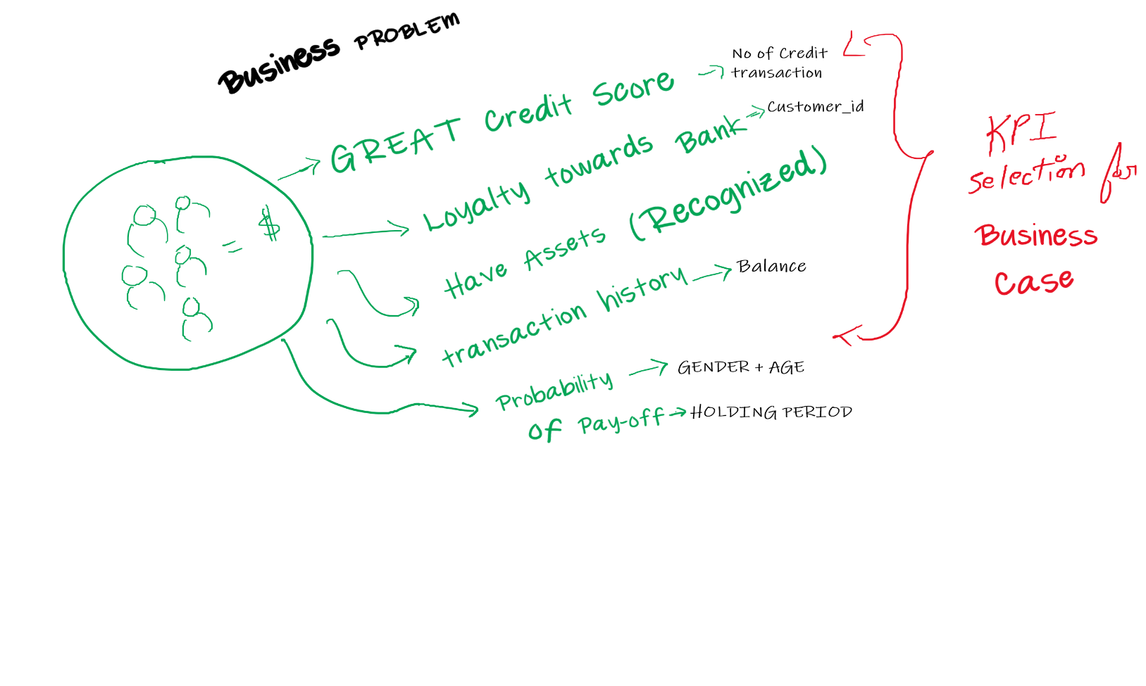**What is given?**

**Source Variables:** Age, Gender, Balance, Occupation, Holding Period, No of credit transaction

**Target Variables:** Loan_Predictor variable – 0 or 1

**What to Do?**

Predict the interest of customers to take a loan