## MINI PROJECT REPORT

**on**

**SCIENTIFIC STREAM SELECTION- MAP YOUR TALENTS**

**Submitted in partial fulfilment for the completion of the course**

**Mini Project I in**

**III Semester of B.E.**

**INFORMATION TECHNOLOGY**

**By**

**CHITTI SAITEJA (160117737041)**

**GONE KALYAN REDDY (160117737028)**

**Under the guidance of**

**Dr B.VeeraJyothi,**

**Assistant Professor,**

**Dept. of IT, CBIT.**

**DEPARTMENT OF INFORMATION TECHNOLOGY**

**CHAITANYA BHARATHI INSTITUTE OF TECHNOLOGY (A)**

**(Affiliated to Osmania University; Accredited by NBA(AICTE) and NAAC(UGC), ISO Certified 9001:2015)**

**GANDIPET, HYDERABAD – 500 075**

**Website:** [**www.cbit.ac.in**](http://www.cbit.ac.in)

**2019-2020**

**CHAITANYA BHARATHI INSTITUTE OF TECHNOLOGY (A)**

DEPARTMENT OF INFORMATION TECHNOLOGY

**(Affiliated to Osmania University)**

**GANDIPET, HYDERABAD – 500 075**

**CERTIFICATE**

This isto certify that the project work entitled “**SCIENTIFIC STREAM SELECTION**” submitted to **CHAITANYA BHARATHI INSTITUTE OF TECHNOLOGY,** in partial fulfilment of the requirements for the completion of III semester of B.E. in Information Technology, during the academic year 2019-2020, is a record of original work done by

**CHITTI SAITEJA (160118737041), GONE KALYAN REDDY (160118737028)** during the period of study in Department of IT, CBIT, HYDERABAD, under my supervision and guidance.

**Project Guide**  **Head of the Department**

**Dr B.Veera Jyothi Dr.Suresh Pabboju**

Assistant Professor, Dept. of IT, Professor, Dept. of IT,

CBIT, Hyderabad. CBIT, Hyderabad.

**CONTENTS**

**Pg. no.**

**ACKNOWLEDGEMENT iv**

**DECLARATION v**

**ABSTRACT vi**

**LIST OF FIGURES vii**

1. **INTRODUCTION 1**
   1. Motivation 1
   2. Objective of the Project 1
   3. Existing System 1
   4. Proposed System 1

1. **SOFTWARE & HARDWARE REQUIREMENTS 2**
2. **METHODOLOGY**

3.1 Architecture of Proposed System

1. **IMPLEMENTATION**
2. **RESULTS AND SCREEN SHOTS**
3. **CONCLUSION & FUTURE SCOPE**
4. **BIBLIOGRAPHY**

**ACKNOWLEDGEMENT**

We would like to express our heartfelt gratitude to Dr B..Veera Jyothi project guide, for her invaluable guidance and constant support, along with her capable instruction and persistent encouragement.

We are grateful to our Head of Department, Dr.Suresh Pabboju, for his steady support and the provision of every resource required for the completion of this project.

We would like to take this opportunity to thank our Principal,

Dr. P.Ravinder Reddy, as well as the management of the institute, for having designed an excellent learning atmosphere.

Our thanks are due to all members of the staff and our lab assistants for providing us with the help required carrying out the groundwork of this project.

**DECLARATION**

This is to certify that the work reported in the present report title “SCIENTIFIC STREAM SELECTION -MAP YOUR TALENTS” is a record of work done by CH.SAITEJA (160118737041) , G.KALYAN REDDY(160118737028) in the Department of Information Technology, Chaitanya Bharathi Institute of Technology, Hyderabad.

No part of the report is copied from books/ journals / internet and wherever the portion is taken , the same has been duly referred. The report and results are based on the project work done entirely by us and not copied from any other source.

**ABSTRACT**

The Mini Project titled "SCIENTIFIC STREAM SELECTION AND CAREER PLANNING" is for showing the Students career options that can be choose on which their potentials are good.

As we are in the era of Modernisation, Education is the most important part of our life. Many Students who can Study well fail to choose the Right Path.

In Life you can become either a Passenger or a Pilot it’s your choice. Our Project focuses on showing them to choose Right Path.

This Project is developed in C++. It contains Operations like Searching Streams, entrances, best Colleges etc . The Project is for Students who just passed out 10th class, 12th class, UG Courses.

**LIST OF FIGURES**

|  |  |  |
| --- | --- | --- |
| **Figure** | **Description** | **Page No.** |
| Figure 4.1 | Student Registration | **6** |
| Figure 4.2 | Profile Page | **6** |
| Figure 4.3 | Student Login | **7** |
| Figure 4.4 | Choosing the Class | **7** |
| Figure 4.5 | Quiz-Maths | **8** |
| Figure 4.6 | Quiz-Biology | **8** |
| Figure 4.7 | Stream Display1 | **9** |
| Figure 4.8 | Stream Display2 | **9** |
| Figure 4.9 | Intermediate Stream | **9** |
| Figure 4.10 | List of Entrances-MPC | **10** |
| Figure 4.11 | Choosing Entrance-MPC | **10** |
| Figure 4.12 | Branch Selection-MPC | **10** |
| Figure 4.13 | List of Entrances-BIPC | **11** |
| Figure 4.14 | Choosing Entrance-BIPC | **12** |
| Figure 4.15 | Branch Selection-BIPC | **12** |
| Figure 4.16 | After UG Courses Details | **12** |
| Figure 4.17 | Course Selection-After UG | **13** |
| Figure 4.18 | Test Performance | **13** |
| Figure 4.19 | Top Colleges List-M.S | **14** |
| Figure 4.20 | College Details | **14** |
| Figure 4.21 | Admin Login | **15** |
| Figure 4.22 | Details of Registered Users | **15** |
|  |  |  |
|  |  |  |
| Figure 4.23 | Displaying Queries asked by the Users | **15** |
| Figure 4.24 | Query Clearance | **16** |
| Figure 4.25 | User asking a Query | **17** |

**1. INTRODUCTION**

**1.1 MOTIVATION**

Nowadays many people are struggling to choose their stream for their career. But our project helps them to overcome this problem. By this project students can Map their talents to the respected streams.

Students can check their performance and improve their studies. In this technical world it is essential to save time. So one can at a time check the top 5 priority wise college’s details and also they can write a Test.

**1.2 OBJECTIVE OF THIS PROJECT**

This project is designed for selecting the Stream and viewing the details of the best colleges. This project can be used by any college/school students to map their talents.This is a simple and secure method that helps to know the streams available in society and choose the appropriate among them.

**1.3. EXISTING SYSTEM**

Existing system is a manual and is paper based this requirement for a lot of human effort. The question papers here are not secured. There can be redundancy of data. There can be errors in the preparations. Maintenance is difficult process.

Guidance and counselling has been limited to few institutions therefore not all the students get the proper guidance. Although some career guidance websites are present it charges huge fees which is not affordable by large group of society .The students nowadays may find uncomfortable to approach a guide who is older in age this is due to generation gap.

**1.4. PROPOSED SYSTEM**

In this system, questions can be stored and retrieved easily. The system checks the answer by matching the predefined answers in the database and user’s answers.In this system, the students have to select the class and their branch, then the test is conducted, after the test they can check their marks. Based on their marks and branch selected branch we suggest them the best colleges priority wise. The admin can see the details of all the users who are registered in to this system. .In this system, the students can ask for the queries and replies will be given by the admin in order to solve the problems of the students.

**2. SOFTWARE AND HARDWARE REQUIREMENTS**

**LANGUAGE :** C++

**PLATFORM :** DEV C++

**OPERATING SYSTEM :** WINDOWS 10 PRO – 64 BIT

**PROCESSOR :** INTEL® CORE™i7 8th GENERATION

**MEMORY :** 8192 MB RAM

**3.METHODOLOGY**

In this system, questions can be stored and retrieved easily. The system checks the answer by matching the predefined answers in the database and user’s answers.In this system, the students have to select the class and their branch, then the test is conducted, after the test they can check their marks. Based on their marks and branch selected branch we suggest them the best colleges priority wise.

The admin can see the details of all the users who are registered in to this system.In this system, the students can ask for the queries and will be given by the admin in order to solve the problems of the students.

**3.1 ARCHITECTURE OF PROPOSED SYSTEM**

**Flow Chart**

Reply to Queries

Login

Scientific Stream Selection

-Map your talents

Admin

Module

Queries

User Module

Upload Queries

Enter

Admin Details

Register with

User credentials

Enter details and Map your Talent

Display all usernames

Exit

**4. IMPLEMENTATION**

**Modules in our Project :**

**4.1. Student Registration:**

Students need to Register with a new Username , Passwordand give their personal details.

**4.2. Student Login:**

Students need to Login with their unique Username and Password and Map their Talents.

**4.3. Admin Login:**

Admin need to login with his unique Userid and Password and he can Access all the Information of the Users and clear the User Queries.

**4.4. Ask a Query:**

User can ask his Queries other than information provided.

**4.1 STUDENT REGISTER**

1. We have given a choice for the student to register by a new Username and Password.

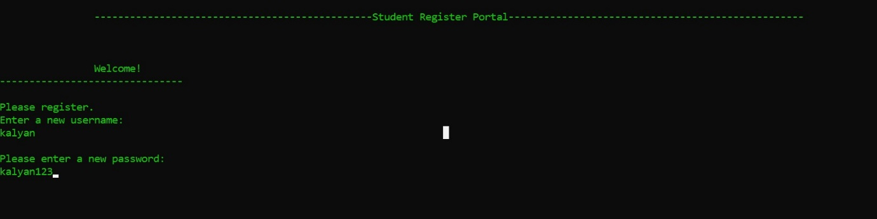

Fig 4.1.

2. Student details like Name, Contact no, Email-id, Father Name are saved into a file after Registering.

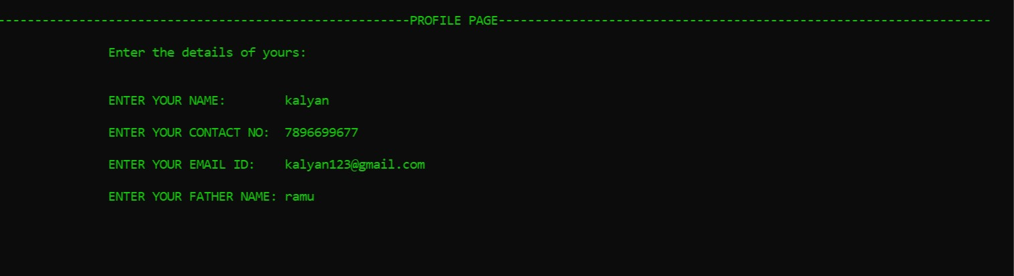

Fig 4.2.

3. Registered Username and Password are saved into another file.

4. Student details are taken in to the file to store them for future reference.

5. Password entered by the user must contain minimum of 6 digits

**4.2 STUDENT LOGIN**

1. We have given a choice for the student to LOGIN by a Registered Username and Password.

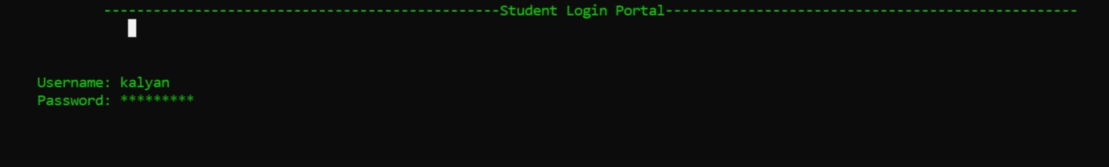

Fig 4.3.

2. Student password is hided for security purpose.

3. After logging in successfully student must enter the class completed.

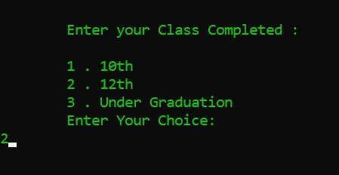

Fig 4.4.

4. We display the streams based on his class completed.

5. If the class completed by the user was 10th,

a. We conduct a simple test on maths and biology.

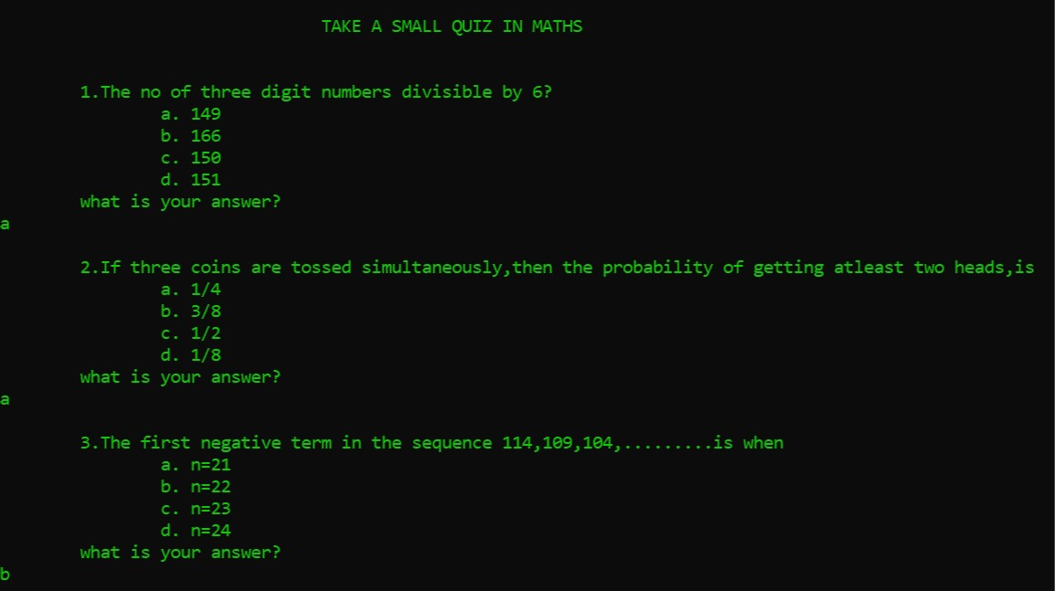Fig.4.5.

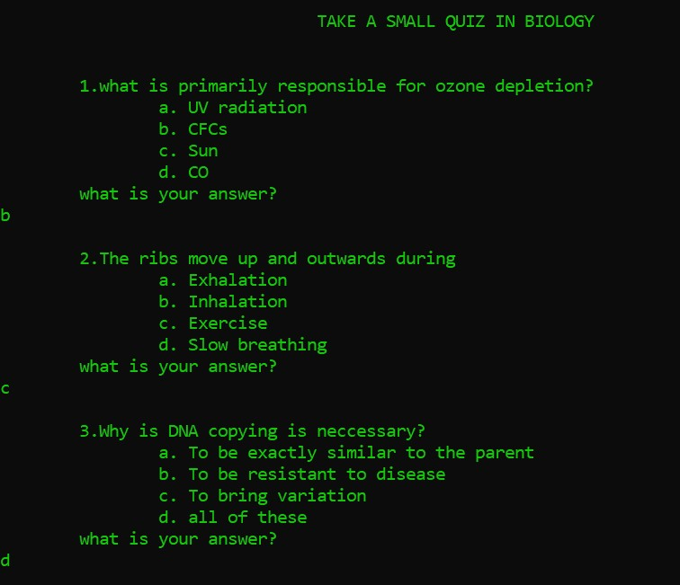 Fig 4.6.

b. Based on the performance we map their talents.

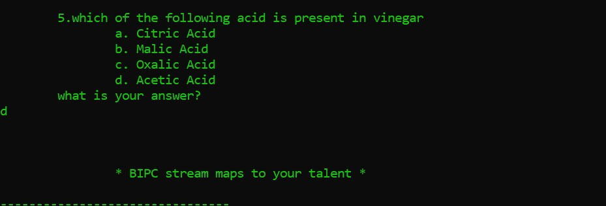

Fig 4.7.

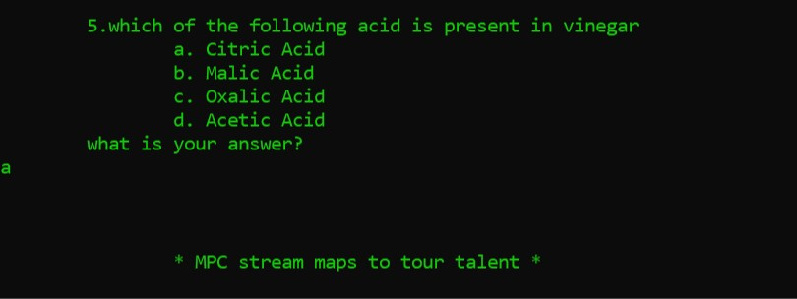

Fig 4.8.

6. If the class completed by the user was 12th

a. We take the stream chosen by user for Intermediate. Student must choose their respective stream (MPC or BiPC).

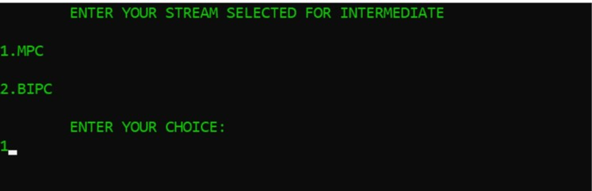

Fig 4.9.

b. If the stream chosen by the user is MPC:

1. We display List of Entrances and their details in user’s selected stream.

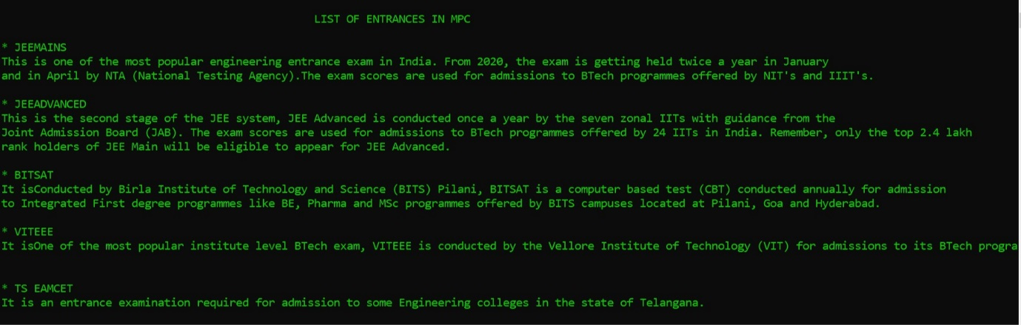

Fig 4.10.

2. For knowing priority wise list of colleges, user needs to choose any entrance.

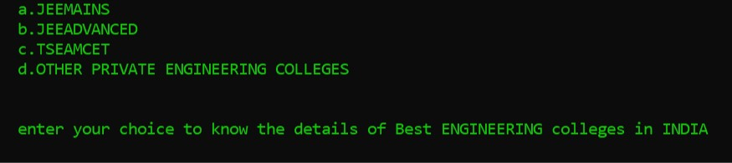

Fig 4.11.

3. Branches will display on the screen and user must choose interested branch among them, then priority wise college list is displayed.

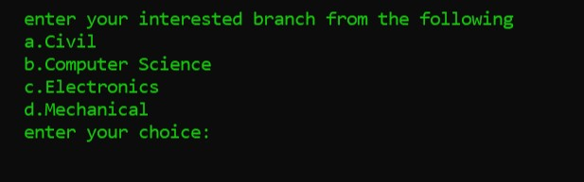

Fig 4.12.

c. If the stream chosen by the user is BIPC:

1.We display List of Entrances and their details in user’s selected stream.

Fig 4.13.

2. We also display the branches available for BIPC students after 12th.

3. For knowing priority wise list of colleges, user needs to choose any entrance.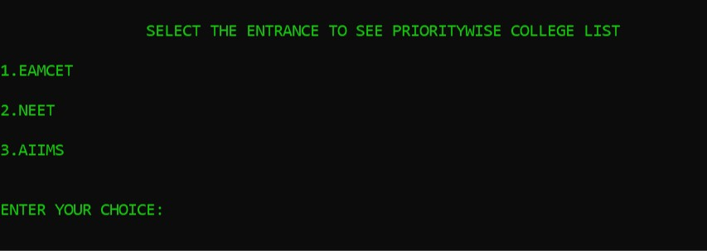

Fig 4.14.

4. Branches will display on the screen and user must choose interested branch among them, then priority wise college list is displayed.

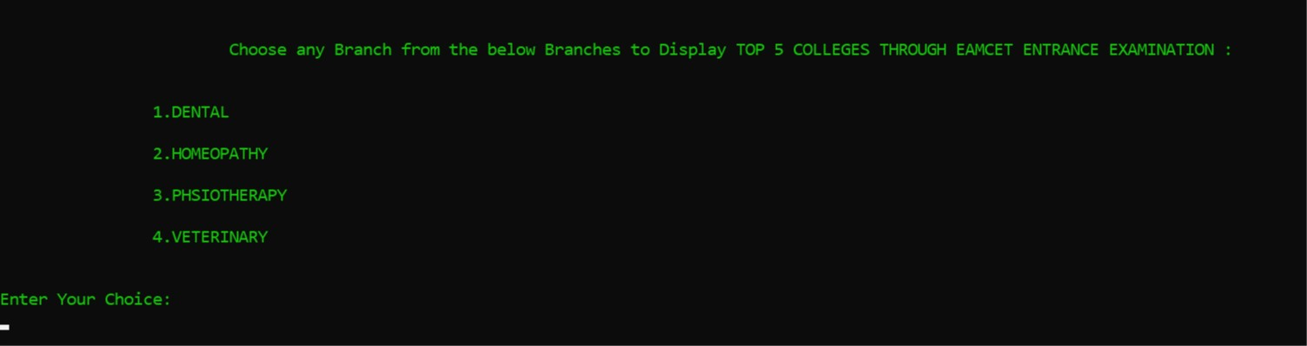

Fig 4.15.

7.If the class completed by the user was Undergraduate.

a. We suggest user, possibilities after under graduation (M.S, M.tech).

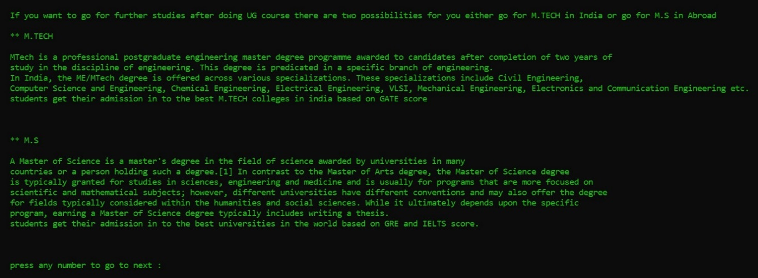

Fig 4.16.

b. User needs to choose in which he is willing to go.

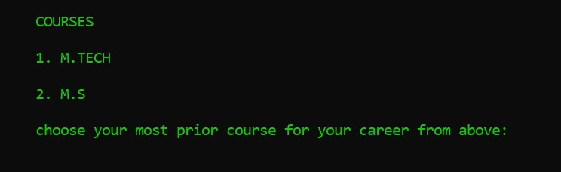

Fig 4.17.

c. A simple test is conducted to view their performance in respected stream.

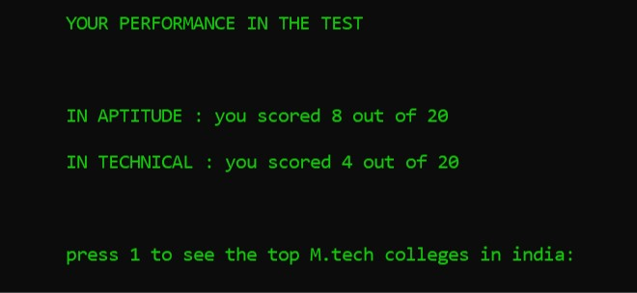

Fig 4.18.

d. User performance is displayed and user can know top colleges in the respected stream.

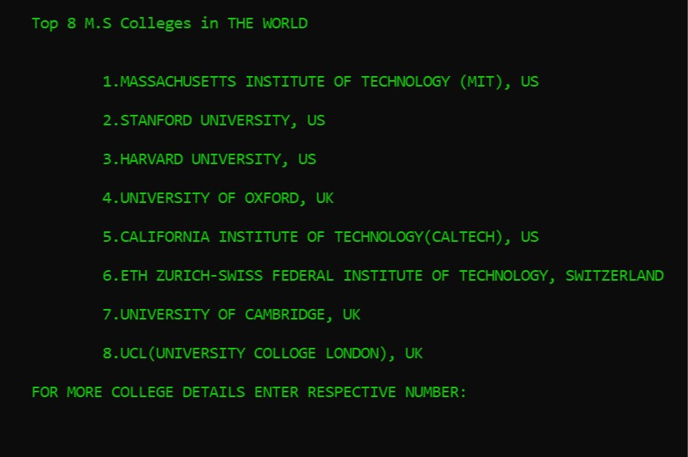

Fig 4.19.

e. College details can also be viewed at a time.

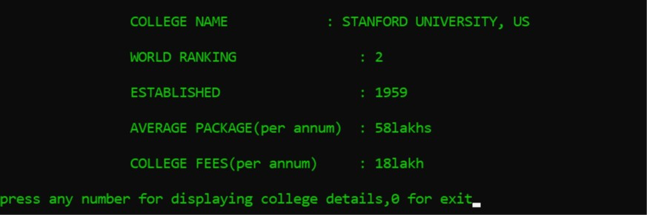

Fig 4.20.

**4.3. Admin Login**

1. Admin must login by his unique username and password.



Fig 4.21.

2. Admin can access all details of registered users.

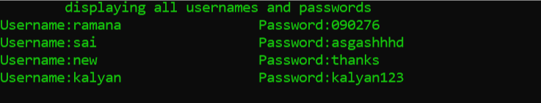

Fig 4.22.

3. Admin can view all the queries asked by the users.



Fig 4.23.

4. Admin can reply to the queries asked by the users.

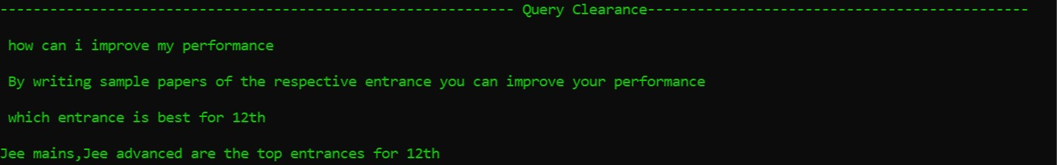Fig 4.24.

**4.4. Ask a Query**

1. Users can ask queries and get answer for those queries.

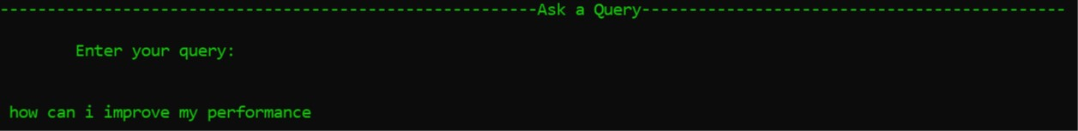

Fig 4.25.

2. Queries asked are sent to admin and will be replied soon.

**5. CONCLUSION AND** **FUTURE SCOPE**

Students bright future is crucial for development of the country. This is why in this paper we have tried to present a model for guiding the student to their best appropriate pathway. So, they can excel in their professional career.

The opportunities provided by the technology is immense and many students can make use of this platform to choose their career more appropriate to their skills. Various challenges in manual career guidance system have been recognized to design effective online career guidance system. Implementing this system will help young ones to choose right career path that best suits them.

This system will fulfill the needs of fast and reliable access to information that is needed to make right career choice.This system provides associated benefits; making the student architect of their own career.There is considerable scope for improvement, and many changes can be made to enhance this project. These includes:

A smoother user interface . Adding the details of the colleges in each state and displaying them priority wise based on their selected stream and entrance. Adding the new feature “Giving Feedback” which makes us to still work more on this project to make it efficient. A permanent web portal that will allow a user to select the stream for the career, and a way to integrate the project with the HTML, CSS JAVASCRIPT.

**7. BIBLIOGRAPHY**

**Text References:**

1. Mastering C++ by K.R Venugopal.

2. C++: The Complete Reference, Fourth Edition by Herbert Schildt.

**Web References:**

1.www.tutorials point.com

2.[www.geeks](http://www.geeks) for geeks.com

3.www.hackerrank.com