“ALCOHOL DETECTION WITH VECHILE CONTROLLING”

-K.Kalyan

Abstract of the Project:

The main purpose of this project is “ drunk driving detection”. Nowadays, many accidents are happening because of the alcohol consumption of the driver or the person who is driving the vehicle. Thus drunk driving is a major reason for accidents in almost all countries over the world. Alcohol Detector in Car project is designed for the safety of the people seating inside the car. An alcohol breath analyzer project should be fitted/ installed inside the vehicle.

Description of the project:

This project is one of the important [Sensor based project ideas](https://www.projectsof8051.com/sensor-based-projects/). The main unit of this project is an “Alcohol sensor”. If the person inside the car has consumed alcohol then it’s alcohol detection is done by the sensor. The sensor gives this signal to a comparator IC. The output of the comparator is connected to the microcontroller. The microcontroller is the heart of this project. It is the CPU of the complete circuit. Microcontroller gives a high pulse to the buzzer circuit and the buzzer is turned on. At the same time, a relay is turned off. Due to this, the ignition of the car is deactivated. [Alcohol Detection System with Buzzer Indication project](https://www.projectsof8051.com/alcohol-detection-system-with-buzzer-indication/) is extended by adding an ignition key at the input and DC motor at the output. The input Ignition key is given to the microcontroller. It is used to find out that the car is started. Whenever a key is inserted into the ignition lock at that time the alcohol detection process is started.

Components Used:

1. Alcohol Sensor
2. L293D Motor Driver IC
3. Microcontroller
4. LCD
5. Relay
6. Buzzer
7. DC Motor(Car Ignition)

About Major Components Used:

1.Alcohol Sensor:

This module is made using Alcohol Gas Sensor MQ3. It is a low cost semiconductor sensor which can detect the presence of alcohol gases at concentrations from 0.05 mg/L to 10 mg/L. The sensitive material used for this sensor is SnO2, whose conductivity is lower in clean air. It’s conductivity increases as the concentration of alcohol gases increases. It has high sensitivity to alcohol and has a good resistance to disturbances due to smoke, vapor and gasoline. This module provides both digital and analog outputs. MQ3 alcohol sensor module can be easily interfaced with Microcontrollers, Arduino Boards, Raspberry Pi etc.

This alcohol sensor is suitable for detecting alcohol concentration on your breath, just like your common breathalyzer. It has a high sensitivity and fast response time. Sensor provides an analog resistive output based on alcohol concentration. The drive circuit is very simple, all it needs is one resistor. A simple interface could be a 0-3.3V ADC.

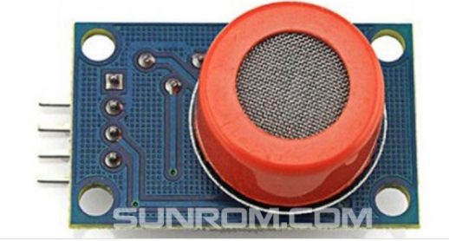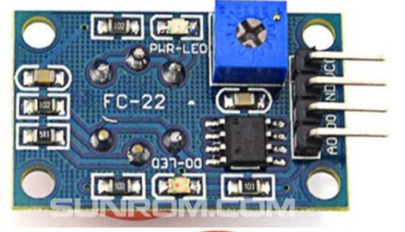

Board Schematic:

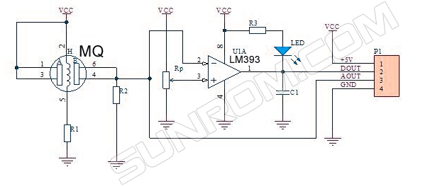Features

* 5V operation
* Simple to use
* LEDs for output and power
* Output sensitivity adjustable
* Analog output 0V to 5V
* Digital output 0V or 5V
* Low Cost
* Fast Response
* Stable and Long Life
* Good Sensitivity to Alcohol Gas
* Both Digital and Analog Outputs
* On-board LED Indicator

Technical Data

* Concentration : 0.05 mg/L ~ 10 mg/L Alcohol
* Operating Voltage : 5V ±0.1
* Current Consumption : 150mA
* Operation Temperature : -10°C ~ 70°C

Pin Out

* VCC – Input Power Supply
* GND – Supply Ground
* DO – Digital Output
* AO – Analog Output

Applications

* Vehicle Alcohol Detector
* Portable Alcohol Detector

2. L293D Motor Driver IC:

## L293D Description:

## L293D is a typical Motor driver or Motor Driver IC which allows DC motor to drive on either direction. L293D is a 16-pin IC which can control a set of two DC motors simultaneously in any direction. It means that you can control two [DC motor](https://www.rakeshmondal.info/High-Torque-Motor-Low-RPM-Motor) with a single L293D IC.

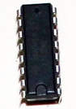

## Concept:

It works on the concept of H-bridge. H-bridge is a circuit which allows the voltage to be flown in either direction. As you know voltage need to change its direction for being able to rotate the motor in clockwise or anticlockwise direction, Hence H-bridge IC are ideal for driving a DC motor.

In a single L293D chip there are two h-Bridge circuit inside the IC which can rotate two dc motor independently. Due its size it is very much used in robotic application for controlling DC motors. Given below is the pin diagram of a L293D motor controller.

There are two Enable pins on l293d. Pin 1 and pin 9, for being able to drive the motor, the pin 1 and 9 need to be high. For driving the motor with left H-bridge you need to enable pin 1 to high. And for right H-Bridge you need to make the pin 9 to high. If anyone of the either pin1 or pin9 goes low then the motor in the corresponding section will suspend working. It’s like a switch.You can simply connect the pin16 VCC (5v) to pin 1 and pin 9 to make them high.

L293D Pin Diagram

[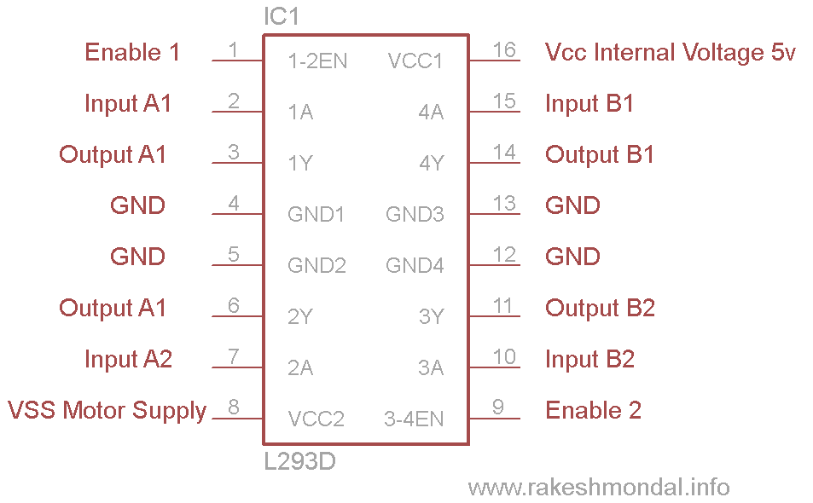](https://www.rakeshmondal.info/pik/l293d%20pin%20diagram.png)

## Working of L293D:

There are 4 input pins for l293d, pin 2,7 on the left and pin 15 ,10 on the right as shown on the pin diagram. Left input pins will regulate the rotation of motor connected across left side and right input for motor on the right hand side. The motors are rotated on the basis of the inputs provided across the input pins as LOGIC 0 or LOGIC 1.In simple you need to provide Logic 0 or 1 across the input pins for rotating the motor.

## L293D Logic Table:

Lets consider a Motor connected on left side output pins (pin 3,6). For rotating the motor in clockwise direction the input pins has to be provided with Logic 1 and Logic 0.

**• Pin 2 = Logic 1**and**Pin 7 = Logic 0 |** Clockwise Direction  
**• Pin 2 = Logic 0**and**Pin 7 = Logic 1 |** Anticlockwise Direction  
**• Pin 2 = Logic 0**and**Pin 7 = Logic 0 |** Idle [No rotation] [Hi- Impedance state]

**• Pin 2 = Logic 1**and**Pin 7 = Logic 1 |** Idle [No rotation]

Circuit Diagram For l293d motor driver IC control:

[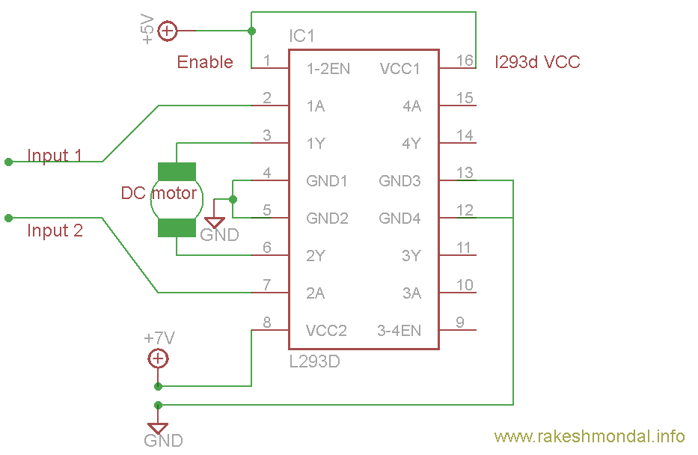](https://www.rakeshmondal.info/pik/l293d%20cirucit%20diagram.png)

## Voltage Specification:

VCC is the voltage that it needs for its own internal operation 5v; L293D will not use this voltage for driving the motor. For driving the motors it has a separate provision to provide motor supply VSS (V supply).  L293d will use this to drive the motor. It means if you want to operate a motor at 9V then you need to provide a Supply of 9V across VSS Motor supply.The maximum voltage for VSS motor supply is 36V. It can supply a max current of 600mA per channel.Since it can drive motors Up to 36v hence you can drive pretty big motors with this l293d.VCC pin 16 is the voltage for its own internal Operation. The maximum voltage ranges from 5v and upto 36v.Don’t Exceed the Vmax Voltage of 36 volts or it will cause damage.

3.Microcontroller:

Software Description:

The Arduino Integrated development environment (IDE) is a cross-platform application (for Windows, macOS, Linux) that is written in the programming language Java/C/C++ .It is used to write and upload programs to Arduino compatible boards, but also, with the help of 3 rd party cores, other vendor development boards. Arduino IDE supplies a software library from the wiring project,which provides many common input and output procedures.

ARDUINO IDE

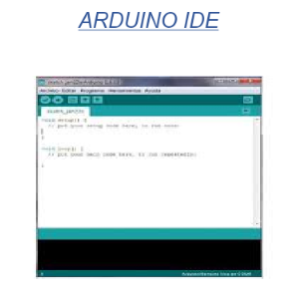

Hardware Description:

1.ARDUINO UNO BOARD:

It is an open source microcontroller board based on the microchip ATmega328P microcontroller and developed by Arduino.cc. The board is equipped with sets of digital and analog input/output pins that may be interfaced to various expansion boards( shields) and other circuits.The board as 14 digital pins,6 Analog pins,and programmable with the Arduino IDE via a type B USB cable.It can be powered by a USB cable or by an external 9v battery,though it accepts voltages between 7 and 20 volts.It is also similar to Arduino Nano.

ARDUINO UNO:

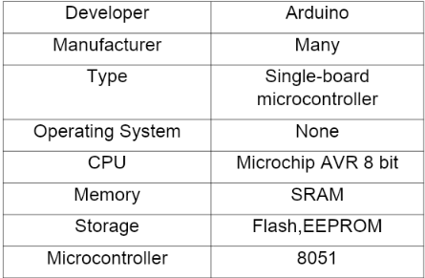

TECHNICAL SPECIFICATIONS:

- Microcontroller:Microchip ATmega328P

- Operating voltages:5v

- Input voltage:7 to 20 volts

- Digital I/O pins:14

- Analog input pins: 6

- DC current per I/O pin:20mA

- DC current for 3.3volts pin:50mA

- Flash memory:32KB

- SRAM:2KB

- EEPROM:1KB

- Clock speed:16MHz

- Length:68.6mm

- Width:53.4mm

- Weight:25g

GENERAL PIN FUNCTIONS

* LED: There is a built-in LED driven by digital pin 13.When the pin is high value,the LED is on, when the pin is low, it’s off.
* VIN: The input voltage to the Arduino board when it’s using an external power source( as opposed to 5 volts from the USB connection or other regulated power source). You can supply voltage through this pin, or, if supplying voltage via the power jack, access it through this pin.
* 5V:This pin outputs a regulated 5V from the regulator on the board. The board can be supplied with power either from the DC power jack(7-20V), the USB connector(5V), or the VIN pin of the board(7-20V). Supplying voltage via the 5V or 3.3V pins bypasses the regulator, and can damage the board.
* 3V3: A 3.3 volt supply generated by the on-board regulator. Maximum current draw is 50mA.
* GND: Ground pins.
* IOREF: This pin on the Arduino board provides the voltage reference with which the microcontroller operates. A properly configured shield can read the IOREF pin voltage and select the appropriate power source or enable voltagr translators on the outputs to work with the 5V or 3.3V.
* RESET: Typically used to add a reset button to shields which block the one on the board.

SPECIAL PIN FUNCTIONS:

Each of the 14 digital pins and 6 analog pins on the Uno can be used as an input or output, using pinMode(), digitalWrite(), and digitalRead() functions.They operate at 5v. Each pin can provide or receive 20mA as recommended operating condition and has an internal pull-up resistor( disconnected by default) of 20-50k ohm.A maximum of 40mA is the value that must not be exceeded on any I/O pin to avoidpermanent damage damage to the microcontroller. The Uno has 6 analog inputs, labelled A0 through A5, each of which provide 10 bits of resolution. By default they measure from ground to 5V,though is it possible to change the upper end of their range using AREF pin and the analogReference() function.

In addition, some pins have specialized functions:

* Serial / UART: pins 0 (RX) and 1 (TX). Used to receive (RX) and transmit (TX) TTL serial data. These pins are connected to the corresponding pins of the ATmega8U2 USB-to-TTL serial chip.
* External interrupts: pins 2 and 3. These pins can be configured to trigger an interrupt on a low value, a rising or falling edge, or a change in value.
* PWM (pulse-width modulation): 3, 5, 6, 9, 10, and 11 Can provide 8-bit PWM output with the analogWrite() function.
* SPI (Serial Peripheral Interface): 10 (SS), 11 (MOSI), 12 (MISO), 13 (SCK). These pins support SPI communication using the SPI library.
* TWI (two-wire interface) / I²C: A4 or SDA pin and A5 or SCL pin. Support TWI communication using the Wire library.
* AREF (analog reference): Reference voltage for the analog inputs.

ABOUT 8051:

The Intel 8051 is an 8-bit microcontroller which means that most available operations are limited to 8 bits. There are 3 basic size of the 8051: Short, Standard, and Extended. The Short and Standard chips are often available in DIP (dual in-line package) form, but the Extended 8051 models often have a different form factor, and are not drop-in compatible. All these things are called 8051 because they can all be programmed using 8051 assembly language, and they all share certain features (although the different models all have their own special features).

Some of the features that have made the 8051popular are:

* 4 KB on chip program memory.
* 128 bytes on chip data memory(RAM)
* 32 bytes devoted to register banks
* 80 bytes of general-purpose memory
* 4 reg banks.
* 128 user defined software flags.
* 8-bit data bus
* 16-bit address bus
* 16 bit timers (usually 2, but may have more, or less).
* 3 internal and 2 external interrupts.
* Bit as well as byte addressable RAM area of 16 bytes.
* Four 8-bit ports, (short models have two 8-bit ports).
* 16-bit program counter and data pointer.
* 1 Microsecond instruction cycle with 12 MHz Crystal.

Variants of the 8051 may also have a number of special,model-specific features, such as UART, ADC,Op_Amps, etc., making it an even more powerfulmicrocontroller.

Typical applications

8051 chips are used in a wide variety of control systems,telecom applications, robotics as well as in the automotive industry. By some estimations, 8051 familychips make up over 50% of the embedded chip market.

Pin diagramof the 8051 DIP

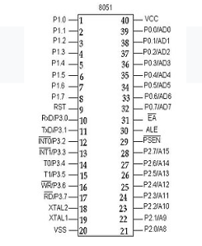

BASIC PINS

* PIN 9: PIN 9 is the reset pin which is used to reset themicrocontroller’s internal registers and ports uponstarting up. (Pin should be held high for 2 machinecycles.)
* PINS 18 &amp; 19: The 8051 has a built-in oscillator amplifierhence we need to only connect a crystal at these pins toprovide clock pulses to the circuit.
* PIN 40 and 20: Pins 40 and 20 are VCC and groundrespectively. The 8051 chip needs +5V 500mA tofunction properly, although there are lower poweredversions like the Atmel 2051 which is a scaled downversion of the 8051 which runs on +3V.
* PINS 29, 30 &amp; 31: As described in the features of the8051, this chip contains a built-in flash memory. In orderto program this we need to supply a voltage of +12V atpin 31. If external memory is connected then PIN 31,also called EA/VPP, should be connected to ground toindicate the presence of external memory. PIN 30 iscalled ALE (address latch enable), which is used whenmultiple memory chips are connected to the controllerand only one of them needs to be selected.We will dealwith this in depth in the later chapters. PIN 29 is calledPSEN. This is program store enable. In order to use the external memory it is required to provide the lowvoltage (0) on both PSEN and EA pins.
* Pin 29: If we use an external ROM then it should have alogic 0 which indicates Micro controller to read data frommemory.
* Pin 30: This Pin is used for ALE that is Address LatchEnable. If we use multiple memory chips then this pin isused to distinguish between them.It is activatederiodically with a constant rate of 1/6th of oscillatorfrequency. This Pin also gives program pulse inputduring programming of EPROM.
* Pin 31: If we have to use multiple memories then byapplying logic 1 to this pin instructs Micro controller toread data from both memories first internal andafterwards external.

PORTS:

There are 4 8-bit ports: P0, P1, P2 and P3.

PORT P1 (Pins 1 to 8): The port P1 is a general purposeinput/output port which can be used for a variety ofinterfacing tasks. The other ports P0, P2 and P3 havedual roles or additional functions associated with thembased upon the context of their usage.The port 1 outputbuffers can sink/source four TTL inputs. When 1s arewritten to portn1 pins are pulled high by the internal pull-ups and can be used as inputs.

PORT P3 (Pins 10 to 17): PORT P3 acts as a normal IOport, but Port P3 has additional functions such as, serialtransmit and receive pins, 2 external interrupt pins, 2external counter inputs, read and write pins for memoryaccess.

PORT P2 (pins 21 to 28): PORT P2 can also be used asa general purpose 8 bit port when no external memory ispresent, but if external memory access is required thenPORT P2 will act as an address bus in conjunction withPORT P0 to access external memory. PORT P2 acts asA8-A15.

PORT P0 (pins 32 to 39) PORT P0 can be used as ageneral purpose 8 bit port when no external memory ispresent, but if external memory access is required thenPORT P0 acts as a multiplexed address and data busthat can be used to access external memory inconjunction with PORT P2. P0 acts as AD0-AD7

PORT P10: asynchronous communication input or Serial

synchronous communication output.

PIN 11: Serial Asynchronous Communication Output or

Serial Synchronous Communication clock Output.

OSCILLATOR CIRCUITS

The 8051 requires an external oscillator circuit. Theoscillator circuit usually runs around 12 MHz, althoughthe 8051 (depending on which specific model) iscapable of running at a maximum of 40 MHz. Eachmachine cycle in the 8051 is 12 clock cycles, giving aneffective cycle rate at 1 MHz (for a 12 MHz clock) to3.33 MHz (for the maximum 40 MHz clock). Theoscillator circuit generates the clock pulses so that allinternal operations are synchronized.

One machine cycle has 6 states. One state is 2 T-states.

Therefore one machine cycle is 12 T-states. Time toexecute an instruction is found by multiplying C by 12and dividing product by Crystal frequency.

T=(C*12d)/crystal frequency

8051 INTERNAL ARCHITECTURE:

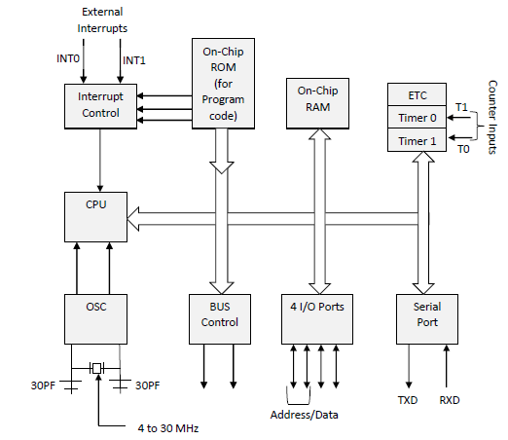

DATA AND PROGRAM MEMORY:

The 8051 Microcontroller can be programmed inPL/M, 8051 Assembly, C and a number of other high-level languages. Some compilers even have supportfor compiling C++ for an 8051.Program memory in the 8051 is read-only, while thedata memory is considered to be read/writeaccessible. When stored on EEPROM or Flash, theprogram memory can be rewritten when themicrocontroller is in the special programmer circuit or,if not using a 8031, through a preinstalled bootloader.

PROGRAM START ADDRESS:

The 8051 starts executing program instructions fromaddress 0000 in the program memory.

SPECIAL FUNCTION REGISTER:

The Special Function Register (SFR) is the upperarea of addressable memory, from address 0x80 to0xFF. A, B, PSW, DPTR are called SFR.This area ofmemory cannot be used for data or program storage,but is instead a series of memory-mapped ports andregisters. All port input and output can therefore beperformed by memory mov operations on specifiedaddresses in the SFR. Also, different status registersare mapped into the SFR, for use in checking thestatus of the 8051, and changing some operationalparameters of the 8051.

General Purpose Registers:

The 8051 has 4 selectable banks of 8 addressable 8-bit registers, R0 to R7. This means that there areessentially 32 available general purpose registers,although only 8 (one bank) can be directly accessedat a time. To access the other banks, we need tochange the current bank number in the flag register.

A and B Registers

The A register is located in the SFR memory location0xE0. The A register works in a similar fashion to theAX register of x86 processors. The A register is calledthe accumulator, and by default it receives the resultof all arithmetic operations. The B register is used in asimilar manner, except that it can receive theextended answers from the multiply and divideoperations. When not being used for multiplicationand Division, the B register is available as an extrageneral-purpose register. The A and B registers canstore up to 8-bits of data each.

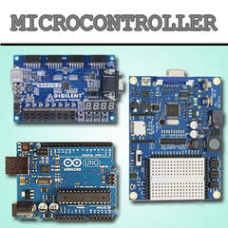

4.LCD:

It has 16 pins and the first one from left to right is the Ground pin. The second pin is the VCC which we connect the 5 volts pin on the Arduino Board. Next is the Vo pin on which we can attach a potentiometer for controlling the contrast of the display.

Next, The RS pin or register select pin is used for selecting whether we will send commands or data to the LCD. For example if the RS pin is set on low state or zero volts, then we are sending commands to the LCD like: set the cursor to a specific location, clear the display, turn off the display and so on. And when RS pin is set on High state or 5 volts we are sending data or characters to the LCD.

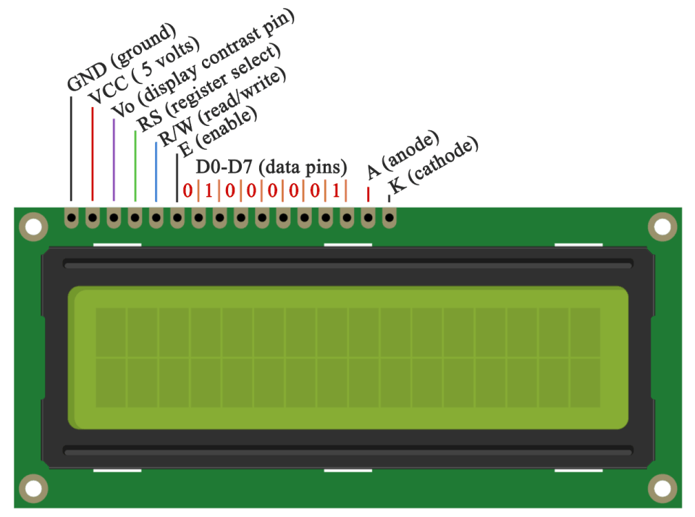

Next comes the R / W pin which selects the mode whether we will read or write to the LCD. Here the write mode is obvious and it is used for writing or sending commands and data to the LCD. The read mode is used by the LCD itself when executing the program which we don’t have a need to discuss about it in this tutorial.

Next is the E pin which enables the writing to the registers, or the next 8 data pins from D0 to D7. So through this pins we are sending the 8 bits data when we are writing to the registers or for example if we want to see the latter uppercase A on the display we will send 0100 0001 to the registers according to the ASCII table.

And the last two pins A and K, or anode and cathode are for the LED back light.

After all we don’t have to worry much about how the LCD works, as the Liquid Crystal Library takes care for almost everything. From the Arduino’s official website you can find and see the functions of the library which enable easy use of the LCD. We can use the Library in 4 or 8 bit mode. In this tutorial we will use it in 4 bit mode, or we will just use 4 of the 8 data pins.

## Components needed for this Arduino LCD Tutorial

* 16×2 Character LCD
* Potentiometer
* Arduino Board
* Breadboard and Jump Wires

## Circuit Schematic

We will use just 6 digital input pins from the Arduino Board. The LCD’s registers from D4 to D7 will be connected to Arduino’s digital pins from 4 to 7. The Enable pin will be connected to pin number 2 and the RS pin will be connected to pin number 1. The R/W pin will be connected to Ground and the Vo pin will be connected to the potentiometer.

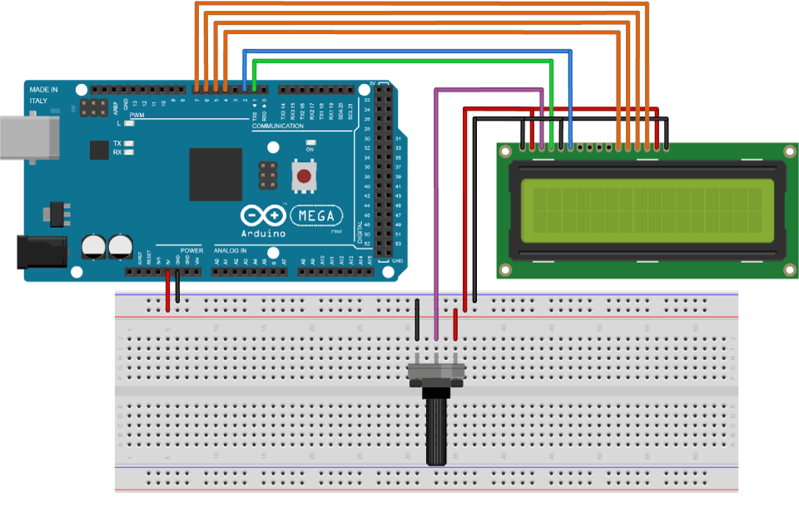

6.BUZZER:

A buzzer or beeper is an audio signalling device, which may be mechanical , electromechanical, or piezoelectric (piezo for short). Typical uses of buzzers and beepers include alarm devices, timers, and confirmation of user input such as a mouse click or keystroke.

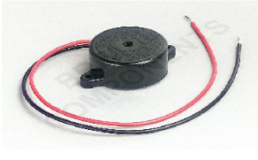

TYPES OF BUZZERS:

1.Electromechanical:

Early devices were based on an electromechanical system identical to an electric bell without the metal gong. Similarly, a relay may be connected to interrupt its own actuating current, causing the contacts to buzz.Often these units were anchored to a wall or ceiling to use it as a sounding board. The words buzzer comes from the rasping noise that electromechanical buzzers made.

2.Mechanical:

A joy buzzer is an example of a purely mechanical buzzer and they require drivers. Other examples of them are doorbells.

3.Piezoelectric:

A piezoelectric element may be driven by an oscillating electronic circuit or other audio signal source, driven with a piezoelectric audio amplifier. Sounds commonly used to indicate that a button has been pressed are a click, a ring or a beep.Interior of a readymade loudspeaker, showing a piezoelectric-disk-beeper (With 3 electrodes ... including 1 feedback-electrode ( the central, small electrode joined with red wire in this photo), and an oscillator to self-drive the buzzer.A piezoelectric buzzer/beeper also depends on acoustic cavity resonance or Helmholtz resonance to produce an audible beep.

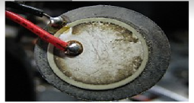

Modern applications:

While technological advancements have caused buzzers to be impractical and undesirable, there are still instances in which buzzers and similar circuits may be used. Present day applications include:

* Novelty uses
* Judging panel
* Educational purposes
* Annunciator panels
* Electronic metronomes
* Game show lock-out device
* Microwave ovens and other household appliances
* Sporting events such as basketball games
* Electrical alarms
* Joy buzzer (mechanical buzzer used for pranks

Block Diagram of the Project:

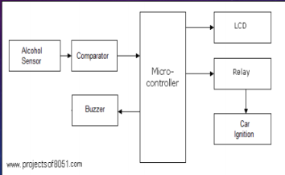

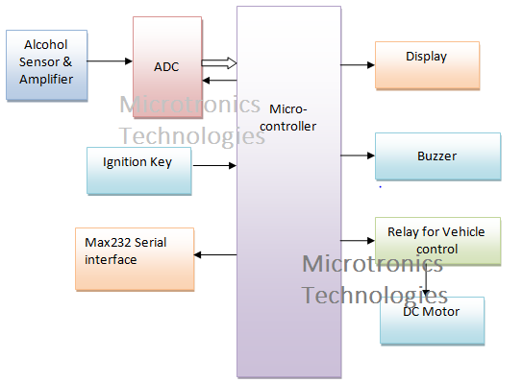

Code:

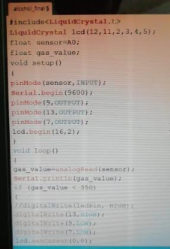

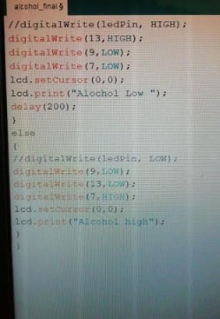

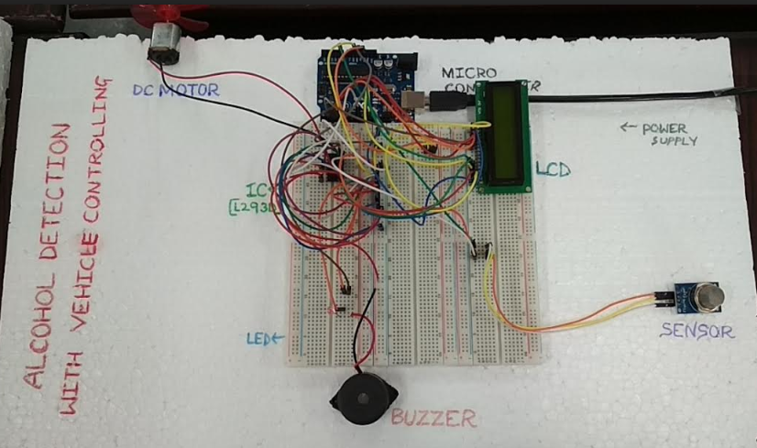

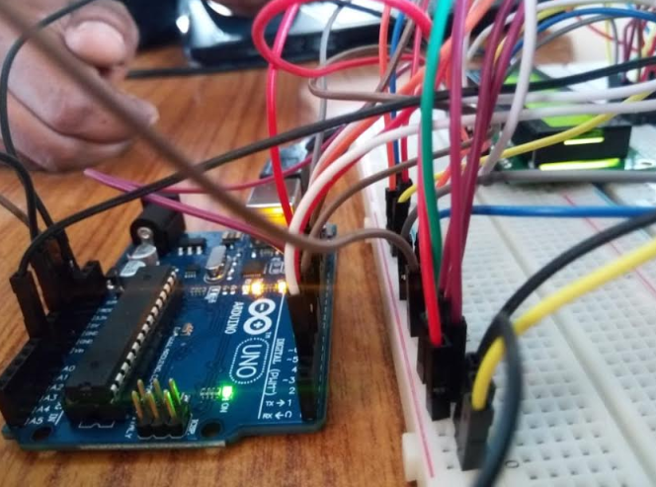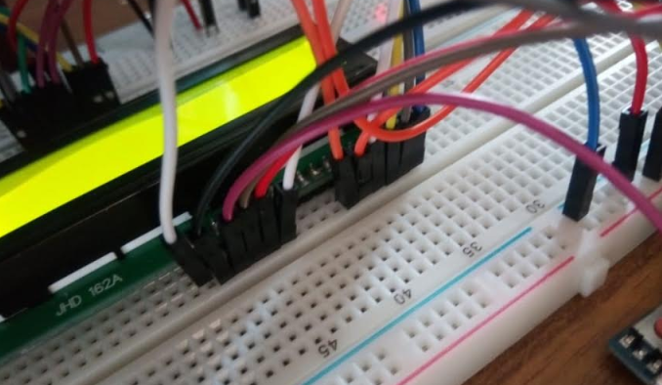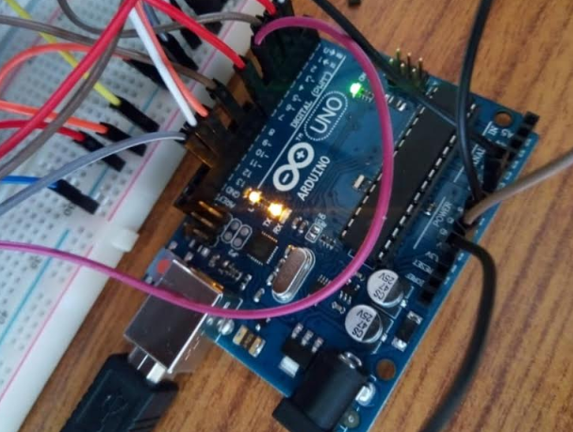

Applications and Advantages of the project:

Applications of Alcohol Detector in Car:

1) “Alcohol Detector project” can be used in the various vehicles for detecting whether the driver has consumed alcohol or not.

2) Breathing analyzer project can also be used in various companies or organization to detect alcohol consumption of employees. Alcohol detection system in an automobile is a must feature which every cab or bus should have.

Advantages of Alcohol Detector project:

“Alcohol Detection System in Cars” provides an automatic safety system for cars and other vehicles as well.

#### Future Development of the project:

1) We can implement GSM technology with alcohol detector. So [Alcohol detection & vehicle controlling through text SMS](https://www.projectsof8051.com/sms-based-alcohol-detection-with-vehicle-controlling-using-gsm-technology/) will inform the relatives or owners of the vehicle about the alcohol consumption.

2) We can implement GPS technology so that once alcohol detection is done, the system will find out the location of the vehicle. This project is called [GPS tracker and alcohol detector with engine locking system using GSM](https://www.projectsof8051.com/gps-tracker-and-alcohol-detector-with-engine-locking-system-using-gsm/).

Conclusion:

Now a days, many accidents are happening because of the alcohol consumption of the driver or the person who is driving the vehicle. Thus Drunk driving is a major reason of accidents in almost all countries in the world. Hence it is concluded that Alcohol Detector in Car project is designed for the safety of the people seating inside the car.