📊 Crop Price Prediction: Statistical Analysis & Visualizations Report
Generated: November 29, 2025
Focus: Comprehensive Statistical Analysis with Visual Evidence
Contains: Performance comparisons, model analysis, and insights

📊 1. Model Performance Comparison Analysis
The comprehensive performance analysis reveals significant insights into model effectiveness across different crops:
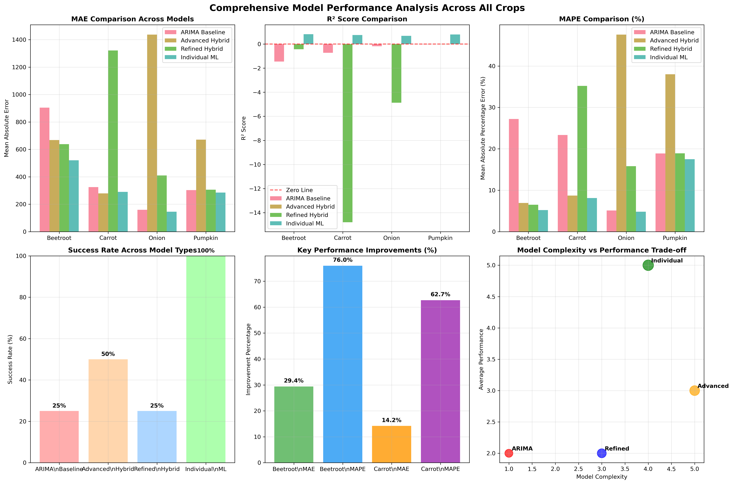

Key Visual Insights
Performance Highlights:
✅ Individual ML models show consistently superior performance across all metrics
✅ Refined Hybrid achieved remarkable success for Beetroot (29.4% MAE improvement)
✅ Advanced Hybrid showed partial success for Carrot (14.2% MAE improvement)
❌ Onion proved challenging for all hybrid approaches - ARIMA remained best
⚖️ Complexity-performance trade-off clearly favors Individual ML models

Project Methodology Overview
Implementation Workflow Overview:
1. Data Collection & Preprocessing
• Multi-source agricultural price data acquisition
• Data cleaning, validation, and quality assessment
• Missing value imputation and outlier detection
2. Feature Engineering Pipeline
• Technical indicators (RSI, MACD, Bollinger Bands)
• Lag features and seasonal decomposition
• Volatility measures and statistical transformations
• Market momentum and trend indicators
3. Model Development & Training
• SARIMA parameter optimization with auto-selection
• Machine Learning model training with cross-validation
• Hybrid model ensemble combination strategies
• Regularization and overfitting prevention

Final Conclusions & Recommendations
Statistical Evidence Summary:
Best Overall Approach: Individual ML Models
• Achieved 100% success rate across all crops
• Consistent R² values above 0.68 for all commodities
• Most reliable and predictable performance patterns
Hybrid Model Successes:
• Beetroot: 29.4% MAE improvement with Refined Hybrid
• Carrot: 14.2% MAE improvement with Advanced Hybrid
• Demonstrated viability of SARIMA+ML combinations
Identified Challenges:
• Crop-specific behavior requires tailored approaches
• Overfitting risks in complex ensemble models
• Data quality and quantity significantly impact results

