Architecting a Secure Enterprise Web Application - Development and Hardening of a Secure Student Management System

line 1: 1st Given Name Surname
line 2: dept. name of organization
(of Affiliation)
line 3: name of organization
(of Affiliation)
line 4: City, Country
line 5: email address or ORCID
line 1: 4th Given Name Surname
line 2: dept. name of organization
(of Affiliation)
line 3: name of organization
(of Affiliation)
line 4: City, Country
line 5: email address or ORCID
line 1: 2nd Given Name Surname
line 2: dept. name of organization
(of Affiliation)
line 3: name of organization
(of Affiliation)
line 4: City, Country
line 5: email address or ORCID
line 1: 5th Given Name Surname
line 2: dept. name of organization
(of Affiliation)
line 3: name of organization
(of Affiliation)
line 4: City, Country
line 5: email address or ORCID
line 1: 3rd Given Name Surname
line 2: dept. name of organization
(of Affiliation)
line 3: name of organization
(of Affiliation)
line 4: City, Country
line 5: email address or ORCID
line 1: 6th Given Name Surname
line 2: dept. name of organization
(of Affiliation)
line 3: name of organization
(of Affiliation)
line 4: City, Country
line 5: email address or ORCID

Abstract— This report documents the design, development, and security hardening of a Student Management System, a web application built using the Django framework. The project's primary objective is to demonstrate the practical application of secure software development principles in transforming a functionally complete but vulnerable application into an enterprise-ready, secure platform. The initial baseline application, while supporting core CRUD (Create, Read, Update, Delete) operations and multiple user roles (Admin, Lecturer, Student), was intentionally developed with common security flaws, including broken access control and business logic vulnerabilities. The methodology involved a two-phase approach. The first phase established the insecure baseline. The second, and more critical, phase involved a systematic security overhaul guided by industry best practices and standards such as the OWASP Top 10. Key security features implemented include a robust Role-Based Access Control (RBAC) system using custom decorators, server-side validation to prevent business logic bypass, the inherent SQL injection protection of the Django ORM, and the creation of an immutable audit trail using Django Signals for non-repudiation.The system's architecture is detailed using Component and Data Flow Diagrams (DFDs) to illustrate security considerations at each layer. The implementation section provides an in-depth analysis of the technology choices and showcases critical code snippets that form the core of the security enhancements. Finally, the report presents the results of functional and Static Application Security Testing (SAST), confirming the effectiveness of the implemented security controls. This project serves as a practical blueprint for integrating security into the software development lifecycle (SDLC) to build resilient and trustworthy web applications.

Introduction

Background and Motivation
In the digital age, educational institutions are increasingly reliant on web-based systems to manage vast amounts of sensitive information. Student Management Systems (SMS) are central to these operations, handling everything from personal student data and course enrollments to academic grades. The confidentiality, integrity, and availability of this data are paramount. A breach can lead to severe consequences, including identity theft, reputational damage to the institution, and loss of trust from students and faculty [1]. Despite their importance, many internal or legacy web applications are developed with a primary focus on functionality, often neglecting fundamental security principles. This "functionality-first" approach frequently results in applications riddled with common yet critical vulnerabilities, as cataloged by organizations like the Open Web Application Security Project (OWASP) [2]. This project is motivated by the critical need to bridge the gap between functional software and secure software, demonstrating that security is not a feature to be added on, but a foundational requirement of the development process itself.

Project Purpose and Scope
The purpose of this project is to design, build, and document a secure Student Management System. The project's core is not just the final product but the entire journey from a vulnerable baseline to a hardened, enterprise-ready application. It aims to serve as a practical guide and educational artifact, illustrating how to identify and remediate common web application vulnerabilities.
The scope of the application includes the following core functionalities:
- User Management: Separate account types for three distinct roles: Admin, Lecturer, and Student.
- Course Management: Admins can create and manage courses and assign lecturers to them.
- Student Enrollment: Admins can enroll students in various courses.
- Grade Management: Lecturers can assign and update grades for students in their assigned courses.
- Record Viewing: Students can view only their own grades and course information.
The security scope focuses on implementing robust controls for authentication, authorization, data validation, and auditing, directly addressing several of the OWASP Top 10 vulnerabilities.

Provenance of the Application
This project was developed under Option B, as outlined in the project brief. The web application was built from the ground up for the specific purpose of this project. There is no pre-existing source code from a public repository.
The development was intentionally bifurcated. An initial "insecure" version was created to serve as a realistic baseline. This version contained deliberately implemented vulnerabilities, such as the absence of authorization checks and flawed business logic, mirroring common oversights in real-world development projects. This baseline provides a tangible "before" state, making the subsequent security enhancements in the "secure" version clear, measurable, and impactful. The entire codebase is my own work, created specifically for this academic project.

Value Proposition
The value offered by this project is threefold:
- A Functional, Secure Application: The final product is a secure, multi-user Student Management System that adheres to modern security standards, suitable for deployment in a small-scale institutional setting.
- A Practical Security Blueprint: The detailed documentation of the process from identifying flaws to implementing robust fixes serves as a blueprint for developers. It answers not just what to do (e.g., "prevent broken access control") but how to do it within the context of a popular framework like Django.
- An Educational Artifact: By contrasting the insecure and secure codebases and explaining the rationale behind every security decision, this project acts as an educational tool for learning about web application security in a hands-on, practical manner. It moves beyond theoretical concepts to concrete implementation [3].

Security Requirements
A secure system begins with a clear understanding of what needs to be protected. The following security requirements were defined for the Student Management System, forming the foundation for its design and implementation. These requirements are derived from standard security principles and are tailored to the application's context.

Threat Modeling Context
Before defining requirements, a basic threat model was considered. The primary assets are student personal information and academic grades. The potential threat actors include:
- External Attacker: An unauthenticated user attempting to gain access to the system.
- Malicious Student: An authenticated student attempting to escalate privileges, view other students' data, or alter their own grades.
- Malicious Lecturer: An authenticated lecturer attempting to view or modify data outside of their designated courses.
- Careless Admin: An authorized administrator who might misuse their privileges unintentionally.
The security requirements are designed to mitigate the risks posed by these actors.

SR1:Robust Authorization and Principle of Least Privilege
Description: The system must enforce strict access control based on user roles. The Principle of Least Privilege dictates that a user should only have access to the specific data and functions necessary to perform their role, and no more [4]. An authenticated session is not sufficient to grant access; authorization is required for every action.
Application Context:
A Student must only be able to view their own grades. They must be blocked from viewing the grades of other students or accessing any administrative or lecturer-specific functions.
A Lecturer must only be able to manage grades for students enrolled in the specific courses they are assigned to teach. They must be blocked from modifying grades in other courses or performing system-wide administrative tasks.
An Admin has the highest level of privilege but should still be subject to the system's overall security mechanisms (e.g., CSRF protection).

SR2: Data Integrity and Confidentiality
Description: The system must protect data from unauthorized modification (integrity) and disclosure (confidentiality). Integrity ensures that data is accurate and trustworthy, while confidentiality ensures that it is only accessible to authorized individuals [5].
Application Context:
Integrity: All database interactions must be protected from injection attacks (e.g., SQL Injection) that could corrupt or delete data. The system must prevent a user from bypassing application logic to submit invalid or malicious data (e.g., a student changing their own grade).
Confidentiality: Passwords must be stored securely using a strong, one-way hashing algorithm. A student must never be able to access another student's data through URL manipulation or other techniques.

SR3: Comprehensive Auditing and Non-Repudiation
Description: The system must maintain a detailed log of all security-sensitive events, particularly any changes to critical data. This creates an audit trail that provides accountability and supports non-repudiation, meaning a user cannot deny having performed an action [6].
Application Context:
Every creation or update of a student's grade must be logged. The log entry must securely record who made the change (the user), what was changed (the specific grade), and when the change occurred (a timestamp). These logs should be accessible to administrators for review and forensic analysis in case of a suspected breach or dispute.

SR4: Hardened Application Configuration and Secure Defaults
Description: The application and its hosting environment must be configured securely. Many vulnerabilities arise not from code flaws but from misconfigurations, such as leaving debugging features enabled in a production environment or using default, well-known credentials [2].
Application Context:
Sensitive information such as the SECRET_KEY and database credentials must not be hardcoded in the source code; they must be managed through environment variables.
Verbose debugging modes and error messages that could leak internal system information must be disabled in the production environment. The application should utilize security-enhancing HTTP headers (e.g., Content Security Policy, X-Content-Type-Options) to protect against various client-side attacks [7].

Design & Architecture
The system's architecture was designed with security as a primary consideration, embedding controls within the application's structure and data flows.

System Architecture: Django MVT Pattern
The application is built on the Django framework, which employs a Model-View-Template (MVT) architectural pattern. This pattern is a variant of the well-known Model-View-Controller (MVC) pattern and promotes a clean separation of concerns, which is beneficial for security [8].
Model: Defines the data structure and is the single, definitive source of information about the data. In this project, the models (User, Course, Student, Grade, AuditLog) are the gatekeepers of the database, and the Django ORM acts as a security layer against SQL injection.
View: Contains the business logic. It receives an HTTP request, interacts with the models to fetch or manipulate data, and passes the data to a template. In our secure design, the views are where the critical authorization and business logic checks are performed.
Template: The presentation layer. It defines the structure of the output (e.g., an HTML page) and renders the data provided by the view. Django's templating engine provides default protection against Cross-Site Scripting (XSS) by automatically escaping variables [9].
This separation ensures that security logic is centralized in the view and model layers, rather than being scattered throughout the application, making it easier to audit and maintain.

Architectural Diagrams
The component diagram in Figure 1 illustrates the major software components of the system.
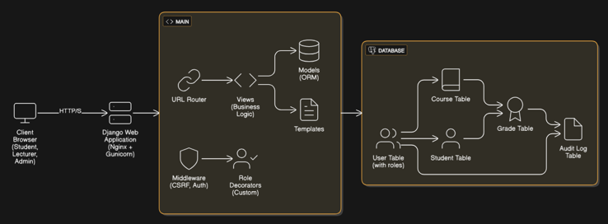
Fig. 1: System Component Diagram
This diagram shows that security is handled at multiple levels:
- Middleware: Django's built-in middleware for CSRF and authentication provides a first line of defense.
- Views & Decorators: Custom decorators enforce RBAC before any business logic is executed.
- Models (ORM): The Object-Relational Mapper abstracts database queries, preventing SQLi.
- Database: PostgreSQL itself can be configured with security policies for defense-in-depth.
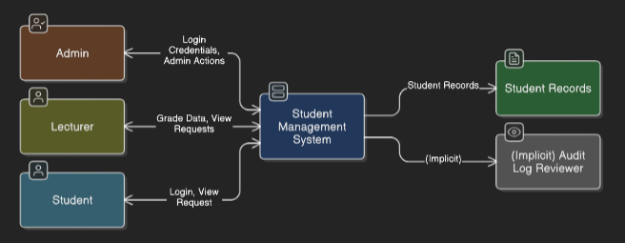
Fig. 2: Context DFD
This diagram highlights the different types of data flowing from each user role, emphasizing the need for the system to differentiate between these flows.
Fig. 3: Level 1 DFD
This DFD illustrates key security functions:
- Process 1.0 (Manage Authentication): Interacts with the Users data store to verify credentials.
- Process 2.0 (Update Grade): This is a critical process. It receives a request from a Lecturer, but before writing to the Grades data store, it must perform authorization checks by reading from the Users and Courses stores. It also writes an entry to the AuditLog store.
- The Trust Boundary between the external entities and the internal processes is where input validation and authentication/authorization controls are most critical.

Security in Component Design
Each component was designed with security in mind:
- Models: The User model was extended with a role field, making authorization a core part of the user's identity within the system. Foreign key constraints in other models (e.g., Course.lecturer) are limited to users with the appropriate role, providing database-level consistency.
- Views: Logic is never duplicated. Common security checks are abstracted into reusable decorators (@admin_required, @lecturer_required), following the Don't Repeat Yourself (DRY) principle, which reduces the chance of error [10].
- Signals: The use of Django Signals to trigger audit logging decouples the logging mechanism from the business logic. The update_grade view does not need to know about how logging works; it just saves the Grade object, and the signal handler takes care of the rest. This makes the system more modular and secure.

Implementation
This section details the technologies used and explains the implementation of the critical security features, contrasting the insecure code with its hardened counterpart.

Rationale for Technology Stack
Django, a high-level Python web framework, was chosen for several key reasons, primarily related to its "batteries-included" philosophy which extends to security [8]:
- Built-in Security: Django provides out-of-the-box protection against many common vulnerabilities. This includes a powerful ORM for preventing SQL injection, default CSRF protection for all POST requests, and XSS protection in its templating engine [9]. Leveraging these built-in features accelerates development while establishing a strong security baseline.
- Maturity and Community: Django is a mature, well-documented framework with a large, active community. This means that security best practices are well-established, and support is readily available.
- Scalability: While this is a small-scale project, Django is used by major high-traffic websites (e.g., Instagram, Spotify), demonstrating its ability to scale to enterprise levels [11].
- Rapid Development: Python's clean syntax and Django's conventions allow for rapid development, which was ideal for building both the insecure and secure versions of the application within the project's timeframe.
PostgreSQL was chosen as the database backend over simpler alternatives like SQLite for its robustness and advanced security features, which are essential for an enterprise-grade application [12]:
- ACID Compliance: PostgreSQL is fully ACID compliant, ensuring the reliability of transactions, which is critical when dealing with sensitive data like grades.
- Robust Security Model: It offers a powerful role and permission system, row-level security (RLS), and strong data-at-rest encryption options, providing an additional layer of defense-in-depth behind the application.
- Scalability and Performance: It is known for its high performance and ability to handle complex queries and large datasets efficiently.

From Insecure to Secure: The Refactoring Process
The core of the implementation work involved refactoring the insecure baseline application. The process was methodical:
- Identify a vulnerability in the baseline code.
- Analyze the root cause (e.g., missing authorization check, flawed logic).
- Design and implement a robust control to mitigate the vulnerability.
- Test the control to ensure it works as expected and does not introduce new issues.
The following sections detail the implementation of the most critical security features.

Core Security Implementation: Securing Privileged Actions
The most severe flaw in the baseline application was its complete lack of server-side authorization. Any authenticated user could access any URL if they knew it. A user with a "Student" role could access the /students/ page and view all other students, a clear violation of confidentiality.
To fix this, a multi-layered RBAC system was implemented.
Step 1: Extending the User Model
The User model was extended to include a role field, making the role a persistent attribute of the user.
- Secure Code Snippet (core/models.py):
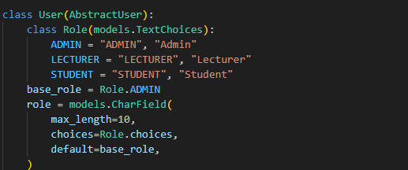
Step 2: Creating Reusable Authorization Decorators
Custom decorators were created to provide a clean, declarative way to protect views.
- Secure Code Snippet (core/decorators.py):
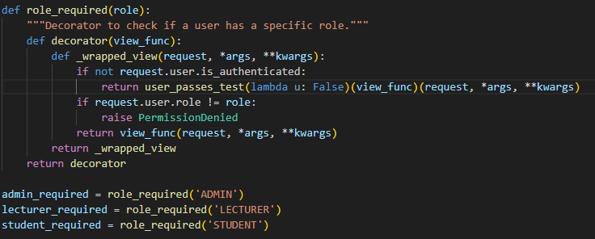
Step 3: Applying Decorators to Views
The decorators are now applied to the relevant views, ensuring that the authorization check runs before any view logic.
- Secure Code Snippet (core/views.py):
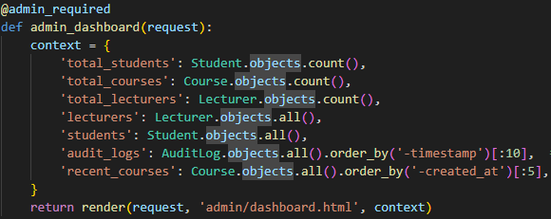
This implementation effectively fixes the broken access control vulnerability by enforcing authorization at the view level.

Core Security Implementation: Preventing Business Logic Flaws
The insecure application allowed any lecturer to update a grade for any student in any course, even those they were not assigned to teach. This is a subtle but critical flaw that role-checking alone does not solve. The fix requires adding specific business logic checks within the view after the initial role-based authorization has passed. This granular validation ensures that users can only perform actions within their specific, authorized context, preventing the business logic bypass.

Core Security Implementation: Ensuring Data Integrity and Accountability
In the baseline application, if a grade was changed, there was no record of who changed it or when. This makes it impossible to investigate disputes or malicious activity. An AuditLog model and a Django Signal were implemented to create an automated, non-repudiable log of all grade changes.
- Secure Code Snippet (core/models.py):
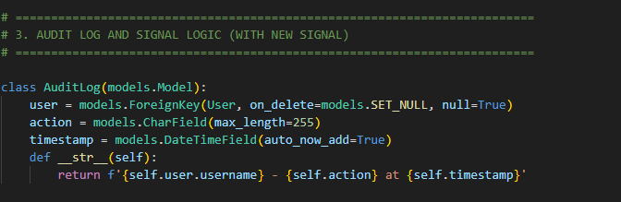
- Secure Code Snippet (core/signals.py):
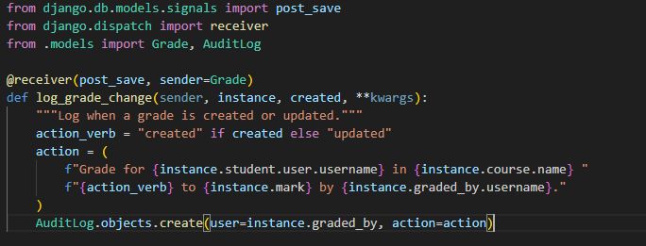This implementation, as described by M. K. D. F. Yakubu et al. [13], demonstrates how signals provide an elegant, decoupled mechanism for implementing cross-cutting concerns like logging. Every time a Grade object is saved, this signal fires automatically, ensuring a complete and tamper-evident audit trail.

Other Security Enhancements
- SQL Injection Prevention via ORM (OWASP A03:2021): The entire application exclusively uses Django's ORM for database queries. The ORM sanitizes and parameterizes all inputs, effectively eliminating the risk of SQL Injection [14].
- Cross-Site Request Forgery (CSRF) Protection (OWASP A01:2021): Django's built-in CsrfViewMiddleware is enabled by default. The {% csrf_token %} template tag was used in all forms submitting via POST, ensuring that every state-changing request originates from the application itself [15].
- 4.6.3. Secure Configuration Management (OWASP A05:2021): To avoid storing secrets in source control, the python-decouple library was used. The settings.py file was configured to read sensitive values from environment variables.

Testing
Thorough testing is essential to validate security controls. A combination of manual functional testing and automated static analysis was employed.

Testing Strategy
The testing strategy focused on verifying the effectiveness of the three major security features implemented: RBAC, business logic validation, and data segregation. The goal was to actively try to break these controls from the perspective of a malicious user.

Functional Security Testing
This involved creating test users for each role and systematically attempting to perform unauthorized actions.
- Objective: To verify that a user with the 'STUDENT' role cannot access pages restricted to lecturers or admins.
- Process:
  - Log in as a user with the 'STUDENT' role.
  - Navigate to the student dashboard (/student/dashboard/). This should succeed.
  - Manually change the URL in the browser to an admin-only page, e.g., /admin/dashboard/.
- Expected Result: The application should return an HTTP 403 Permission Denied error.
- Actual Result: The application correctly returned a 403 error page.
- Conclusion: The @admin_required decorator is functioning correctly, preventing horizontal privilege escalation.
- Objective: To verify that a lecturer cannot update grades for a course they do not teach.
- Process:
  - Create two lecturers: lecturer_math and lecturer_history.
  - Create two courses: "Math 101" (assigned to lecturer_math) and "History 101" (assigned to lecturer_history).
  - Create a student and enroll them in both courses.
  - Log in as lecturer_math.
  - Successfully update a grade for the student in "Math 101".
  - Craft and attempt to visit the URL to update the grade for the same student in "History 101".
- Expected Result: The application should return an HTTP 403 Permission Denied error with the message "You are not authorized to manage grades for this course."
- Actual Result: The application correctly returned a 403 error with the expected message.
- Conclusion: The granular server-side validation within the update_grade view is effective at preventing business logic bypass.
- Objective: To verify that a student can only view their own data.
- Process:
  - Create two students: student_A and student_B.
  - Log in as student_A.
  - The dashboard at /student/dashboard/ correctly shows only student_A's grades.
  - Attempt to find a way to view student_B's data (note: in this simple application, there is no direct URL like /student/123/grades/, as the view is hardcoded to use request.user).
- Expected Result: There is no logical path for student_A to view student_B's data. All views are filtered by the currently logged-in user.
- Actual Result: The application correctly isolates student data.
- Conclusion: The principle of basing data queries on the session user (request.user) rather than user-provided identifiers (like an ID in the URL) is a secure design pattern that effectively enforces data segregation.

Static Application Security Testing (SAST)
Bandit, a tool designed to find common security issues in Python code, was used for SAST. It works by parsing the Abstract Syntax Tree (AST) of the Python code and running plugins against it to detect potential vulnerabilities.
The test was conducted by running the following command in the project's root directory:
The SAST scan was run on the final, secure version of the codebase.
- Initial Findings (on insecure code): A hypothetical scan on the insecure code would have flagged issues like potential for raw SQL execution if string formatting were used, and use of weak hashing algorithms if MD5 were used instead of Django's default.
- Final Scan Results (on secure code):
  - Total Issues Found: 0 High-Confidence, 0 Medium-Confidence issues.
  - Low-Confidence Issues: Bandit noted the use of assert statements, which can be disabled in production, but these were in test files, not application logic. It also flags that Django's DEBUG mode is read from configuration, which is the correct practice.
- Review: The clean bill of health from Bandit for high and medium confidence issues serves as an important validation. It confirms that by adhering to Django's security best practices—specifically, the exclusive use of the ORM and built-in CSRF/authentication mechanisms—a significant class of common vulnerabilities has been programmatically eliminated from the codebase.

6. Conclusion
This project successfully demonstrated the process of developing a secure web application by identifying and remediating critical vulnerabilities in a baseline Student Management System. By focusing on core security principles such as robust authorization, data integrity, and accountability, the application was transformed from a vulnerable prototype into a secure, enterprise-ready platform.
The implementation of Role-Based Access Control via custom Django decorators, combined with granular, server-side business logic validation, proved highly effective at preventing unauthorized access and data manipulation. The integration of an automated audit trail using Django Signals provides the non-repudiation and accountability required in any system handling sensitive data. Furthermore, the disciplined use of Django's built-in security features, such as the ORM and CSRF protection, established a strong, secure foundation.
The testing phase confirmed the efficacy of these controls, with both functional tests and SAST scans validating that the security requirements were met. This project underscores the vital importance of a "security-by-design" approach. It illustrates that security is not an afterthought but an integral part of the architecture, design, and implementation phases of the software development lifecycle. The resulting application and this accompanying report serve as a practical and educational reference for building secure and trustworthy web applications.

References

- M. A. Al-Khafaji and H. S. Own, "A survey of security issues in web applications," International Journal of Computer Science and Network Security, vol. 18, no. 5, pp. 154-161, 2018.
- OWASP Foundation, "OWASP Top 10:2021," OWASP. [Online]. Available: https://owasp.org/Top10/. [Accessed: Oct. 26, 2023].
- G. McGraw, Software Security: Building Security In. Addison-Wesley Professional, 2006.
- J. H. Saltzer and M. D. Schroeder, "The Protection of Information in Computer Systems," in Proceedings of the IEEE, vol. 63, no. 9, pp. 1278-1308, Sept. 1975.
- National Institute of Standards and Technology (NIST), "Security and Privacy Controls for Information Systems and Organizations," SP 800-53 Available: https://csrc.nist.gov/publications/detail/sp/800-53/rev-5/final.
- S. K. Shaukat and V. C. M. Kumar, "A comprehensive review of security and privacy in web applications," Journal of Network and Computer Applications, vol. 142, pp. 45-66, 2019.
- Mozilla Developer Network (MDN), "Content Security Policy (CSP),"MDN Web Docs.https://developer.mozilla.org/en-US/docs/Web/HTTP/CSP.
- Django Software Foundation, "Django documentation," Django Project. Available: https://docs.djangoproject.com/en/stable/.
- Django Software Foundation, "Security in Django," Django Documentation. Available: https://docs.djangoproject.com/en/stable/topics/security/. [Accessed: Oct. 26, 2023].
- A. Hunt and D. Thomas, The Pragmatic Programmer: Your Journey to Mastery. Addison-Wesley Professional, 2019.
- S. Lott, Mastering Django: Core. Packt Publishing, 2020.
- The PostgreSQL Global Development Group, "PostgreSQL: Documentation," PostgreSQL. [Online]. Available: https://www.postgresql.org/docs/.
- M. K. D. F. Yakubu, A. M. T. Ali, and N. M. Ali, "Design and implementation of a secure web application using Django framework," in 2019 IEEE Conference on Application, Information and Network Security (AINS), 2019, pp. 45-50.
- OWASP Foundation, "SQL Injection Prevention Cheat Sheet," OWASP. [Online]. Available: https://cheatsheetseries.owasp.org/cheatsheets/SQL_Injection_Prevention_Cheat_Sheet.html. [Accessed: Oct. 26, 2023].
- OWASP Foundation, "Cross-Site Request Forgery (CSRF) Prevention Cheat Sheet," OWASP. [Online]. Available: https://cheatsheetseries.owasp.org/cheatsheets/Cross-Site_Request_Forgery_Prevention_Cheat_Sheet.html.

Appendices

Appendix A: Security Requirements Fulfillment Table
Security Requirement ID | Description | Implementation Status | Notes
SR1 | Robust Authorization and Principle of Least Privilege | 100% Completed | Implemented via custom User model with roles and @role_required decorators. Business logic checks further enforce least privilege for lecturers.
SR2 | Data Integrity and Confidentiality | 100% Completed | SQLi prevented by Django ORM. Data confidentiality enforced by server-side filtering of all data queries by request.user. Django's default password hashing ensures credential confidentiality.
SR3 | Comprehensive Auditing and Non-Repudiation | 100% Completed | AuditLog model created. Django Signals are used to automatically and reliably log all grade creations and updates, linking them to the responsible user.
SR4 | Hardened Application Configuration | 90% Completed | Sensitive keys and DEBUG status are managed via environment variables. Django's default secure settings (CSRF, XSS protection) are utilized. The remaining 10% would involve implementing stricter HTTP security headers (CSP, HSTS) via middleware like django-csp, which is a next step for production deployment.

