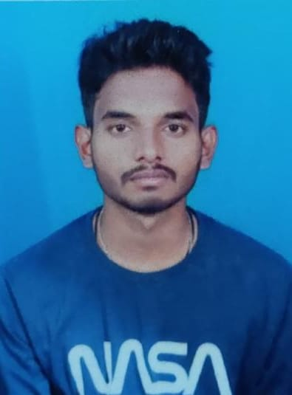
AMMISETTY KALYAN SRINIVAS
4-3-30/3
BAPATLA
BAPATLA(DIST)
Email: ak.srinivas961@gmail.com
Pin code: 522101
Phone Number: 6301377530

Career Objective:
Seeking a role in an MNC where I can upgrade my skills with time and take the company to the next level.

Educational details:
S.No | Course | College/University | Year of passing | Percentage/CGPA
1 | B-Tech | Bapatla Engineering College | 2022-2026 | Pursuing
2 | Intermediate | Surya junior college | 2020-2022 | 96 %
3 | SSC | Little Flower High School:: Bapatla | 2020 | 100 %

Exposure:
1. Internship in skillDzire on Full Stack Java

Technical Skills:
1. Python
2. Java
3. C
4. HTML, CSS, JS

Strengths:
- Innovative thinker
- Leadership Qualities
- Time Management
- Good communication skills
- Fast learner
Achievements:
- Achieved 1st place in the science day competition held at our school.

Extra-Curricular Activities:
1. Playing Indoor and Outdoor Games.
2. Tutoring for primary and secondary school students.
3. Studying about new things.

Personal details:

Name : Ammisetty Kalyan Srinivas.
Gender : Male.
D.O.B : 20-03-2003
Marital status : Unmarried.
Blood group : A+
Nationality : Indian
Languages know : Telugu, English and Hindi
Hobbies : Watching movies, Playing cricket and kabaddi.
Permanent Address:
4-3-30/3
BAPATLA
BAPATLA(DIST)
ANDHRA PRASESH
Email: ak.srinivas961@gmail.com
Pin code: 522101

Date : 24-05-2024
Place : Bapatla

(A.Kalyan Srinivas)

