We are referring this product link as our example product.

<http://www.karnival-house.co.uk/1960s-purple-suit-adult-fancy-dress-costume-p-7331.html>

I am going to add the same product in the magento structure.

I am doing the full process step by step that will be easier for all to understand.

Step 1: Login into the magento admin panel. We will see this window.

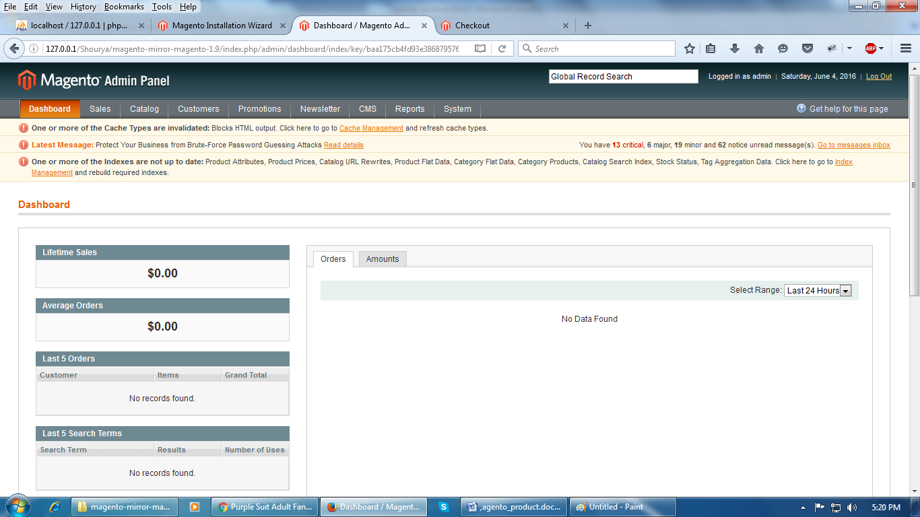

Step 2: Click on the **catalog and into the manage product**. You can see this window.

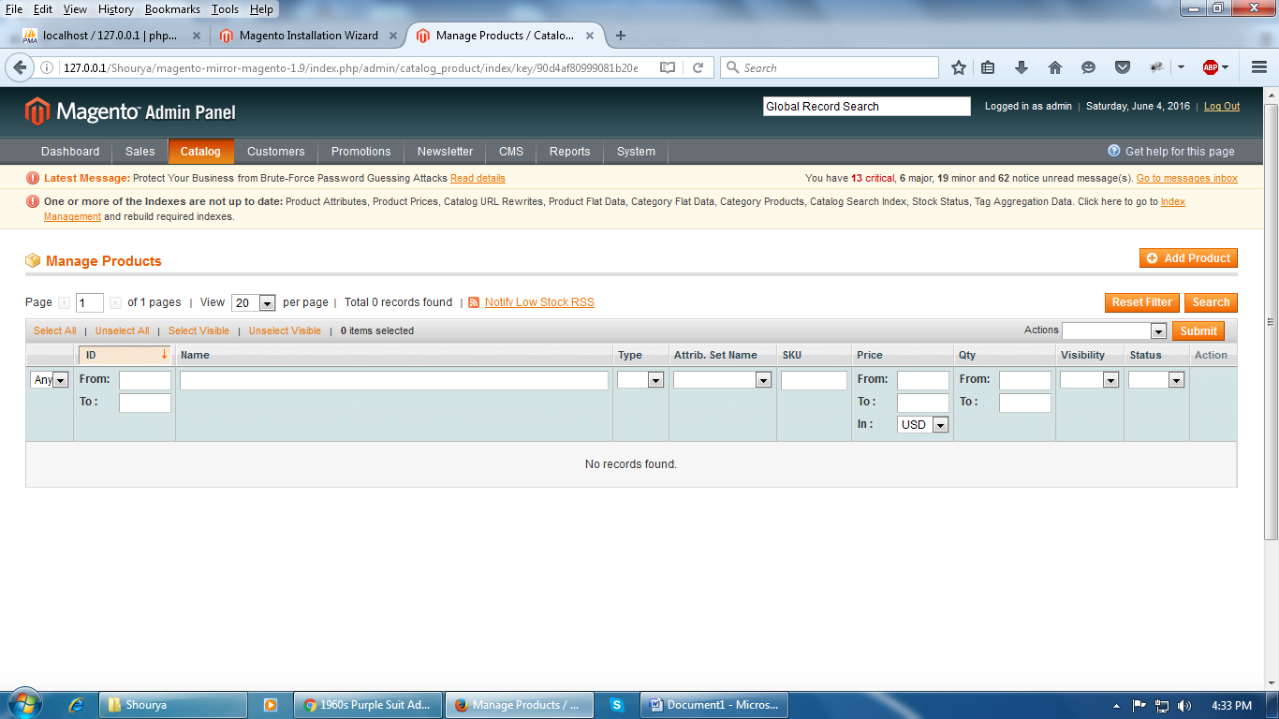

Step 3: Click on the **“Add New”** product option and then selecting the product attribute type and the product type we can see the product configure page. Then add the product name and the other products details step by step.

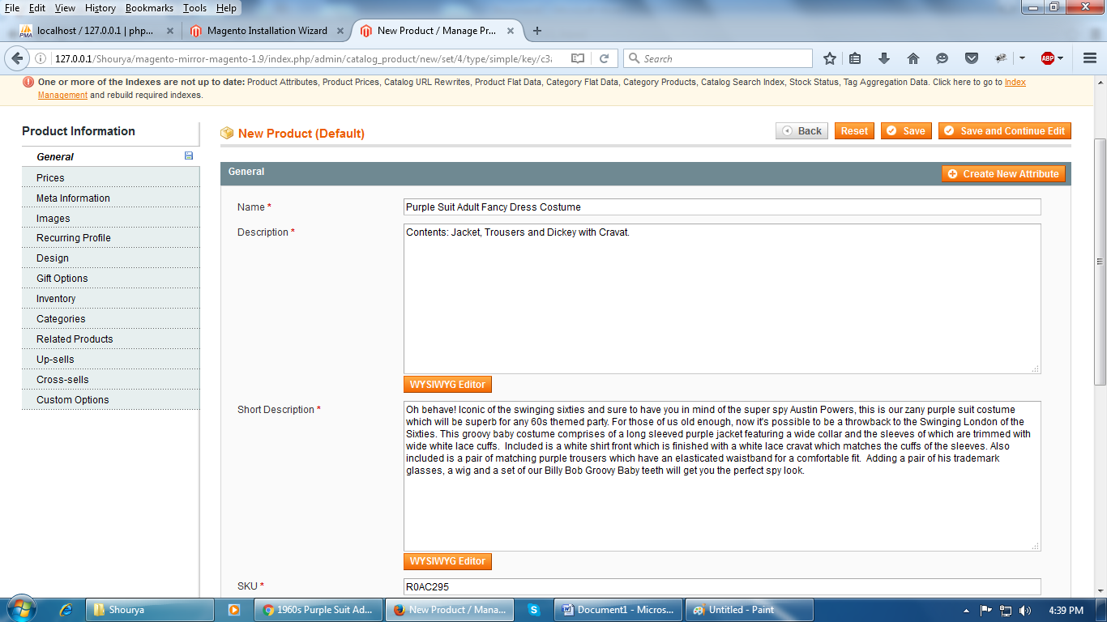

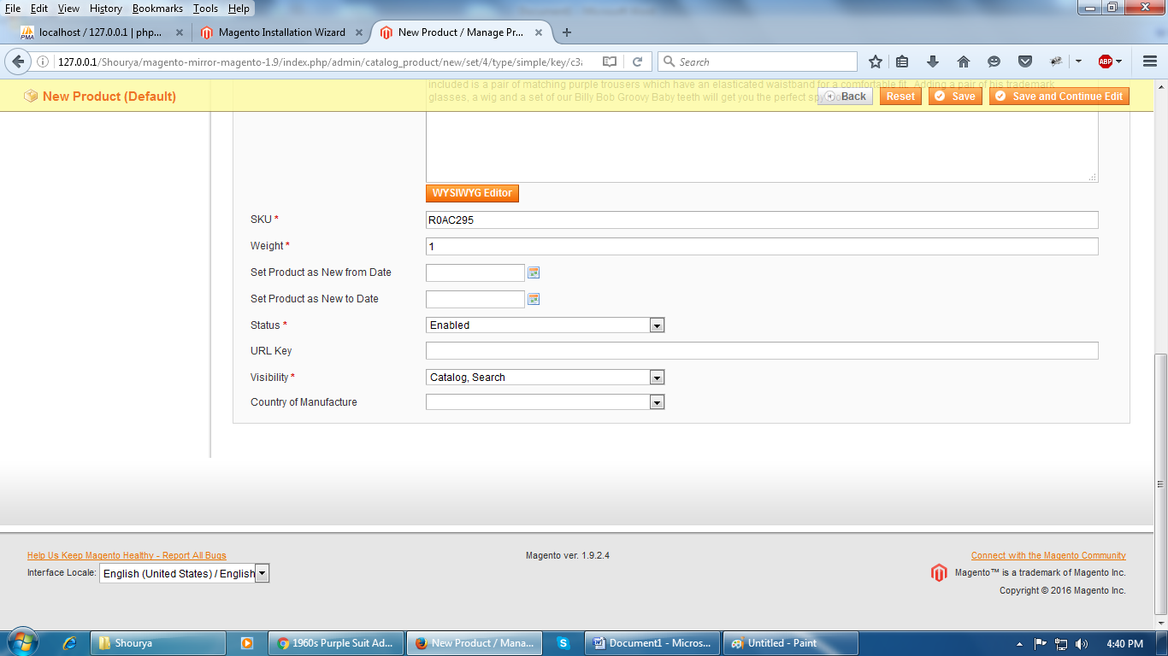

Now we can add the **price** of the product by clicking on the price tab at the left panel of the product configuration page. Magento gives us this type of pricing option.

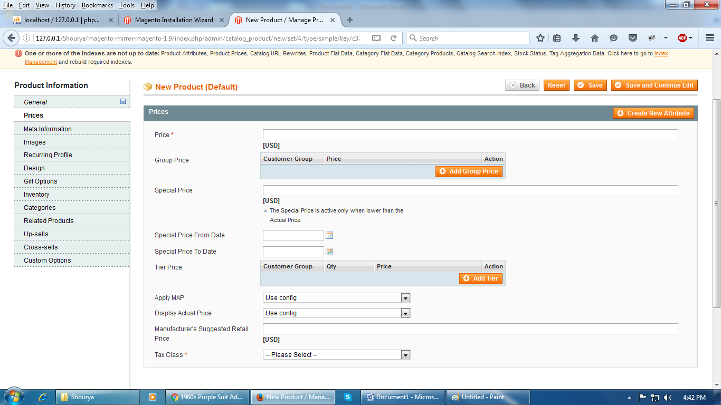

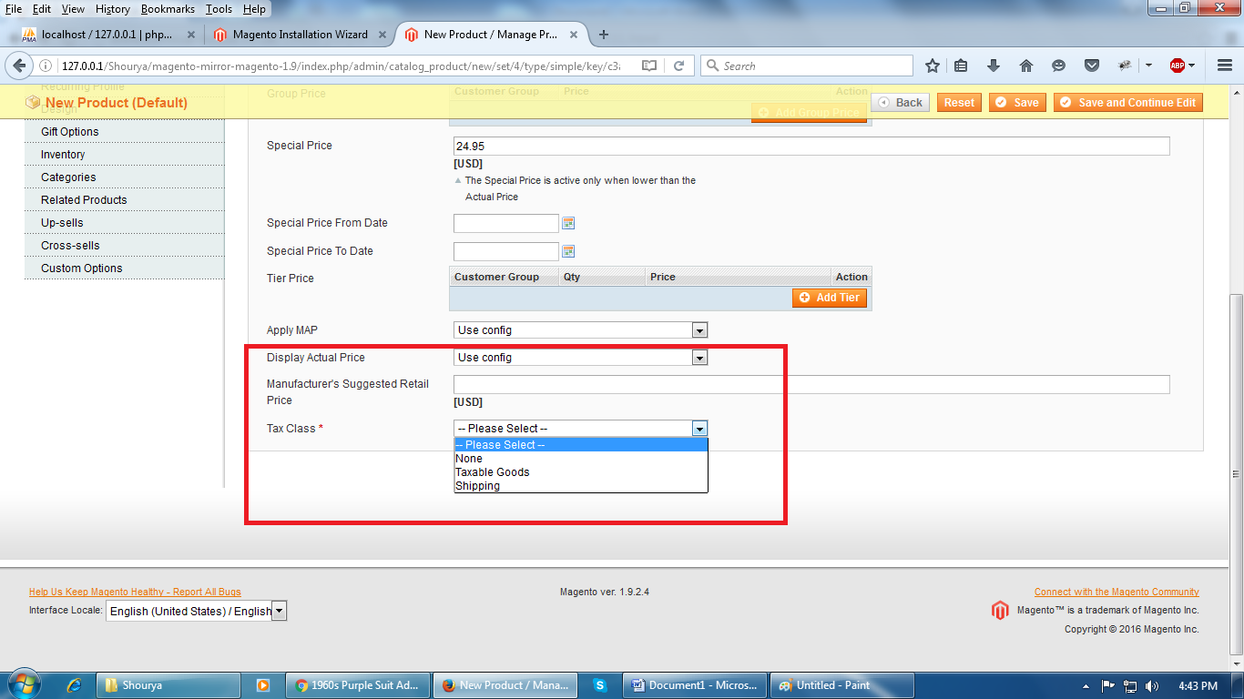

We can have these types of **tax** classes in magento.

Now add the **Meta information** for the **SEO** details in the magento.

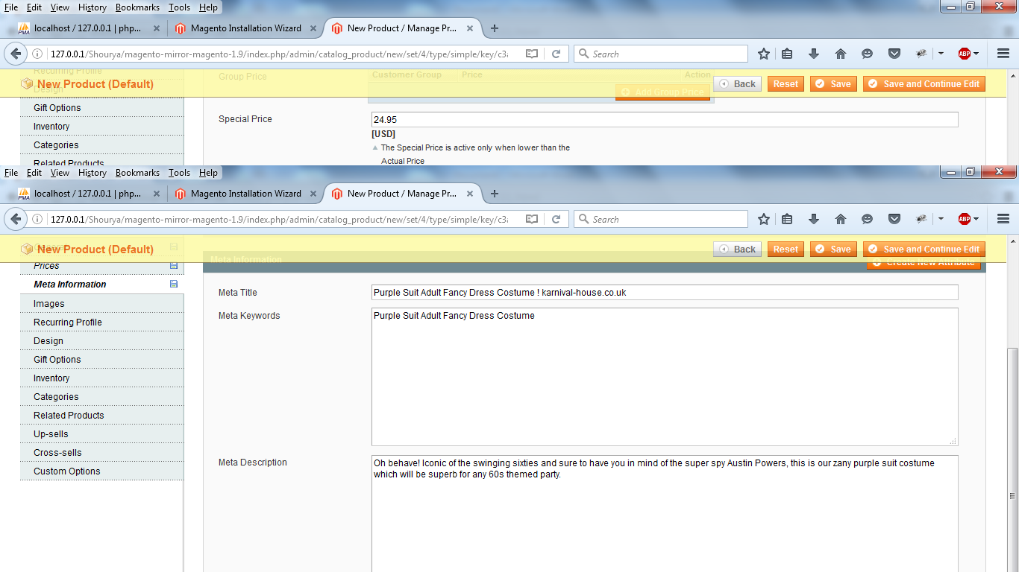

Now we can upload the **images** and we can upload as much as **images** we want to upload.

Now just save the product by clicking on the **Save and Continue.**

Now your product is ready just you have to check it on the frontend.

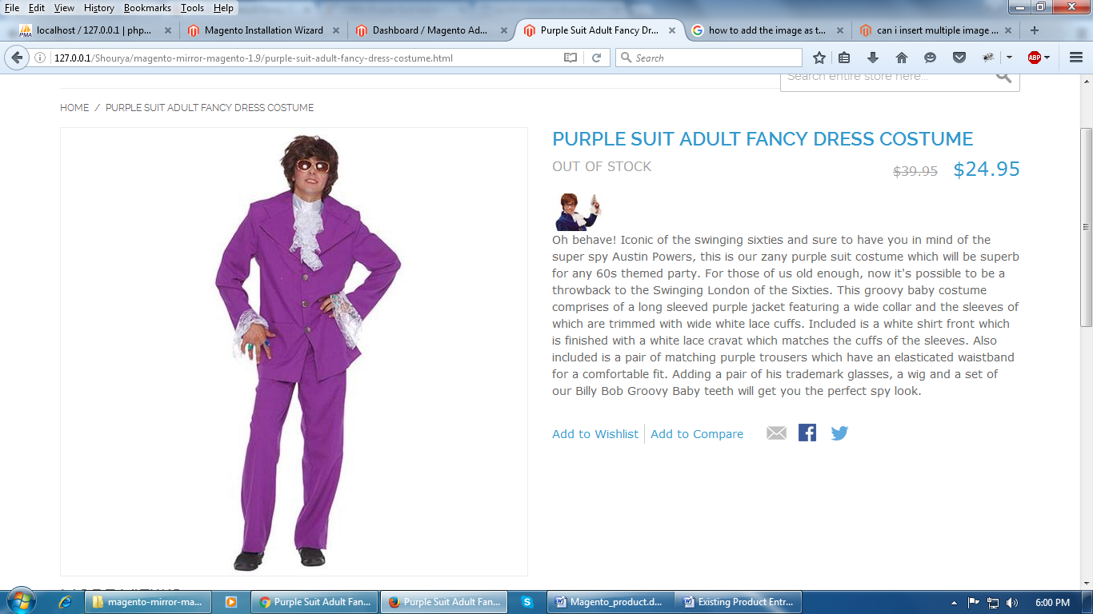

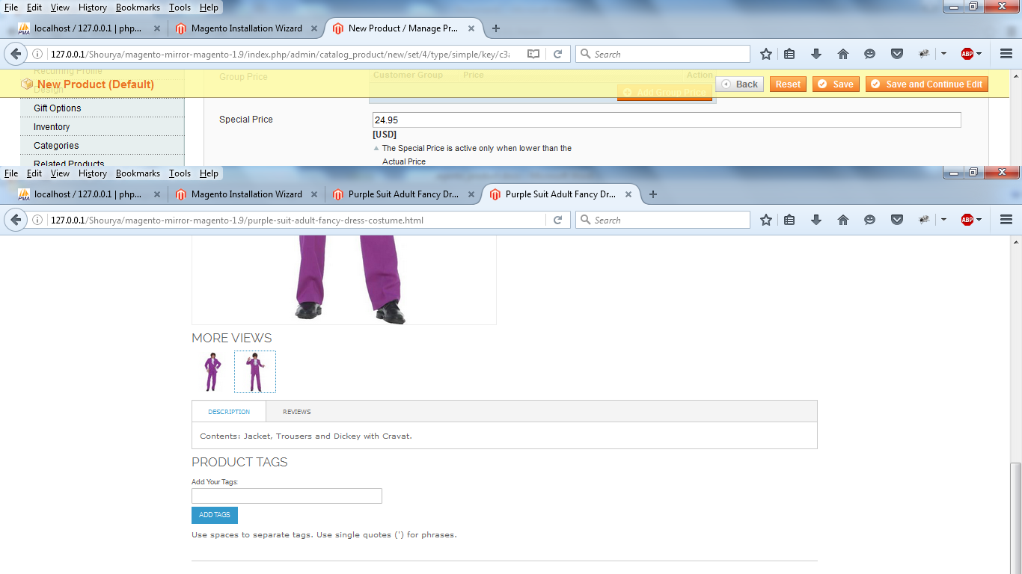

Your total product page will look like that.

We can add the product in the cart from the front end and as well as the from the back end.

Now check out the cart page now.

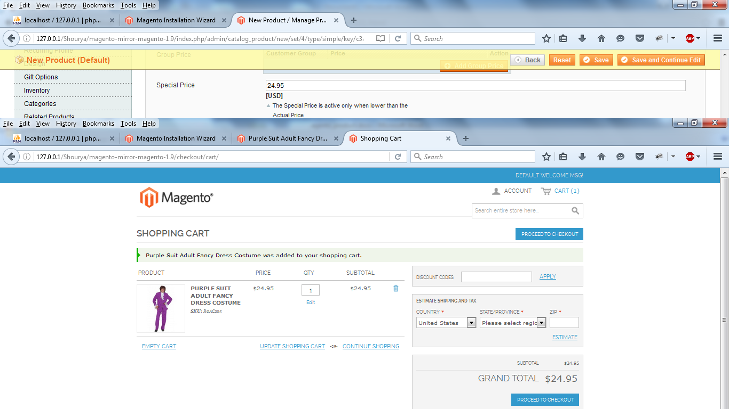

Now check on the checkout page.

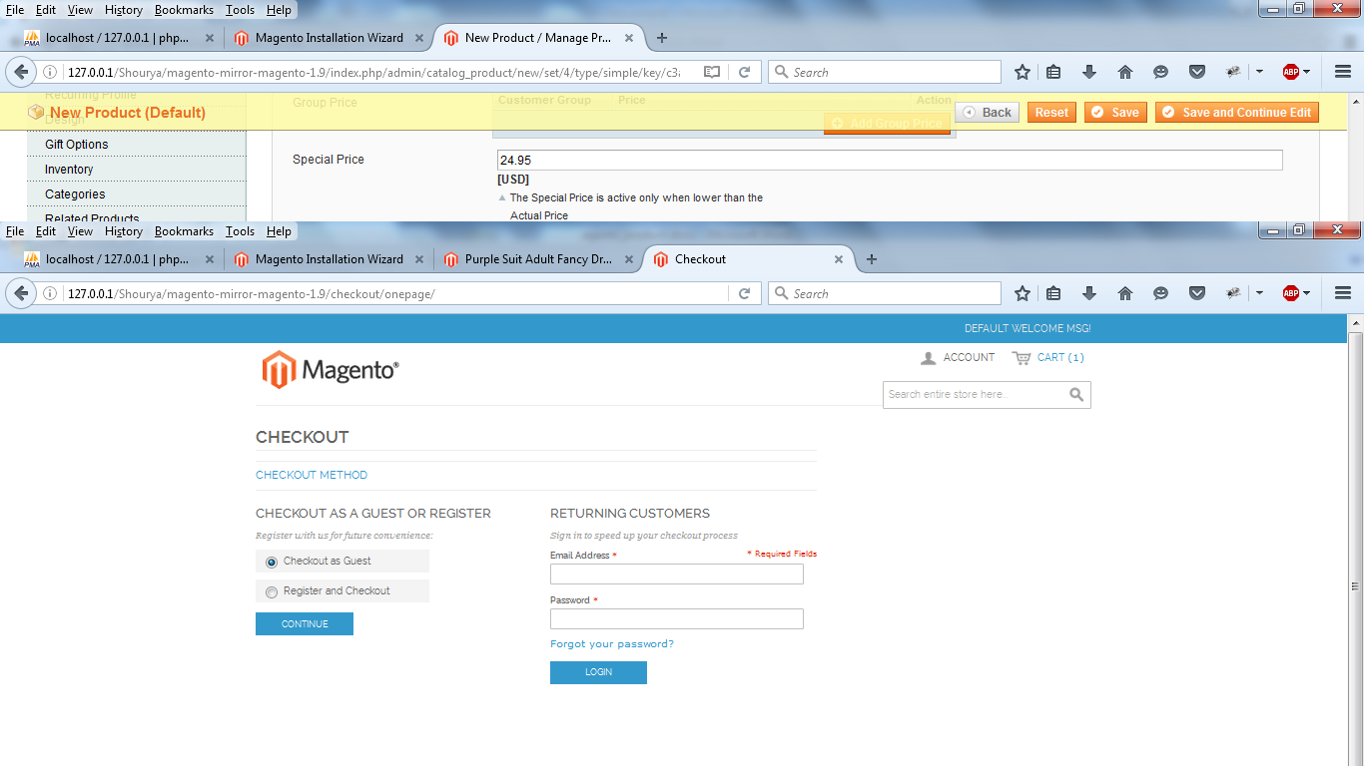

You can checkout as a guest and as well as the register customer.

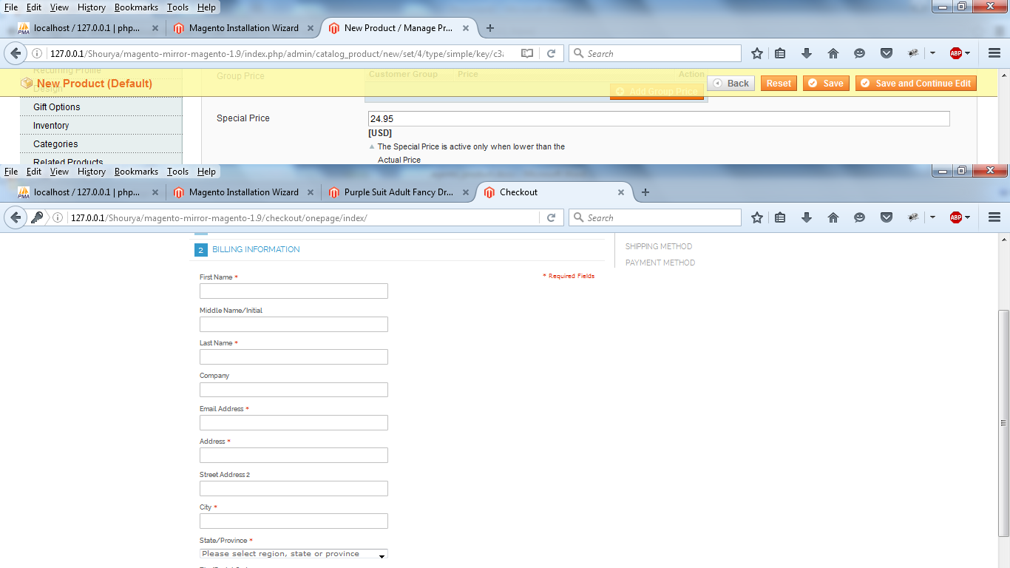

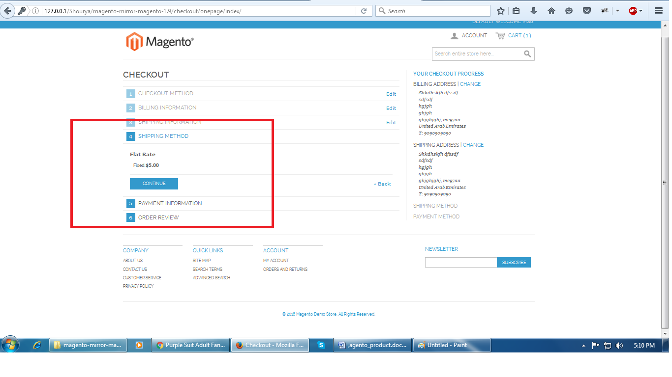

You can see the shipping rates at the checkout page.

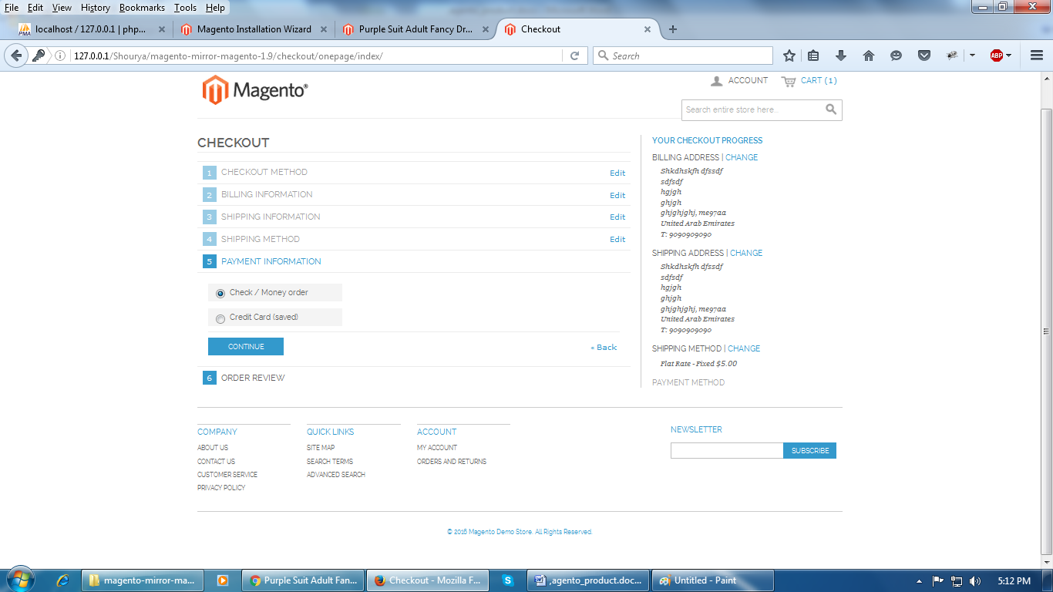

We can select the payment methods.

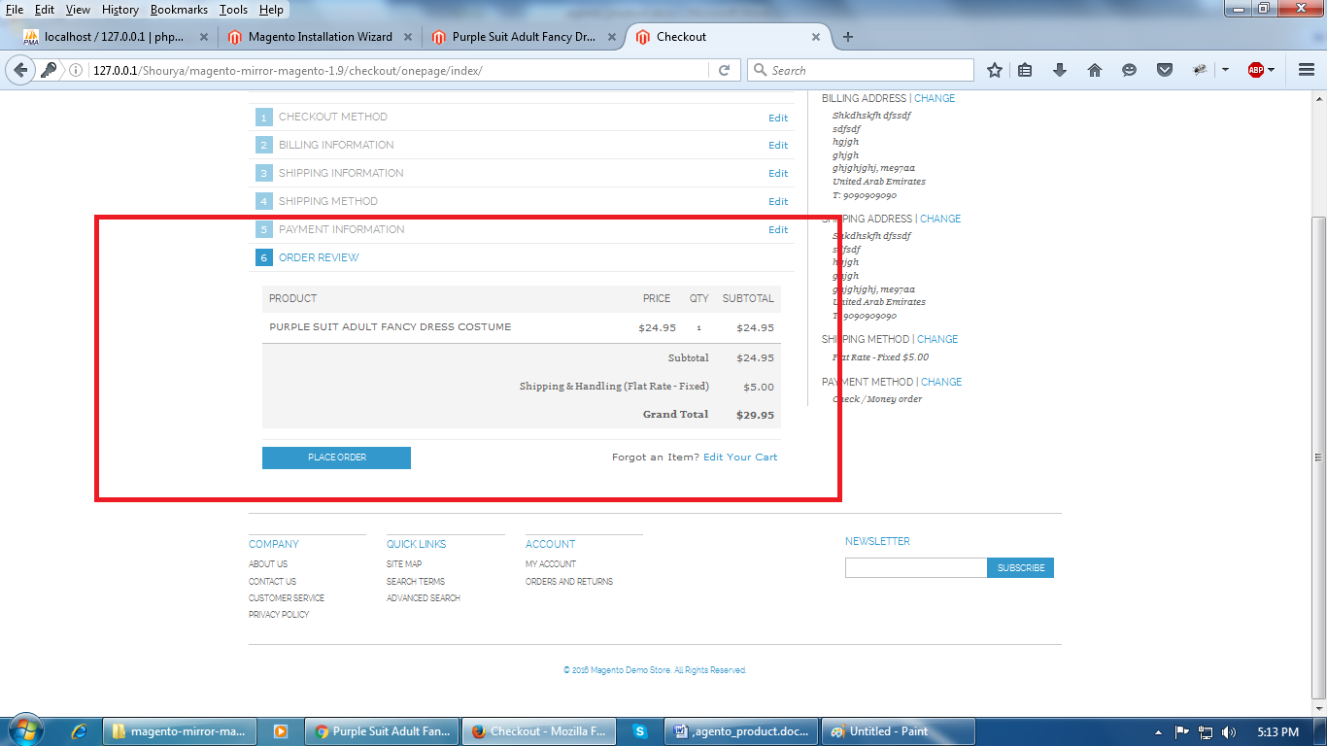

This is the order review section in the checkout page.

Note: All of the above structure of the product, product page, cart page and the check out page are the default magento pages. We can change the pages as your requirement.

For Google Feed we have to use the Google feed extensions.

For the phone order we have to order the product from the back end.

Easy to the newsletter and the feedback extensions.

**About the other requirements**

* Needs to auto resize images (Possible)
* Number of images – is 4 the limit? (No we can add any no of images)
* Need to be able to include video clips – as separate tab before ‘reviews’? (Not sure)
* Color and size options BUT sizes vary between manufacturer – it might better as a tab? (Possible)
* Currency needs to be UK Sterling (£) with auto conversion to Euro, US$, Canadian $ and Aus $ conversion rates are currently picked up daily and if selected all costs are changed to selected currency.(Not sure)
* Shipping costs vary by PRICE in UK and by Quantity and Destination for overseas shipments – these are controlled by tables (Possible) (Shipping methods will be shown in the check out page by default. We have to check how to implement this in the product page.)
* All prices include VAT BUT for certain countries outside of EU, VAT is deducted from the price – controlled by table (compiled from HMRC -UK Govt., publication)(Not sure)
* Free Shipping is available to UK postal addresses at spending of over £50 including VAT(Possible)
* Need the ability to add additional tabs along the bottom (Details – Reviews) for example, when we sell colored lenses for the eyes, we want to be able to make the customer tick a box to say that they have read some Customer Care information. (Possible)
* SKU – needs to be ‘item reference’, this is our own reference for the item which contains information about manufacturer as well as product. We do capture the manufacturers SKU but it’s not shown to the customer, rather it’s used as part of the shopping feed. (Possible)

Note: Those points have **the not sure** comments its does not mean that it is not possible. Basic magento do not provide those functionalities so we to do some research about those points.

If we have to implement the functionalities and add at least one or two products of each categories it’s may take at least 2 months.

After getting approval from yours end we will upload rest of the products.