CELPIP READING TESTS TEST-1: SECTION 1: PART 1-

Dear Mom and Dad,

How do I put into words what my wedding day meant to me and the enormous gratitude I have for everything you did! For so long, I dreamt of the day when Aiden and I would say ―I do‖ and then you made my dream come true. Your support, financially and emotionally, has always been there for me.

I have so many fond memories of all of us working together for the wedding. I will always remember how you focused on what Aiden and I wanted. There were fun times, silly times, hard work times and times of pure joy – and you were always there for me.

Mom, shopping with you for dresses was so special – where did you get all your patience and energy! Dad, I‘ll always remember what you said  to me before we walked down the aisle. And there are a hundred more memories, all because of you two.

Our wedding day was an unbelievable celebration with my family and friends. What memories I will always have!

Thank you for the wedding and reception, and thank you for the washer and dryer you gave us. Laundromat days are over – hooray – because of your very generous and practical gift.

I love you and adore you for everything you did for October 29, 2011. Most of all, thank you for being the extraordinary example of how rich and full married life can be. Your marriage has been a rock in my life and I will work hard to create a marriage as wonderful as the one I have witnessed under your roof.

Love,

Mandy

Q1. Mandy's parents supported her

a. in her worst times

b. psychologically and economically

c. in paying fiscal

d. to compensate and adore

Q2. Aiden is

a. Mandy's helpmate

b. Mandy's real sister

c. Mandy's very close friend

d. always patience and energetic

Q3. Mandy went for shopping

a. with her fiancé

b. with Aiden

c. with her cousin

d. with her mother

Q4. Mandy received

a. a roof and some money

b. a beautiful dress

c. a washer and a dryer

d. a hundred memories

Q5. The wedding was on

a. the 29th day of the 10th month

b. the last day of the month

c. a silly time

d. very pleasant day

Q6. Mandy's parents

a. are financially very well settled

b. filled her life with happiness

c. put the best example of a happy married life.

d. didn't like Aiden

PART 2- Dear Mandy,

All we ever wanted was a daughter and how lucky we are to get you. You have brought so much------------------------- (Q7) to our lives. You made our family complete, and we can‘t wait until you experience this (Q8)----------------------. We are proud of everything you have accomplished in your life and the woman you have become. We pray for your everyday happiness with days filled with hope and possibilities as you and Aiden discover ------------------------ (Q9). Just remember, a happy marriage is built on ------------------------------ (Q10) of dependence on each other. Focus on what is strong in your marriage, not on what is wrong. A happy marriage is a willingness to live with things you can‘t change.

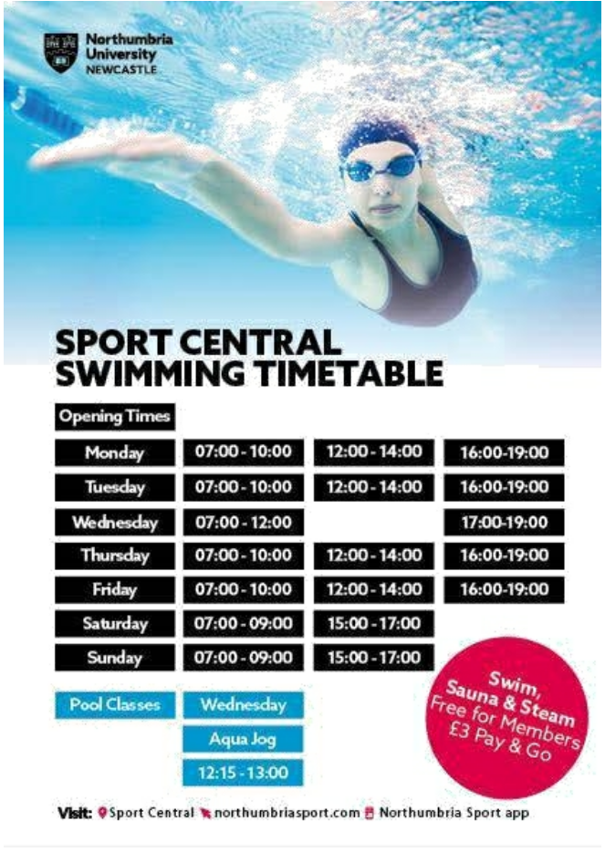

Subject: - Timetable of a swimming pool. To: Herby Patterson <herbypat1@occ.com> From: Jack Karley<jackisgreat@hmail.com> Hi Herby, I was planning to meet you in the morning but unfortunately my boss called on me and we had to leave for an important meeting. But don‘t worry; I have managed to discover the perfect place for swimming with (Q1). From my understanding, it is coherent to adjudge that you will be interested in taking classes for the same. This can be availed on every (Q2). In addition, if you become a member, you will get access to free (Q3) but this is not something of our interest, Right? Luckily, the center offers three time slots on weekdays but only two time slots on(Q4).Since you have an off on Wednesdays, you can also take (Q5). I hope this information would suffice to your requirements. In case of any further query, you can visit their website. Let me know, and I'll see you soon. Jack.

QUESTIONS- PART 1- Q1. a. flexible timings. b. a myriad of instructors to choose from. c. yoga and other physical exercises availability. d. private booking as an indispensable component. Q2. a. Thursday b. Monday. c. Wednesday. d. SaturdaySaturday Q3- a. Demo classes. b. Aqua jog. c. Sauna bath and massage. d.  Swimming, sauna and steam. Q4. a.  Every 2nd Saturday. b.  All weekends plus Wednesday c. Alternate Sundays. d.  Only Saturdays. Q5. a. Zumba. b. Steam bath. c. Aqua jog. d. Sauna. PART 2- Q6. Herby and Jack know each other because they- a. stay together. b. have a relation of a manager and an employee. c. are companions of the same field. d. are siblings. Q7. Herby and Jack are planning to join the swimming classes together to a. solve their ongoing fight. b. spend quality time together. c. experience a new environment. d. rejuvenate their minds from their busy schedule of work. Q8. When Jack said that swimming, sauna and steam are not of their interest, what did he mean by that? a. these classes are not under their budget. b. they are seeking swimming mainly. c. they feel suffocated. d. sauna and steam is injurious to health.

SECTION 3- A.  Canada's culture has historically been influenced by European culture and traditions, especially British and French. Canada's federal government has influenced Canadian culture with programs, laws and institutions. In general, the way of life, family structure, cuisine, and dress are closer to those of the United States than to those of Britain or France. B.   Canada has become a cultural mosaic in which immigrant groups have been able to retain much of their ethnic culture. The major metropolitan centers have provided several focal points for artistic activity stimulated by a rapidly urbanizing society. Like the cultures and customs of other countries, culture and customs of Canada are very distinctive and unique. Canada occupies a very specific piece of the world's geography. C.   Food plays an inextricable role in our daily lives. Food is such an essential element of people's lives that many people think of countries first and foremost in terms of their food and cuisine. While Canada is not known internationally for its culinary contributions or accomplishments the way China, India, France and Italy are, it is known in many parts of the world for its diverse foods and foodstuffs, as well as its regional specialties and escalating gastronomic achievements. This is due to the incredible diversity of the country's environment, its Italy are, it is known in many parts of the world for its diverse foods and foodstuffs, as well as its regional specialties and escalating gastronomic achievements. This is due to the incredible diversity of the country's environment, its multicultural character, and its rapidly growing coterie of world-class chefs, cooks and culinary specialists. D.   Canada is well known throughout the world today for the quantity and quality of its fresh-water fish, ocean fish, and shellfish and the like. Many of these delicacies are packed up in fresh, frozen, or smoked form and shipped off to destinations in other parts of the world in response to the high demand for them. While drink is an essential part of the food and cuisines of all peoples and countries in the world - think of what tea means to China and Japan and wine and beer mean to Germany, France, and other European countries - Canada does not have a long tradition in this area. E. Not in any of the paragraphs. QUESTIONS- 1. An idiosyncratic civilization prevails in the country. 2. Country is renowned for fish farming throughout the globe. 3. Lifestyles of other countries have a large effect on the native land‘s grounding. 4. Natives follow a single culture all over the nation. 5. Comestible, an indispensable element recognized worldwide