Contents
What is JIP 1
Key-points for JIP using for Mule 1
Profiling using JIP 2
Prerequisites 2
Procedure 3
JIP report Viewer 6
Prerequisites 6
Procedure 6
References 10

What is JIP
JIP is a high performance, low overhead profiler that is written entirely in Java. You can also filter out classes and packages as well as control the output.

Key-points for JIP using for Mule
- JIP helps in monitoring method call duration
- Display info in reports, tree views.
- Reports contains most expensive methods
- As of now, profiling using JIP is done only at development phase.
- Memory profiling can't be achieved using JIP.
- There is no option of enabling or disabling profiler on server.
- Reports can be generated in textual and xml formats.
- Reports can only be generated by explicit invoking flows using JUnit or MUnit Tests.
- Report will be generated in all the situations (either in success or failure execution).
- Most expensive methods summary is traced in textual format file.
- Works better with jUnit.
- XML report file is used to analyze time consumption with the help of JIPViewer.jar. (kind of GUI)
- Same flow gives different execution time.(which is expected)
- In case of mUnit, need to mock necessary components of the flow.
- In case of mUnit, need to use 'runFlow' method instead of 'muleClient.send'.

Profiling using JIP

Prerequisites
To run the profiler, you need the following:
- profile.jar
- a profile properties file (optional)
These files are loaded by the application classloader and should not be in the extensions loader path. The jar files need to be in the same directory. The properties file can be anywhere.
To use the profiler, you need to use the following JVM arguments:
-javaagent:[DIR]\profile.jar -Dprofile.properties=[DIR]\profile.properties

Note:where [DIR] must be a fully qualified path is the directory that contains the profile.jar

Procedure
Step 1: write a Junit test method which invokes flow.
Below is sample code snippet
Flow flow = (Flow) getFlowConstruct("jip-usecase1");

//Preparing MuleMessage with inboundProperties
MuleMessage message= new DefaultMuleMessage("",muleContext);
message.setProperty("insertCount", "5",PropertyScope.INBOUND);

//Invoking flow
MuleEvent event = getTestEvent(message, flow);
MuleEvent result = flow.process(event);

assertNotNull(result.getMessage().getPayloadAsString());

Step 2: Add java agent to VM
- Right click on the java class.
- Hover option ‘Run as’
- Select ‘Run Configurations’
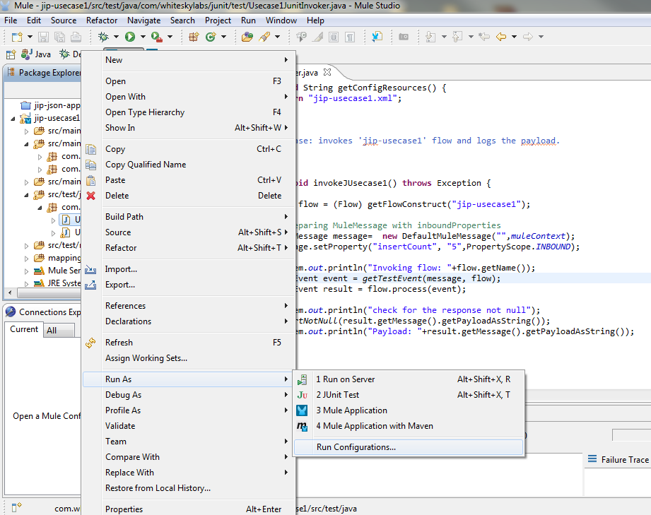
- Select ‘Arguments’ tab of the respective Junit class and add java agent.
-javaagent:F:\JIP\jipProfiler\profile.jar -Dprofile.properties=F:\JIP\jipProfiler\profile.properties
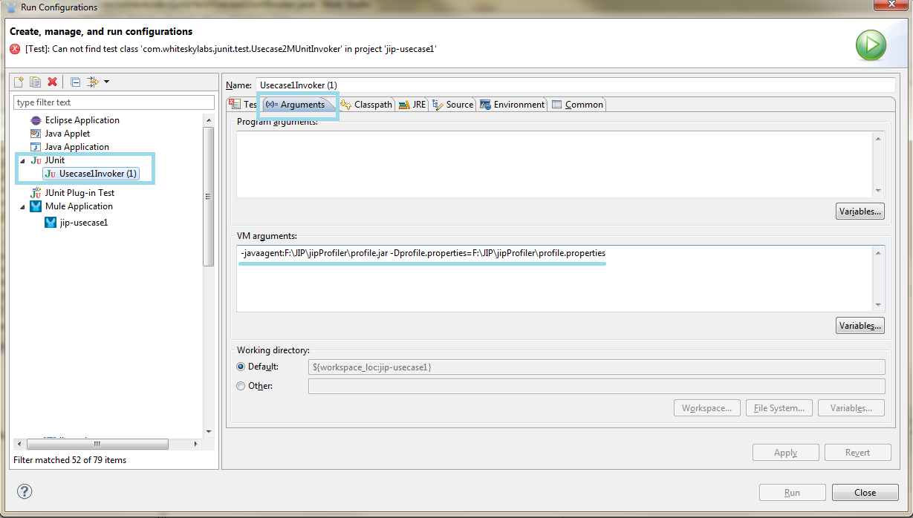
- Hit Apply and Close button.
Step 3:
- Right click on the java class.
- Hover option ‘Run as’.
- Select ‘Junit Test’.
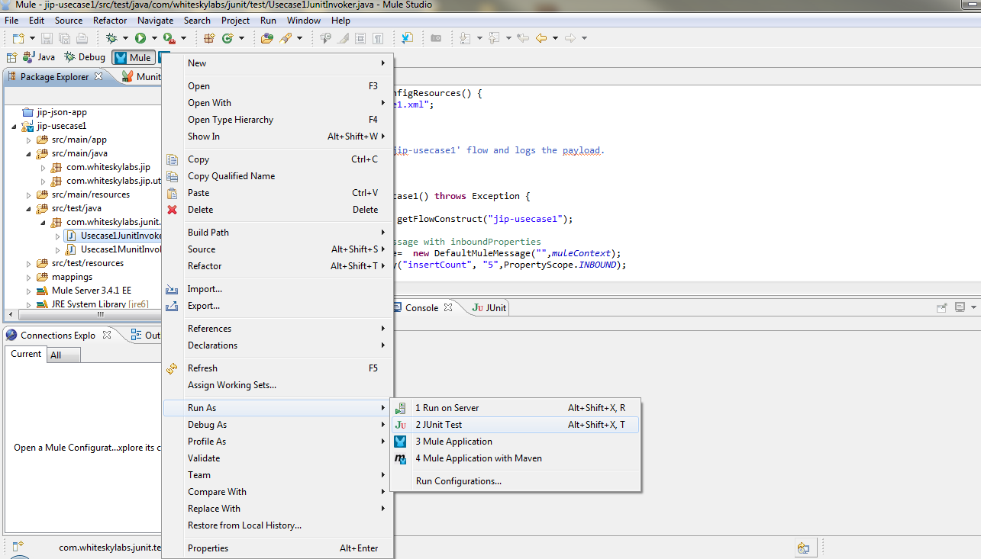
- A report should be generated as per profiler.properties file.

JIP report Viewer

Prerequisites
To see the profiled report, you need the following:
- jipViewer.jar
- a profiled XML file

Procedure
Step 1: Place jipViewer.jar and generated profile report in place and execute below command, GUI will be prompted.
java -jar jipViewer.jar profiles\profile-JUNIT-U2-v1.xml

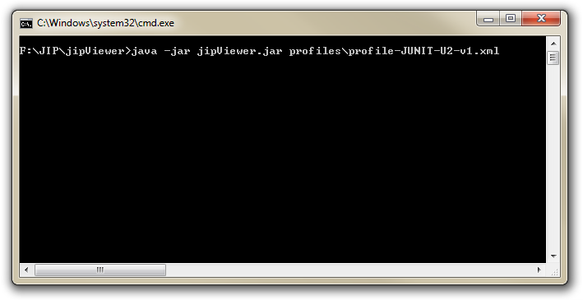

Step 2:
Analyze the report as per the options available.
Under ‘methods’ tabs one can sort for the most expensive methods by a simple click on %net button
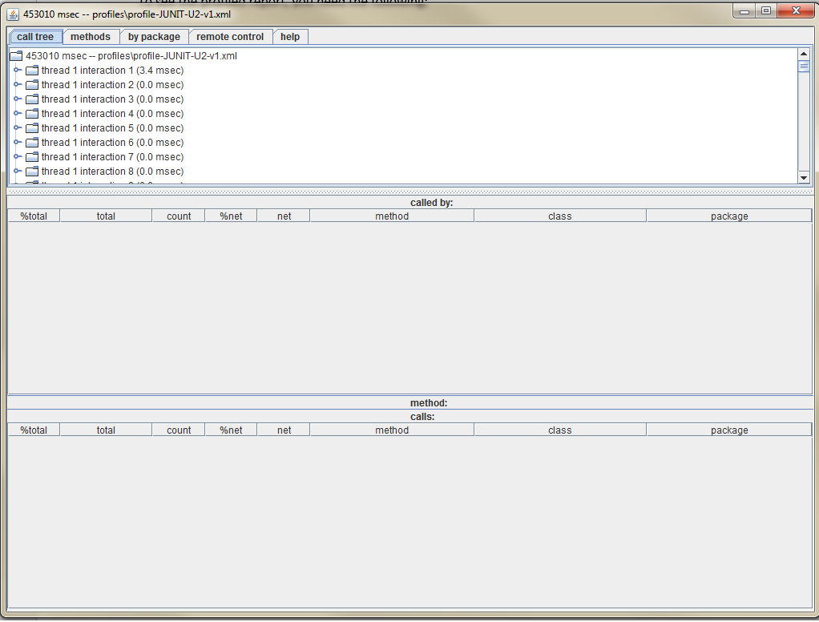
Downloading Jars
- Viewer jar: http://trac.assembla.com/groudsim/export/193/trunk/GroudSim/profile/jipViewer.jar
- Profile jar: http://sourceforge.net/projects/jiprof/ --
Note: This also contains complete documentation on JIP under jip-src-1.2\doc.

Appendix A – The call graph section of the profiler output
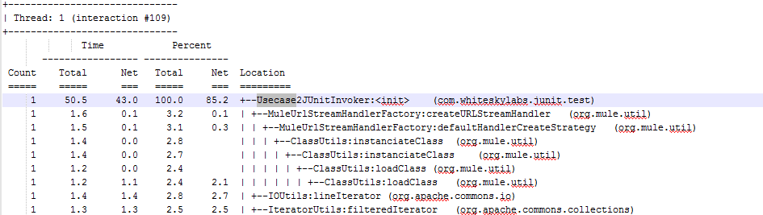

Appendix B – The flattened call graph sorted by method net time
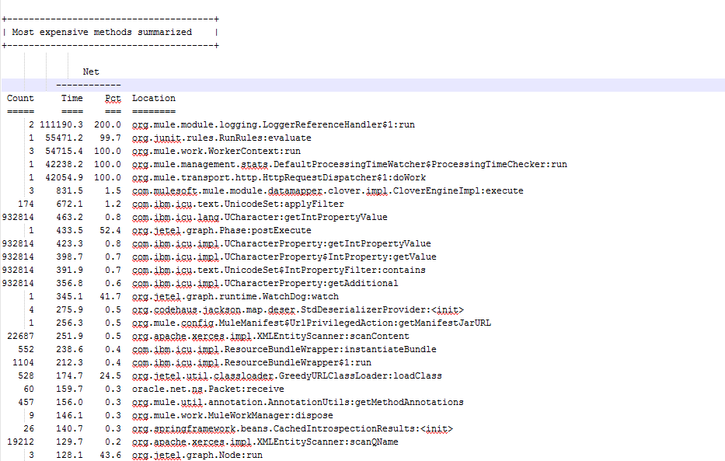

Appendix C – The most expensive methods
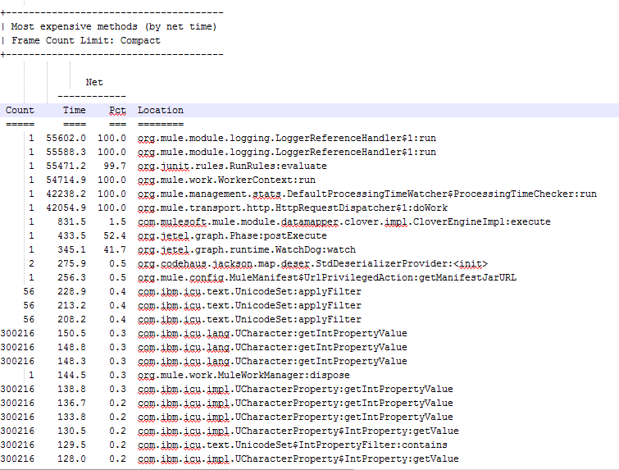

References
http://sourceforge.net/projects/jiprof/
http://confluence.concord.org/display/CCTR/attachments/15911/1574.pdf

