**Overview**

Build a web app that displays a list of Mag7 stocks which are ticker symbols Google, Amazon, Apple, Microsoft, Meta, NVIDIA, Tesla and their glassdoor ratings. Create a

**Tech Stack**

**Core Framework:**

* **Next.js 14+ (App Router)**
* **React 18+**
* **TypeScript**

**Data Management:**

* **Static JSON files for stock data**
* **React useState/useReducer for local state**
* **localStorage for user preferences**

**UI & Styling:**

* **Tailwind CSS**
* **@tanstack/react-table (for advanced table features)**
* **Lucide React (icons)**
* **clsx (conditional classes)**

**Utilities:**

* **date-fns (date formatting)**
* **numeral (number formatting)**

**Dashboard/Homepage:** <https://www.tradingview.com/markets/stocks-usa/market-movers-large-cap/>

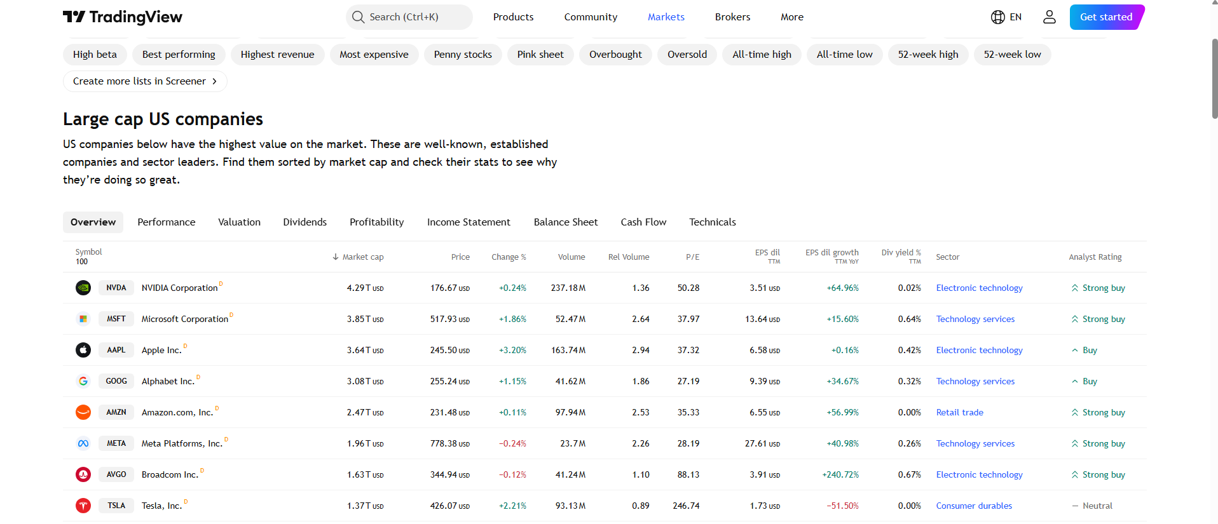

**Stock Chart example:** <https://www.tradingview.com/widget-docs/widgets/charts/symbol-overview/>

