#12Jul2026
hello_llm.py
import os, sys
from dotenv import load_dotenv
from openai import OpenAI
# Load OPENAI_API_KEY from the environment — never hard-code keys
load_dotenv()
client = OpenAI(
base_url="https://openai.vocareum.com/v1"
)
def ask(question):
resp = client.chat.completions.create(
model="gpt-4o-mini",
messages=[
{"role": "system", "content": "You are concise."},
{"role": "user", "content": question},
],
)
return resp.choices[0].message.content
if __name__ == "__main__":
q = " ".join(sys.argv[1:]) or "Say hello."
print(ask(q))

#Commands
pip install openai python-dotenv
python hello_llm.py 'what is rag agent'

#Output

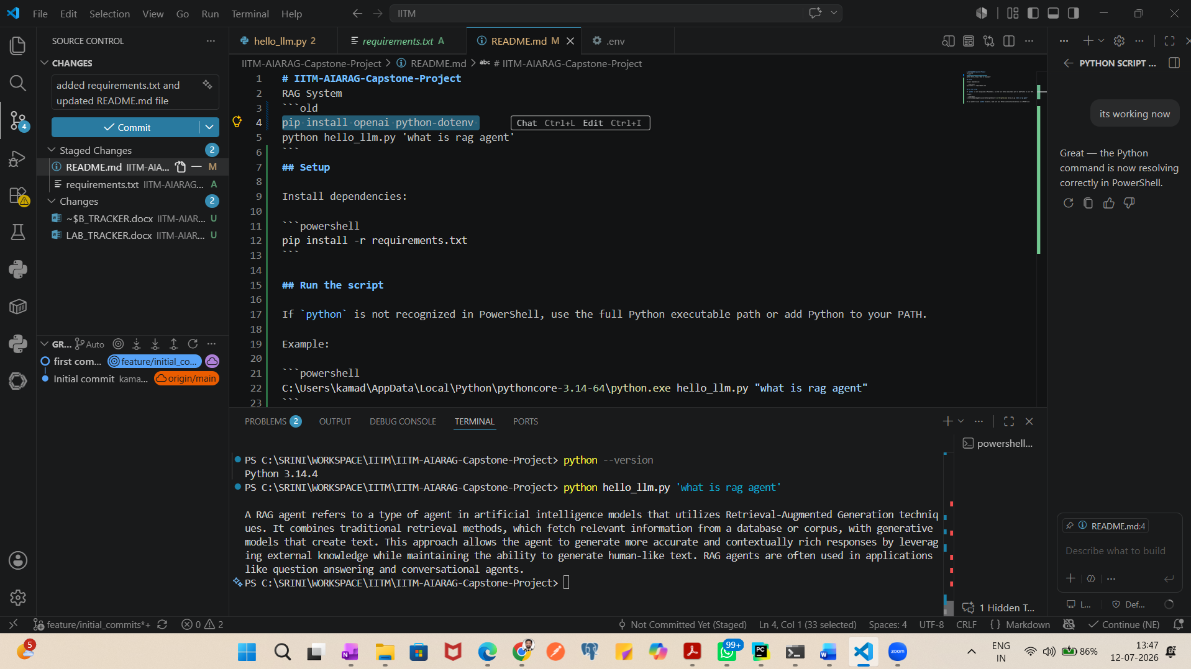

#Git repository
https://github.com/kamadasrinivas/IITM-AIARAG-Capstone-Project/blob/feature/initial_commits/README.md

